Mental Causation

Henry P. Stapp
Theoretical Physics Group
Lawrence Berkeley National Laboratory
University of California
Berkeley, California 94720

Abstract

Classical mechanics is formulated without reference to conscious experience. Quantum mechanics, in contrast, is, both by design, and in actual practice, a theory of relationships between the actions we choose and the consequences we experience. The theory includes not only laws that define a continuous evolution described in purely physical terms, but also an elaborate theoretical machinery that relates that continuous evolution to our actions and observations. This machinery injects into the dynamics an “element of wholeness symbolized by the quantum of action and completely foreign to classical physical principles”. The resulting process disrupts the principle of the causal closure of the physical and provides a natural mechanism for mental causation.

1. The Mind-Brain Problem

In 2002 Scientific American published a special issue entitled “The Hidden Mind”. It begins with a pronouncement by Antonio Damasio:

At the start of the new millennium, it is apparent that one question towers above all others in the life sciences: How does the set of processes we call mind emerge from the activity of the organ we call brain?

He notes that some thinkers “believe the question to be unanswerable in principle’’, and remarks that “The naysayers argue that exhaustive compilation of all these data (of neuroscience) adds up to correlates of mental states but to nothing resembling an actual mental state.” (His emphasis) He adds that: “In fact, the explanation of the physics related to biological events is still incomplete” and says that “the finest level of description of mind … might require explanation at the quantum level.”

An article in the same issue written by Francis Crick and Christoph Koch opens with a similar assertion:

The overwhelming question in neurobiology today is the relationship between the mind and the brain.

After surveying the difficulties Crick and Koch conclude that “Radically new concepts may indeed be needed---recall the modifications in scientific thinking forced on us by quantum mechanics.”

Thus these leading neuroscientists agree that the relationship between mind and brain is an important, difficult, but still unsolved puzzle, whose solution may require turning to quantum mechanics, or to some similar radical modification of contemporary classical-physics-based neuroscience.

In psychology, William James wrote, more than a century ago, that consciousness seems to be:

an organ, superadded to the other organs which maintain the animal in its struggle for existence; and the presumption of course is that it helps him in some way in this struggle, just as they do. But it cannot help him without being in some way efficacious and influencing the course of his bodily history. (James 1890, p. 139)

James went on to examine the circumstances under which consciousness appears, and ended up saying:

The conclusion that it is useful is, after all this, quite justifiable. But if it is useful it must be so through its causal efficaciousness, and the automaton-theory must succumb to common-sense'' (James 1890, p.144).

The “automaton theory” is the theory of human beings implied by the classical physics of James’s day. That theory entails the causal closure of the physical, namely the claim that the entire history of the physically described universe, including all physically described aspects of human behavior, are determined jointly by the physically described conditions of the early universe and the eternal physical laws, both of which are expressed entirely in terms of physically described properties alone.

James clearly recognized the incompatibility of his psychology-based conclusions with the then-reigning principles of classical physics. At the end his later book “Psychology: The Briefer Course” he said, presciently, of the scientists who would one day illuminate the mind-body problem:

the best way in which we can facilitate their advent is to understand how great is the darkness in which we grope, and never forget that the natural-science assumptions with which we started are provisional and revisable things. (James 1892)

Shortly thereafter, during the early part of the twentieth century, the precepts of classical physics were found to be incompatible with the growing body of empirical data, and classical mechanics was replaced, at the basic level, by quantum mechanics.

Quantum mechanics violates the causal closure of the physical in two separate ways. The first is the injection of statistical variations into the outcomes of certain experiments. This introduction of randomness into the dynamics provides no opening for mental causation, for the statistical variations are asserted to be truly random, hence independent of our conscious intentions.

The second violation of physical closure enters through what is variously called the free choice on the part of the experimenter, or the choice of basis, or the process 1 action specified by von Neumann’s rigorous mathematical formulation of quantum theory. Von Neumann describes in detail the causal effects of this process 1 action upon the physically described world, but he calls this action an “intervention”, undoubtedly because: (1), The principles of orthodox quantum theory, although requiring the occurrence of such an action in association with each observation, specify no physical cause for it, and place no statistical conditions upon it; and (2), In actual scientific practice the effective cause of each such action is an experimenter’s reason for acting in the way he or she chooses to act, rather than in some other way that the basic quantum principles would equally allow.

The dynamical room for this element of freedom stems from Heisenberg’s uncertainty-indeterminacy principle, which injects into the dynamics at the microscopic level an amount of indeterminateness sufficient to permit, without contradiction, the necessary causal inputs at the macroscopic level. As Niels Bohr put it:

"The freedom of experimentation, … corresponds to the free choice of experimental arrangement for which the mathematical structure of the quantum mechanical formalism offers the appropriate latitude." (Bohr 1958, p.73)

The shift from classical mechanics to quantum mechanics is as much metaphysical and philosophical as physical and mathematical. Indeed, the most radical change wrought by the founders of quantum theory is the switch from an ontological construal of physical theory to an epistemological one. The need to abandon the classical idea of a physical world containing “solid, massy, hard, impenetrable moveable particles” (Newton, 1704) caused the founders of quantum theory to emphasize that what makes a physical theory useful and testable is its predictions concerning connections between our possible actions and their experienced consequences. Thus Bohr writes:

In physics…our problem consists in the coordination of our experience of the physical world. (Bohr 1934, p. 1)

In our description of nature the purpose is not to disclose the real essence of phenomena but only to track down as far as possible relations between the multifold aspects of our experience. (Bohr 1934, p. 18)

the very word “experiment” refers to a situation where we are able to tell others what we have done and what we have leaned. (Bohr 1958, p. 72)

This revised outlook on the nature of physical theory leads to the introduction of a special procedure for connecting the quantum mathematics to empirical observations. It starts with a division of the physical world into an ‘observing system’ and an ‘observed system’. The observing system includes both ourselves and our measuring devices, and it is described in a language that allows us “to communicate to others what we have done and what we have learnt”. The observed system is the system being probed and hence acted upon by the observing system. It is described in the mathematical language of quantum mechanics. Thus the observing system is described in terms of the knowledge gleaned from our experiences, while the observed system is described in terms of the quantum mathematics.

At the interface between these two worlds there is generally a mismatch, which is resolved by a “quantum jump”: the mathematical description of the observed system is asserted to determine only the relative probabilities for the entries of various alternative possible increments of knowledge into our stream of consciousness. The theory thus becomes, fundamentally, an account of relationships between mathematical descriptions and psychological descriptions.

Measuring devices are conceived to consist of physical constituents, or, more precisely, of the quantum analogs of such constituents. Consequently, each such device can be shifted from its original place in the portion of the world described in psychological terms to the part described in physical terms. Von Neumann showed---at least in idealized cases---that, for all practical purposes (FAPP), one can, without altering the psychologically described predictions of the theory, shift more and more of the psychologically described observing system into the physically described observed system, until finally all the brains and bodies of all the observers are described in physical terms, with only the streams of consciousness of the observers being described in psychological language. This division is obviously the most natural division of nature into observing and observed parts, for in this division the entire physical world is described in physical terms, and all streams of consciousness are described in psychological terms. Using this division converts the elaborate quantum mechanical machinery for connecting physical descriptions to psychological descriptions to the machinery for connecting brains to minds. The way this works is worth knowing.

2. Quantum Theory of Observation.

The quantum theory of observation is a technical subject that must in the final analysis be expressed in terms of the appropriate mathematical concepts and symbols. This circumstance tends to render an understanding of the quantum theory of the mind-matter connection inaccessible to scientists and philosophers whose specialties lie outside the domain of mathematics and theoretical physics. Yet an understanding of what quantum physics says about the mnd-brain connection should useful in other fields, such as neuroscience, psychology, and philosophy. The aim of this chapter is therefore to explain the essential features of the orthodox von Neumann quantum theory of observation by using, not von Neumann’s mathematical formulas, but rather some visual displays of their principal features.

Niels Bohr speaks of

The element of wholeness, symbolized by the quantum of action and completely foreign to classical physical principles. (Bohr 1962, p. 60)

This element of wholeness pertains to certain “all or nothing” features of discreteness about our observations. The Geiger counter, in experimental situations prepared and observed with maximal allowed precision, is either heard to click, with a certain probability, or is not heard to click: there is no smearing of ‘hearing the click’ and ‘not hearing the click’, even though the purely physically described aspects of the theory produce only continuous values at finite times and locations, and generally a combination of the two observationally distinct possibilities.

This discreteness at the empirical level matches an empirical feature of perception emphasized by William James:

a discrete composition is what actually obtains in our perceptual experience. We either perceive nothing, or something already there in a sensible amount. This fact is what is known in psychology as the laws of the ‘threshold.’ Either your experience is of no content, of no change, or it is of a perceptible amount of content or change. Your acquaintance with reality grows literally by buds or drops of perception. Intellectually and on reflection you can divide these into components, but as immediately given they come totally or not at all. (James 1911)

Thus perception exhibits an empirical element of wholeness that is phenomenally like what quantum theory is designed to explain. However, the element of wholeness described in quantum physics is tied to an elaborate mathematical machinery involving Planck’s quantum of action. This makes the features of observational wholeness that are generated by the quantum machinery strictly inaccessible within classical mechanics.

The quantum machinery pertaining to observation is based upon representing the state of the system being observed as a vector, and tying the discrete possible outcomes of any observational process to a discrete set of basis vectors, one for each of the elementary possible outcomes. Planck’s quantum of action lies at the core of this machinery.

The quantum mechanical representation of the state of the physical system of interest here, namely someone’s brain, is a vector in a vector space of a very large number of dimensions. But the basic idea of a vector in a vector space, and of its relevance to empirical observations, can be illustrated by a simple example in which that space has just two dimensions.

Take a flat sheet of paper and put a point on it. (Imagine that your pencil is infinitely sharp, and can draw a true point, and perfectly straight lines of zero width.). Draw a straight line that starts at this point, called “the origin”, and that extends out by a certain amount in a certain direction. That directed line segment, or the displacement from the origin that it defines, is a vector in a two-dimensional space.

Any pair of unit-length vectors in this space that start from the origin and are perpendicular to each other constitute a “basis” in this two-dimensional space. (They are in fact an “orthonormal basis”, but that is the only kind of basis that will be considered here.) Because any pair of perpendicular unit-length vectors rigidly rotated (about the origin) by any angle between 0 and 360 degrees gives another perpendicular pair, there is an infinite number of ways to choose a basis in a two-dimensional space.

Given a basis, there is a unique way of decomposing any vector in the space into a sum of displacements, one along each of the two perpendicular basis vectors. The two individual terms in this sum are a pair of perpendicular vectors called the components of the vector in this basis. One such decomposition is indicated in Figure 1.

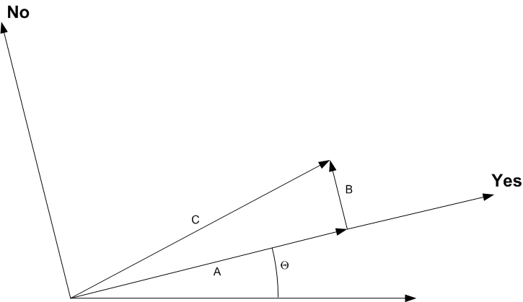

Figure 1. Decomposition of vector V of length C, in a two-dimensional space, into components of lengths A and B directed along a pair of mutually perpendicular basis vectors that correspond, respectively, to the two alternative possible answers to a possible process 1 question labeled by the angle Ө. These two possible answers are labeled ‘Yes’ and ‘No’---e.g., ‘click’ or ‘no click’.

If V has unit length and A and B are the lengths of the components of V that are directed along these two basis vectors, then, by virtue of the theorem of Pythagoras, A² + B ² = 1: the sum of the two squares is unity. This is what a sum of probabilities should be. Consequently, the concept of probability can be naturally linked to the concept of vectors in a space of vectors. The angle Ө specifies the different observational processes that are possible in principle for vectors in this space; and, for any fixed Ө, the two corresponding basis vectors correspond to the two possible distinct outcomes of the observational process specified by that angle Ө.

An N-dimensional (vector) space is similar, but has N dimensions instead of just two. This means that it allows not just two mutually perpendicular basis vectors, and hence two possible outcomes, but N of them, and hence N possible outcomes. As a mathematical idea, an N-dimensional vector space is well defined. There are clearly an infinite number of ways to choose a basis---a set of mutually perpendicular unit-lenth vectors---in any space of two or more dimensions, hence an infinite set of observational processes that are possible in principle. For any N, and for any basis in the N-dimensional space, there is a unique way of decomposing any vector in that space into a sum of displacements each lying along one of the mutually perpendicular basis vectors.

Each possible observational process is, according to the basic principles of quantum theory, associated with such a choice of basis vectors. The N-dimensional generalization of the theorem of Pythagoras says that the sum of the squares of lengths of the mutually perpendicular components of the unit length vector V that represents the quantum state of the physical system is unity. Consequently, the probability interpretation of the lengths of the components of the vector V carries neatly over to the N-dimensional case. Vectors in vector spaces provide, therefore, a natural framework for expressing the probabilities associated with the disjoint discrete alternative possibilities that arise in the natural world

The reason for giving this brief account of the quantum mechanical machinery for connecting mathematical description to experiential reality is, first, to emphasize that there is such a special machinery, in which our choices of how we will act upon [probe] an observed system are represented in an abstract space, together with the set of mutually exclusive possible observational outcomes of each [probing] action; and, second, to contrast the structure of this machinery with that of its classical counterpart.

Quantum mechanics is somewhat analogous to classical statistical mechanics, which, however, is formulated not in a vector space but in so-called “phase space”. For a single point particle in classical mechanics each possible state is specified by giving the location of the particle and also its momentum. (The momentum of the particle is the product of its velocity times its mass.)

The collection of all possible states of the particle is called its phase space. There is an analogous phase space for every classical system.

The basic procedure in classical statistical mechanics is this: first, on the basis of a preparation, one distributes a unit probability over the phase space of the system; next, one lets the points in phase space evolve in accordance with the laws of classical physics, with each moving point carrying its local probability (density) value along with it; and finally, one asserts that the probability at some later time “t” for the system to be in a certain region R will be the amount of the distributed probability that lies in region R at time “t”.

According to quantum theory, the probabilities associated with the various possible outcomes of any fixed process of observation are associated with a corresponding set of basis vectors. However, each of these basis vectors corresponds only to a fuzzy region in the associated phase space of classical physics. And the sizes and shapes of these fuzzy elementary regions that are associated with observational wholeness are not arbitrary. The size of an elementary region is fixed by Planck’s quantum of action. Thus points, or overly small, or arbitrarily shaped, or sharply defined, regions in phase space cannot be assigned probabilities associated with the observations or preparations described by quantum mechanics.

The entire quantum machinery associated with the connection between mathematical/physical description and observations is wiped out by classical physics, or by the classical approximation to quantum physics (which is obtained by replacing the actual value of Planck’s quantum of action by zero). The restrictions on the sizes and shapes of the allowed regions R are lost. Also lost is the Heisenberg indeterminacy at the micro-level that opens up the possibility of injecting physically undetermined causal inputs at the macro-level. Given the existence of this elaborate vector-based, Planck’s constant dependent, machinery for connecting physical descriptions to observations how could one reasonably expect to understand the actually existing connection between brain activity and observations within the conceptual framework of a classical-physics that destroys that machinery?

Quantum mechanics provides, then, an elaborate machinery devoted explicitly to the specification of the connection between mathematical description and experiential reality. This quantum machinery lies completely beyond anything that the classical concepts can encompass. What quantum mechanics explains so neatly and rationally can be seen only as illusion within the classical mechanical conceptualization of nature. For the quantum machinery rests on “The element of wholeness, symbolized by the quantum of action, and completely foreign to the classical physical principles.”

I shall now describe the quantum machinery in more detail. The first step is to recognize that, according to von Neumann’s work, a human brain, as a physical system imbedded in the physical universe, is best represented not simply as a vector in a vector space in N dimensions, but as an N-by-N matrix, called the density matrix.

An N-by-N matrix is like a crossword puzzle with N rows and N columns, but with each little box filled by a number. The N rows run over the N discrete states of some set of basis states of the brain, and the N columns run over the same set of N basis states in the same order. Each such basis state corresponds to some small fuzzy region in the phase space of classical physics, with the size of the region specified by Planck’s quantum of action. The off-diagonal elements, for which the row and the column correspond to different basis states, specify the strengths of possible quantum interference effects between these two different basis states, whereas the diagonal elements correspond most closely to the concepts of classical physics.

Before proceeding further one important idea needs to be introduced. It is the concept of “template for action”. If you are in the process of performing some coordinated action there is presumably some active pattern of neural activity in your brain that is in overall charge of activating the coordinated sequence of neural signals that is leading to the well-orchestrated performance of that action. I call this pattern of neural (or brain) activity the template for action associated with this particular action. The dynamical assumption is that if this template for action remains active for a sufficiently long period of time then the associated action will tend to occur.

To put the idea of “different possible actions” in a definite context, suppose you are walking in a jungle at night and shadowy form jumps out of the darkness. The job of your brain is to evaluate your situation and construct a coordinated plan of action, perhaps to fight, or perhaps to flee. According to a classical model, your brain will, if well conditioned, decide on one plan or another, not produce both plans with no decision between them. However, in the case of a ‘close call’ the actual decision may depend on the particular state of the background noise associated with all of the random spikings of all the neurons in your brain.

In the quantum description there is, at the micro-level of the calcium ions entering nerve terminals a significant and unavoidable indeterminateness introduced by the narrowness of the ion channels through which the ions enter the nerve terminals. (Schwartz, 2005) Although perhaps damped out by massive parallel processing in those special cases where one particular response is overwhelmingly favored, the alternative mutually incompatible classically described possibilities of “fight” and “flight” could, in ‘close call’ cases, both be created and sustained by the purely physically described processing: in view of the underlying basic indeterminacy at the micro-level the Schroedinger equation could generate a macroscopic analog in your brain of Schroedinger’s cat.

Figure 2 shows the density matrix representation of a brain with two sets of rows singled out. The first singled-out set corresponds to brain states in which the template for action corresponding to “fight” is active, and the other singled-out set of rows corresponds to states in which the template for action corresponding to “flight” is active. The two corresponding sets of columns are also indicated. It is assumed that the available energy and organizational structure will go to one template or the other, so that at the classical level of description the two templates will not be simultaneously activated. Correspondingly, the two intervals along the diagonal corresponding ‘fight’ and ‘flight” are well separated in Figure 2. Nonzero numbers in the boxes corresponding to ‘fight’ rows but ‘flight’ columns---or vice versa---correspond to the possibility of observing interference effects between the ‘fight’ and ‘flight’ parts of the state of the brain represented by this density matrix. The diagonal elements correspond most nearly to the phase space of classical physics. However, the phase space of classical physics is not partitioned by some process---related to Planck’s quantum of action---into discrete regions of finite size and special shapes that are associated, by virtue of the workings of this process, with discrete alternative possible experiences.

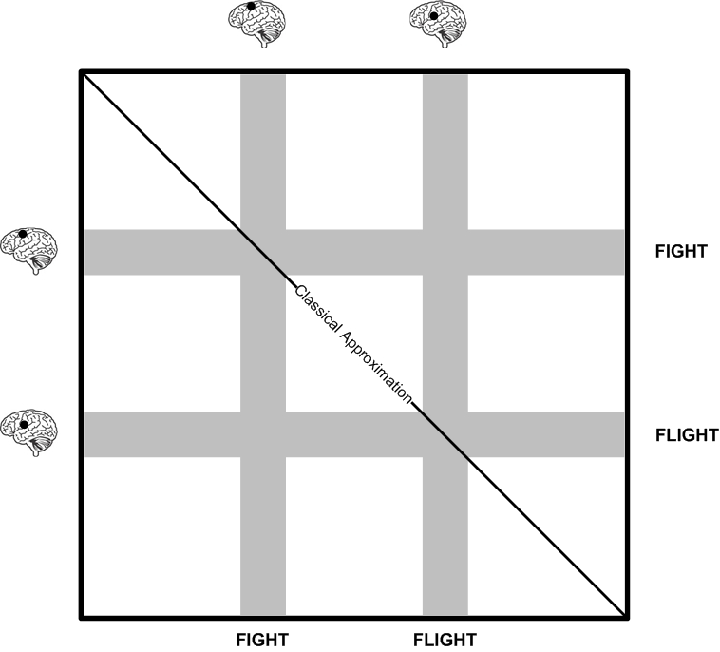

Figure 2. The density-matrix representation of the brain with the sets of rows and columns corresponding to the activation of a template for a “fight” action or for a “flight” action both shaded.

The much-discussed decoherence effect arising from interactions with the environment is shown schematically in Figure 3: the elements not lying in the shaded region are damped essentially to zero. The diagram illustrates the two main points:

1) The decoherence effect does not single out any one particular nearly classical state: it merely damps effectively to zero all significantly-non-classical possibilities, leaving the entire range of essentially classical possibilities intact and untouched, including both the ‘fight’ and ‘flight’ portions of the (nearly classically interpretable) diagonal. Thus environmental decoherence produces no choice between the (nearly) classically interpretable--but very different---states corresponding, respectively, to “fight” or “flight”. The entire portion of the matrix that corresponds to classically describable possibilities is retained essentially untouched.

2) The off-diagonal parts of the density matrix that can lead to interference effects between the ‘fight’ and ‘flight’ potentialities has been effectively damped out by the interaction with the environment.

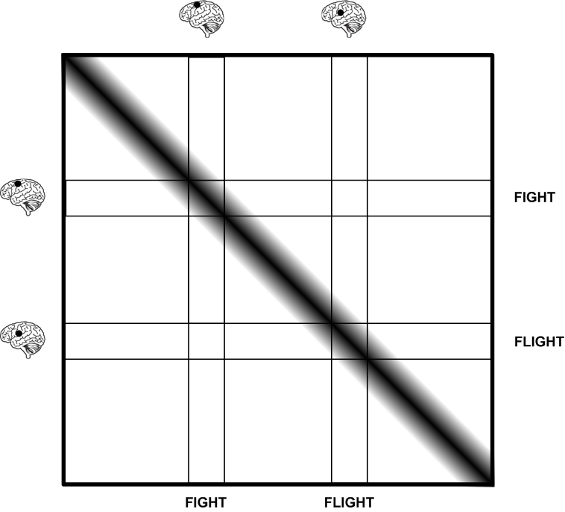

Figure 3. Environmental decoherence effectively damps out the matrix elements not on the diagonal or close to them, but does not choose between alternative essentially classical possibilities

The environmental decoherence effect, being a consequence of the physically describable Schroedinger equation alone, does not come to grips with the discreteness issues pertaining to the connection of the quantum state to probabilities associated with observations. That connection involves, critically, von Neumann’s process 1 intervention.

Process 1 acts, in general, upon the density matrix that specifies the state of some system that is being observed. It sets certain of the elements of that matrix to zero and leaves the rest unchanged. Figure 4 shows the effect on the density matrix of the particular process 1 action that is such that its the ‘Yes’ outcome saves only those states of the brain in which the template for ‘fight’ action is active. The shaded regions of Figure 4 indicate those elements of the density matrix that are left unchanged by this process 1 action, while the whitened regions indicate those elements that are set to zero.

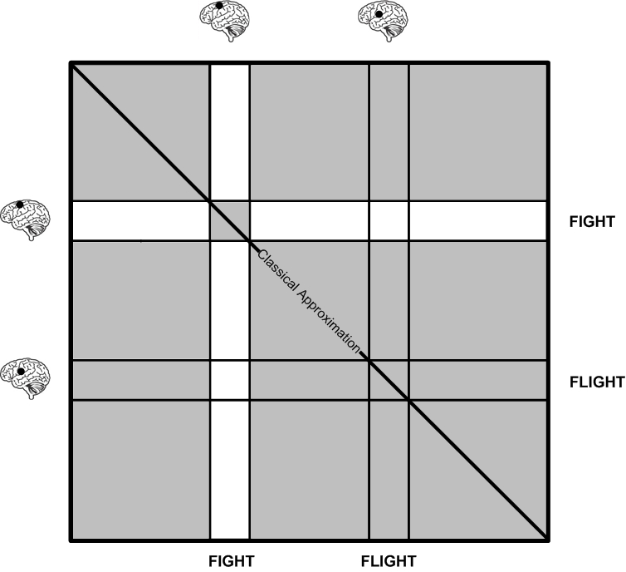

Figure 4. This figure shows the effect on the density matrix representing the state of some person’s brain of the process 1 action whose ‘Yes’ component singles out the “fight” possibility. The process 1 action sets strictly to zero all (whitened) elements lying in a ‘Yes’ column and a ‘No’ row or a ‘Yes’ row and a ‘No’ column, but leaves unchanged all other (shaded) elements.

Note that process 1 is a decoherence effect, in the sense that it sets to zero certain off-diagonal elements, but leaves all diagonal elements unchanged. It is more incisive, in a certain sense, than the environmental decoherence effect in that it sets strictly to zero the elements in a region that extends right down to the (classically interpretable) diagonal. Consequently, the process 1 action carves out a set of ‘Yes’ diagonal elements, and, by exclusion, a complementary set of ‘No’ diagonal elements. The latter set consists of all the diagonal elements that are not ‘Yes’ elements.

It is important that the quantum decomposition into separate boxes is in terms of elements corresponding to basis vectors associated with possible observable outcomes. It is this essential feature that establishes the connection of the quantum mathematics to empirical/phenomenal data.

Figure 5 shows the effect of the process 1 action shown in Figure 4 upon the state of the environmentally reduced brain shown in Figure 3.

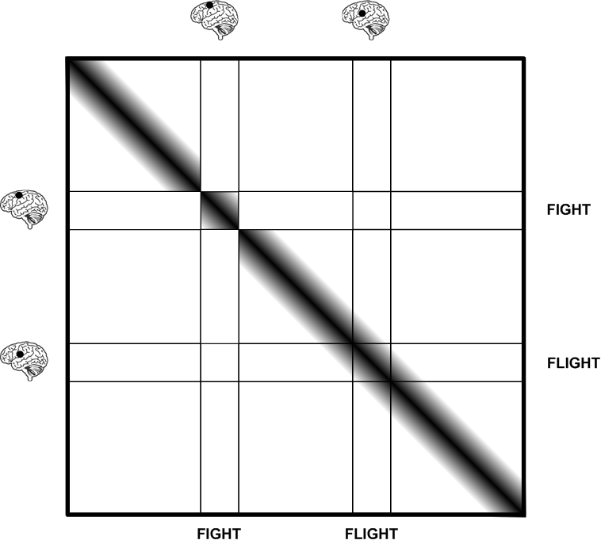

Figure 5. The effect upon the environmentally reduced state of the brain produced by the process 1 action that is such that its ‘Yes’ outcome preserves only those states of the brain in which the ‘fight’ template for action is active.

Figure 6 shows the effect of nature’s choosing the ‘Yes’ outcome. The surviving states of the brain are those in which the template for ‘fight’ action is active.

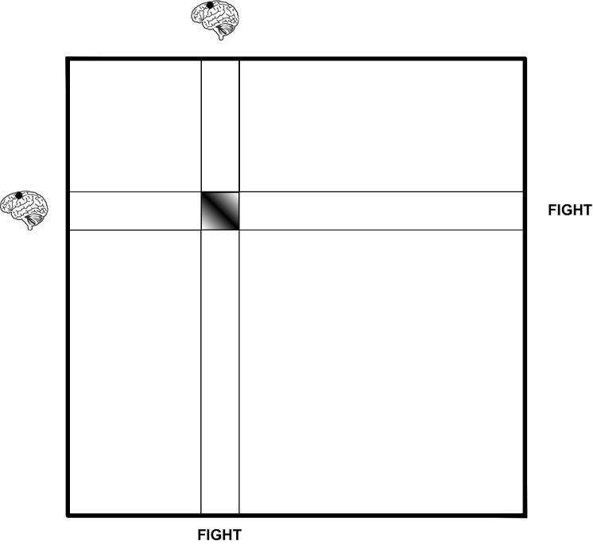

Figure 6. The effect of nature’s answering ‘Yes’ to the question “Will the template for fight be active?” The effect is to set to zero of all elements of the density matrix of the brain except those in the shaded area.

According to the precepts of quantum theory the reduction event leading to the ‘Yes’ state shown in Figure 6 is the physically described aspect of a psycho-physical event whose psychologically described aspect is the experiencing of the intention to perform this “fight’ action. In general, the basic realities in quantum theory are psycho-physical events, and for each such event its physically described aspect is the reduction of the quantum state of an observed system to the part of that state that is compatible with the psychologically described aspect, which is an increment in knowledge entering a stream of consciousness. The evolving physical state is thereby kept in accord with our evolving state of knowledge, in accordance with Bohr’s words cited earlier, and Heisenberg’s famous statement:

The conception of objective reality of the elementary particles has thus evaporated not into the cloud of some obscure new reality concept but into the transparent clarity of a mathematics that represents no longer the behavior of particles but rather our knowledge of this behavior. (Heisenberg 1958, p.100)

Figure 7 shows the effect on the ‘Yes’ state shown in Figure 6 that would be generated by the normal evolution in time specified by the Schroedinger equation.

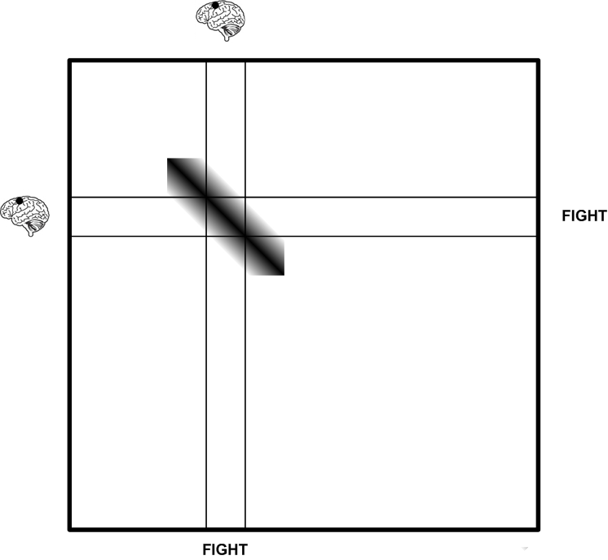

Figure 7. The ‘diffusion’ effect generated by the normal Schroedinger equation evolution of the ‘Yes’ state of the brain shown in Figure 6.

I shall come back to these figures later.

3. The Physical Effectiveness of Conscious Will

A crucial question now arises: How does this dynamical psycho-neurological connection via Process 1, which can merely pose a question, but not answer it, allow a person’s effort to influence his or her physical actions?

Take an example. Suppose you are in a situation that calls for you to raise your arm. Associations via stored memories should elicit a brain activity having a component that when active on former occasions resulted in your experiencing your arm rise, and in which the template for arm-raising is active. According to the theory, this component of brain activity will, if sufficiently strong, cause an associated process 1 action to occur. This process 1 action will partition the quantum state of your brain in a way such that one component, labeled ‘Yes’, will be this component in which the arm-raising template is active. If the ‘Yes’ option is selected by nature then you will experience yourself causing your arm to rise, and the state of your brain will be such that the arm-raising template is active.

But the only dynamical freedom offered by the quantum formalism in this situation is the freedom to perform at a selected time some Process 1 action. Whether or not the ‘Yes’ component is actualized is determined by “nature” on the basis of a statistical law. So the effectiveness of the “free choice” of this process 1 in achieving the desired end would generally be quite limited. The net effect of this “free choice” would tend to be nullified by the randomness in nature’s choice between ‘Yes’ and its negation ‘No’.

A well known non-classical feature of quantum dynamics provides, however, a way to overcome this problem, and convert the available “free choices” into vehicles of mental causation.

3.1 The Quantum Zeno Effect
A well studied feature of the dynamical rules of quantum mechanics is this: Suppose a process 1 query that leads to a ‘Yes’ outcome is followed by a rapid sequence of very similar process 1 queries. That is, suppose a sequence of identical or very similar process 1 actions is performed, that the first outcome is ‘Yes’, and that the actions in this sequence occur in very rapid succession on the time scale of the evolution of the original ‘Yes’ state. Then the dynamical rules of quantum theory entail that the sequence of outcomes will, with high probability, all be ‘Yes’: the original ‘Yes’ state will, with high probability, be held approximately in place by the rapid succession of process 1 actions, even in the face of very strong physical forces that would, in the absence of this rapid sequence of actions, quickly cause the state to evolve into some very different state. (Stapp 2004, Sect. 12.7.3)
The timings of the process 1 actions are, within the orthodox formulations, controlled by the “free choices” on the part of the agent. Mental effort applied to a conscious intent increases the intensity of the experience. Thus it is consistent and reasonable to suppose that the rapidity of a succession of essentially identical process 1 actions can be increased by mental effort. But then we obtain, as a mathematical consequence of the basic dynamical laws of quantum mechanics described by von Neumann, a potentially powerful effect of mental effort on the brain of the agent! Applying mental effort increases the rapidity of the sequence of essentially identical intentional acts, which then causes the template for action to be held in place, which then produces the brain activity that tends to produce the intended feedback.
This “holding-in-place” effect is called the quantum Zeno effect, an appellation picked by the physicists E.C.G. Sudarshan and R. Misra (1977) to highlight a similarity of this effect to the “arrow” paradox discussed by the fifth century B.C. Greek philosopher, Zeno the Eleatic. Another name for this effect is “the watched-pot effect”.
The “quantum Zeno effect” can, in principle, hold an intention and its template in place in the face of strong mechanical forces that would tend to disturb it. This means that agents whose mental efforts can sufficiently increase the rapidity of Process 1 actions would enjoy a survival advantage over competitors that lack such features. They could sustain beneficial templates for action in place longer than competitors who lack this capacity. Thus the dynamical rules of quantum mechanics allow conscious effort to be endowed with the causal efficacy needed to permit its deployment and evolution via natural selection.

In terms of the figures of section 2, the quantum Zeno effect entails that if the process 1 action indicated by Figure 5 is repeated sufficiently rapidly then the diffusion action indicated in Figure 7 will be blocked, and the state of the brain will be restricted essentially to the ‘Yes’ condition, indicated in Figure 6---namely to the set of states such that the neurological activity identified as the template for a ‘fight’ action is activate---for longer than the classical precepts would allow. The effect of holding this template for action in place for this longer period should be to cause the intended ‘fight’ response to occur. In this way, anything that influences the process 1 choice of basis, and the choice of the rapidity with which the process 1 action occurs, also influences, via the quantum laws that govern the causal connections between observation and brain activity, the person’s physical actions.

The process 1 choices are not determined by any known physical cause, but seem to be, and in actual life effectively are, determined by our value-driven reasons to act in the way we do. It is perfectly consistent with the psycho-physical quantum model to take these reasons to be indeed the causes of these choices. This brings the model into accord with common sense, and back to the assertion of William James quoted earlier: ``The conclusion that it [consciousness] is useful is, after all this, quite justifiable. But if it is useful it must be so through its causal efficaciousness, and the automaton-theory must succumb to common-sense'' (James 1890, p.144).

3.2 William James on Volition

This theory of volition was already in place when a colleague, Dr. Jeffrey Schwartz, brought to my attention some passages from ``Psychology: The Briefer Course'', written by William James. In the final section of the chapter on “Attention” James (1892) writes:

I have spoken as if our attention were wholly determined by neural conditions. I believe that the array of things we can attend to is so determined. No object can catch our attention except by the neural machinery. But the amount of the attention which an object receives after it has caught our attention is another question. It often takes effort to keep mind upon it. We feel that we can make more or less of the effort as we choose. If this feeling be not deceptive, if our effort be a spiritual force, and an indeterminate one, then of course it contributes coequally with the cerebral conditions to the result. Though it introduce no new idea, it will deepen and prolong the stay in consciousness of innumerable ideas which else would fade more quickly away. The delay thus gained might not be more than a second in duration---but that second may be critical; for in the rising and falling considerations in the mind, where two associated systems of them are nearly in equilibrium it is often a matter of but a second more or less of attention at the outset, whether one system shall gain force to occupy the field and develop itself and exclude the other, or be excluded itself by the other. When developed it may make us act, and that act may seal our doom. When we come to the chapter on the Will we shall see that the whole drama of the voluntary life hinges on the attention, slightly more or slightly less, which rival motor ideas may receive. ...

In the chapter on Will, in the section entitled “Volitional effort is effort of attention” James writes:

Thus we find that we reach the heart of our inquiry into volition when we ask by what process is it that the thought of any given action comes to prevail stably in the mind.

and later

The essential achievement of the will, in short, when it is most `voluntary,' is to attend to a difficult object and hold it fast before the mind. ... Effort of attention is thus the essential phenomenon of will.

Still later, James says:

Consent to the idea's undivided presence, this is effort's sole achievement.”...“Everywhere, then, the function of effort is the same: to keep affirming and adopting the thought which, if left to itself, would slip away.

James’s description of the effect of volition on the course of brain process is remarkably in line with what had been proposed, independently, on the basis quantum theory. But now the features described by James are explained on the basis of the same dynamical principles that had been introduced by physicists to explain atomic phenomena. Thus the whole range of science, from atomic physics to mind-brain dynamics, is brought together in a single rationally coherent theory of a reality that is constituted not of matter, as classically conceived, but rather of a sequence of psycho-physical events that are located in space-time and are causally linked together by a field of potentialities described in the mathematical language of quantum mechanics

No comparable success has been achieved within the framework of classical physics, in spite of intense efforts spanning more than three centuries. The reasons for this failure are easy to see: classical physics systematically exorcizes all traces of mind from its precepts, thereby banishing any logical foothold for recovering mind. Moreover, according to quantum physics all causal effects of consciousness act within the latitude provided by the uncertainty principle, and this latitude shrinks to zero in the classical approximation, thereby eliminating all causal effects of consciousness.

4. Squaring With Neuroscience.

How does the quantum conception of mind-brain dynamics square with contemporary neuroscience?

Steven Pinker is an able reporter on contemporary neuroscience. In the lead article “The Mystery of Consciousness” in the January 29, 2007 Mind & Body Special Issue of Time Magazine he notes that while certain mysteries remain, neuroscientist agree on one thing: “Francis Crick called it ‘the astonishing hypothesis’---the idea that our thoughts, sensations, joys and aches consist entirely of physiological activity in the tissues of the brain.”

Of course, the phrase “physiological activity” needs to be replaced by

“psycho-physiological activity” since this activity is being explicitly asserted to have psychological or experiential content. Later Pinker says that “Consciousness turns out to consist of a maelstrom of events distributed across the brain.” These events should evidently be labeled psycho-physical events, since being located in the brain is a physical attribute, while being the components of consciousness entails that these events have psychological aspects.

These psycho-physiological or psycho-physical characterizations fit quantum theory perfectly. According to von Neumann’s formulation each of the quantum events in the brain has both a psychological aspect and a physical aspect. The physical aspect is the jump of the quantum state of the brain to that part of itself that is compatible with the increment in knowledge specified by its psychologically described aspect. It is this tight linkage between the psychologically and physically described aspects of the events that keeps a person’s brain in alignment with his or her experiences. These repeated reductions are both possible and needed because the indeterminacy present at the microscopic/ionic level, keeps generating at the macroscopic level a profusion of brain states corresponding to mutually incompatible observations. These dynamically needed interventions, whose causal origin is left unspecified by the physical theory, provide a natural vehicle for mental causation.

This all depends on accepting the utility of the quantum mechanical program of building science’s conception of nature on the notion of a sequence of macroscopically localized psycho-physical events, rather than on the notion of mindless matter.

Pinker refers to “The Hard Problem”. He says:

The Hard Problem is explaining how subjective experience arises from neural computation. The problem is hard because no one knows what a solution would look like or even is a genuine scientific problem in the first place. And not surprisingly everyone agrees that the hard problem (if it is a problem) is a mystery.

Of course this “hard” problem is---and will remain---a mystery insofar as one’s thinking is imprisoned within the fundamentally invalid conceptual framework postulated by classical physics, which has no rational place for consciousness. Within that framework the problem is seen to be “explaining how subjective experience arises from neural computation”, since all that is given is mindless matter. But the mystery immediately dissolves when one passes over to quantum theory, which was formulated from the outset as a theory of the interplay between physical descriptions and conscious thoughts, and which comes with an elaborate and highly tested machinery for relating these two kinds of elements.

Some quantum physicists want to justify basing neuroscience on classical physics by suggesting that once the neural activity reaches a classically describable level, say at the firing of a neuron (i.e., the triggering of an action potential), one may assume that the quantum jump from ‘potential’ to ‘actual’ has occurred, and hence that one can deal simply with the actualities of neuron firings, and ignore their quantum underpinnings.

That approach would be a misuse of the quantum mechanical use of the concepts of classical mechanics. The founders of quantum mechanics were very clear about the use, in the theory of observations, of the concepts of classical mechanics. Those concepts were needed and used in order “to communicate to others what we have done and what we have learned.” The use of the classical concepts is appropriate in that context because those pertinent experiences are actually describable in terms of the classical concepts, not because something was mysteriously supposed to actually happen merely when things became big enough for classical ideas to make sense. That criterion was too vague and ambiguous to be used to construct a satisfactory physical theory. The boundary between the large and the small could be shifted at will, within limits, but actuality cannot be shifted in this way.

When one is describing one’s perceptions of devices lying outside one’s body the experience itself is well described in terms of classical ideas about where the parts of the device are and how they are moving. But one’s subjective phenomenal experience is not geometrically similar to the pattern of neural firings that constitute the neural correlate of that experience.

If one assumes that the reduction events in the subject’s brains are tied fundamentally to classicality per se, rather than to increments in the subject’s knowledge, then one loses the essential connection between physical description and subjective experience that quantum theory is designed to provide This quasi-classical approach of accepting quantum mechanics at the microscopic level, but tying the reduction events occurring in the subject’s brain to some objective condition of classicality, rather than to the subject’s experiences, has the great virtue---relative to the approach of simply accepting a fully classical conception of the brain---of not just ignoring a hundred years of development in physics. However, in the context of solving the problem of the mind-brain connection, it inherits the fatal deficiency of the classical approach: the conceptual framework does not involve mind. There is, as in the classical approach, no intrinsic conceptual place for, or dynamical need for, our conscious experiences. There is within the given structure no entailment either of any reason for conscious experiences to exist at all, or of any principle that governs how these experiences are tied to brain activity. “The Hard Problem of explaining how subjective experience arises from neural computation” remains, as Pinker said “a mystery”. Moreover, the quasi-classical approach inherits also the principal difficulty of all the quantum theories that accept reductions, but reject the orthodox principle of placing the reduction events at the boundary between the physically described and psychologically defined aspects of our scientific understanding of nature. Where, within such an approach that does not involve consciousness, can one find either any reason for any reduction to occur at all, or any objective principle that specifies where, between one single atom and the more than 10²⁴ atoms in the brain, do the collapses occur. Orthodox quantum theory ties these two problems of ‘consciousness’ and ‘collapse’ together in a practically useful way, and provides, simultaneously, a way for the universe to acquire meaning.

Acknowledgements

This essay constitutes a précis of my book “The Mindful Universe: Quantum Mechanics and the Participating Observer”, which is currently in production at Springer-Verlag. The figures and portions of the text have been taken from that source. This work was supported by the Director, Office of Science, Office of High Energy and Nuclear Physics, of the U.S. Department of Energy under contract DE-AC02-05CH11231

References

Bohr, N. (1934): Atomic Theory and the Description of Nature. (Cambridge University Press, Cambridge)

Bohr, N. (1958): Atomic Physics and Human Knowledge. (Wiley, New York)

Bohr, N. (1963): Essays 1958/1962 on Atomic Physics and Human Knowledge. (Wiley, New York)

Heisenberg, W. (1958): The representation of Nature in contemporary physics. Daedalus 87 (Summer), 95-108. p.100

James, W. (1890): The Principles of Psychology Vol. I. (Dover, New York)

James, W. (1892): Psychology: The Briefer Course. In William James: Writings 1879-1899. (Library of America (1992), New York)

James, W. (1911): Some Problems in Philosophy, Chapter X, Novelty and the Infinite---The Conceptual View. Writings 1902-1910. (Library of America, New York) p. 1061

Misra, B. and Sudarshan, E.C.G. (1977): The Zeno’s paradox in quantum theory. Journal of Mathematical Physics 18: 756-763.

Newton , I. (1704): Optics (Baldwin & Cradock, London)

Schwartz J.M., Stapp H.P., and Beauregard M. (2005): Quantum theory in neuroscience and psychology: a neurophysical model of mind/brain interaction. Philosophical Transactions of the Royal Society B 360, 1309--1327. [http://www-physics.lbl.gov/~stapp/stappfiles.html]

Stapp, H.P. (2004):: Mind, Matter, and Quantum Mechanics, Second Edition, Section 12. (Springer, Berlin, Heidelberg, & New York)

von Neumann, J. (1955/1932): Mathematical Foundations of Quantum Mechanics. (Princeton University Press, Princeton) Chapter VI.

