FY07 System Design Proposal:

ID layout, Mechanical Integration, Barrel Support, Installation and Services Routing

Since we began preliminary studies on various inner detector layouts (e.g., projective vs. fixed length), a strawman baseline design has emerged, at least in the case of a stave (vs. modular) approach. This “fixed length” design features +/-2 meter long strip outer staves and +/- 1 meter inner short strip staves. Inside the strip barrels are two layers of pixels and an innermost “B” 3-d layer. We intend to further evolve this design by considering the interrelated issues of

- volume/routing of services
- coupling/independence of pixel and strips
- integration of barrels and disks
- assembly
- barrel support structure
- installation plan and ease of installation
- power and cooling
- moderator
- grounding schemes
- material budget

A coherent plan that addresses simultaneously these many facets at an early stage is desirable to further optimize the ID layout. This will require coordination with R&D groups devoted to these particular aspects. However, we have begun initial studies of some of these aspects and their impact on the layout. For example, using early estimates of stave power and allowable power loss in cables, as well as referencing cooling studies for the present SCT, a first sketch of the services volume supplying staves is shown in Figure 1. Diameters for the LV cables are shown for both 20% and 100% power loss (compared to total detector power) in 25 meters of low voltage cable for a typical power scheme, i.e. no serial power or DC-DC conversion. The conclusion is that local cable volume is manageable with any power distribution scheme. Figure 2 shows parts of our recent study of an assembly procedure for a fixed length geometry with integrated pixel.

We expect the fixed length strawman design to develop and change as work by the simulation group attempts to optimize the layout with regards to specific physics goals. We have positioned ourselves to study the mechanical aspects of such changes through modeling of the inner detector with CATIA. CATIA is a 3-D mechanical modeling package that we recently installed at BNL and is being adopted by Atlas. Atlas is currently in the process of converting their models from the obsolete Euclid software into CATIA.

As we are involved in a separate stave proposal, it’s a natural extension to consider some mechanical aspects of the inner detector beyond modeling, specifically the design of the barrel support structure. We are currently developing finite element models in ANSYS to provide thermal and mechanical models of staves and the support structures. Figure 3 shows an initial simulation of a CDF style stave; understanding the requirements on stave kinematical supports will in part drive the barrel structure design, one example of which we show in Figure 4.

Figure 5 shows provides a comparison of the mounting scheme of Figure 4 to a Lorentz-angled rotated stave mounting. The un-rotated scheme leads to simpler kinematic supports as the radial and r-φ components are decoupled. However, input from detector and readout simulations are needed to determine whether it is a necessity to compensate for the larger Lorentz angle (~17º) expected for electron drift in p-type detectors.

One primary goal for the coming year is to have a complete 3-D model of one version of the inner detector. The model will include services, endcaps, and other major components so that the space and other constraints can be easily visualized and understood. Additionally, we will develop finite element analyses of barrel structures in an attempt to understood the stability-mass relationship. As the scope of this effort is large, we will be actively looking to collaborate with other institutions.

Manpower

BNL Personnel
Jason Farrel, Anatoli Gordeev, David Lissauer, David Lynn, Sue Norton, David Rahm Magareta Rehak, Yannis Semertzidis, John Sondericker

Collaborators
Rutherford Lab Marc Weber
CERN Steiner Stapnes, Andrew Catinaccio

Budget Request FY07

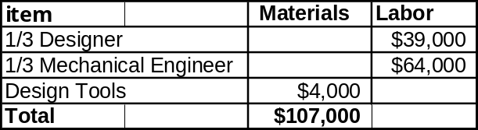

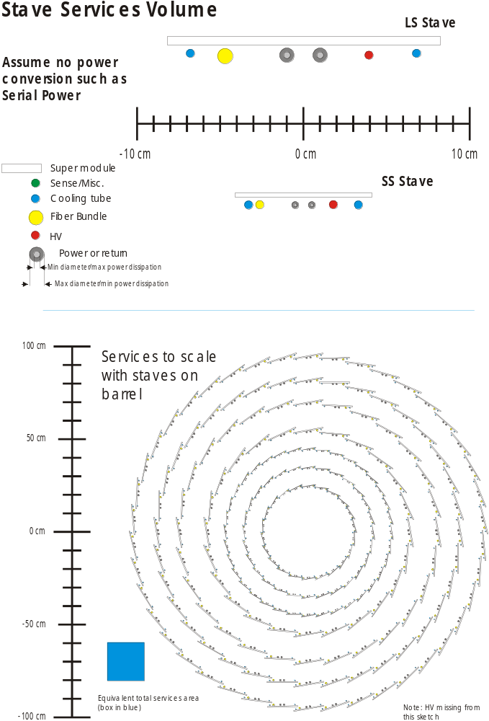
Figure 1. Stave Services Volume with Standard Powering Scheme

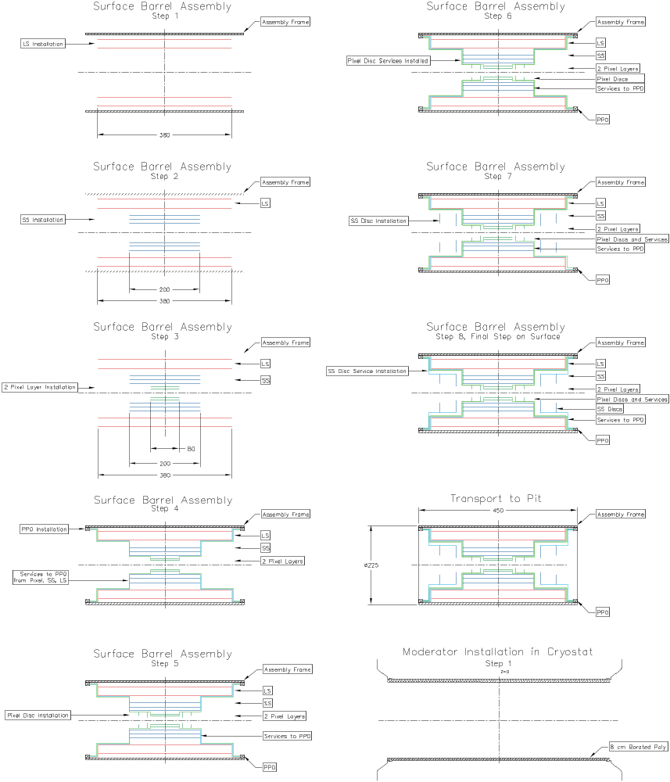I
Figure 2. Possible assembly sequence for a fixed length barrel geometry with integrated pixel

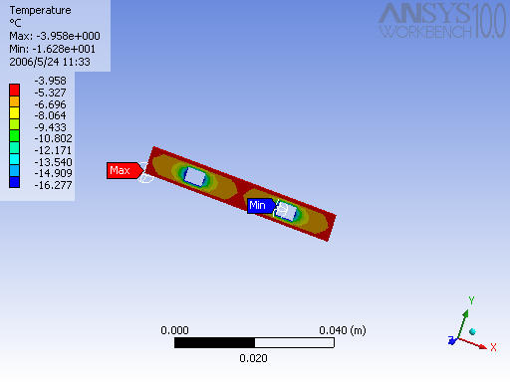
Figure 3. 0th order thermal finite element analysis of a CDF style stave

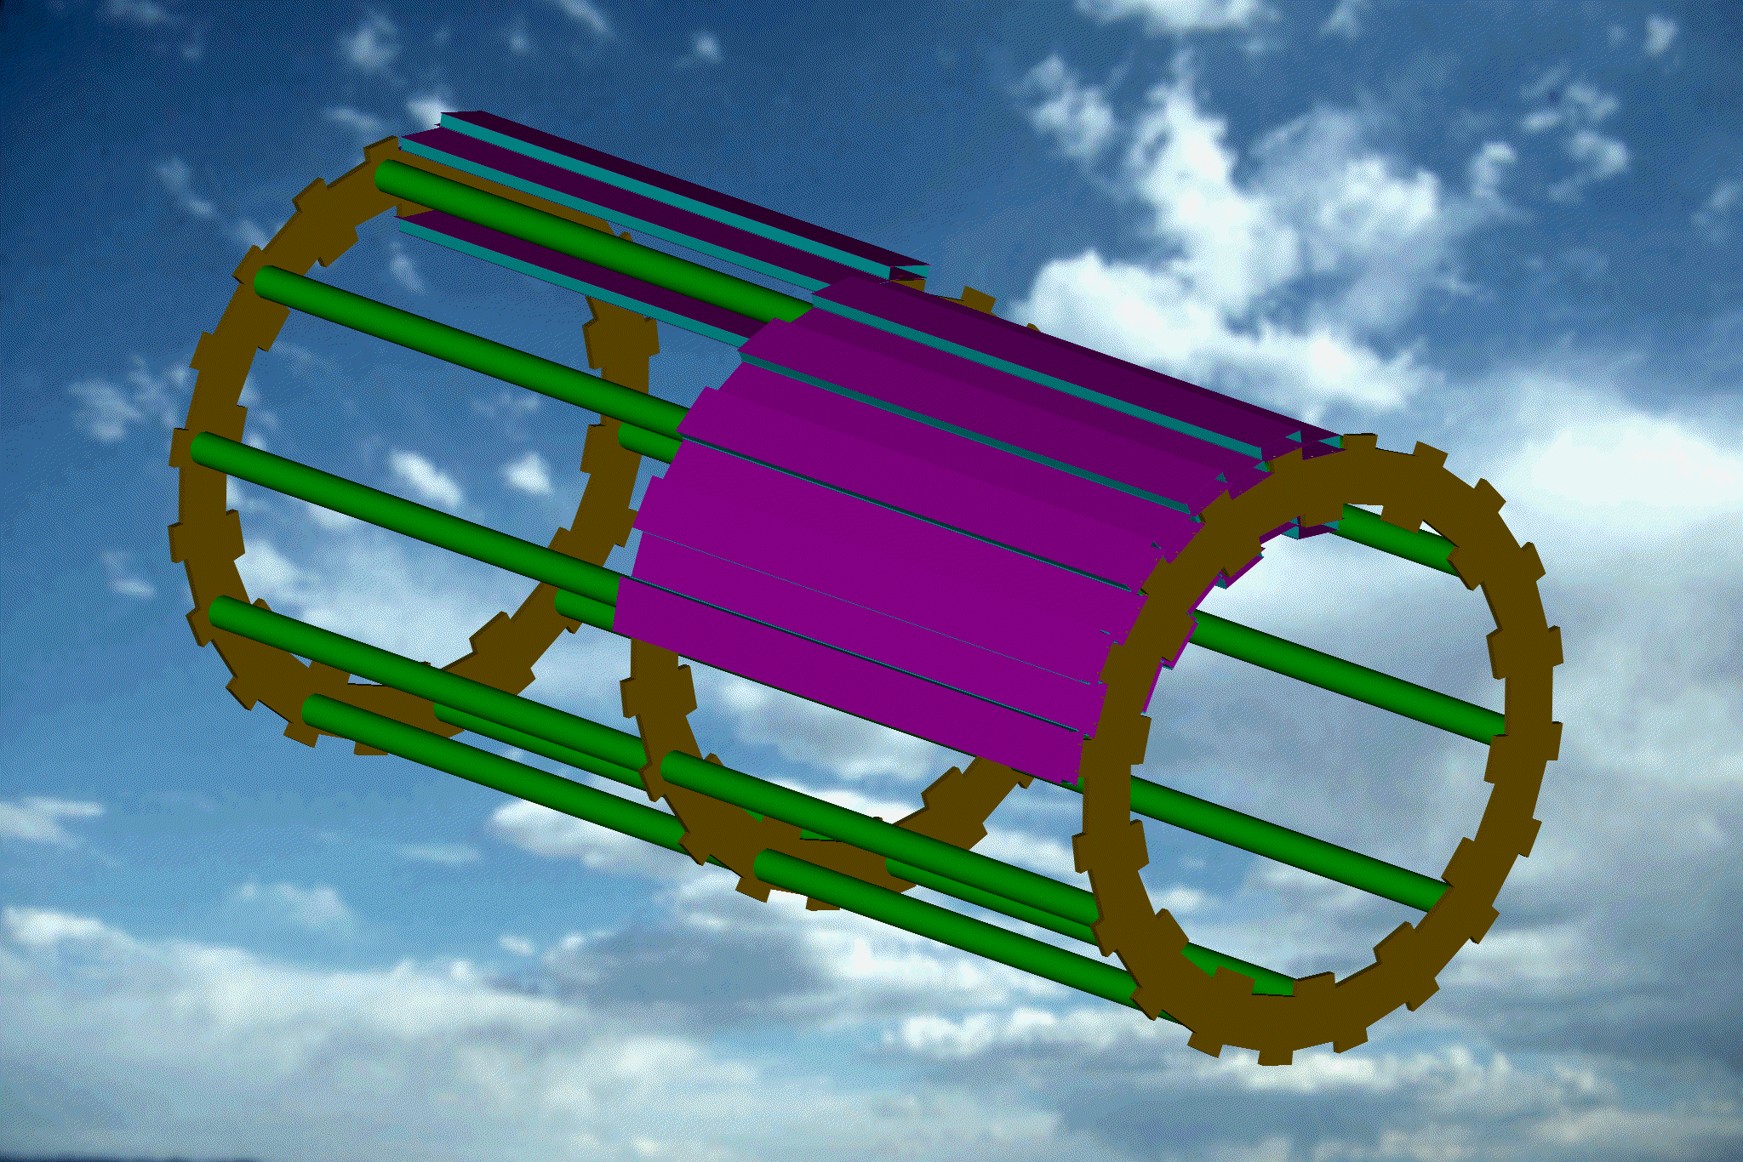

Figure 4. Early look at possible support for outer (2 meter long) staves.

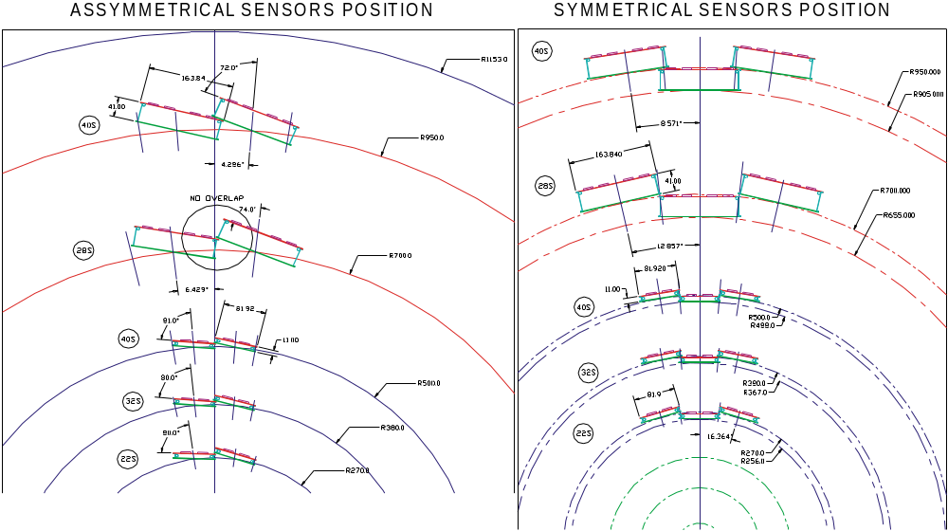
Figure 5. Comparison of Lorentz angle rotated and un-rotated mounting schemes

