Foreign Trip Report

Part I

1. Title of report: |  | ATLAS Trip Report
2. Report date: | November 17, 2006
3. Date(s) of travel:
4. Name of all traveler(s) on this trip report: |  |  |  |  |  |  |  |  |  |  | M. G. D. Gilchriese  K, Krueger  A. Pekedis  R. Post
5. Position/title of traveler:
6. Employing organization: |  |  |  |  |  |  |  |  |  | Ernest Orlando Lawrence Berkeley National Laboratory Organization Code: LB
7. Business address:  (street, city, state and zip) |  |  |  | One Cyclotron Road, Berkeley, CA 94720.
8. FTMS trip number:
9. Travel destinations:  (include organization, facility, city, state/province, country) |  |  |  |  |  |  |  | Geneva, Switzerland/CERN
10. Brief purpose of the trip: |  |  |  |  |  |  |  |  |  | Attend meetings of the ATLAS pixel and Inner detector collaboration and the overall ATLAS collaboration
11. People contacted: |  |  |  |  |  | Approximately 150 institutions and 1500 physicists
12. Facilities visited: |  |  |  |  | CERN
13. Abstract (such as major highlights, benefits of the travel, results of meetings, including their locations) |  |  |  |  | A trial insertion of two pixel service quarter panels into a section of the pixel support tube was completed A repair of pixel endcp A was completed. Other tasks related to the integration of the pixel detector at CERN were also accomplished.
Part II (Complete report on & thorough analysis of the trip)

Background and Purpose
Lawrence Berkeley National Laboratory (LBNL) is a member of ATLAS Collaboration building the ATLAS detector at the Large Hadron Collider at CERN in Geneva, Switzerland. LBNL is responsible for aspects of the preparation of physics simulation tools and analysis, software development for data acquisition and data analysis, the design, development and fabrication of the Pixel Detector Subsystem and the design, development and fabrication of Semiconductor Tracker Subsystem.

Activities

Trial Insertion of Service Quarter Panels
A key goal was the trial insertion of two pixel service quarter panels mounted on the beam pipe support structure into a section of the pixel support tube. The pixel detector will be inserted from one end of the pixel support tube. This requires a configuration of the services such that the clearance between the service panels is very small, a mm or less. Thus a trial insertion is required to determine if the design clearance is sufficient to insert the pixel detector. This can only be done with the real components. A temporary rail system, a section of the pixel support tube and two service panels were used in this trial. The pictures below show the basic setup and trial insertion. A period of three weeks was required to create the temporary setup, configure the service panels and refine the techniques needed for a wire configuration and insertion.
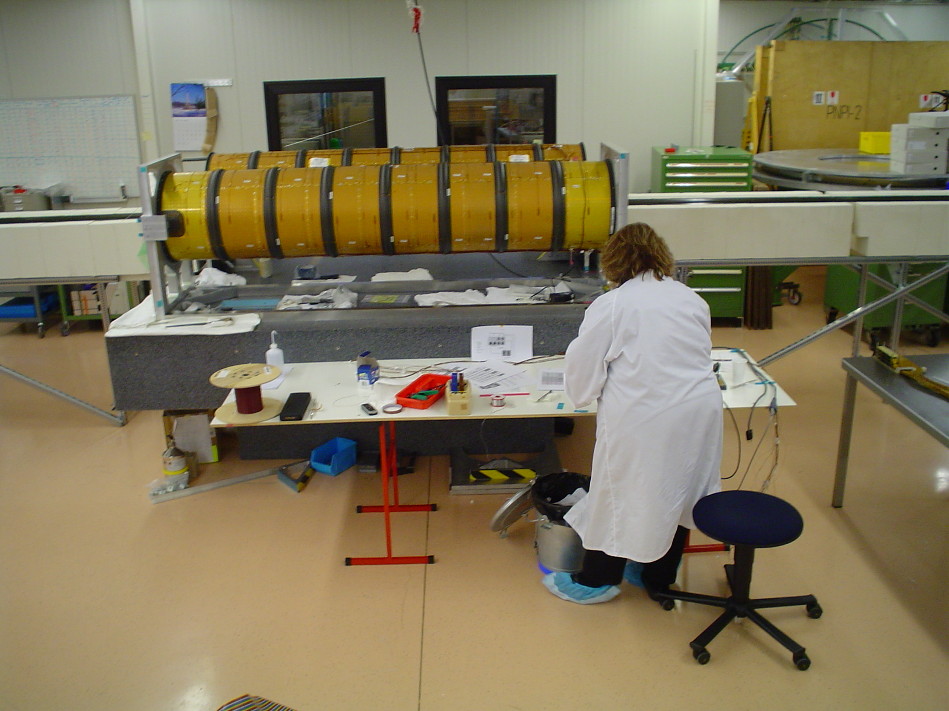
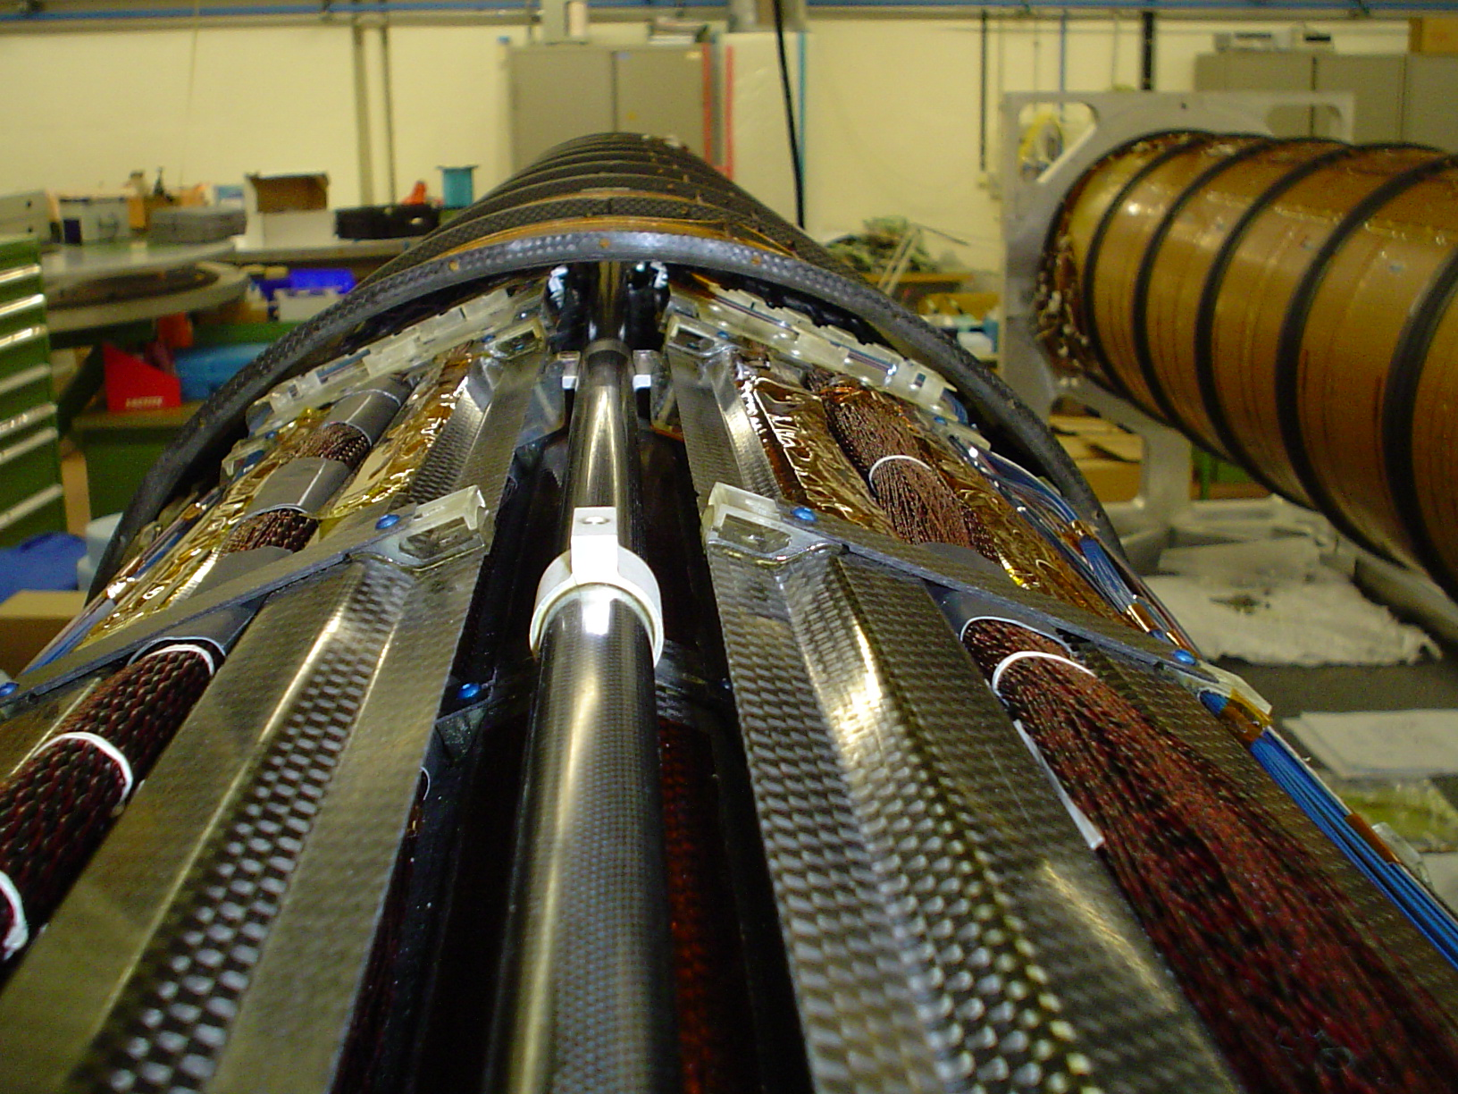
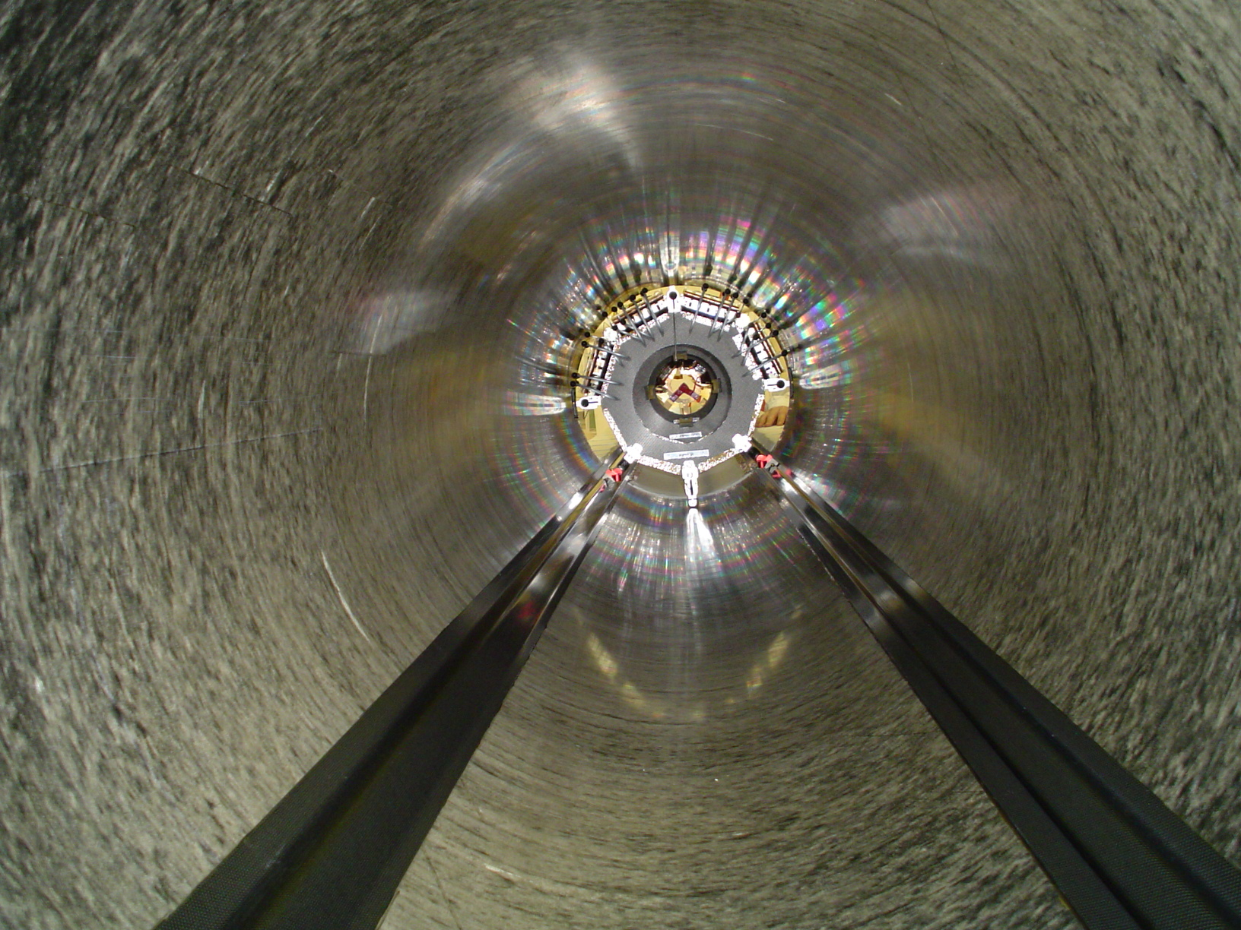

Repair of EndCap A
Endcap A is in use in a system test configuration at CERN. The cooling circuits in the endcap were tested at about 4 bar absolute as part of this process. A leak in one of the endcap circuits developed in this process. A key goal for this trip was to repair this leak in place. This was done using forceps and special tooling. The leak was traced to one fitting that apparently had a slightly displaced pipe. A tool was inserted to force a better connection between the connecting pipes. This fixed the leak.

System Test Connections
Leak checking and other work was also done on the overall system test coolant piping.

Roles

M. Gilchriese. Dr. Gilchriese is the physicist leader at LBNL of the pixel services. He helped to direct the setup of the trial insertion and assisted in this insertion. He also helped to develop the repair strategy for endcap A.

K. Krueger. Mr. Krueger is a technician from LBNL. He was part of the construction team for the pixel services at LBNL. He assisted in all of the setup and initial preparation for the trial insertion.

A. Pekedis. Mr Pekedis is a technician from LBNL who also participated in the construction of the pixel services at LBNL. He assisted in the final assembly and trial insertion tests. He also did extensive leak checking on the pixel system test.

R. Post. Mr. Post is technician from LBNL who also had a large role in the services fabrication at LBNL. He led the setup, assembly and insertion trials. He also developed and used tooling to fix the leaky circuit on endcap A.

Recommendations

No changes in LBNL responsibilities within the ATLAS Collaboration resulted from these meetings and no impact on current DoE planning is foreseen.

Appendix I

Itinerary
Traveler | Departure Point | Departure Date | Arrival Date | Arrival Point
M. Gilchriese | San Francisco |  |  | Geneva, Switzerland

Persons Contacted
The ATLAS Collaboration is very large - approximately 150 institutions and 1500 physicists. It is not possible to list here all of the persons contacted during ATLAS meetings.

Literature
A wiki page was kept for the trial insertion. Leak checking and the endcap repair were similarly logged by an electronic system.

