P____

 | Date | Change or Same? | Initials
1. Clear, after build
2. Pre-hybrid attach
3. Post-hybrid attach
4. After wire bonding
5. During testing
6. Final inspection
Label remarks by step number
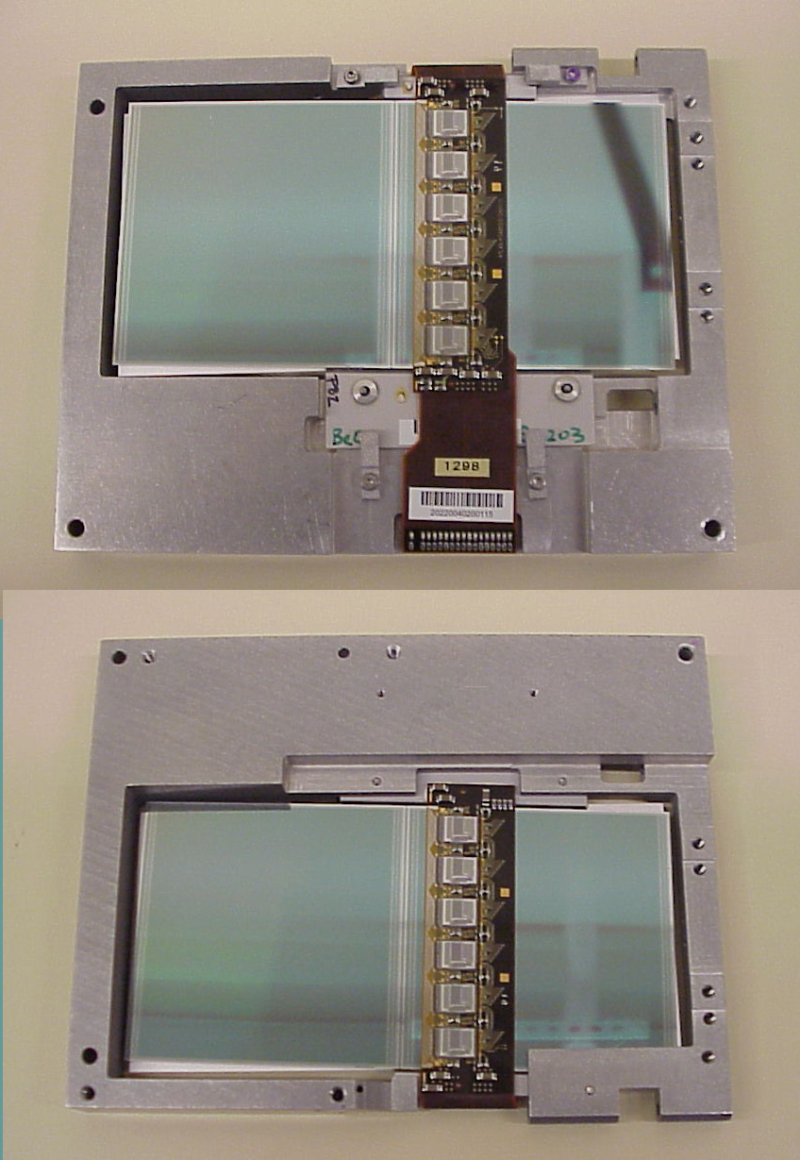
TOP
BOTTOM

