IV Measurements

Before Hybrid – In Metrology Frame

Mount vacuum block on backside of metrology frame.

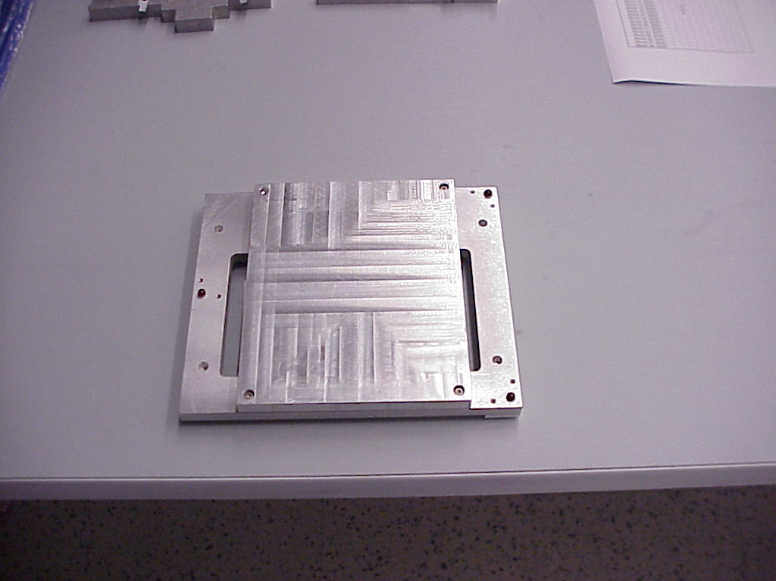

Make sure that HV is off.

Put vacuum block/metrology frame onto probe chuck in dark box. Adjust so that probes can reach. Turn on vacuum switch on side of station.

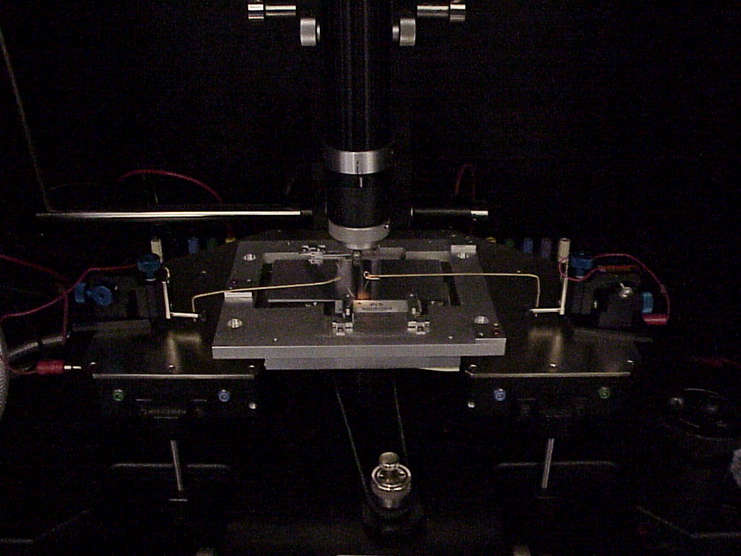
Bring left probe into contact with gold contact on baseboard.

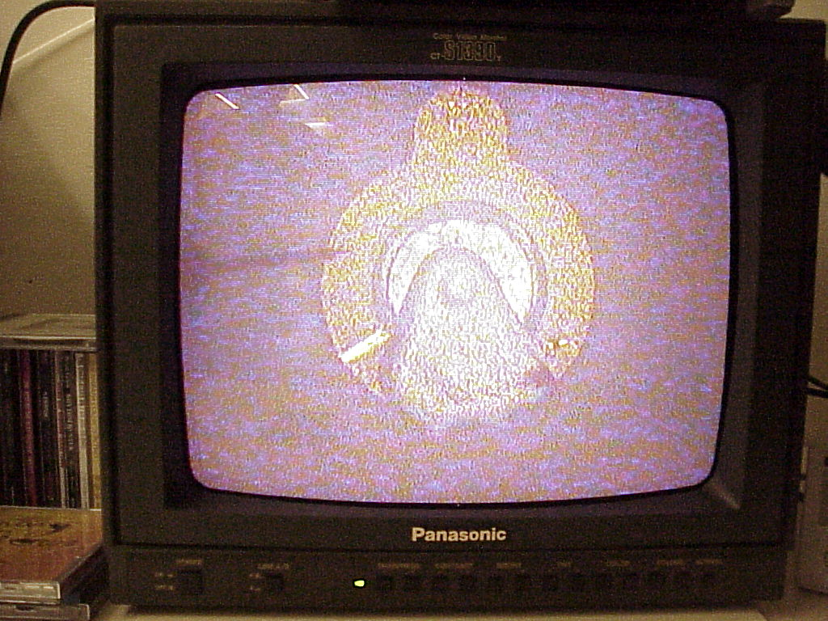

Bring right probe into contact with pad on one of the two detectors.

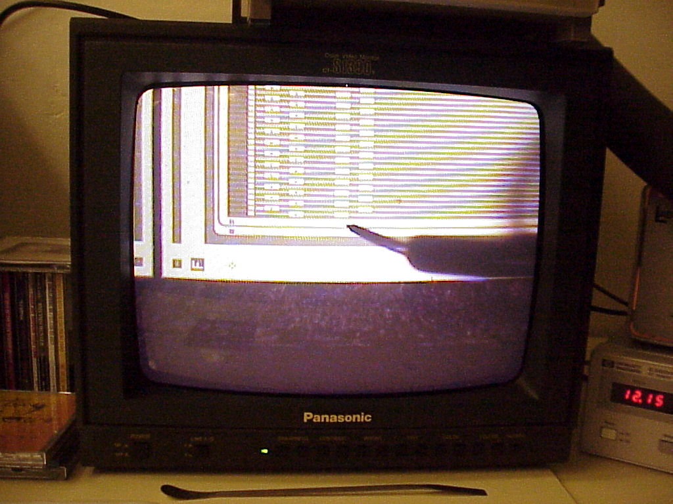

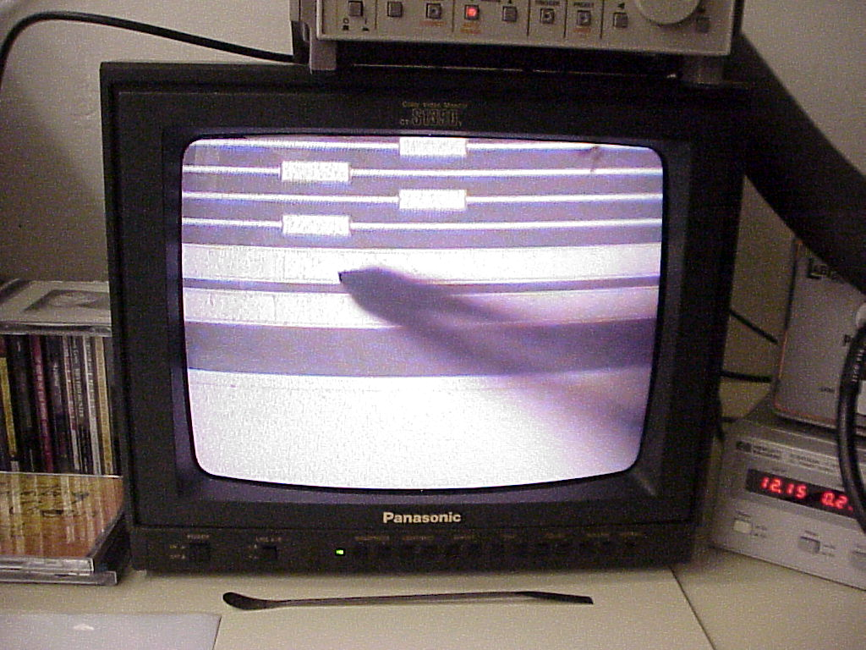

Turn off lights. Close and latch dark box.

Run program on desktop “487controller.vi”. Click on run arrow(upper left). Look in logbook to get serial numbers for detectors. Blue boxes need input.Type in serial number in two places – in serial number box and in database file box. In the latter put .iv at end of serial number. Look at temperature on side of dark box and type in.

Click save I(V) Data. You can go to Edit menu and copy serial number and paste into file name and add .iv at end. May have to create new folder for module if necessary. Also click on Save to DB to save to database. Record value in logbook.

Check that voltage is off. Open darkbox. Move right probe to other detector. Turn off light. Close dark box. Change serial number in LabView screen. Do IV and save data twice as before.

Move probes vertically and carefully move off of detector. Switch vacuum off.

Remove vacuum plate and attach to other side of metrology plate. Insert with baseboard mounting surface at back of probe station. This will put the back right detector on the left side as you face the darkbox.

