7.7 Installation
Upon completion of the integration of the pixel detector (described in the previous section), the pixel package was transferred from the ITT to a temporary support structure, Dummy Support Tube or DST, for transport from the surface assembly building to the ATLAS detector underground.

The DST was designed to receive the detector from the integration tool on surface and to keep it dry and protected during the transport to the ATLAS pit. The detector support conditions changed during the extraction from ITT to DST. The load was transferred from the supports on beam pipe plane, used during whole integration period, to the sliders mounted on the diagonals of the lower two quadrants. A set of V-Flat rails in the DST, replicating the ones in the Pixel Support Tube (or PST), provided the new interface to the sliders by which the detector is guided first into the DST and later on, in the pit, into its final location.

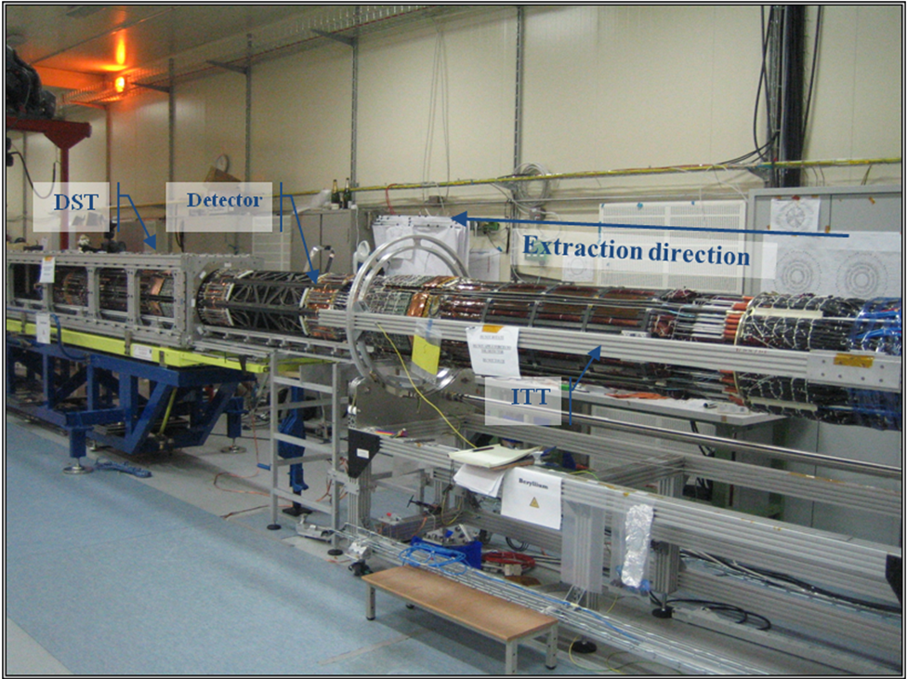
Figure 7.7.1 The pixel detector leaves the tool on which has been integrated and it enters into the transportation tool [DST]. The blue structure underneath is equipped with pivoting and spring loaded wheels for an easy and shock free transfer outside the building.

The driving force required to move the detector has been provided by a winch attached to the far end of the DST that pulled the detector by a metal line attached underneath of the detector at the PP0 area.
The detector transfer to the ITT provided important information that was useful for the installation that would have taken place few days later in the ATLAS underground hall. In particular:
- The very limited clearances between the detector and the PST have been checked. In some cases structures of the detector had to be modified to recover from the envelope violation at the PP0 area.
- The impact of the alignment in the clearance at the entrance of the PST has been understood and the installation procedures updated accordingly.
- The force required to make the detector slide partially passes through the detector and validating the estimated friction coefficient with was very also important.

The pixel detector inside the DST was transferred from the surface assembly building to a staging area above an access shaft to the ATLAS underground cavern. A combination of a custom-wheeled cart (see the blue structure in Figure 7.7.1) and a portable crane were used. Once in the staging area, the DST was picked up by an overhead crane and slowly lowered into the ATLAS underground hall (Figure 7.7.2a), coming to rest on a platform at the end of the ATLAS ID volume, with the ATLAS endcap calorimeter retracted to provide sufficient room (Figure 7.7.2b)

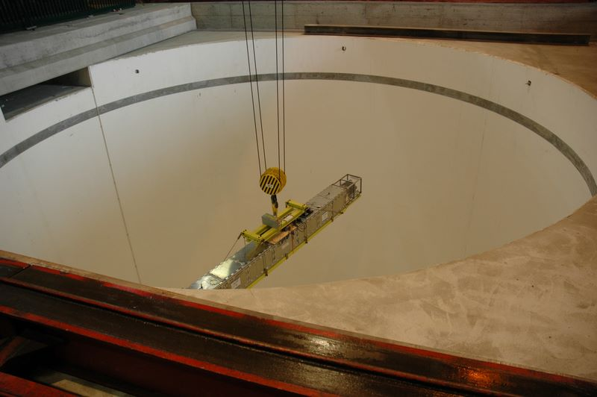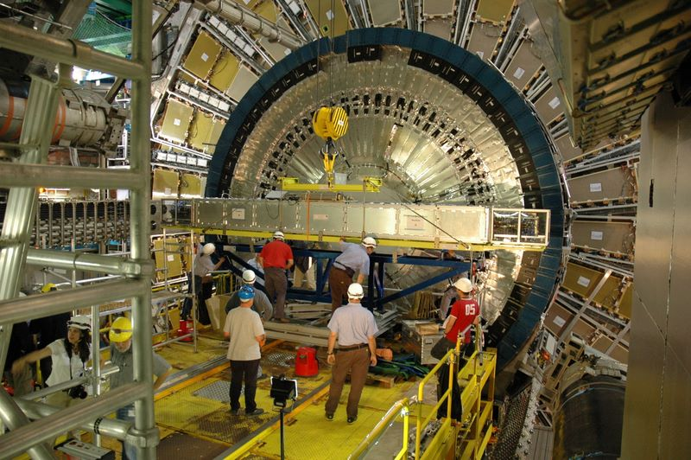
Fig. 7.7.2 (a) the pixel detector in the Dummy Support Tube (see text) being lowered into the ATLAS underground hall and (b) the Dummy Support Tube and pixel detector on a platform between the Inner Detector area and the endcap calorimeter.

The DST was rotated and carefully aligned with the PST, already installed within the Inner Detector. The pixel package was slowly pulled into the PST over about a two day period. The clearance between the pixel package and the PST was very small (by design) in a number of positions along the package, requiring very careful monitoring and small last-minute adjustments. This process is illustrated in Figs. 7.7.3a and 7.7.3b.

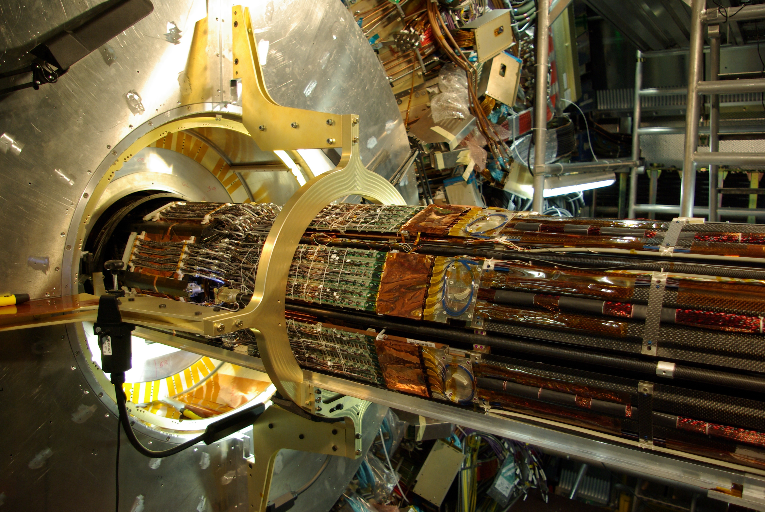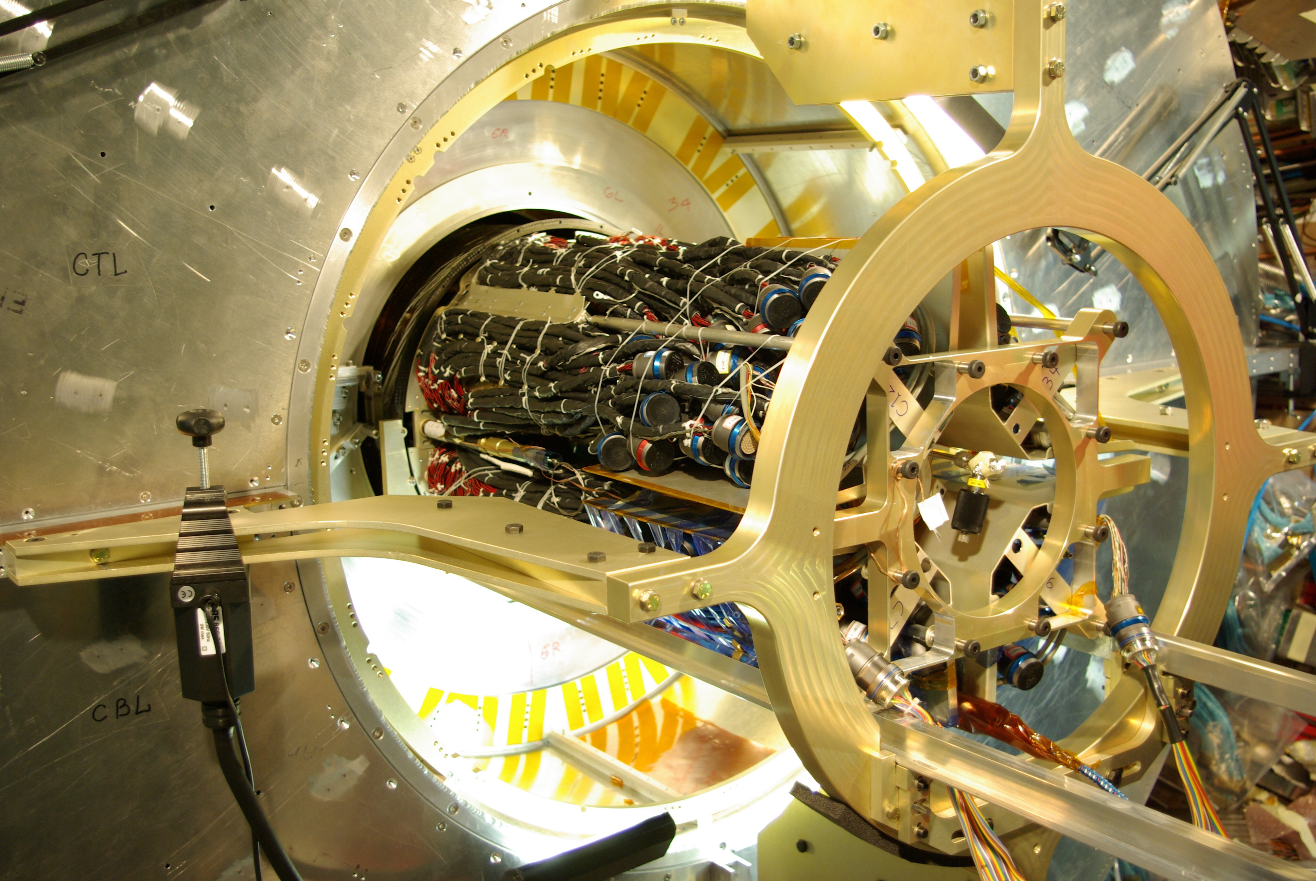
Fig. 7.7.3 (a) the pixel package during transfer from the DST to the PST showing the region at the end of the inner detector and (b) just before completion of the insertion showing the temporary support of internal services at the end of the package.

The mounts attached to the pixel detector global support frame engaged the mating mounts within the PST with excellent alignment (viewed by TV cameras) on June 29, 2007 and the basic installation process of the pixel package completed shortly thereafter.

