 | Pixel Detector Mechanics Conceptual Design Review
ATLAS Project Document No: | Institute Document No. | Created: 24/06/2001 | Page: 1 of 2
ATL-IP-ES-0018 |  | Modified: | Rev. No.: 1
Technical Specification
Pixel Detector Global Support Frame

Abstract
This document describes the technical specifications for the design and fabrication of the global support frame for the ATLAS pixel detector.
Prepared by:  E. Anderssen, M. Gilchriese, W. Miller | Checked by: | Approved by:
Distribution List

History of Changes
Rev. No. | Date | Pages | Description of changes

Table of Contents

1 Introduction 4
2 Dimensions and Envelopes 4
2.1 Disk Support Rings 6
2.2 Layer 1 and Layer 2 Barrel Shells 6
2.3 B-layer Support Shell. 6
2.4 Mounts To SCT 6
2.5 Services 7
2.6 Services Support Panels 7
2.7 Pixel Support Tube 7
3 Final Assembly 7
4 Survey Requirements 7
5 Load Conditions, Stability and Analysis 8
6 Other Requirements 9
7 Materials 9
8 Qualification Tests 10
8.1 Material Coupon Testing 10
8.2 As-built Dimensions 10
8.3 Load Tests 10
8.4 Assembly Test 10
9 Quality Assurance 10

Introduction
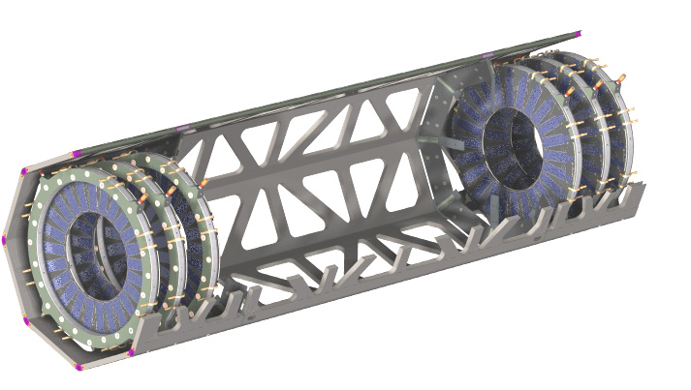
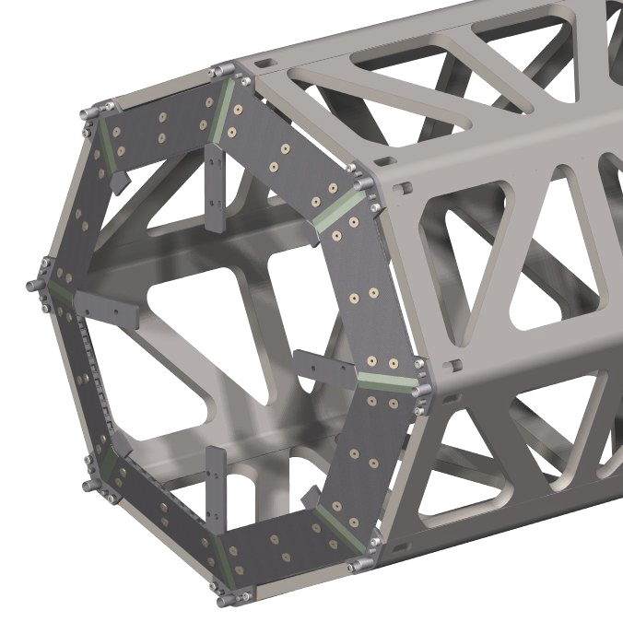
The global support frame consists of a flat-panel space frame in three sections - a barrel section and two, identical disk sections as shown in Figure 1. These sections are joined to make the complete frame.
Figure 1. ATLAS Pixel global support frame, which consists of three sections - barrel and two disk sections. The barrel and two disk sections are shown joined on the left. One of the support cones for the barrel shells is shown in the right model.
Included in the barrel section are two End Cone supports for the barrel shells as also shown in Figure 1.
A complete prototype disk section of the global support frame has been fabricated and tested. A prototype of an End Cone is under fabrication and test.

The three sections of the support frame and the two End Cones will be fabricated by a vendor under contract to LBNL.

Dimensions and Envelopes
The current baseline dimensions of the global support frame are shown in Figure 2. Detailed envelopes will be addressed later in the creation of fabrication drawings for the global support sections. The current envelopes for the radial dimensions of the global support exceed the nominal by 0.5 mm both on the inner and outer surfaces. The envelope for the total length is also 0.5mm(each side) greater than the nominal dimension

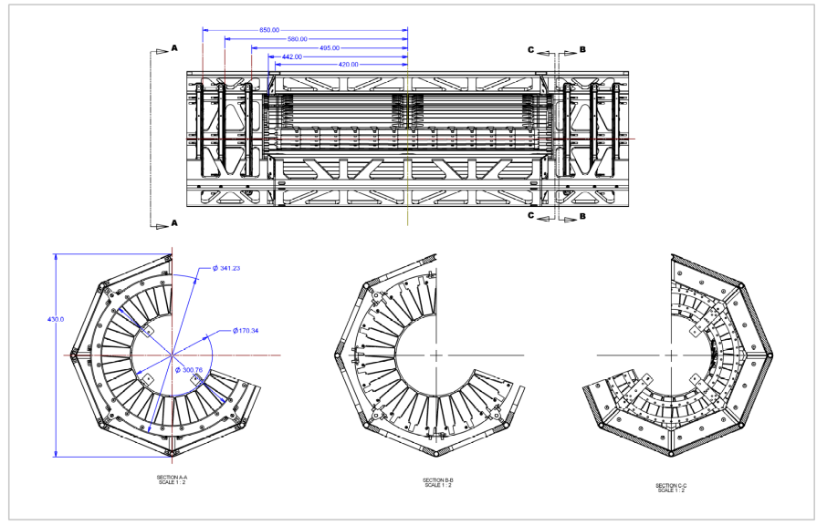
Figure 2. Current baseline dimensions of the barrel and disk sections of the global support frame.

The current baseline dimensions of the End Cones are shown in Figure 3 and Figure 4.

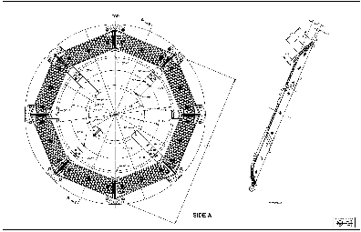
Figure 3. Current baseline dimensions of the End Cone, side A.

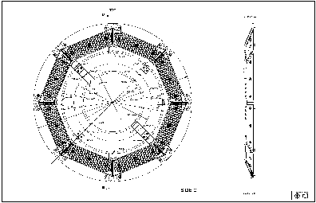
Figure 4: Current dimensions of the End Cone, Side C.

Interfaces
The principal interfaces to the global support frame are (1) the disk support rings; (2) the Layer 1 and Layer 2 barrel, stave support shells; (3) the B-layer support shell; (4) the mounting structure to attach the global support frame to the SCT barrel structure; (5) services(cables and pipes) from the modules mounted on the barrel staves and disk sectors; (6) services support panels that hold services within the pixel support tube; and (7) to the pixel support tube(PST).

Disk Support Rings
Interfaces to the disk support rings are covered in the Technical Specification for the Disk Support Rings.

Layer 1 and Layer 2 Barrel Shells
Interfaces to these shells are covered in the Technical Specification for the Layer 1 and Layer 2 Barrel Shells.

B-layer Support Shell.
**Eric can you provide something eg. a figure for this and some short text. If we don't know just say not defined at this time.***

Figure 5. B-layer shell interface region.

Mounts To SCT
The global support frame is attached to the SCT barrel structure at four locations. The mounting conditions are shown in Figure 6(***Eric please provide***).

Figure 6. Support conditions for the global support frame attached to the SCT barrel structure.
A preliminary definition of the dimensional interfaces to the SCT structure are shown in Figure 7(***Eric please provide figure and short text if needed***).

Figure 7. Dimensional interfaces of the global support frame to the SCT barrel structure.

Services
Barrel electrical services and coolant piping run from the ends of the bi-stave assemblies across the support cone, through a gap between the barrel and disk sections of the frame, and then along the outside of the disk sections of the frame. Disk electrical services run along the inside of the disk sections of the frame. Strain relief fixtures will be attached to the endcones and to the disk sections using a regular array of PEEK inserts for support of the fixtures. The location of these inserts is fixed for the End Cone(see Figure 3 and Figure 4) but remains to be determined for the disk frame sections.

Services Support Panels
Services support panels hold cables and pipes inside the PST and slide with the global support frame inside the PST during installation or removal. There is a mechanical connection between each end of the global support frame and the service panels so that they may slide together inside the PST. The design of this interface does not yet exist. The fabrication of these interfaces pieces is the responsibility of LBNL, not the vendor manufacturing the global support frame.

Pixel Support Tube
The global support frame slides on four riders attached at the ends of the frame on the detector V- and flat-rails inside the PST. The design of this interface does not yet exist. The fabrication of these riders is the responsibility of LBNL, not the vendor manufacturing the global support frame.

Final Assembly
The End Cones and barrel shells are mounted in to the barrel section of the support frame. No design exists yet for the tooling and procedures needed for this assembly step. The disks are mounted into the disk section and the disk sections are joined to the barrel section as illustrated in Figure 8).
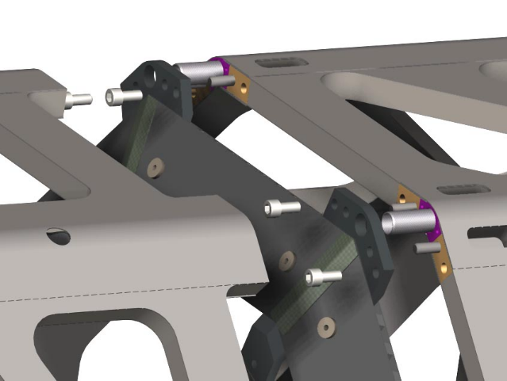
Figure 8. Illustration of the method for joining the barrel and disk sections of the support frame.
An initial conceptual design for the procedures necessary to mount the disks and to join the disk and barrel sections has been done and is illustrated at http://www-atlas.lbl.gov/~goozen/assdetset.html. Attachment of tooling for barrel and disk assembly, and for joining the barrel and disk sections, will be made to the corner blocks in the frame sections shown in Figure 8Figure 8.

Survey Requirements
The locations of the pixel modules must be referenced to the mounting structure connecting the global support frame to the SCT barrel structure. This is to be done in multiple steps
- Modules referenced to the local supports(staves and disk sectors)
- Local supports referenced to the intermediate supports(barrel shells and disk rings)
- Intermediate supports referenced to the global support frame - to survey references mounted in or attached to the corner blocks in each section
- Support frame referenced to SCT mounts after final assembly of the barrel and disk sections.
The procedures, survey markers and tools for accomplishing the surveys referenced to the support frame have not yet been developed.

Load Conditions, Stability and Analysis

The conceptual analysis of the Global Support frame has been completed. The objective of the analysis was to confirm that reducing the frame dimensions from the original baseline did not invalidate the extensive analysis and prototype testing conducted previously. This task was accomplished.

Stability requirements are estimated assuming a maximum of 20% degradation in the (rms) φ, R or Z measurements. The "stability budget" is arbitrarily apportioned among the local supports(staves or sectors), intermediate supports(shells or rings) and the support frame. Tolerances are assumed to be √12 x the rms value. In the barrel region, the apportionment is 8:1:1 for stave, shell and frame, respectively. In the disk region, it is 1:2:4 for sector, ring and frame, respectively. The tolerance(rms) values are given in Table 1.

The recent analysis of the Global Supports conceptual design specifically addressed gravitational loading, dynamic stiffness, and torsional stiffness. Gravitational sag is of concern in the context of maintaining detector alignment. Dynamic stiffness on the other hand quantifies the susceptibility of the detector to unforseen vibration. Torsional stiffness is assessed to ascertain what level of disturbance is required to twist the detector assembly. The final Global Support configuration incorporated end plate stiffening panels to provide radial stiffness in the plane of Pixel to SCT support. The total mass of the structure and non-structure mass derived from the FE model was 28.89kg, with the two end plate stiffeners being 0.25kg.

Stability Item | Tolerance(rms) in microns | Analysis
Radial and lateral motion -“R” | Disk: 200(58)  Barrel: 5(1.5) | Gravitational sag-11.5μm; response to random vibration in R <<1μm (lateral motion suppressed by frame end plate)
Tangential motion-“ϕ” | Disk: 24(7)  Barrel: 1.8(0.5) | ϕ-position set by planarity and rigidity of the frame 4-point support; detector twist with 1-support point removed is 53.5μm
Axial motion-“Z” | Disk: 425(122)  Barrel: 14(4) | Thermal length change ~1.4μm/°C
Table 1. Stability tolerance(rms) values for barrel and disk regions and estimates of frame motions.

Internally, relative positional change between the pixel disks and the barrel detector elements is controlled by using materials with very low coefficients of thermal expansion (CTE), in most cases approaching zero CTE. Temperature control of the evaporative coolant system, ensures virtually no change in length or radial position between the pixel sections, the disk array and staves. Initially, the detector will potentially expand in length 56μm when cooling from room temperature to -15°C, thereafter the sensitivity in Z to a change temperature is less than 1.4μm/°C. Consequently, from outer disk array to outer disk array for a 5°C change (cyclical in time, short term periodicity) the detector stability is within 7μm, well within the stability limit of 425μm for Z. Radial positional changes due to the same effect is much less. Time varying, spatial temperature changes that cause bending of the frame have not been address. This effect is anticipated to be within the required limits because the global CTE effect is small. This effect will be evaluated once the Pixel Detector system is completely defined.

The detector vibration stability without reinforcing end plates is marginal. If exposed to a harmonic input of 0.01G’s the detector motion would be less than 10μm laterally, and 2.82μm rms if subjected to a random vibration. The response may grow to an unacceptable amount if the fundamental mode dropped to roughly 30Hz. The non-structural mass from services, strain relief, etc., is expected to increase above the current assumed values, during the preliminary design phase. An increase in non-structural mass impacts frame dynamic stiffness, lowering the frame fundamental mode. To offset this prospect, end reinforcment plates were added to raise the fundamental mode to 89Hz, above potential vibration sources. These plates, at this stage of our design formulation, ensure vibration will not be a stability issue, unless non-structural mass grows out of expected proportions. Of equal importance, these plates simplify the design of the connection between the Global Support frame and the Pixel Detector Support tube.

Other Requirements
The sections of the global support frame will be coated with Parylene(0.008-0.012 mm thick) after fabrication to contain conducting carbon dust or fragments.

Materials
The materials of construction to be used in constructing the Global Support frame and sub-components will use commercially available composite materials. The outer frame, end cones, and end plate reinforcement panels use a sandwich construction. All sandwich facings will use very high modulus pitch based graphite fibers for maximum stiffness. Prototype frame tests were conducted with a quasi-isotropic panel composed of XN80 (Nippon) fibers and EX1515 cyanate ester resin from Bryte Technology. (It appears that Nippon is replacing the XN fiber series with their new fiber series, designated YSH). Recent prototpyes have been constructed with the YSH 50, a replacement for XN50 and M55J. Results of the prototype tests were satisfactory and met our expectations. Table 2 lists the materials chosen for the Global Support frame.

Table 2. Global Support Frame Materials
Global Support Frame Item | Material
Outer Frame
Sandwich Facings | YSH90 unitape with RS3 or EX1515 cyanate ester resin, quasi-isotropic laminate
Honeycomb Core | XN50 woven cloth/cyanate ester resin, by YLA Cellular, 6.35mm cell, density 48kg/m³
Vertex Corner Mounts (frame section connections) | YSH50 woven cloth and RS3 cyanate ester resin laminate
Corner Tubes | YSH90 unitape and RS3 cyanate ester resin
Corner Splice | YSH90 unitape and RS3 cyanate ester resin
Vertex Joint Inserts | Aluminum
End Cones
Sandwich Facings | YSH90 or P30cyanate ester quasi-isotropic laminate
Honeycomb Core | XN50/cyanate ester resin, by YLA Cellular, 6.35mm cell, 48kg/m³
Inner and Outer Mounting Tabs | YSH50/RS3 cyanate ester
End Plates | Same materials as end cone

Qualification Tests
Qualifications tests are to be performed by the fabrication vendor on materials to be used in the ring construction and on each ring after fabrication. LBNL will also perform qualification tests.

Material Coupon Testing

Tensile test coupons will be cut from a sample of the laminates (0.43mm thick) prepared for the sandwich facings. Tensile tests, for tensile modulus and strength, will be performed to ASTM D3039. No specialized tests are planned for solid laminate material (4mm thick) used in the support tabs and mounting connections.

As-built Dimensions
The fabrication vendor will measure the as-built dimensions of the subcomponents(flat panels, etc) before assembly of the individual frame sections. The as-built dimensions will also be measured by the vendor and cross checked by LBNL.

Load Tests
A static load will be performed on each completed outer frame section. The test will be a simple cantilever test, to 1.5 times the required load transfer between frame sections. The test will verify the structural integrity of the composite construction.

A separate static load test of the complete outer Global Support frame will be performed. Non-structural mass equivalent to 1.5 times design load will be added to the frame, at the appropriate Z locations. The static load test will verify the structural design and validate the fabrication quality.

Assembly Test
A trial assembly of the endcones to the barrel section and of the disk sections to the barrel section(with endcone) will be done by the fabrication vendor and by LBNL. It is planned to have a trial assembly of the intermediate supports into the support frame as well.

Quality Assurance
The fabrication vendor will provide a quality control plan to LBNL as part of the fabrication contract.

ATL-IP-ES-0025, "Technical Specification for Pixel Detector Disk Support Rings". June 2001.
ATL-IP-CS-0007, "Specification for Barrel Layer 1 and 2 Support Structures", November 2000.
W. O. Miller, Structural Analysis of ATLAS Pixel Detector Global Support Frame-432mm Envelope, HTN-106210-0002, HYTEC, Inc., dated May 18, 2001

