 | Requirements and Interfaces for  ATLAS Pixel Detector Support Tube
ATLAS Project Document No: | Institute Document No. | Created: 07-04-2001 | Page: 1 of 11
ATL-IP-ES-0019 |  | Modified: 02-06-2002 | Rev. No.: 2.2
Requirements and Interfaces for
ATLAS Pixel Detector Support Tube

Abstract
The requirements and the critical interfaces for the ATLAS pixel detector support tube are presented.

DRAFT FOR COMMENTS
Prepared by:  E. Anderssen, M. Gilchriese, N. Hartman, M.Olcese, E.Perrin | Checked by:  R.Hawkings, M.Tyndel | Approved by:  PDSG
Distribution List

History of Changes
Rev. No. | Date | Pages | Description of changes
1  2 | 4/7/01  20/05/02 | All | Original version  Complete revision

Table of Contents

1 Introduction 4
2 General Requirements 4
3 Support Conditions 5
4 Dimensions and Global Envelope 6
5 Interfaces 6
5.1 Pixel Detector 6
5.2 SCT Barrel 7
5.3 SCT Forward 9
5.4 ID End Support Plate 9
5.5 Beam Pipe 11
5.6 Rails 12
6 Installation and Assembly 13
7 Design Parameters, Load Conditions and Stability 14
7.1 Design parameters and specific requirements 14
7.2 Load conditions and stability requirements 14
8 Production Plan 16

Introduction
This document describes the requirements and critical interfaces for the pixel support tube and associated structures (two thermal end plugs, end supports and SCT barrel supports).
The pixel support tube (PST) consists of a 7m long cylinder extending coaxially all the way through the Inner Detector (ID) volume. This is to allow and independedent installation and removal of the Pixel Detector while the rest of the Inner Detector is in place.
The PST is illustrated schematically in Figure 1. The PST consists of three sections - a barrel section and two forwards. A barrel section is connected to a forward section through mating flanges. The PST has rails to allow the pixel detector and its services to slide into position inside the Inner Detector. The endplugs provide a thermal and gas barrier, support electrical and coolant feedthroughs and are part of the EMI screening around the pixel detector. The barrel section of the PST is supported by the SCT barrel structure. The forward sections of the PST are flanged onto the barrel section and supported at each end of the ID volume by supports linked to the barrel cryostat. the VI section of the vacuum beam pipe is supported by a structure in turn supported by rails in the PST.
Figure 2 shows a schematic of the PST with the internal pixel system in place.
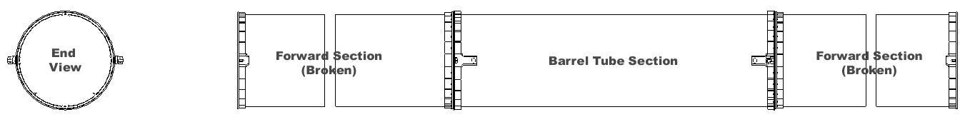
Figure 1. Current pixel support tube conceptual model (two views shown – side view shown broken for clarity).
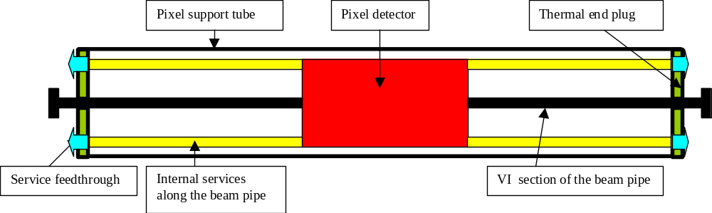

Figure 2:Schematic cross-section of Pixel Support Tube with internal pixel system

General Requirements
The pixel support tube and associated structures (endplugs, end supports) must satisfy some general requirements:
- The PST must allow the pixel detector and its services to be installed via the rail system in the PST from Side C of ATLAS.
- The PST and rails are to be designed for a minimum of twenty insertion cycles. However, sliding interface blocks (“sliders”) may be replaced after each insertion/extraction cycle.
- The pixel detector is held by supports connected to the PST barrel flanges. Once the transition is made from the PST rails to the pixel supports, no contact between the pixel detector and PST rails will exist.
- The PST and the endplugs provide a gas barrier for the environmental gas around the pixel detector.
- It must be possible to keep the internal volume of the gas enclosure at a slight overpressure with respect to the outside environment with a moderate dry gas input.
- It must be possible to maintain the outside of the PST and endplugs above a temperature of 15^{O}C for all operating conditions of the pixel system and the remainder of the Inner Detector.
- The PST and endplugs provide EMI shielding of the pixel detector. The EMI shielding on the barrel- and end-sections of the PST must be connected. The endplugs complete the EMI shielding and are connected to the PST. A provision for connection of the endplug EMI shielding to EMI shielding around the beam pipe(if it exists) must be made.
- The PST/flanges are electrically isolated from the SCT and the cryostat.
- The PST mounts to the SCT barrel have to allow for misalignments of the PST with respect to the barrel SCT on the perpendicular plane to the detector axis by up to +/-3 mm in horizontal direction and +1/-5 mm in vertical direction. There is no adjustment in z. Compensation for misalignment is to be done without impacting the thermal integrity of the barrel SCT or pixel detector. <<COMMENT>> Pixel Detector is not present when this adjustment is made.
- The PST/end plugs/end supports must support the internal structure holding the beam pipe and allow adjustment of the beam pipe in radius by up to 9mm.
- The PST/rails must be constructed such that carbon dust or fibers are not created as the pixel system and services slide into the operating position.

Support Conditions
The support conditions for the PST are given in Figure 3. The barrel of the PST mounts to the SCT interlinks (four in the horizontal plane), while the ends of the forward support tubes are mounted to supports extending from the ID end support plate connected to the cryostat wall.
The ID end support plate supports the PST, the beam pipe and the external pixel services from the end plug patch panel (PP1) up to the barrel cryostat corner (PPF1).
The forward end supports are designed to allow motion in the z-direction of up to 1.5 mm. Since shell modes dominate the lowest frequency modes for the PST, all supports give no freedom of motion in the horizontal (x-direction). The entire PST structure is constrained in the z-direction by one of the two mounts on the C-side of the SCT barrel. The second mount on the C-side and the mounts on the A-side allow movement in the z-direction.

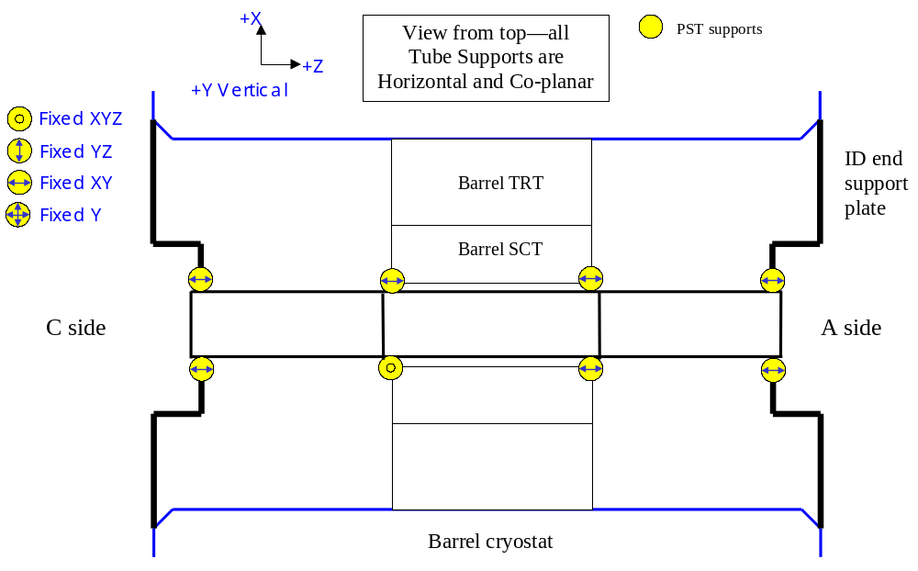
Figure 3. Schematic of support conditions for the pixel support tube.

Dimensions and Global Envelope
All these envelopes are controlled at ID level.
The outer envelope of the PST and the inner envelopes of the SCT are given in Figure 4.
These envelopes include deflections and as-built tolerances.
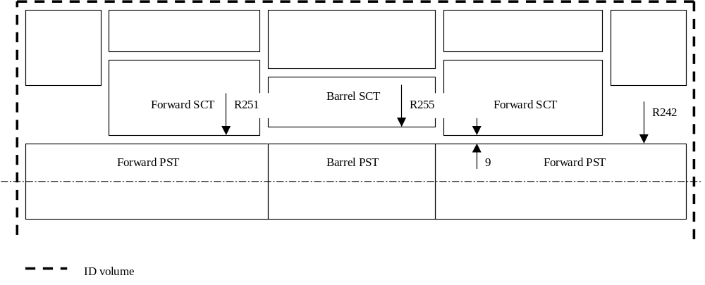
Figure 4. Envelopes between PST and SCT barrel/forward.
All flanges, ribs, heaters, EMI shielding, etc., must reside within the 242 mm radial envelope.
The barrel mounts, however, protrude through the envelope to attach to the SCT interlink through the inner SCT thermal barrier. The detailed interface of the mounts to the SCT interlinks is described in the interface section.
The axial envelope of the PST end plugs is provisionally set to +/-3300 mm. The final axial position of the two end plugs is driven by the service layout in PP1 area, which is still at a conceptual stage.

Interfaces
The critical dimensional interfaces, thermal interfaces and electrical interfaces are covered in this section.

Pixel Detector
The pixel detector is supported by mounts that are attached to the barrel flange of the PST. The mount fixation scheme is shown in Figure 5. The pixel detector will be fixed in the z-direction on the C-side of the ID (the installation direction side), but allowed to float on the A-side. It will not be constrained in the x-direction (across the barrel). After delivery of the pixel detector to the barrel PST on the installation rails, the detector will be transferred to the pixel detector supports,which are integrated into the PST barrel flanges. <<COMMENT>> there is an error in the figure—both pixel mounts on the +X side are flats—they are meant to float in both x and z (fixed y) there is limited motion of in the Z direction on the +X C-Side mount.
These mounts are electrically isolated from the PST.
The interface between the pixel detector and the PST is controlled by an integrated 3D model of the pixel outer frame, mounts and PST. This model is not yet complete

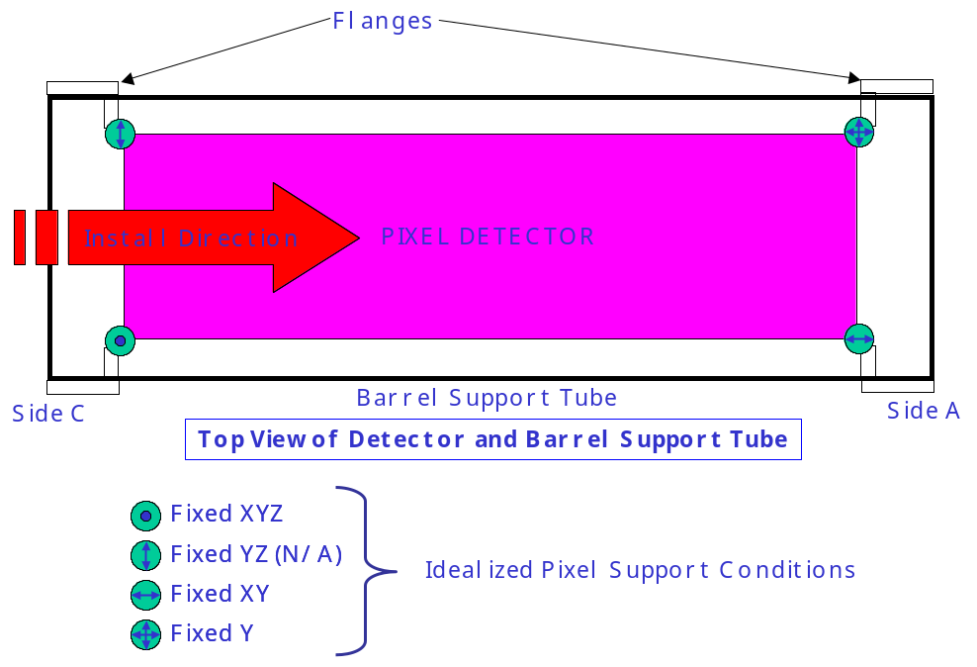
Figure 5. Pixel detector fixation scheme within the PST.

SCT Barrel
The PST is supported by the barrel SCT interlink structure by interface blocks. One of the two supports on the C-side of the detector is fixed in all directions and thus it gives the fixed reference point of the pixel detector relative to the SCT barrel. The other support on the C-side and the two supportss on the A-side are comprised of one-dimensional flexures that allow z-motion in order to absorb a CTE mismatche between the PST and SCT barrel (although this is predicted to be very small).
The interface and envelopes of PST to SCT barrel mounts are shown in Figures 6 and 7.
Figure 8 illustrates a concept for the z flexure.
The PST/flanges are electrically isolated from the SCT barrel interlink structure.
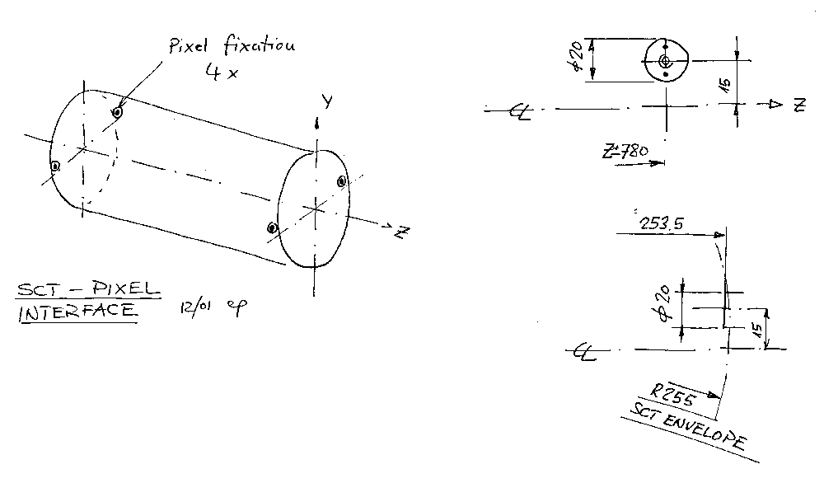
Figure 6. Interface of PST to SCT mounts at the SCT barrel.

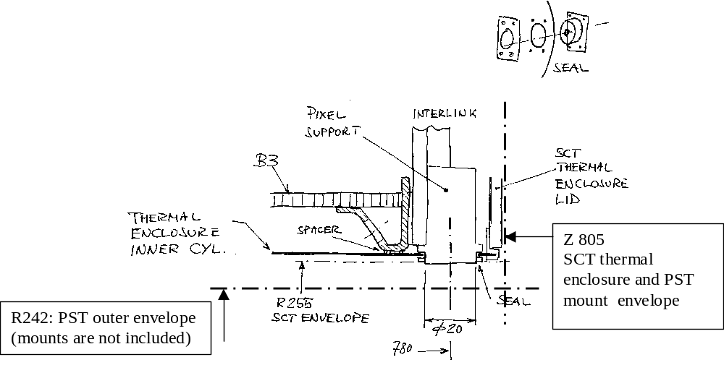
Figure 7. Interface of PST to SCT mounts at the SCT barrel: thermal barrel penetration and envelopes.

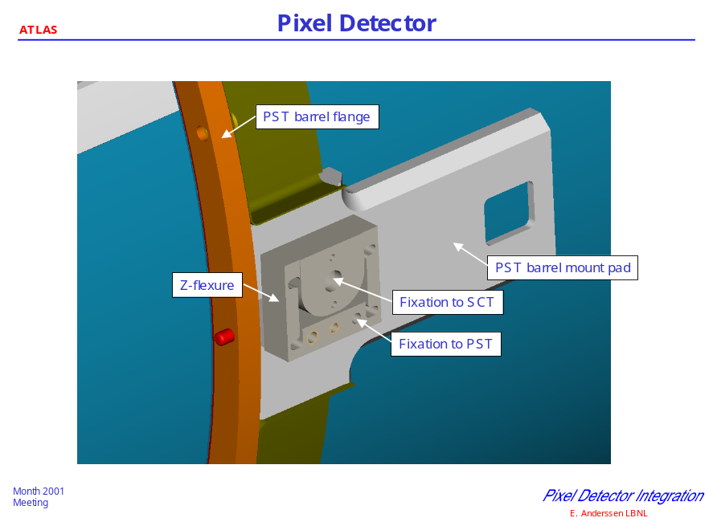

Figure 8. Concept of PST to SCT Z-flexure mount

Both the PST barrel and the SCT barrel inner thermal enclosure are equipped with heaters which in certain conditions will have to keep these two surfaces above 15 °C to prevent condensation.
There are three possible operating scenarios:
- Normal running: both heaters are turned off, since the gas in the gap will be maintained dry
- Pixel removal with the rest of SCT in place and cold: the inner volume of the pixel system will be exposed to cavern air and the heaters on the PST will have to be turned on to prevent condensation. However, the total incoming heat flow into the SCT barrel will be small (far less than 100 W) due to the thermal insulation of the two in series gaps: in between the PST and the inner SCT thermal enclosure and in between the inner SCT thermal enclosure and the SCT first support cylinder.
- failure of the ID dry environmental gas system: the dew point in the gap in between the PST and the SCT can be as high as the cavern one (13 °C) and both the heaters on PST and SCT thermal barrier will have to be turned on to keep the surface temperature at least at 15 °C.
<<COMMENT>> move point three up to the second position—move comment on Heat ingress to SCT to separate section.

SCT Forward
There is no connection between the PST and related structures and the SCT forward systems.
The thermal interface between the PST and the SCT forward inner thermal enclosure is similar to the barrel one. There are heaters on both surfaces facing the gap, and the same operating scenarios as described in the previous section for the barrel are expected.

ID End Support Plate

The two ends of the PST will be affixed to the ID End Support Plate which is connected to the cryostat end chamfer. Since the PST forwards are long the end supports are designed to allow z-motion up to 1.5 mm due to the CTE mismatch and differential temperature between the PST and the cryostat wall. The concept for a flexure mount is shown in Figure 9.
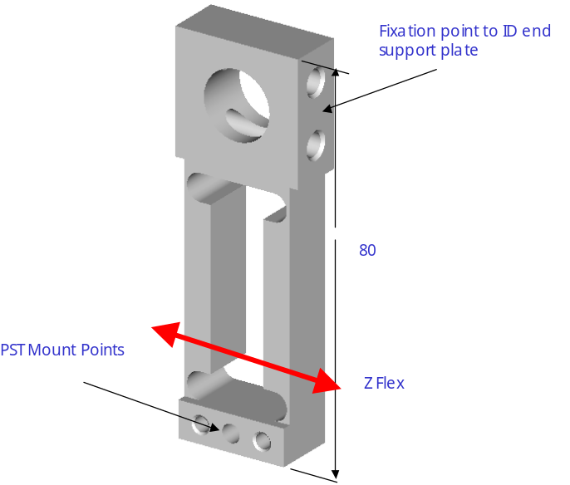
Figure 9. PST mount blocks for fixation to the cryostat supports.
The ID End Support Plate also provides the support for the pixel services going out radially from PP1 up to PPF1 and for the beam pipe supports located immediately outside the pixel volume at the two ends of the VI section.
The provisional envelopes of this region, whose design is still conceptual, are shown in Figure 10.
At the end of the ID volume there is an End Plate, sealed around the beam pipe. The End Plate extends from the beam pipe over the services routed along the cryostat side surface. The end plate should protect the services and equipments at the end of the ID volume and should act as an overall gas enclosure for the ID volume. Although it will be impossible to efficiently seal the end plate outer edge given the large amount of services coming out radially through this region, it should be possible to maintain a reasonably dry environment in the area around the beam pipe in front of the pixel PP1.
This is a very important requirement as it will be extremely difficult, if not impossible, to achieve a condensation-poof design of the end plug feed throughs and of the cold return cooling tube, due to the 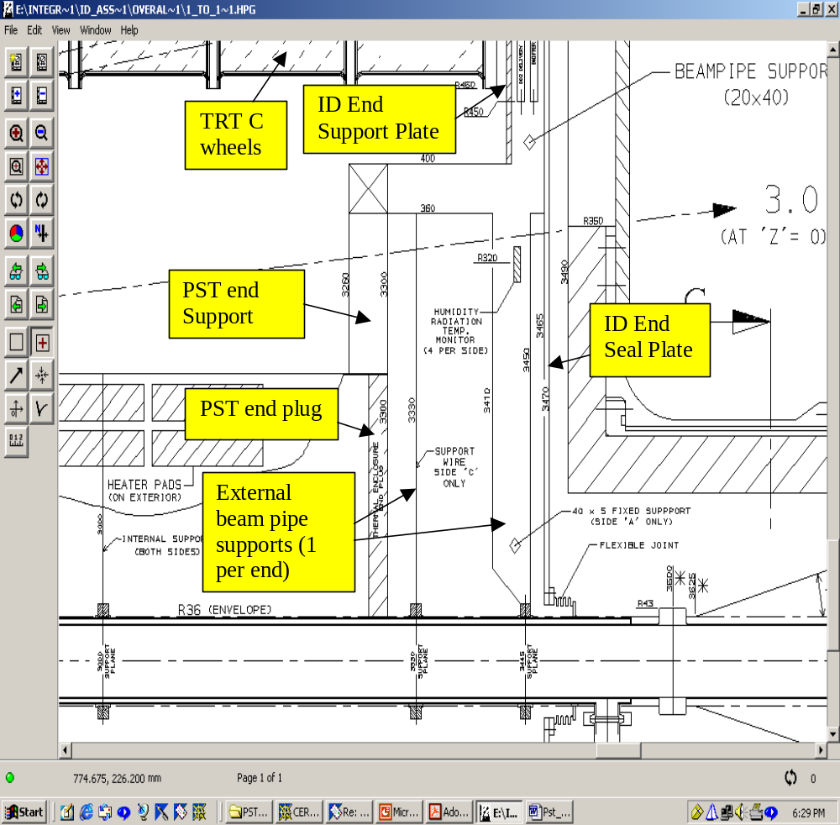
Figure 10: envelopes at the end of the ID volume around the beam pipe

complexity of the area.
Figure 11 illustrates a conceptual design of one section of pixel PP1 and end plug feed through, giving an idea of the congestion in this area.
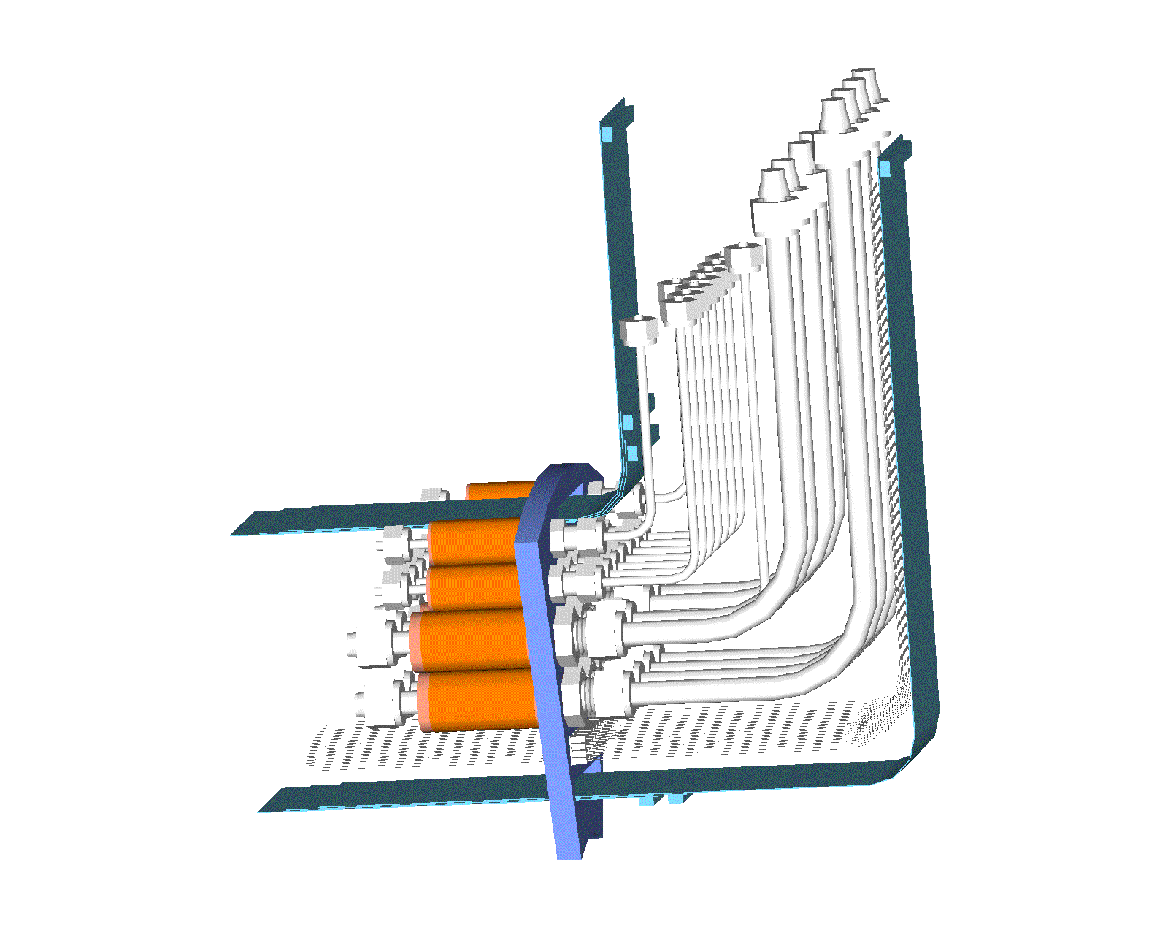
Figure 11: conceptual design of pixel PP1 (1 octant); end plug in blue

Beam Pipe
There is an indirect interface from the PST to the VI section of the beam pipe. The beam pipe(and services) support structure rides on and is supported by rails integrated into the PST.
The VI section of the beam pipe will be supported at four points: two internal to the pixel gas enclosure located at the end of the ID barrel (z = +/- 800) and two external located immediately outside PP1.
The two internal beam pipe supports will be connected to the PST rails through the support structure and the two external ones will connect to the ID end support plate.
During the installation and the removal of the pixel system, two additional fixed supports connecting the VI section of the beam pipe to the two end plug structures will be required, since the two external supports will not be there.
The two internal beam pipe supports slide on the PST rails allowing for the installation and the removal of the pixel system and maintain the same relative position of the beam pipe with respect to the rest of the pixel system..
All the 4 supports will fix the beam pipe in x and y.
The beam pipe will be fixed in z direction only by the external support at side A: the other three supports will allow float in z. The max design axial movement of the z-floating support is 25 mm (worst case, external support at side C), this is the expected beam pipe expansion over 7 m during the bake out process which will be carried out with all the beam pipe supports in place.
The z-floating supports will have to be wire-like supports with build in spring-loaded load-limiter mechanism working like a rigid support until a given threshold is exceeded. Otherwise these supoorts might determine the vibration modes of the beam pipe.
The beam pipe support scheme is illustraded in Figure 12.
The capability to adjust the beam pipe in radius up to 9 mm is required.
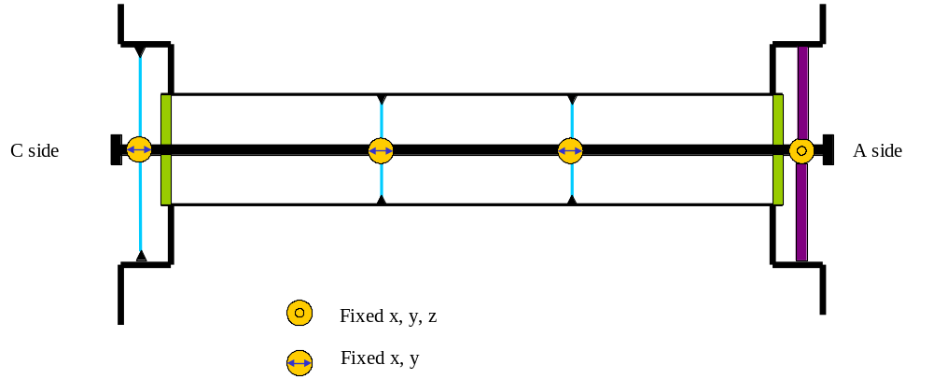

Figure 12: position and type of VI section beam pipe supports

The adjustment of the internal supports will have to be possible with the ATLAS detector in a short access configuration from the outside of the pixel volume through the end plugs with the pixel installed and all the services connected(but not fully operational).
The beam pipe supports/adjustment must be electrically isolated from the PST.

Rails

The pixel system will be installed as a package consisting of the pixel detector itself, the forward services along the beam pipe, the end plugs and the VI section of the beam pipe.
All these components will move and be slid into the PST as a 7 m long object.
Four rails are foreseen inside the PST to allow the installation and removal of the pixel package. Their positions and shapesares shown in Figure 13.
The rails will also be the final support of the forward services structure which includes the beam pipe supports, while the pixel detector load will be transferred to independent supports connected directly to the PST mounts to SCT barrel.
The service supports are electrically isolated from the PST by an insulating (glass) layer on the rails, which also acts to prevent the creation of carbon particles during sliding.

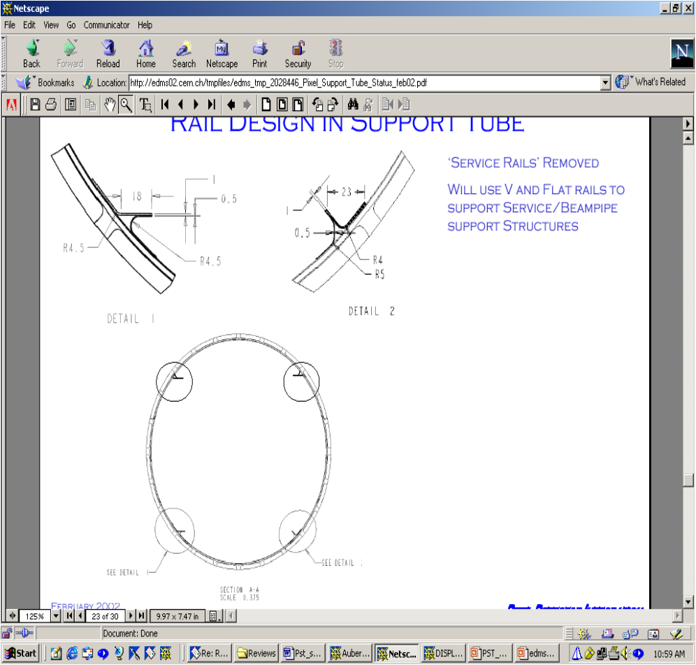

Figure 13: PST rail system

Installation and Assembly
The barrel section of the PST is attached to the SCT barrel structure before the barrel TRT/SCT is lowered into the ATLAS pit and installed in the cryostat. The end-sections of the PST are connected to the barrel section before the forward TRT/SCT elements are installed into the cryostat. The end-sections of the PST must be installabe in the pit. The end-sections are only supported by the barrel connection during the forward TRT/SCT installation.
The pixel system must be removed before removing the forward TRT/SCT sections. The PST is not required to support the pixel detector, its services and the beam pipe with the end supports removed.
During the assembly and installation procedure of the PST into the ID there are some alignment steps to be carried out:
- When the barrel section of the PST is installed into the barrel ID in the surface lab, the two forward PST sections will be temporarely connected and the whole PST will be aligned wrt the ID dummy rails to its nominal position. This alignment will be carried out by using only the barrel ID to ID rails adjustments.
- Once the ID barrel with the barrel PST is installed in the cryostat, the position of the barrel PST will be surveyed wrt the cryostat end survey reference marks. Then the two forward PST sections will be mounted again to the barrel section and the position of the two ends of the PST wrt the ID rails will be checked. In case of macroscopic misalignment which might unacceptably affect both the PST-SCT forward clearances (and hence next assembly steps) and the final pixel position, possible emergency x, y corrections of the PST position can be done whithin the maximum allowable range of the PST-SCT mounts. This is currently foreseen to require replacing the PST-to-SCT mounts(flexures) to correct the misalignment. This could be accomplished by having pre-fabricated flexures with different bolt-pin locations.

Design Parameters, Load Conditions and Stability

Design parameters and specific requirements
The following design masses are assumed for the PST analysis:
- Pixel detector: 35 kg
- Forward services (including support structure and beam pipe supports): 20 kg (per side)
- PP1 and end plugs: 15 kg each
- Beam pipe (only the straight section up to PP1): 4 kg
It is assumed that all the PP1 connections (both electrical and hydraulic) are supported by the PST end supports.
The natural sag of the forward PST,without the pixels installed. has to be included in the forward PST envelopes This follows from assuming the pixels are removed to remove the forward TRT-SCT sections.
Overall mechanical tolerances:
- As built straightness (not including sag) of the three assembled sections of the PST: 1 mm (this has to be measured on the Cryostat rails wrt the mount points to SCT)
Rail mechanical tolerances (these apply to every section):
- Max out of plane of the flat bottom rail: ± 0.25 mm at the rail-to-rail locations and 1 mm elsewhere.
- Max parallelism error of upper rails wrt the average plane of the bottom rails: ±1 mm
- Max x and y deviation of V-rail from nominal: ± 0.25 mm at the rail-to-rail locations and 1 mm elsewhere.
PST mounts to SCT mechanical tolerances:**I don’t understand this*** <<Comment>> unsure how to use these—requires GD&T Drawing specifying surfaces/holes indicated➔also, what is meant by ‘pixel-SCT’ interface—there is a Pixel-PST interface, and a PST-SCT interface, but is this aimed at the overall tolerance between pixel and SCT? In which case, separate budgets for the two interfaces comprising this need to be specified.
- Max parallelism error of the two pixel-SCT interface surfaces at one side wrt those on the other side: 0.05 mm
- Tolerance on the distance between opposite pixel-SCT interface surfaces: +/- 0.05 mm
- Coplanarity of the pixel-SCT interface pin-holes of all the 4 supports: 0.05 mm
Other structural requirements:
- Max natural sag of the 4 mount points to SCT under the nominal pixel detector weight: 0.02 mm. This requirement is linked to the dynamic stability of the pixel detector which will be discussed later. As worded this is a requirement on the SCT. For us we allotted 10microns per interface (Pixel to roller, Roller to PST, Pixel mount to SCT mount)
- Max design overpressure of the inner environment wrt the external one: 4 mbar (for this to be a part of the requirements, it should be shown that there is a system which limits the pressure to this value—there is no analysis which shows that the pressure is ok, though this is another point.
- Max pixel system insertion/removal axial load on PST: 15 kg. The two PST end supports will have to be temporarely locked in z during the installation/removal to minimize the load being supported by the barrel SCT.
- Each end plug must provide a flexible gas barrier wrt the beam pipe to account for a max of 25 mm axial displacement
Thermal and gas requirements:
- Max total leak rate of the pixel gas barrier: 1 l/hour/mbar
- Minimum PST operating temperature: -10 °C
- Min PST temperature with the active heating turned on: +15 °C
- Max PST temperature in fault conditions: 50 °C. This is associated with a failure of the control system of the heaters. However is going to be a local effect (limited to one heater or to a few heaters in parallel/series) having a small impact on the overall PST structure.
Electrical
- Continuous EMI path across barrel, forward and end-plugs

Load conditions and stability requirements

The stability requirements of pixel and SCT detectors are fixed in terms of maximum allowable displacements along the three directions: R, R-φ and z of the detector modules.
There are two different requirements:
- Short term stability
- Medium/long term stability
The short term stability requirements (1) are defined wrt a time scale shorter than the time needed to achieve a complete re-alignment of ID by tracks. This time will be of the order of days.
If this requirement is applied to an entire detector, moving as a rigid body, then the detector position could be traced on a quasi-on-line basis and hence the associated stability requirements are much more relaxed.
The short term individual module stability requirements are set by the criteria of not degrading by more than 20% the intrinsic point resolution of the detector.
It is also to be said that in general the pixel detector is more sensitive than the SCT barrel to the stability requirements since it is supported off the SCT barrel itself and hence is affected by displacements of the mount points.
However, due to the intrinsic high stiffness of the pixel global frame and to the adopted Pixel-to-PST mounts support scheme, the pixel detector movement induced by most of the external actions, will be very close to a rigid body movement.
There are 3 PST-related load cases potentially affecting the stability of Pixel and SCT, these are illustrated in table no. 1 and relevant impact on stability together with the requirements are discussed. All the stability requirements are expressed as +/- tolerances (these are 12^{1/2} times the corresponding r.m.s. values).
Both the short term rigid body stability budget and the long term budget have been extrapolated from the short term module stability budget with some guessed factors.
Table 1 gives both the total stability budget and the fraction stability budget associated to the PST load cases (in italics, tbd).

Load case | description | source | timescale | Stability requirements: +/- tolerences (μm)
 |  |  |  | Pixel |  |  | SCT
 |  |  |  | R | z | R-φ | R | z | R-φ
1 | Differential axial and radial displacement of PST barrel and SCT barrel cylinder n.3 due to ΔCTE and ΔT | Temperature change of PST or SCT barrel cylinder due to turning ON or OFF of the thermal barrier heaters | Short term | 100  (RB) | 300  (RB) | 40  (RB) | 346 | 173 | 41
2 | Differential displacement of the PST sections from z-fixed point to end supports | Temperature change of PST due to turning ON or OFF of the heaters on PST surface | Short term | NA | 300  (RB) | NA | NA | 200  (RB) | NA
3 | Offset of one or both end supports of the PST | Change of ID-cryostat thermal conditions, | Long term | 200 | NA | 80 | 600 | 300 | 120
RB = rigid body
NA = not affected (or negligibly)

The dynamic stability of the detectors against vibrations is usually expressed in terms of minimum natural frequency, which is directly proportional to the stiffness and to the natural sag for the vibration modes along the vertical direction.
The amplitude of the vibration is driven by the damping of the system which is an unknown factor.
However from past experience on previous detectors a first mode above 100 Hz is deamed as acceptable in terms of associated amplitude of displacements.
This requirement is looser for the ID axial modes, which are the most difficult to manage, because of the looser stability requirements along this direction.
In the case of the PST, its axial mode will be driven by the axial mode of the ID barrel, which is relatively low.
The vibration modes of the PST along the other directions should not affect the Pixel detector dynamic stability due to the strong direct link of the Pixel to the SCT through the PST mounts, which should filter most of the excitations coming from the PST structure.
Therefore the tighter dynamic specification is on the Pixel to SCT mounts which have been given a first frequency specification of about 80 Hz.
However the shell and bending modes of the PST should be kept above 50 Hz to also limit the possible negative impact on the stability of the services and beam pipe support structures.

Production Plan Summary

For convenience, and to understand the practicalities of the interfaces, we provide below a summary of the production plan.

ITEM | IMPLEMENTATION
Barrel and forward shells and related stiffeners | Fabricated at LBNL using vendor and/or LBNL supplied tooling
Flanges | ???
PST to SCT mounts | LBNL assembled with in-house and/or vendor supplied parts
Pixel mounts | LBNL assembled with in-house and/or vendor supplied parts
Services support structure | LBNL assembled with in-house and/or vendor supplied parts
Beam pipe supports | LBNL/CERN*
PST end support | CERN
Flexures for PST end support | LBNL provided
PP1 structure, including pipe feedthroughs, electrical feedthroughs and beam pipe support adjustment interface | LBNL assembled with in-house and/or vendor supplied parts
PP1 optical fiber feedthroughs | TBD to provide to LBNL for final PP1 assembly
* Assumes US financial support in 2003 and later becomes available.

References

(1) S. Haywood et al, Offline Alignment and Calibration of the Inner Detector, ATL-INDET-2000-005

