 | Pixel Local Supports FDR
ATLAS Project Document No: | Institute Document No. | Created: 26/05/2000 | Page: 1 of 25
ATL-IP-ER-0004 |  | Modified: | Rev. No.: 1

ATLAS PIXEL LOCAL SUPPORTS (DISK SECTOR)
DESIGN STATUS AND PLAN

This document summarizes the design status and tests of prototypes of the ATLAS Pixel System Local Supports for the disk sectors. A plan of work leading up to the Production Readiness Review is also given.
Prepared by:  E. Anderssen, M. Gilchriese,  F. Goozen, F. McCormack, W. Miller, J. Taylor, T. Weber, J. Wirth | Checked by: | Approved by:
Distribution List

History of Changes
Rev. No. | Date | Pages | Description of changes

Table of Contents

1 Introduction 4
2 Disk Sectors 4
2.1 Design and Prototype History and Status Summary 4
2.1.1 Overview 4
2.1.2 Carbon-tube Design 4
2.1.3 Sealed-tube Design 5
2.1.4 Aluminum-tube Design 7
2.2 Thermal Performance 8
2.2.1 Introduction 8
2.2.2 Test Samples and Single Sectors 9
2.3 Sealed-tube Thermal Tests 9
2.4 Stability Performance 15
2.4.1 Introduction 15
2.4.2 Test Samples and Single Sectors 15
2.4.3 Prototype Disk 19
2.5 Material 21
2.6 Miscellaneous 22
2.7 Summary of Status and Critical Outstanding Issues 22
3 Work Plan 24
3.1 Introduction 24
3.2 Sealed-tube Plan 24
3.3 Aluminium-tube Plan 24

Introduction
This note summarizes the design status and measurements on prototypes of the ATLAS Pixel Local Supports the Disk Sectors. A proposed plan of work leading up to the Production Readiness Review (PRR) is also provided. This note assumes familiarity with the ATLAS Pixel System and the corresponding local-support requirements.

Disk Sectors

Design and Prototype History and Status Summary

Overview
Three different types of disk sectors have been designed and prototypes fabricated. Tests have been performed on these prototypes to determine if the designs meet the requirements. The design concept for each of these prototypes is summarized here. A more detailed description of the fabrication process for two of the designs - those based on aluminum cooling tubes and sealed carbon-carbon tubes - is available. All disk sector designs share the common feature of having carbon-carbon faceplates. The carbon-carbon faceplates have high in-plane thermal conductivity, adequate transverse thermal conductivity and high stiffness. Pixel modules are mounted on both sides of the sector. Coolant is contained in a tube between the faceplates that is arranged to meet the thermal requirements with the minimum material (for each design). The three different designs differ in the composition of the cooling tube, how the tube is attached to the faceplates and how structural stiffness is maintained for the finished sector.

A complete set of measurements does not yet exist to demonstrate that all requirements can be met. An enumeration of outstanding issues and a plan to address them are included in this note.

Carbon-tube Design
The carbon-tube design was developed by Energy Sciences Laboratory, Inc (ESLI) under a direct contract from the US Department of Energy. The coolant tube is a glassy carbon tube that can be formed as shown in Error: Reference source not found. The tube is mechanically and thermally connected to the faceplates by using high-thermal-conductivity fibers that are "flocked" onto the carbon tube and machined flat, using a proprietary process from ESLI. The concept is illustrated in Figure 2. The resulting structure is then thermally and otherwise processed to provide an all-carbon structure with good matching of the coefficients of thermal expansion among the various sub-components.

ESLI developed a number of generations of these prototypes. Nine prototypes were manufactured to develop the technique. These prototypes have been used in three critical tests to assess the ability to meet the design requirements. One, evaporative cooling tests (with C₄F₁₀) were performed in four different orientations of the sector to determine if gravity affected the evaporative cooling concept using a cooling tube with multiple bends. No significant differences were observed. Two, a later generation of prototype was used with evaporative cooling (also with C₄F₁₀) to understand operating margins and compare with theoretical calculations. These tests are described later. Third, ESLI produced an additional twelve prototype sectors (of which two developed leaks during handling) that were mounted on a prototype disk support ring. Extensive stability measurements were performed on this complete disk at simulated operating conditions. These tests are also described later.

ESLI is not currently considered to be a viable alternative for production of the disk sectors. The reasons for not considering them include cost, reliability of the design under pressure fault conditions, reliability of the fabrication process and schedule.

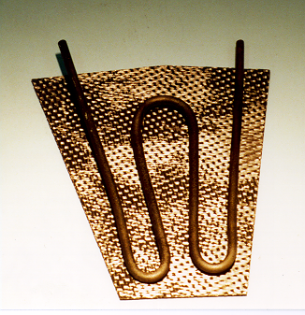  Figure 1. Glassy carbon tube manufactured by ESLI. | 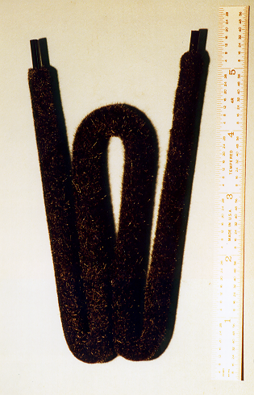  Figure 2. Glassy carbon tube with fibers attached.

Sealed-tube Design
The tube in this design has been developed by HYTEC, Inc under direct contract from the US Department of Energy. The tube is a resin-sealed carbon-carbon (C-C) tube developed by HYTEC, Inc and illustrated in Figure 4. It is attached to the faceplates with a rigid epoxy (right inset of Figure 4) and there is no material other than the tube between the faceplates. There is a very good match of coefficients of thermal expansion between the carbon-carbon tube and the carbon-carbon faceplates.

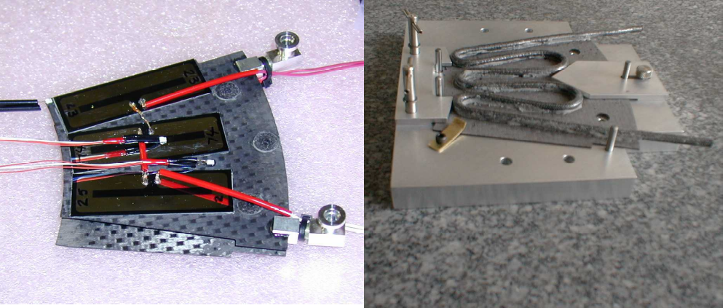
Figure 3. Left inset is photograph of a completed sector with a carbon-carbon sealed tube. The right inset illustrates the C-C tube bonded to the first faceplate, an initial step in the assembly process.

To date, 11 sectors have been built, 2 development sectors and 9 sectors as given in Error: Reference source not found. Additional sectors are under fabrication to be completed by June 2000.

HYTEC is conducting a series of thermal, stability, and pressure tests on each sector. Table 1 lists the status of the sector testing. For clarification, thermal tests are performed at both room temperature and at –15 °C inlet coolant temperature. The cold tests simulate the actual detector performance conditions and this condition is essential for conducting a stability test. Not all sectors are tested at –15 °C. However, all sectors will be thermally tested with room temperature coolant. This test is conducted to validate thermal performance of each sector. Sector stability is recorded with a real-time holography system, PRISM, at HYTEC, for both cold and room temperature inlet conditions. Leak and elevated pressure tests are to be performed on all sectors. Elevated pressure testing on each sector comprises 10 cycles at 4 bar absolute and a 10 bar proof test. Exploratory high pressure tests were performed on units 3 and 4, were cycling up 150 times at 5 bar was performed. Mechanical strain data were recorded holographically throughout the pressure cycling.

Four sectors have been thermally tested with a methanol and water solution, as well as pure water. The methanol/water coolant is used to evaluate thermal performance at -15°C, the chosen inlet temperature for confirmation of thermal performance.

HYTEC is preparing to evaluate the thermal and stability performance of a dual sector arrangement with evaporative coolant, C₄F₁₀. This test is intended to demonstrate that no stability differences exist between a liquid and evaporative coolant system. It is believed that the stability, quantified by out-of-plane thermal strains, is entirely governed by the change from room temperature conditions to the sub-cooled operating state. In addition, one sector will be tested in June at CERN with the current baseline coolant, evaporative C₃F₈.

Sector Unit # | Tube wall | Status | Weight-g
1 | single | Development unit | n/a
2 | single | Development unit | n/a
3 | single | Thermal, stability, and pressure | 21.02
4 | double | Thermal, stability, and pressure | 23.84²
5 | single | Pressure | 21.63²
6 | single | Thermal, stability, and pressure | 19.17
7 | single | Pressure | 17.5³
8 | single | Pressure | 17.93²
9 | double | Available for testing | 21.25³
10 | double | Available for testing | 21.01³
11 | double | Available for testing | 20.32³
12 | double | Tube becomes available 5/26/00
13 | double | Tube becomes available 5/26/00
14 | double | Tube becomes available 5/26/00
15 | double | Tube becomes available 5/26/00
16 | double | Tube becomes available 5/26/00
Table 1. List of HYTEC sector configuration and status.

The thermal structure depicted in Figure 3 utilizes high thermal conductivity facings, which are 0.5mm thick carbon-carbon, produced from a balanced 2D woven fabric of K321 fibers. The facings were lightly sanded to a 0.5mm thickness, after being carbonized and infiltrated with carbon (CVD). As carbonized and heat-treated, the facings are 0.7 mm thick.

Initially, the tubes were configured to be a 3.2mm ID carbon tube with a wall thickness of 0.25 mm. The C-C tube wall comprised a matrix of carbonized phenolic resin, and a single layer of T300 carbon fibers. The tube was sealed with an overcoat of EPON815C resin. The mass for the sector with a 0.25 mm wall (unit #3) was 19.5 gm, with the C-C facings comprising 64% of the mass. The aluminum tube fittings are not included in the mass since they will be ultimately replaced with C-C or graphite tube extensions.

In more recent sectors (Table 1), the coolant tube wall thickness was increased by a factor of two (unit #4). The wall thickness was increased primarily for added strength, but also to increase the surface area for heat conduction into the coolant fluid. The increased wall thickness was accomplished by using two layers of carbon fibers, as opposed to a single layer (unit #3). This change amounted to using two layers of the woven sock (braided fibers), and outer and inner layer. The combined woven sock layers were then impregnated with phenolic resin and carbonized. The same tooling was used in the processing the double and single fiber-layer tubes; hence, the thicker walled-tube developed a flatter appearance. Throughout the various processing steps, and subsequent tube sealing process, the robustness of the thicker-walled tube was quite evident. The tube weight increased from nominally 2.8 to 5.8gms. This change, if adopted would increase the radiation length of the tube contribution in the active pixel detector area from 0.11 to 0.22%.

The sealed-tube design remains an option for the final production of disk sectors.

Aluminum-tube Design
The tube in this design is a bent, rectangular aluminum tube - see Figure 4. The thermal contact with the faceplates is provided by thermally conductive compound (CGL-7018 from AI Technologies) as shown in Figure 5 and tube is captured by carbon foam and a few carbon-carbon hard points that are rigidly bonded to the faceplates as also shown in Figure 5. These sectors have been designed and fabricated at Lawrence Berkeley National Laboratory.

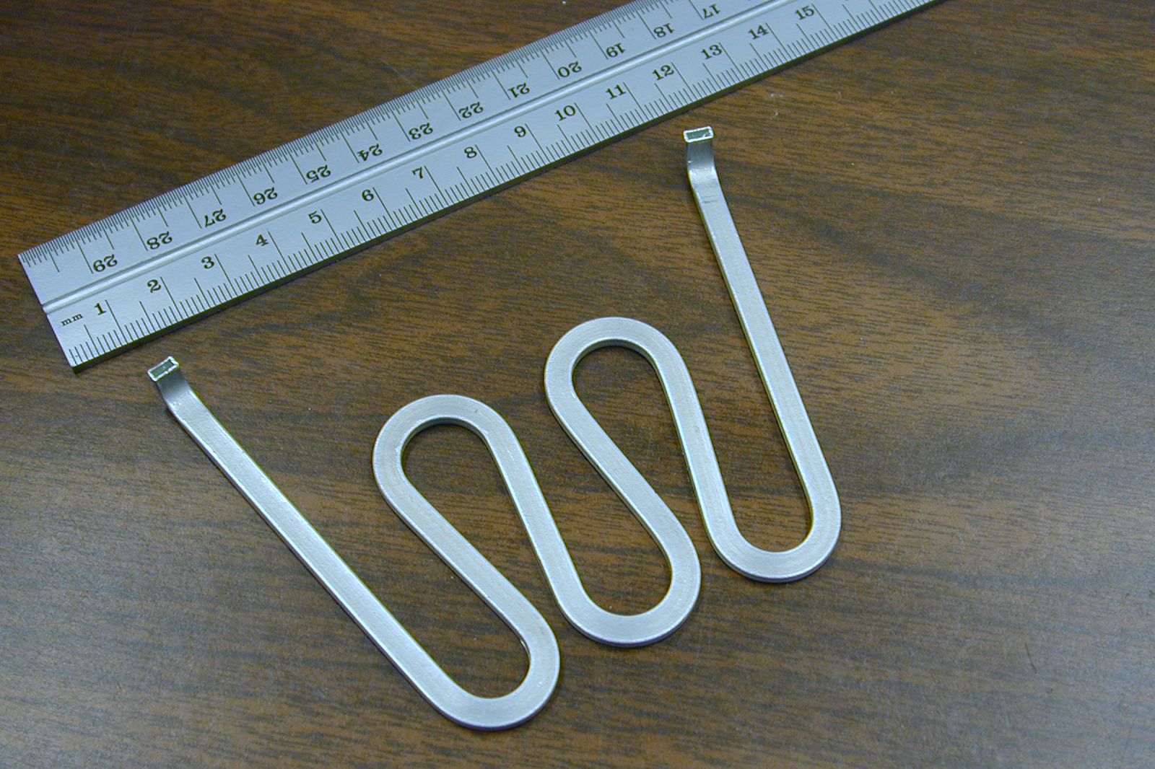  Figure 4. Aluminum tube for disk sectors. | 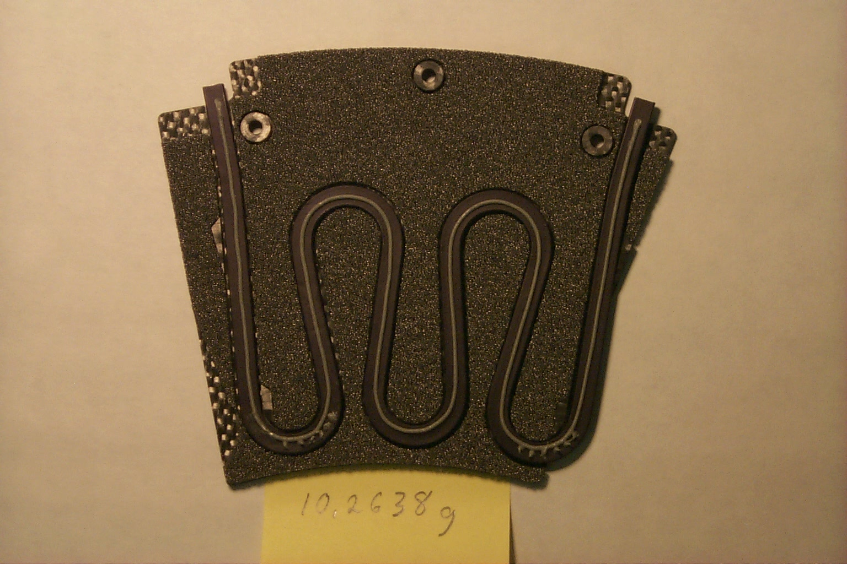  Figure 5. Tube in foam showing construction.

Ten prototypes of this design have been fabricated (as of early June 2000) and additional prototypes are under fabrication. The basic parameters of these prototypes are summarized in Error: Reference source not found. Test results for some of these sectors are reported below. Prototypes #1 and #2 were fabricated some years ago for disk layouts that are no longer relevant. Prototype #5 was poorly made and rebuilt to become prototype #6.

Number | Facing thickness | Fill material  carbon foam | fill to c-c adhesive | Al-tube
3 | 0.50 mm | 0.05 gm/cc | 3M-9460 | Round  3.6 mm ID  0.20 mm wall
4 | 0.30 | 0.10 | Cyanate ester | Round/flattened  3.6 mm ID  0.20 mm wal
5 | 0.30 | 0.10 | Cyanate ester | Rectangular  ID 1.69x4.06 mm  0.20 mm wall
6 | 0.30 | 0.10 | Cyanate ester | Rectangular  ID 1.69x4.06 mm  0.20 mm wall
7 and 8 | 0.42±0.03 | 0.10 | Cyanate ester | Rectangular  ID 1.69x4.06 mm  0.29 mm wall
9 and 10 | 0.42±0.03 | 0.10 | Cyanate ester | Rectangular  ID 2.74x4.19 mm  0.29 mm wall
Table 2. Summary of aluminum-tube prototype sectors.
This design is the current baseline for the disk sectors and thus is an option for the final production.

Thermal Performance

Introduction
The essential thermal requirement is to maintain the pixel silicon sensor temperature below -6ºC with a uniformity across the sector of L10ºC under all conditions. The thermal performance of the sectors has been assessed by attaching dummy heat loads to the sectors to simulate the heat load introduced by the pixel electronics. This has been done by evaporating thin platinum on 0.300 mm silicon in a pattern that simulates the pixel electronics heat load. These resistive heaters are attached to the sectors in a manner similar to that expected for actual pixel module attachment. Thus the actual heat loads are simulated as well as can be done in the absence of real pixel modules.

Thermal measurements are done by infrared (IR) thermography coupled with measurements at discrete points using RTDs or other devices. The IR measurements are normalized to the single point measurements. The overall absolute accuracy in the temperature scale is estimated to be ± 1.5ºC. Two different types of IR cameras have been used so far.

The thermal performance of the sectors depends on a number of factors. These include the coolant temperature, the coolant flow rate, the temperature differential between the coolant and the surface of the sector faceplates and the temperature differential between the faceplate and the simulated pixel module. The last item is an interface to the sector, and imposes requirements on the module attachment that are not directly addressed here.

The current baseline coolant system is evaporative C₃F₈. Thermal performance tests on disk sector prototypes have been done with water/alcohol mixes, liquid fluorinert (C₆F₁₄) and evaporative C₄F₁₀ but NO tests have been done on disk sectors with the baseline coolant. First tests with the baseline coolant are planned in June 2000. Our test results exhibit a good correlation between the thermal performance measured with different fluids, in particular the temperature differential between the local coolant (or coolant pipe) and the surface of the sector faceplates. Thus we believe measurements made with coolants other than evaporative C₃F₈ are reliable indicators of thermal performance.

Test Samples and Single Sectors
Thermal measurements have been done on prototypes of the disk sectors and smaller test pieces used for pre- and post-irradiation comparisons. These test pieces were constructed in a manner similar to the sectors.

Normal Operating Conditions
The measurement of thermal performance of an aluminum-tube sector is illustrated in Figure 6 and Figure 7. The IR measurements are cross-referenced to measurements using RTDs at a few points on the platinum-plated, silicon dummy heaters. Measurements without power are taken to determine a base state and then measurements are taken at different power levels and coolant conditions. The coolant used in this example was a water/methanol mixture. Figure 6 and Figure 7 also show reference surfaces (points 3 and 4) that are used to calibrate the measurements. The measurements on aluminum-tube prototypes #4 and #5 can by summarized briefly as follows:
- the temperature differential between the bulk coolant temperature and the surface of the silicon simulated heaters can be kept ≤ 12ºC at full power (50 W) in the worst locations for flow conditions that are believed to approximate those that would prevail in evaporative C₃F₈ cooling;
- the uniformity of temperature can be ≤ 7ºC under the same conditions; and
- these temperature differentials are linear in the power, for fixed coolant temperature and flow.
The maximum temperature differential occurs near the edges of the sector, and additional design modifications (small movements of the aluminum tube) are being implemented to reduce further the maximum temperature differential.

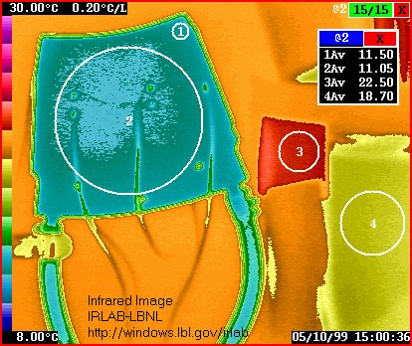  Figure 6. Infrared image of aluminum-tube prototype# 4 without power at 10 cc/sec flow of coolant. | 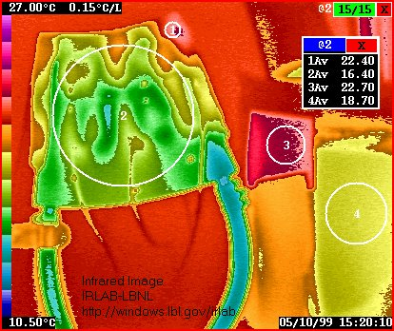  Figure 7. Infrared image of aluminum-tube prototype #4 at 48W of power with 10 cc/sec flow of coolant.

Sealed-tube Thermal Tests
HYTEC component sector thermal tests have been conducted in a dual-sector arrangement shown in Figure 8. RTD recordings of the temperature rise from power off to power on were made at six points on the thermal structure. The temperature increase is measured with respect to coolant inlet temperature, which remained constant at room temperature throughout the test.

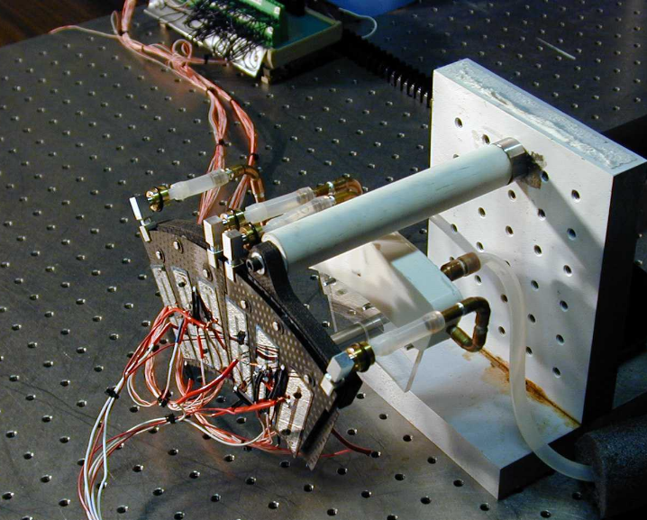
Thin plastic plate
Silicone rubber band
Figure 8. Close-up of the dual thermal structure test arrangement with partial view of coolant manifold.

For sector unit #4, the points of highest temperature increase above inlet coolant temperature is about 12°C at 50W and are located in the extreme lower corners of the facing overhang. In this location, heat must be conducted nominally 15mm before encountering a cooled zone. The overhang is like a fin being subjected to a constant heat flux. The thin facing material provides the primary path for heat conduction. Since the heat flux is constant in this region, the resulting temperature drop is very sensitive to the path length, an L² effect. The 15mm distance is somewhat greater than anticipated due to the tube Triple U-pattern not matching the intended path exactly. Part of this problem is shrinkage caused by the tube carbonization cycle. HYTEC has plans to reconfigure the tube path for follow-on sector construction.

The other temperature differentials recorded for front and back faces of the thermal structure are within a spread of 1.8°.

The highest surface temperature rise point on the body of unit #4 is 7.2°C. See Figure 9. This differential implies that in the HYTEC sector one should anticipate a faceplate surface temperature no warmer than nominally –7.0°C with a -15°C inlet condition; a small allowance is made for thermal boundary layer effects in the more viscous fluid.
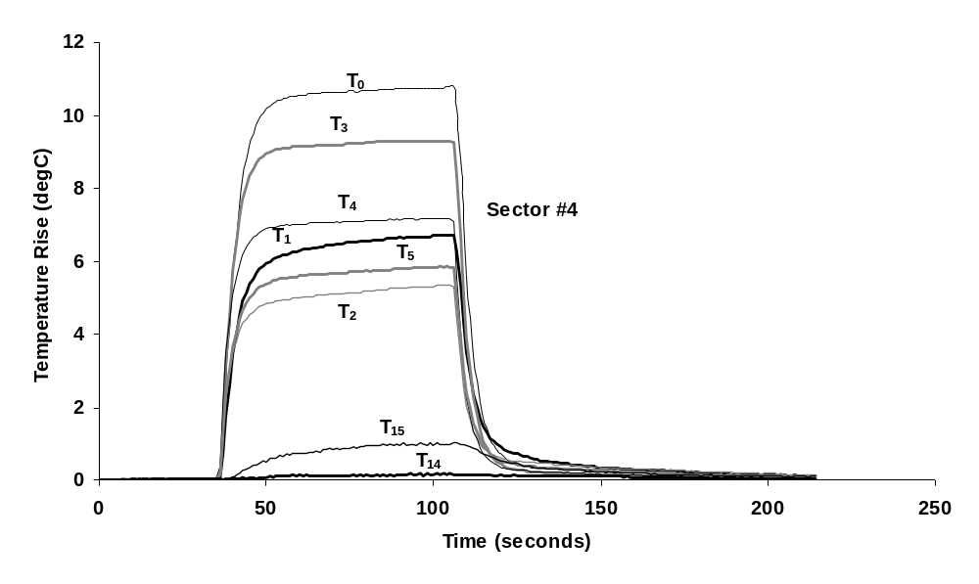
Figure 9. Thermal test results for unit #4, which is constructed with a carbon-carbon coolant tube with two layers of carbon fibers. Power input is 36W and coolant flow rate is 9 cc/sec with an inlet water temperature of 25°C. Peak temperature occurs at the outermost point of the facing overhang, both front and back facings. Silicon wafer heating is approximately 15mm from the corner of the cooling tube in this region. Temperatures T₂, and T₅ are recordings on the body of the sector adjacent to the silicon wafers, whereas T₁ and T₅ are located on the silicon wafer.
HYTEC has performed thermal tests as a function of power for unit #4, using room temperature coolant. See Figure 10. The temperature difference between surface recordings and the inlet bulk temperature are a linear function of power. This characteristic is consistent with expectations.
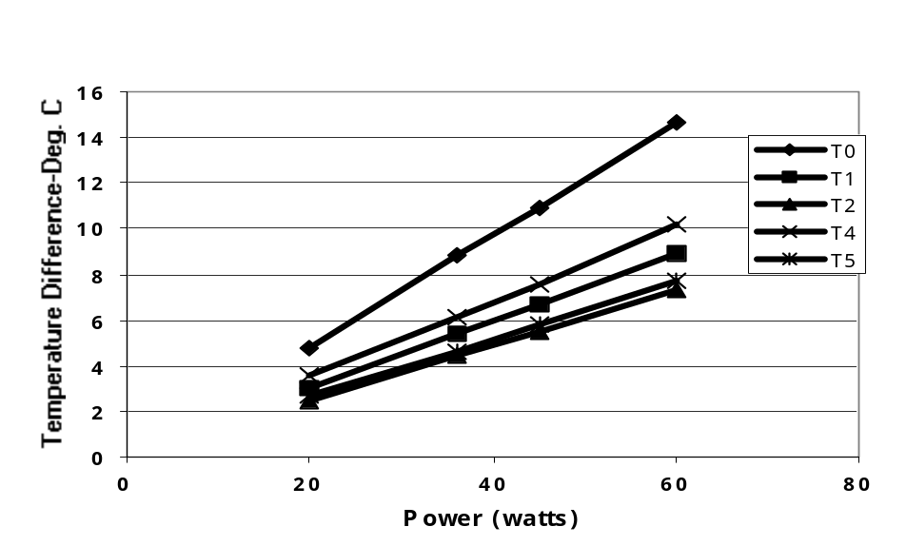
Figure 10. Thermal test of unit #4 as function of power at 20 cc/sec of room temperature water. RTD T0 is a display of the maximum temperature at the lower corner of the sector.

After Temperature Cycling
Temperature cycling measurements occur naturally as the thermal performance is measured although usually over a restricted range of temperature. Aluminum-tube prototype #4 was cycled between room temperature (22^{O}C and -18^{O}C) without heaters attached, the heaters attached and the thermal performance measured (also after the pressure cycling described in the next section). The thermal performance met the requirements. The temperatures measured at discrete points for low temperature operation are shown in Figure 11. Thermal measurements were repeated on this sector using liquid C₆F₁₄ coolant that resulted in temperature cycling multiple times from room temperature to about -20ºC. No degradation in thermal performance has been observed after temperature cycling from room temperature to about -20ºC for aluminum-tube prototypes measured so far. However, it should be noted that in all cases the dummy heaters were attached solely with CGL7018, which has a very, very low shear modulus and decouples any CTE mismatch between the silicon and the sector structure. Measurements are just starting on thermal cycling effects with dummy heaters attached both with CGL-7018 and with small tacks of UV epoxy that are required to prevent long-term creep using CGL-7018 alone. This will couple the silicon more rigidly to the faceplates, and will induce delaminating forces from the CTE mismatch between silicon and the carbon-carbon. It remains to be proven that the design can withstand such forces.

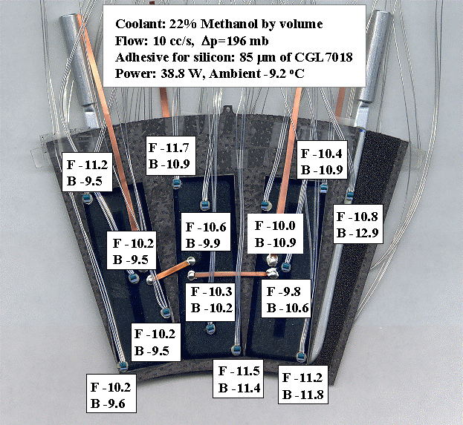
Figure 11. Typical results of measurements at low temperature, and after temperature cycling.
F => front and B => back of sector.

After Pressure Cycling
The thermal performance after pressure cycling has been measured on aluminum-tube prototypes #4 and #5. Prototype #4 was cycled from atmospheric pressure to 5 bar absolute 24 times and then heaters attached. It was then cycled to 3.7 bar absolute 20 times with the heaters attached. The thermal performance of this prototype before and after cycling with heaters attached is shown in Figure 12 and Figure 13, respectively. The power was 60 W, the coolant was water at 11ºC and the flow rate 20 cc/sec. No significant change in thermal performance was observed. Similar results were obtained with prototype #6, cycled to 5 bar absolute 140 times without heaters attached.

The thermal performance of sealed-tube sectors has been measured at discrete points after pressure cycling150 times to 4 bar and after pressurizing to 10 bar. No degradation has been observed.

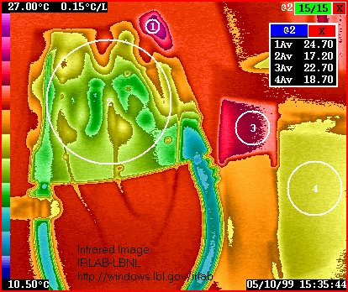  Figure 12. Aluminum-tube prototype #4 before pressure cycling (see text). | 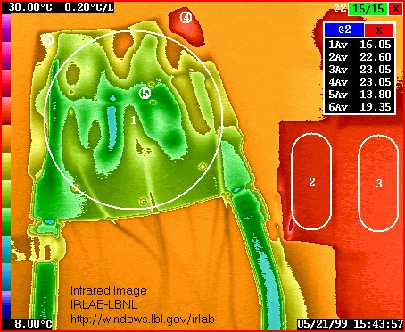  Figure 13. Aluminum-tube prototype #4 after pressure cycling (see text).

After Irradiation
The thermal performance of aluminum-tube prototype sector #3 was measured before and after irradiation with a Co⁶⁰ source to 22 MRad. The before and after comparison is shown in Figure 14 and Figure 15, respectively. The power level was 36 W, the coolant was water at 23ºC and the flow rate was 15 (after) and 17 (before) cc/sec. The temperature differential between the bulk coolant temperature and the silicon heater surface was the same within about 1ºC, and even this small difference can be attributed to slightly different flow conditions. Thus there was no evidence of effects from radiation at 22 MRad.

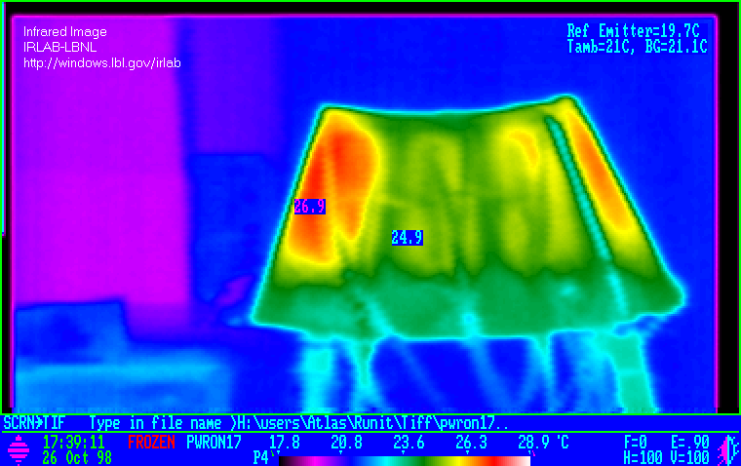  Figure 14. Before 22 MRad irradiation. | 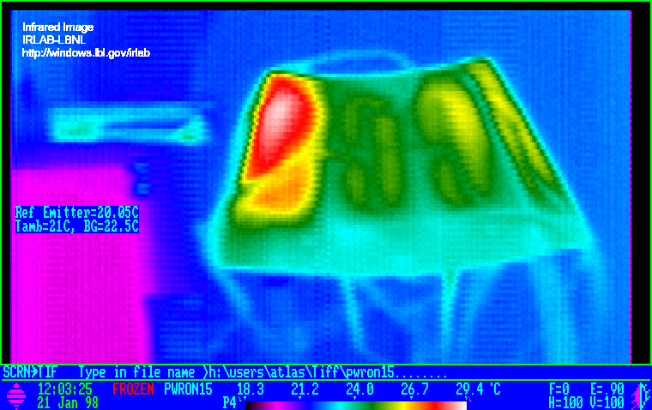  Figure 15. After 22 MRad irradiation.

A test piece that is essentially one-third of a sector has been irradiated to 50 MRad. The thermal performance before and after irradiation is shown in Figure 16.and Figure 17, respectively. The thermal performance degrades by 1-2ºC under the flow conditions used. The coolant was water/glycol at about 6ºC but at a very low flow rate of about 2.5 cc/sec.

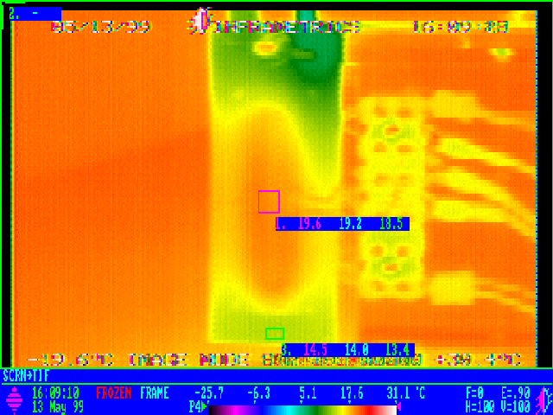  Figure 16. Test piece before irradiation. | 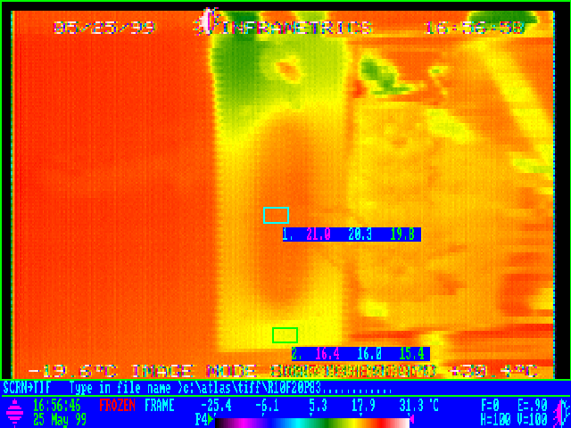  Figure 17. Test piece after 50MRad irradiation.

After Transient and Fault Conditions
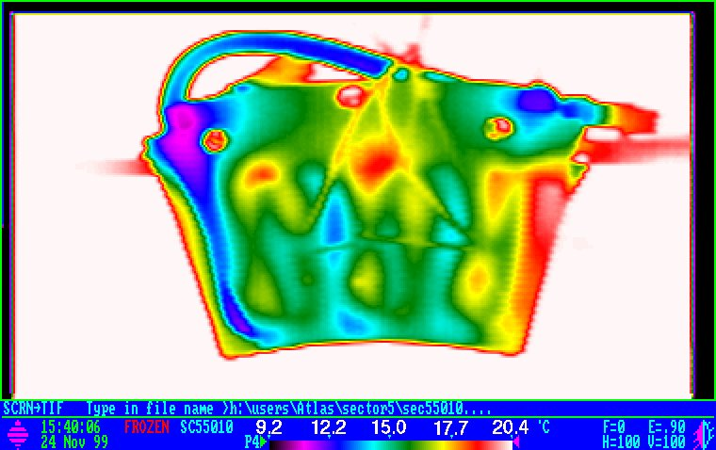
Figure 18. Aluminum-tube prototype #6 after pressure conditions described in the text.
Thermal measurements on aluminum-tube prototype #6 were made after cycling to 7 bar absolute without heaters attached. This followed the cycling to 5 bar absolute described previously. The thermal performance of this prototype met requirements, as can be seen in Figure 18. The power level was 50 W, the coolant was water/methanol at 11ºC and the flow rate 10/cc/sec.

Measurements of aluminum-tube sectors have not yet been done at 8 bar absolute, the recently established single fault maximum pressure. Measurements to simulate no-flow conditions also have not yet been done.

Thermal measurements already shown for the sealed-tube sectors #4 were done after pressurizing to 10 bar absolute.

Measurements with Evaporative Cooling

Evaporative cooling measurements have been done with an ESLI prototype sector with C₄F₁₀ but with a design configuration corresponding to an obsolete disk layout. A direct comparison to measurements using water/methanol was made. These measurements were made about one year ago. A good correlation was observed between the thermal performance using water/methanol at the exhaust temperature used in the C₄F₁₀ measurements. An attempt was made to compare the measurements with calculations of the expected performance of C₄F₁₀ evaporative cooling and extrapolate to the use of C₃F₈ evaporative cooling. These calculations indicated that a hydraulic diameter larger than 2.4 mm, which is the hydraulic diameter of aluminum-tube prototype #6, would be needed but there is considerable uncertainty in these extrapolations. It is planned to compare directly the thermal performance of aluminum-tube sectors(#7 and #8), which have hydraulic diameters of 2.4 mm with sectors(#9 and #10), which have hydraulic diameters of 3.3 mm, to fix finally the required hydraulic diameter required. The sealed-tube sectors have an hydraulic diameter of 3.2 mm.

Stability Performance

Introduction
The stability performance of the disk sectors has been assessed by performing thermal cycling measurements and pressure cycling measurements. In each case the motion, primarily out-of-plane, of the sectors has been measured. This has been done using optical targets attached to the sectors and two types of optical coordinate measurement machines. Each of these optical CMMs has an accuracy of approximately 0.002 mm (rms) in the plane of the sector faceplate and about 0.005 mm (rms) in the out-of-plane (Z) measurements. More precise measurements of the Z motion has been done at Hytec, Inc using TV Holography, which has an intrinsic accuracy of about 0.00025 mm in the Z coordinate. The TV holographic technique has not been used so far for in-plane measurements but is being adapted for this purpose.

Test Samples and Single Sectors
Measurements have been done on a variety of single sectors and on a few test samples that simulate the sector construction techniques.

Thermal Effects
The out-of-plane deflection of aluminum-tube prototype #4 was measured by cooling the sector in cold box without coolant flow. Optical targets located on the sector were viewed by an optical CMM. A temperature change of 40ºC(from 22^{O}C to -18ºC) resulted in out-of-plane motion of less than ±0.020 mm relative to the location at room temperature. The in-plane motion is negligible for a single sector well supported by the three support points. Similar distortion measurements were performed on prototype #3 before and after irradiation, and the differences were within measurement errors. These measurements have been done with dummy heaters attached only with CGL-7018 or without heaters.

An evaluation was made of the thermal stability of the dual thermal structure arrangement of sealed-tube sectors. The objective of this test was to quantify the thermal stability of the sandwich structure and to assess the potential impact on the stability from the coolant manifold.

A stability sensitivity coefficient, μm/°C, is determined through several steps. First, the change in shape is recorded from power off to power on. This step change effectively produces a thermal gradient throughout the structure. The temperature distribution causes a corresponding dimensional change, reflected by out-of-plane motions of the surface.

As a further step in this process, in a power off condition, the thermal structure temperature is decreased gradually by circulating coolant. At various temperature plateaus, the shape change is recorded. For this test the temperature gradient through the thermal structure thickness is nominally zero, only the structure temperature ideally changes uniformly. This test condition simulates cooling the structure from room temperature to -15°C, the initial setting before power to the pixel detector is turned on.

In the final step, power is turned on with the structure at -15°C. A total shape change from room temperature to a powered operating state is then recovered from a series of recordings.

An initial holography test of the dual thermal structure is complete. A test from power-off to power-on at 18W per sector was performed at room temperature. The shape change is shown in Figure 19. It difficult to discern the 1mm gap between structures, since the fringes of one sector blends with the other. A fringe count (1 fringe ~0.26 μm) reveals a peak distortion of 1.3μm in Sector #4 and 1.56μm in Sector #3. The peak distortions occur in the lower corners of the facing overhangs. The sector facings, exclusive of overhangs distort somewhat less. These results extrapolated to a 50W condition, suggest the sectors would distort 3.6 and 4.3 μm respectively.

Sensitivity coefficients, based on the peak temperatures and peak displacements, for Sectors #3 and Sector #4 are 0.39μm/°C and 0.26μm/°C respectively. A rough extrapolation to a condition of cooling the sectors from room temperature to -15°C (no power) would suggest a shape change of 15.6μm and 10.4μm for Sectors #3 and #4 respectively. Further testing is planned to see to what extent these changes are additive. For the moment, we assume a worst-case total distortion of 17.2μm and 13μm for Sector #3 and #4 respectively.
Sector #3

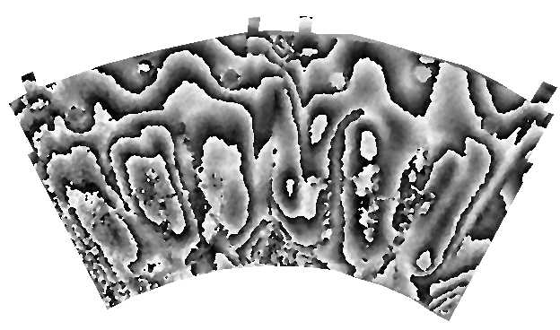
Sector #4
Back face of overhang
Front face of overhang
Support points
Support points
Coolant tubes
Figure 19. Phase map of fringe pattern illustrating out-of-plane distortions from power off to power on condition. Power state of 18W, with room temperature coolant at 9 cc/sec.

Pressure Effects
The distortions caused by pressure have been evaluated on aluminum-tube prototypes #4 and #6. Many points on prototype #6 were measured - see Figure 20. Data were taken up to about 5 bar absolute and after cycling 140 times to 5 bar absolute. The distortions in the "wing" regions on either side of the sector are the greatest. Distortions at the worst points are plotted in Figure 21. There is clear evidence of a permanent distortion (in the worst case about 40 microns). The magnitude of the distortion vs pressure is reduced after the initial distortion. The maximum distortion over most of the sector, not including the wing regions was less than 15 microns even at 7 bar absolute. Dummy heaters were mounted on this sector and the thermal performance easily met requirements, as already described above. The permanent distortions are attributable to distortions in the aluminum tube(confirmed by direct measurements of a bare tube). These results are (just) acceptable. Prototypes 7-10 have a thicker tube wall (0.029 mm rather than 0.020 mm) and will be tested, and should exhibit less distortion. Prototype #4 was tested to 5 bar absolute in a similar manner at -7ºC and showed similar distortions.

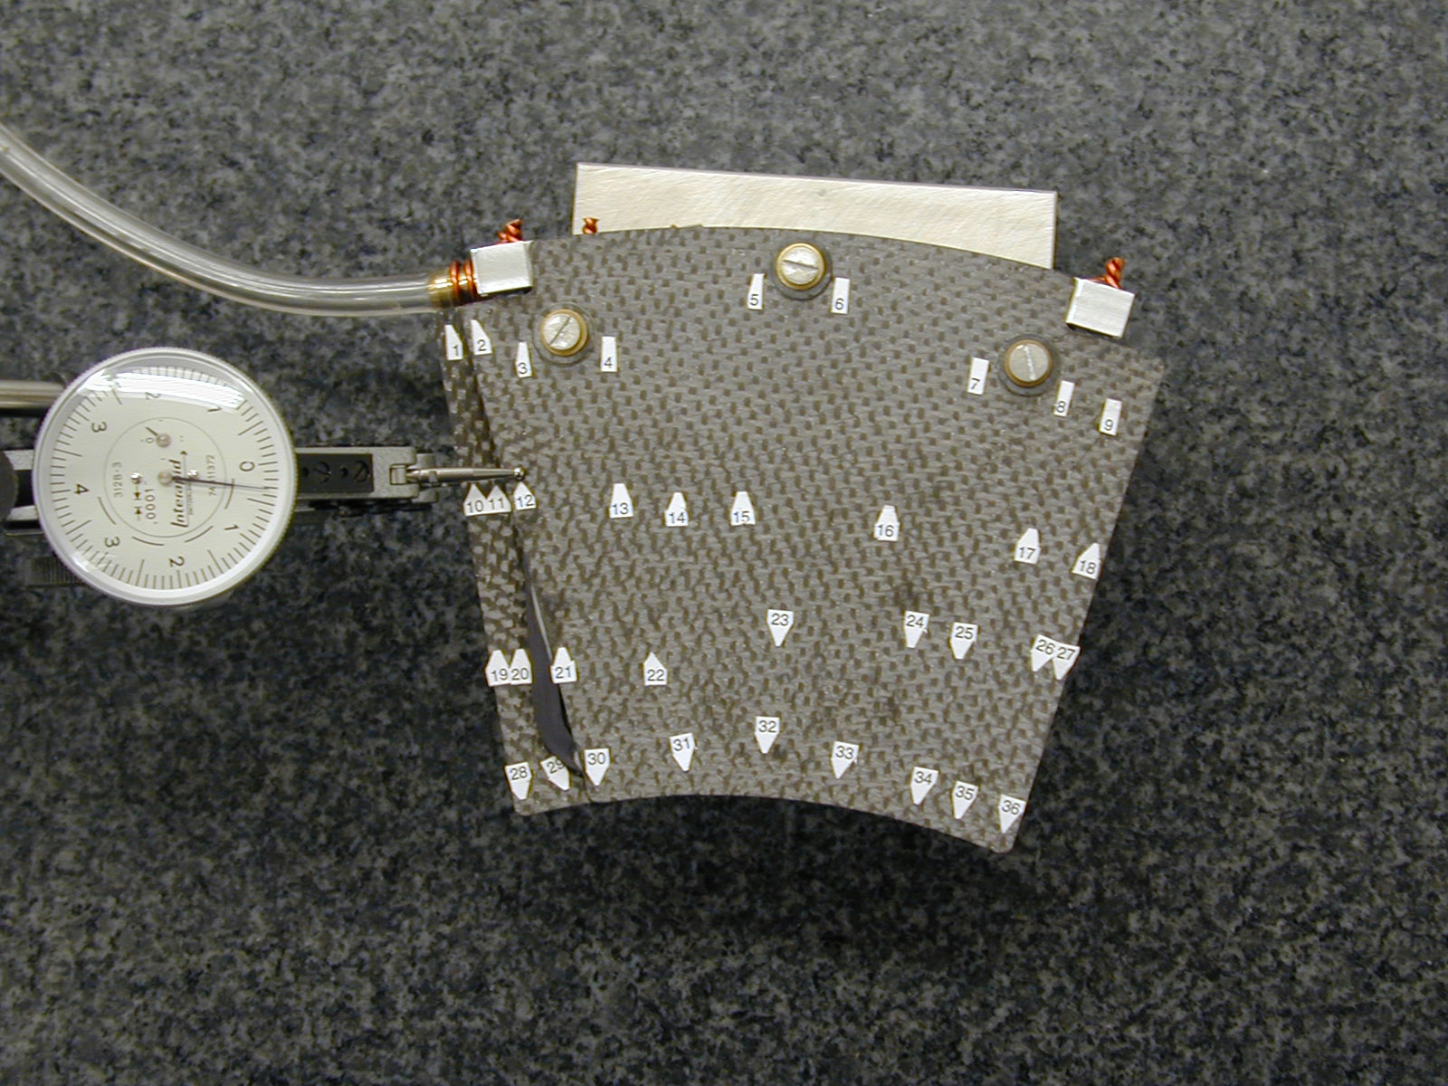  Figure 20. Prototype #6 showing points measured during pressure testing. | 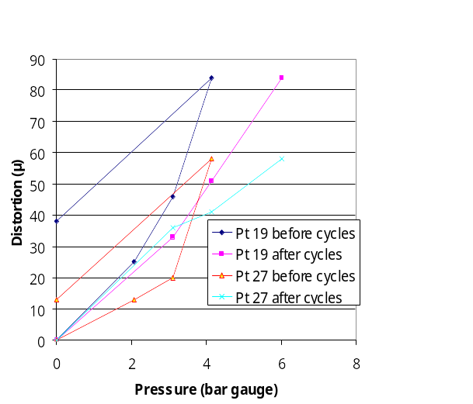  Figure 21. Distortion vs pressure at worst points before and after pressuring cycling(see text).

HYTEC Pressure Tests

Pressure tests were performed on HYTEC unit #4, using the setup shown in Figure 22. Thermal stability is quantified by establishing the structure shape change with internal pressure using TV Holography.

The distortion observed for HYTEC unit #4 is quite low, 1.2 μm at 5 bar and 2.9 μm at 10 bar as shown in Figure 23. The low distortions are attributed to the high stiffness achieved by direct bonding of the carbon-carbon.
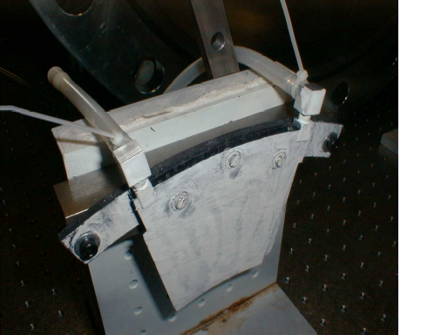
Pressurized inlet

Figure 22. Photograph of HYTEC sector pressure test setup. Inlet tube at upper right is open to pressure source. Exit tube at the left is sealed to prevent flow during the test.

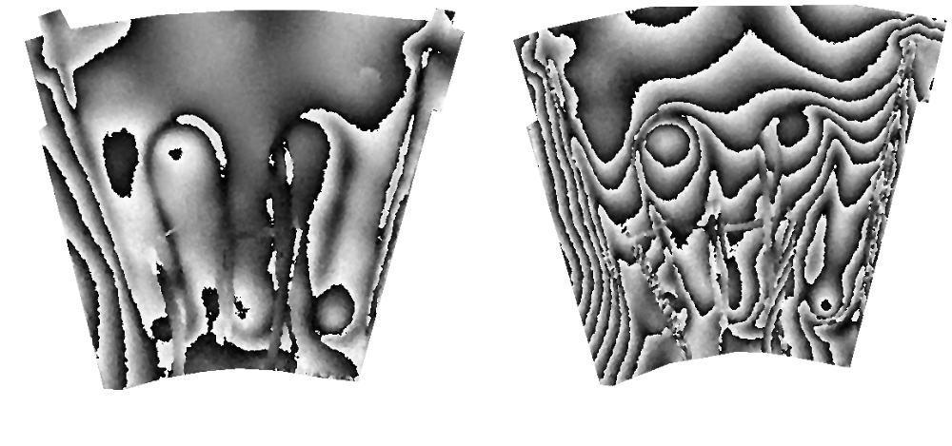
Figure 23. TVH results of pressure test with HYTEC unit #4. Left view illustrates fringe pattern for applied pressure differential of 5 bar. Right view illustrates pressure differential of 10 bar. Distortion from applied pressure amounts to 1.2 micron and 2.9 micron at 5 and 10 bar respectively.

Dynamic Motion
Some measurements of the dynamic response of prototype aluminum-tube sectors have been measured using TV holography. The sector is firmly attached at the three support points and driven by a piezoelectric oscillator and the fringe pattern observed. This was done on prototype#3 before and after irradiation and the results are shown in Figure 24. The frequency response (of a single sector) is well above our nominal 100 Hz requirement.
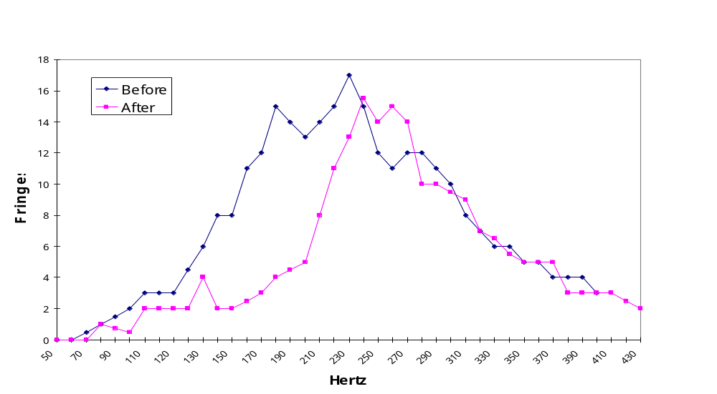
Figure 24. Frequency response of a prototype aluminum-tube sector before and after irradiation to 22 MRad.

Transient and Fault Conditions
Distortion measurements on aluminum-tube sectors after 7 bar absolute pressure have already been described. Similarly, we have already described measurements in sealed-tube sectors up to 10 bar. No distortion measurements have been made yet after a loss-of-coolant fault condition.

Prototype Disk
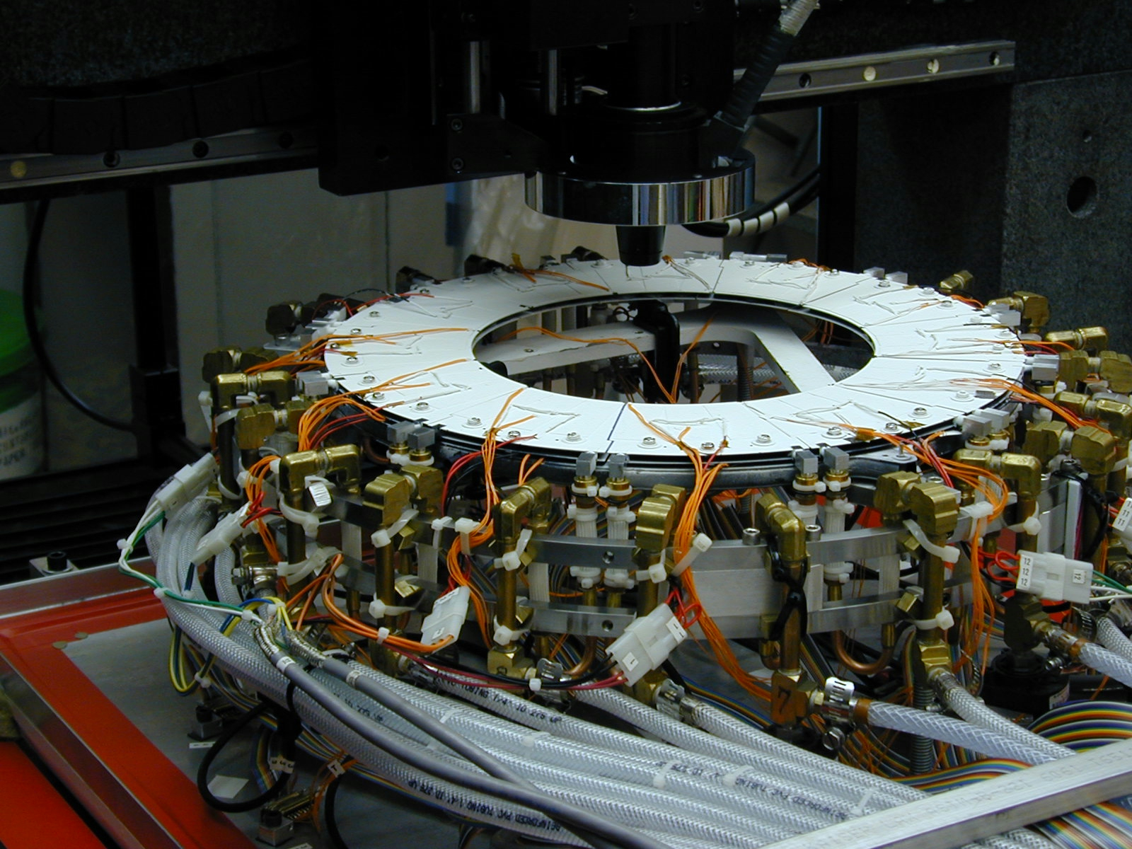
Figure 25. Prototype disk with 12 ESLI sectors in optical CMM.
Cover of environmental box has been removed.
A complete disk of 12 sectors manufactured by ESLI was assembled and tested. Each sector had six dummy heaters. The sectors were attached to a prototype support ring designed by HYTEC, Inc and fabricated by Allcomp, Inc. The disk-support ring was attached to an Invar support triangle at three points, which simulates the mounting expected in ATLAS. Coolant and power connections were made and the entire assembly placed in an environmental box on the table of an optical CMM as shown in Figure 25.
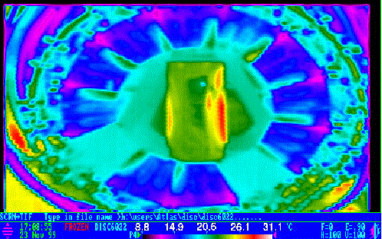
Figure 26. IR image of the disk prototype operated at 60W per sector.
The inlet cooling temperature was 11^{O}C. Two sectors were not powered(leaked).
Thermal measurements were made of the complete disk and are shown in Figure 26 for completeness.

Stability measurements were made by attaching optical targets to each sector (four locations), to the supporting ring and to the Invar support. The location of the targets is shown in Table 3.

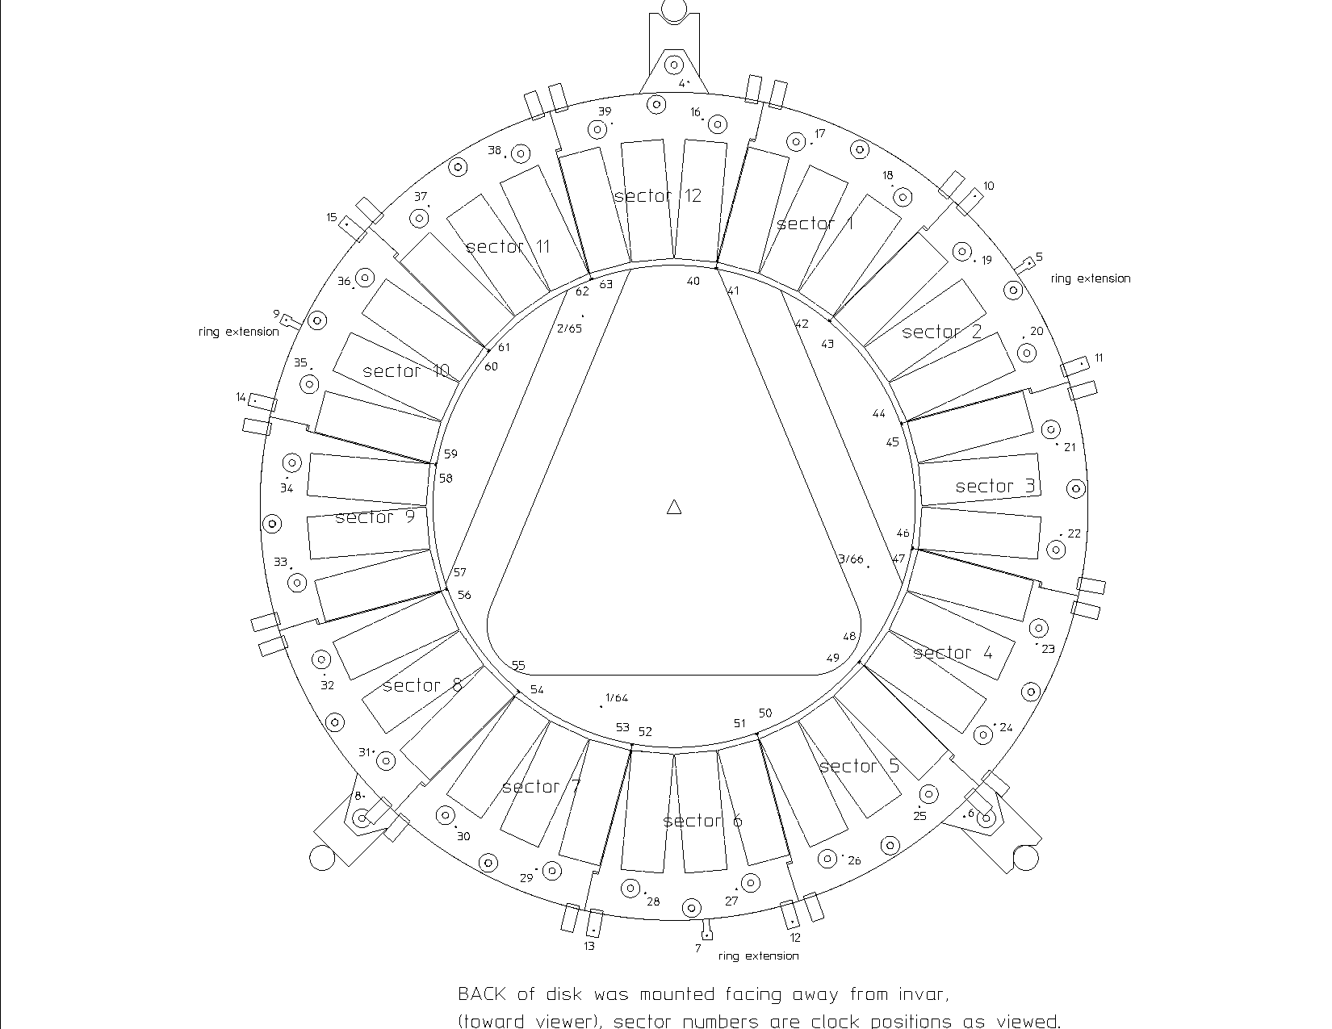
Table 3. Location of optical targets on prototype disk.
Temperatures on each sector and pressures were also recorded. The optical CMM was programmed to find and record the target locations. Measurements were taken at different coolant temperatures down to -10^{O}C. The distortions from temperature or pressure changes in the plane of the disk(X and Y) and out-of-plane(Z) were measured for each sector and for the ring. These extensive measurements are briefly summarized here.

Distortions are determined by comparing the locations of the targets to an average base state taken at room temperature and no flow. A typical example of distortions observed at 60W per sector and at -10⁰C are summarized in Table 3. AVE is the average motion between the two states, SPREAD is the largest motion-smallest motion(including sign) and RMS is the standard deviation. The results are tabulated for different locations on the disk: on the ring, on a few coolant connections(in/out), at the outer radius of sectors(mount), the inner radius of sectors and the Invar support, which should not move. The largest distortions are in the Z(out-of-plane) motion but are well within requirements. In-plane motions are a few microns, also within the requirements. Although ESLI sectors are no longer considered for production, these measurements are indicative of the stability performance expected for a complete disk.

 | X | Y | Z
RMS (ring) | 0.0038 | 0.0055 | 0.0073
RMS (in/out) | 0.0088 | 0.0052 | 0.0111
RMS (sector @ mount) | 0.0023 | 0.0041 | 0.0083
RMS (sector @ inner R) | 0.0028 | 0.0033 | 0.0091
SPREAD (ring) | 0.0105 | 0.0134 | 0.0180
SPREAD (in/out) | 0.0206 | 0.0133 | 0.0323
SPREAD (sector @ mount) | 0.0079 | 0.0141 | 0.0320
SPREAD (sector @ inner R) | 0.0107 | 0.0134 | 0.0378
SPREAD (invar, final) | 0.0041 | 0.0018 | 0.0014
AVE (ring) | -0.0027 | -0.0005 | 0.0014
AVE (in/out) | -0.0005 | 0.0014 | 0.0013
AVE (sector @ mount) | -0.0013 | 0.0002 | 0.0014
AVE (sector @ inner R) | -0.0010 | -0.0012 | 0.0135
AVE (invar, final) | -0.0008 | -0.0005 | -0.0016

Table 4. Example of distortions measured at -10ºC and 60W as explained in the text.
Units are mm.

Material
The radiation length of a disk sector, averaged over the active region, is desired to be ≤ 0.7% Xo, assuming other requirements can be met. The radiation length of aluminum-tube prototype sector #6, based on measured weights, is summarized in Table 4. A number of fabrication options for aluminum-tube sectors remain and the impact of these on the radiation length, scaling from the measured weights of prototype #6, are given in Figure 27. Plans to narrow the options to a single choice are presented later.

 | Radiation Length(%)
Faceplates | 0.256
Al tube | 0.162
Foam | 0.031
Hard points | 0.008
CGL+glass beads | 0.047
Cyanate ester | 0.035
TOTAL | 0.539
Table 5. Radiation Length of Aluminum-tube Prototype Sector #6.

Faceplate Thickness | Tube Interior Dimensions | Tube Wall Thickness | Radiation Length(%)
300 microns | 1.69mmx4.06mm | 200 microns | 0.539
432 | 1.69mmx4.06mm | 200 | 0.652
300 | 1.69mmx4.06mm | 290 | 0.610
432 | 1.69mmx4.06mm | 290 | 0.723
300 | 2.743mmx4.191mm | 200 | 0.572
432 | 2.743mmx4.191mm | 200 | 0.685
300 | 2.743mmx4.191mm | 290 | 0.658
432 | 2.743mmx4.191mm | 290 | 0.771
Figure 27. Radiation Length of Options for Aluminum Tube Sectors.
The radiation length of the sealed carbon-carbon tube sectors................. (to be added).

Miscellaneous
Corrosion resulting from galvanic action between the aluminum tube and the carbon-carbon faceplates or foam is prevented by anodizing the aluminum tube and by using glass beads in the CGL-7018 to prevent direct contact between the tube and the faceplates.

Carbon-carbon is an electrical conductor. Dust or particles from the surface may be a problem in the presence of the bias voltage for the silicon sensors or other voltages. This can be prevented by properly impregnating the carbon-carbon faceplates, although there is a tradeoff in thermal performance through the resin (cyanate ester) and ensuring the absence of particles or dust. The foam is friable and must be sealed to ensure the absence of particles. This has not yet been done on any prototypes.

Summary of Status and Critical Outstanding Issues
The current ability of the aluminum-tube and sealed-tube sectors to meet the requirements is summarized in Table 6.

Item | Requirement | Al-Tube | SealedTube
Normal Thermal Conditions
ΔT from coolant to face of local support(^{O}C) | ≤12 | ≤10 | ≤12
Si temperature uniformity on local support(^{O}C) | ≤10 | ≤7
Meet all requirements after T cycles(+20ºC ↔ -20ºC) | 20 cycles | TBD¹
Minimum temperature of silicon sensor | -20^{O}C | OK | OK
Normal Pressure Conditions
Maximum normal operating pressure(bar absolute) | 4.0 | OK² | OK
Pressure cycling of ± 0.1 bar about ? bar absolute | Nnnnnn cycles | TBD | TBD
Radiation Conditions
Total dose | 500,000 Gy  (50,000,000 Rads) | OK³ | TBD
Transient and Fault Conditions
Minimum temperature on start-up of cooling | -35ºC | TBD | TBD
Once-per-lifetime pressure fault for one hour | 8 bar absolute | 7 bar | 10 bar
Once-per-lifetime temperature fault for 60 sec. | 50^{O}C(??) | TBD | TBD

Item | Requirement | Al-Tube | SealedTube
Miscellaneous Conditions
Conducting particles from carbon or other materials | Not allowed | TBD | TBD
Corrosion from all sources | Prevent | TBD | OK
Erosion from fluid flow | Prevent | TBD | TBD
Repair after complete assembly | Not required | OK | OK
Surface characteristics | Compatible with  module attachment | OK | OK
Material
Radiation length(active region) | ≤0.7 | ≤0.77 | ≤??
Envelopes and As-Built Tolerances
Faceplates as cut(mm) | ± 0.25 | ±0.10 |  | ±0.10
Thickness of sector not including support buttons(mm) | ≤ 5.0 | OK |  | OK
Faceplate planarity(mm) | ± 0.075 | TBD |  | TBD
Survey Tolerances
Reference targets on faceplates to mounting holes(mm) | ± 0.010 | OK |  | OK
Reference targets front-to-back sides(mm) | ± 0.025 | TBD |  | TBD
Stability Tolerances
Z (out-of-plane)(mm) | ± 0.10 | ± 0.08 |  | ± 0.02
Y(R) in-plane(mm) | ± 0.065 | OK |  | OK
X(φ) in-plane(mm) | ± 0.006 | OK |  | OK
¹ Demonstrated for bare sectors without silicon tacked in place.
² Same comment as above.
³ Thermal performance only.
Table 6. Summary of current ability of aluminum-tube and sealed-sectors to meet requirements.

There are many design issues remaining to be addressed but some are more critical than others. Measurements on more than one or two sectors are required for both design options - more statistics is required.

The most critical issues for the aluminum-tube sector are:
- Operation with the baseline coolant and selection of the tube inner dimensions (hydraulic diameter). This affects also the radiation length of the sector.
- Demonstration under all conditions, with sufficient statistics, of the reliability of the CGL-7018 thermal joint between the tube and the faceplate. In particular, measurements must be done with the silicon dummy heaters more rigidly attached, which is the current plan, so that delaminating forces are properly imposed.
- Demonstration that requirements, particularly thermal performance, can be met after pressure and temperature fault conditions.

The most critical issues for the sealed-tube sector are:
- Continued demonstration that sealed-tubes can be manufactured reliably to meet the pressure requirements and not leak
- Demonstration that the thermal performance can be met over a number of sectors.
- Feasibility of meeting requirements with thinner faceplates.

Work Plan

Introduction
The fabrication and test of additional sectors for both design options is in progress. The work program will focus first on addressing the critical issues outlined above but eventually all requirements.

Sealed-tube Plan
A composite ring is under construction by HYTEC for testing a full complement of 12 sectors, in a disk configuration typical of the ATLAS Pixel Detector. Thermal stability of both the individual ring and a complement of 12 sectors assembled onto the ring will be evaluated for temperature conditions simulating the detector application. In addition to these system tests, HYTEC intends to construct several sectors with 0.4 mm facings with the objective of reducing the amount of support material. These sectors will be subjected to the full standard evaluation tests, in a manner identical to that planned for the aluminum-tube sectors – see below. Sectors will be tested with evaporative C₄F₁₀ at HYTEC and one or more sectors will be tested at CERN with evaporative C₃F₈.

Aluminium-tube Plan
Prototypes 7-10 are planned to be tested in June with evaporative C₃F₈ at CERN. These sectors differ in the hydraulic diameter of the tubes. They will be tested operating singly, in series and in parallel to determine the optimal hydraulic diameter and to compare with calculations of the cooling performance of the evaporative system.

These sectors and additional sectors(as well as sealed-tube sectors) will be subjected to a test protocol to verify that requirements can be met. Dummy silicon heaters will be attached with CGL-7018 only(or similar low modulus materials) and with CLG-7018+UV-cured epoxy tacks(or just with a low modulus adhesive) to address the critical issue of delaminating forces introduced by the CTE mismatch between silicon and carbon-carbon. In brief this protocol is the following:
- Survey the sector before imposing significant thermal or pressure loads
- Cool with water/methanol at 10-15^{O}C in air and establish a thermal base state with IR thermography
- Perform temperature cycling tests, determine distortions and resurvey and remeasure thermal performance
- Perform pressure cycling tests, determine distortions and resurvey and remeasure thermal performance
- Establish fault conditions and resurvey and remeasure thermal performance

A similar measurement protocol will be performed on test pieces irradiated to 50 MRad.

It is also planned to build additional sectors with 300 micron thick faceplates to compare their stability performance to sectors with 425 micron thick faceplates.

Weight without aluminum tube connections
Carbon-carbon mounting bushings
PEEK mounting bushings
This mass may be trimmed further by decreasing the facing thickness slightly. Our first thermal structure mass was 25.5 gm.
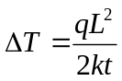, where for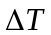, q is the heat flux, L the distance, k material conductivity, and t the material thickness.
Overview of the ATLAS Pixel System - Final Design Review.
ATLAS Pixel Local Support Requirements - Final Design Review.
ATLAS Disk Sector Fabrication and Specifications - Final Design Review
Energy Sciences Laboratory, Inc ..................
HYTEC, Inc, 110 Eastgate Dr., Los Alamos NM 87544.
HYTEC-TN-DOE/SBIR-04, January 2000.
Smaller test pieces for studies after irradiation were used because of size limitations of the Co⁶⁰ source that was used in the irradiation.
D. Bintinger, Lawrence Berkeley National Laboratory, "Evaporative Cooling Calculations", presentation at CERN, November 1999. See http://edms.cern.ch/TWDM/fcgi/twdmdoc/ATL/Get/ROOT/_1000069889/_1799526688/_1904596489/_1814683311/1831898395/evap_cool_calcs_updated.pdf
The measurement procedure may be seen at http://www-atlas.lbl.gov/mov/Proto_Disk_video.html.
A note on the measurement results may be found at http://www-physics.lbl.gov/~jtaylor/REPORT_comb.doc.

