A major milestone was achieved last month when the ATLAS silicon pixel detector was installed at CERN in Geneva, Switzerland for the ATLAS experiment at the Large Hadron Collider(LHC). The ATLAS silicon pixel detector has 80 million channels and is the most complex detector of its type every constructed. The ATLAS group at LBNL from the Physics and Engineering Divisions started work on this detector about 15 years ago and has led the pixel project from conception through the recent installation.

The endcap regions of the pixel detector, major elements of the overall support structure and all of the internal electrical and cooling services were designed and sub-elements fabricated at LBNL. One-by-one these parts of the pixel detector were shipped or carried to CERN (see http://www.lbl.gov/Publications/Currents/Archive/May-19-2006.html#head1 for how the endcaps were flown to CERN). All major parts were delivered to CERN by the end of 2006.

A large team of senior physicists, postdoctoral fellows, engineers, graduate students and technicians was formed at CERN, including frequent commuters from Berkeley, to complete the assembly of the pixel detector in collaboration with other teams from the Czech Republic, France, Germany, Italy, elsewhere in the US and CERN. The delicate process of assembling and testing the pieces of the pixel detector took place in a large clean area in a building near the access shafts to the ATLAS detector, which is located deep underground.

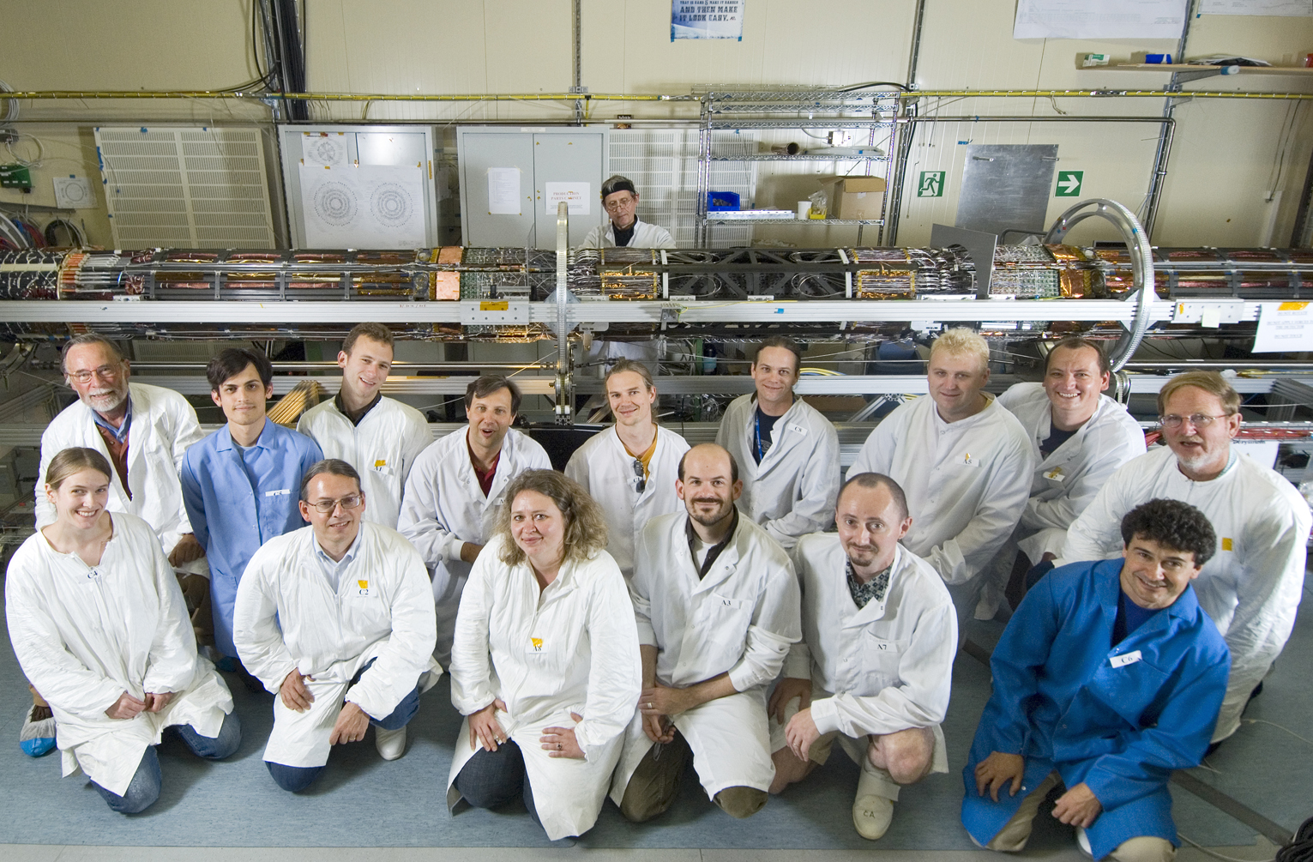
Some members of the LBNL pixel team (and pixel team member from Italy and the Czech Republic) after completion of the assembly of the ATLAS pixel detector at CERN. The pixel detector is shown in the background on its assembly fixture.

The assembled pixel detector was transferred in June from its assembly fixture to a transport fixture for the journey to the underground ATLAS detector. During a short break in the rainy weather in Geneva, the pixel detector inside the transport fixture was rolled out of the clean room, picked up by a portable crane and lifted into an adjacent building over the large vertical access shafts to the ATLAS detector.
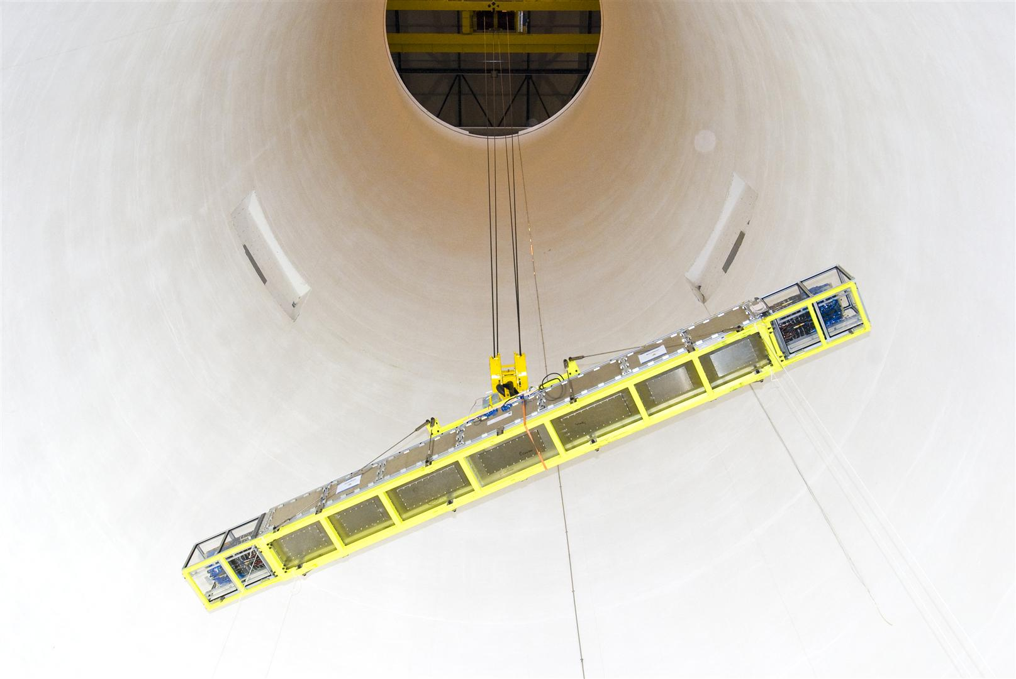
The ATLAS pixel detector inside its transport fixture being lowered through the large vertical access shaft to the ATLAS detector deep underground.

The pixel detector and fixture were then placed on large, adjustable tables to position the detector for final insertion into the ATLAS detector. ****You might want to skip this figure *****
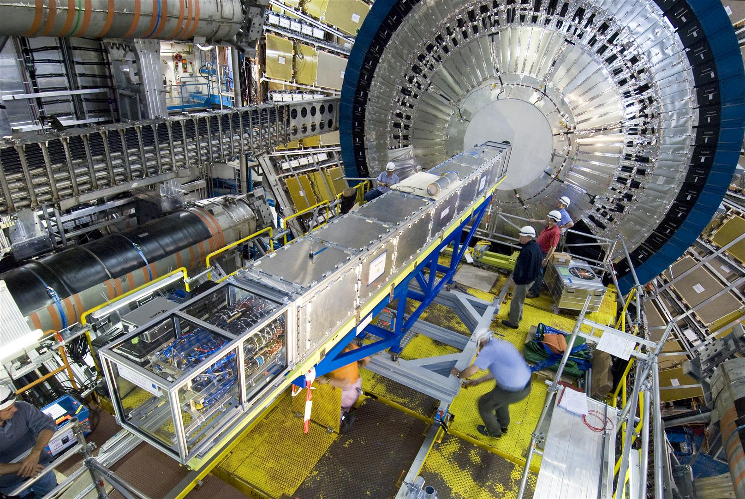
The ATLAS pixel detector inside its transport fixture being positioned for final insertion into the ATLAS detector.

The final home of the pixel detector in the ATLAS detector is a 6.5m long carbon-composite support tube with rails to guide the insertion of the pixel detector. This tube (in three sections) and the precision structures for mounting and guiding the pixel detector into place were made at LBNL and installed before the pixel detector was lowered into position.

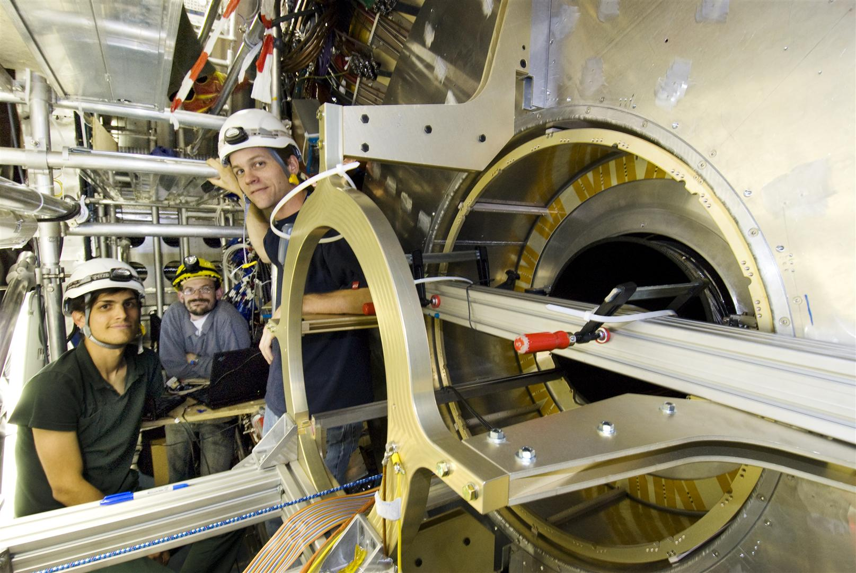
The LBNL crew pulling in the pixel detector while monitoring electrical signals and watching miniature webcams (on laptops). On the right is Tom Johnson, mechanical technician from the Engineering Division, in the middle is Neal Hartman, mechanical engineer also from the Engineering Division and, on the left, Michael Leyton, a physics graduate student from UC Berkeley.

The pixel detector was very slowly moved from its transport fixture into the support tube. It took about two days to complete this process since the clearance between the pixel detector and the supporting tube is less than one millimeter in a number of locations.

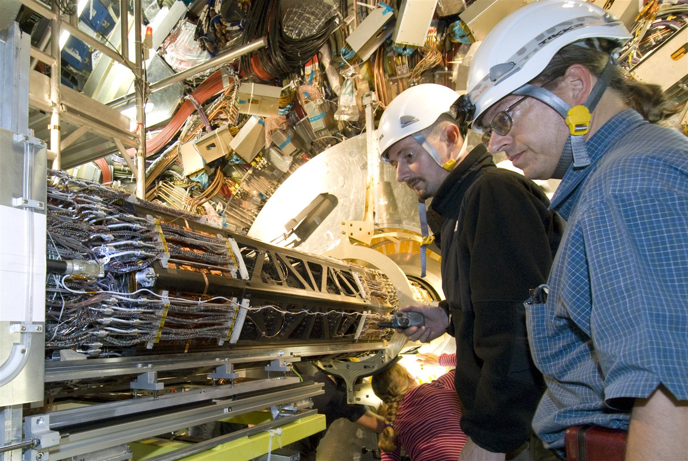
Dr. Kevin Einsweiler(on the right, from the Physics Division), the overall ATLAS Pixel Project Leader and LBNL Group Leader at CERN and Eric Anderssen (on the left, from the Engineering Division), lead LBNL mechanical engineer, watching the pixel detector as it is installed into the ATLAS detector.

After a few heart stopping moments, a bit of fine adjustment and some last minute filing of a few corners, the pixel detector move gently into its final resting place on June 28.

In one sense, this culminates many years of the invention and development of the silicon pixel technology that began at LBNL near the end of the1980s. On the other hand, a new chapter is about to begin. The electrical and cooling connections that are needed to operate the pixel detector will be carefully made over the remainder of 2007. And then operation of the detector will begin, first using cosmic rays, and finally the Large Hadron Collider will turn on in the summer of 2008.

