 | Pixel Disk Ring and Global Support Production Plan
ATLAS Project Document No: | Institute Document No. | Created: 25/01/2002 | Page: 1 of 6
ATL-IP-QA-0010 |  | Modified: | Rev. No.: 1

ATLAS PIXEL DISK SUPPORT RING AND GLOBAL SUPPORT PRODUCTION PLAN

The production plan for the ATLAS pixel disk support rings and the ATLAS pixel global support structures are presented.
Prepared by:  M. Gilchriese. W. O. Miller | Checked by: | Approved by:
Distribution List

History of Changes
Rev. No. | Date | Pages | Description of changes

Table of Contents

1 Introduction 4
2 Background 5
3 Production Overview 5
3.1 Disk Support Rings 5
3.2 Global Support Frame 5

Introduction
This note and the attached appendices summarize the production plans for the Disk Ring Supports of the ATLAS Pixel System and Pixel Global Support Frame. The Disk Support Ring is illustrated below in Figure 1. It supports eight disk sectors holding pixel modules. The disk sectors are located and held by three mounting holes per sector. The Disk Support Ring is attached at four points to the Pixel Global Support Frame.

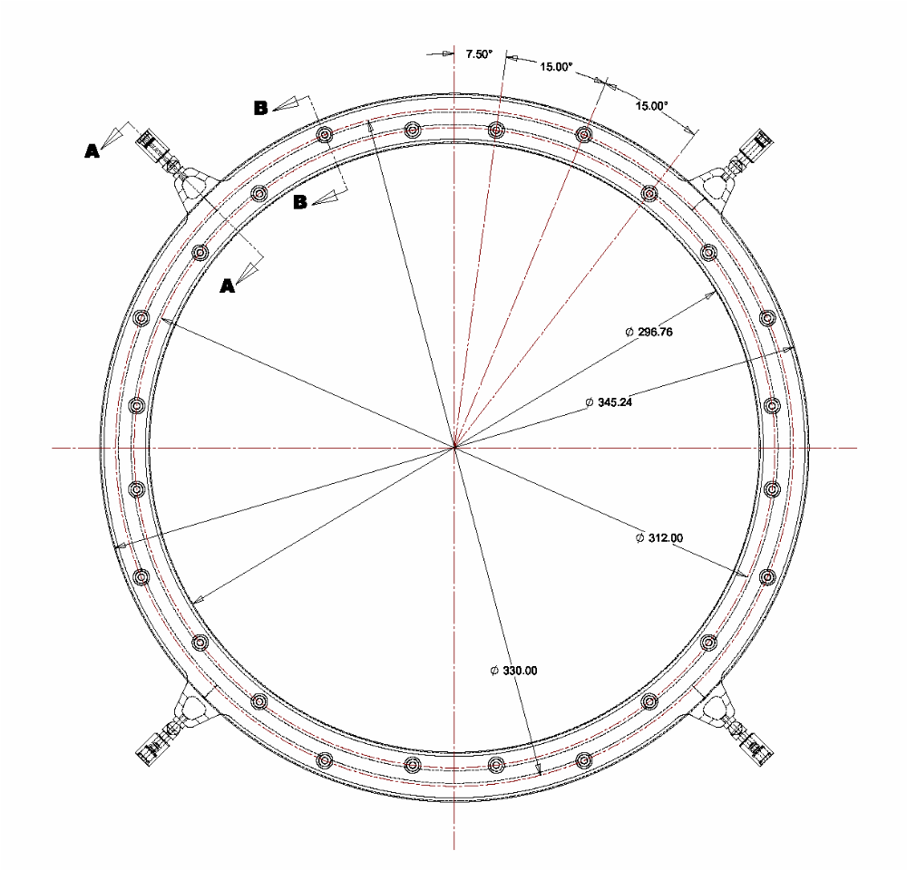
Figure 1. Disk Ring Support with nominal dimensions.

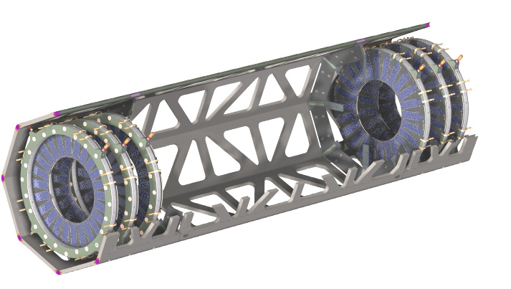
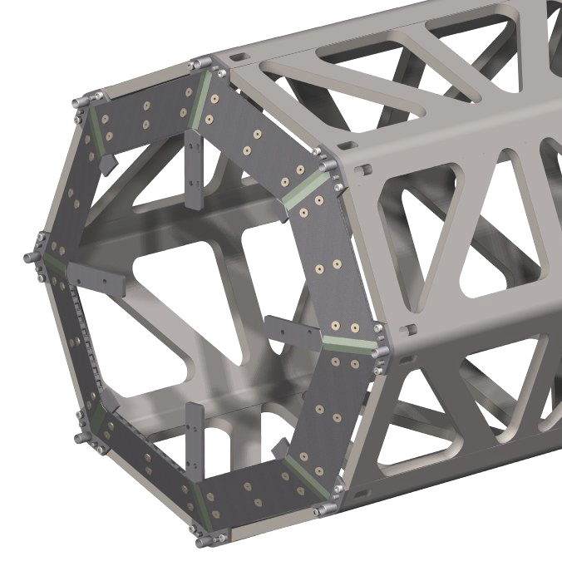
The global support frame consists of a flat-panel space frame in three sections - a barrel section and two, identical disk sections as shown in Figure 2. These sections are joined to make the complete frame.
Figure 2. ATLAS Pixel global support frame, which consists of three sections - barrel and two disk secitons. The barrel and two disk sections are shown joined on the left. One of the support cones for the barrel shells is shown in the right model. The endplate attached to the frame is not shown in these figures.

Background
The requirements and interfaces for the Disk Support Rings and the Global Support Frame were reviewed in July 2001. The documents(http://edmsoraweb.cern.ch:8001/cedar/doc.info?cookie=884786&document_id=316092&version=1) presented then remain valid. There have been no significant changes to requirements since the review in July 2001. There have been minor changes to interfaces to take into account small modifications in dimensions of pixel components and the support of the Global Support Frame. Therefore, this note presents only the production plans for the Disk Support Rings and the Global Support Frame.

Production Overview
We present here a brief overview of the proposed production plan. The Disk Support Rings and the Global Support Frame will be provided by the United States. All procurements related to these items will be handled by Lawrence Berkeley National Laboratory.

Disk Support Rings
The disk support rings will be produced in three phases. Phase I is the production of C-channels meeting specifications. The C-channels are the most demanding fabrication item. Phase II is the fabrication of one pre-production ring. Phase III is the fabrication of all production rings(currently six). The fixed-price contract for Phase I and Phase II was placed in November 2001. The scheduled date for completion of Phase I is 7-March-2002. The scheduled date for completion of Phase II is 4-April-2002. These elements are currently on schedule. The contract for Phase III will be placed after inspection of the pre-production ring, which is planned to be completed by the end of April 2002. Production of the Disk Support Rings is planned to be completed by October 2002.

The documents controlling the fabrication and inspection of the Disk Ring components and final assemblies are given in Appendix A(“Procurement Plan for the ATLAS Pixel Detector Disk Support Rings”, HTN-106210-0005) and Appendix B(“Process Control Inspection 432mm Disk Support Ring”, HTN-106210-0006). A list of drawings related to the Disk Support Rings is given in Appendix C. These drawings will be posted on EDMS and undergo a formal approval before the production(Phase III) begins.

Global Support Frame
The production of the Global Support Frame is planned to occur in two major phases: production of tooling and production of sub-components and assembly of the final frame elements. We plan to have a separate contrac t(or contracts) for the fabrication of tooling. The tooling will be provided to a vendor(or vendors) for fabrication of the major subcomponents of the Global Support Frame. A maximum of two vendors is planned for the fabrication of sub-components and assembly of the Global Support Frame Elements. Our current planning is to begin the formal procurement process by the end of February 2002. We plan to complete the initial evaluation of bids by the end of March 2002 and subsequently place the initial orders. Fabrication of the Global Support Frame is planned to be completed by April 2003.
The document controlling the fabrication of the Global Support Frame is given in Appendix D(“…..”, HTN-????). A list of drawings for tooling, sub-components and assembly is given in Appendix E. These drawings will be posted on EDMS and undergo a formal approval before the production begins.

