Science and Engineering Research Program
Volume 3
3.1 Introduction
The purpose of this volume is to describe the integration of scientific goals and the experiments designed to meet these goals into the proposed design for the DUSEL facility. A brief overview of the scientific goals for experiments at DUSEL is presented in Section 3.2. A detailed review of the potential science that could be done at the DUSEL facility is beyond the scope of this volume. A short overview of the proposed facility is given in Section 3.3.2. More detailed descriptions are available in other volumes of this Preliminary Design Report. The candidate experiments that were used to establish the requirements for the DUSEL facility are described in detail in Section 3.3. An early scientific program is under way at Sanford Laboratory and is described in Section 3.4. In Sections 3.5 to 3.9, we describe the process for establishing facility design requirements based on the candidate experiments, the experience at Sanford Laboratory, and other criteria. The essential requirements of the facility are also presented in these sections. Finally, preliminary research program planning is described in Section 3.10.
3.2 Overview and Scientific Motivation
The deep underground, low-background environment, at DUSEL is required to confront experimentally some of the most critical issues in fundamental physics and cosmology. DUSEL will be a unique facility not only in which to address questions in fundamental physics, astrophysics, and cosmology but also simultaneously to engage in cutting-edge research in underground biology, geosciences, and construction engineering. In the sections below, very short introductions to the scientific goals for experiments projected to operate at DUSEL are given. Specific examples of experiments proposed for implementation at DUSEL are presented in Section 3.3.
3.2.1 Physics
The Standard Model of elementary particles, though successful in describing the basic structure of elementary particle components and their interactions is incomplete. Gravitation is not included. There is uncertainty about the as yet unobserved Higgs boson and associated mechanism of electroweak symmetry breaking. And CP violation effects are entirely too weak to account for the baryon asymmetry of the universe. While the Standard Model amended with neutrino masses gives a good description of all particle physics phenomena observed in accelerator-based experiments, an outstanding question is how to accommodate neutrino masses. It is not yet known whether neutrinos are Dirac fermions (as are quarks) or Majorana fermions. In the latter case, lepton number conservation, a fundamental standard-model rule, can be violated. A most promising way to probe this is by searching for neutrinoless double-beta decay (0νββ), a process only allowed if neutrinos are Majorana particles. The theoretical expectations for 0νββ decay depend sensitively on other neutrino parameters as well, most notably on the mass scale and the ordering (hierarchy) of the neutrino masses.
While the existence of dark matter is well established by cosmological observations on a wide range of scales, its nature is completely unknown, a major puzzle of nature. Speculation abounds. Indeed, well-motivated theoretical considerations suggest strongly that new physics will appear at the TeV energy scale. Theoretical models typically contain new particles, often including an electrically neutral, stable, Weakly Interacting Massive Particle (WIMP). An exemplar is supersymmetry (SUSY), which extends the Standard Model to include a new set of particles. The lightest neutral SUSY particle, the neutralino, is thought to be stable. It is a suggestive and nontrivial coincidence that the TeV scale and typical weak interaction cross sections are just right, so that such a particle could be a thermal relic of the early universe and account for the observed dark-matter abundance. If this is correct, it may be possible to produce such a particle in p-p collisions at the Large Hadron Collider (LHC), and detect it in experiments there. The identity of dark matter in the universe is a central question in particle physics and cosmology. Knowing more about the properties of dark matter will, therefore, have profound and broad implications on fundamental particle physics as well as astrophysics. The large-scale dark-matter experiments that would be possible at DUSEL will likely be critical to understand the nature of dark matter.
Over the past decade, substantial progress has been made toward understanding neutrino properties. It has been well established that neutrinos of different flavors oscillate into one another, and must therefore have non-zero masses. Precision neutrino-oscillation experiments are essential to advance the understanding of the oscillation parameters and to search for CP violation in the neutrino sector. The detection of CP violation might be key to understanding the baryon asymmetry in the universe. The opportunity to provide spaces both for the needed large-scale double-beta experiments as well as neutrino-oscillation experiments is unique to the DUSEL facility.
Are protons absolutely stable? There is currently no evidence for proton decay after decades of experimental research: the proton lifetime is greater than 1 x10³⁴ years, about 10²¹ times the lifetime of the universe The detection of proton decay would have profound implications for understanding of the universe. The very large detectors needed to advance determination of neutrino-oscillation parameters, would also extend substantially the search for proton decay.
Nuclear astrophysics is concerned with the origin of elements in stars and stellar explosions through charged-particle, neutron, and weak interaction induced nuclear processes. These phenomena are at the intersection of nuclear physics, astrophysics, and observational astronomy. Measurements of very low reaction cross sections, a critical aspect of increased understanding, can only be done with an accelerator underground to achieve acceptably low backgrounds.
3.2.1.1 Dark Matter¹
A broad range of observations—including inferences of the mass of astronomical objects from galaxies to superclusters, the anisotropies in the cosmic microwave background, the dimming of supernovae with distance, and the observation of light element abundances—tell us that our universe consists of ~70% dark energy, ~25% nonbaryonic dark matter, and 5% baryons. In spite of its fundamental importance to cosmology, astrophysics, and elementary particle physics, the nature of dark matter remains unknown. It is likely some new form of matter beyond the Standard Model of particle physics.
Among the many candidates suggested but as yet undetected, one of the most compelling possibilities is that the dark matter is composed of WIMPs that were produced moments after the Big Bang from collisions of ordinary matter. WIMPs denote a general class of particles thermally produced in the hot early universe that drop out of equilibrium when they are no longer relativistic. Their density today is inversely proportional to their annihilation rate, and in order for them to represent 25% of the critical density, their annihilation cross section must be typical of electroweak-scale interactions, hinting at new physics outside the Standard Model at the TeV scale. The lightest neutral SUSY particle, the neutralino, thought to be stable, is a natural dark-matter candidate.
WIMPs from the galactic halo are detected by their scattering off of atomic nuclei in terrestrial detectors. Because the energy of these nuclear recoils is of order 10 keV, where electromagnetic backgrounds can dominate by many orders of magnitude, the technical challenge consists of combining low-radioactivity materials and environments with background rejection of electron recoil events to keep spurious signals at bay. These detectors must be sited in deep-underground laboratories to shield them from cosmic-ray-induced backgrounds. The dark-matter community has developed a broad range of techniques to address these challenges. At present, the upper limit on the WIMP-nucleon cross section approaches 10⁻⁴⁴ cm², well into the region of parameter space where SUSY particles could account for the dark matter (illustrated in Figure 3.2.1). The next 2 to 3 orders of magnitude represent a particularly rich region of electroweak-scale physics. The combination of what we may learn from direct searches and astrophysical observations, combined with accelerator-based experiments, is truly profound.
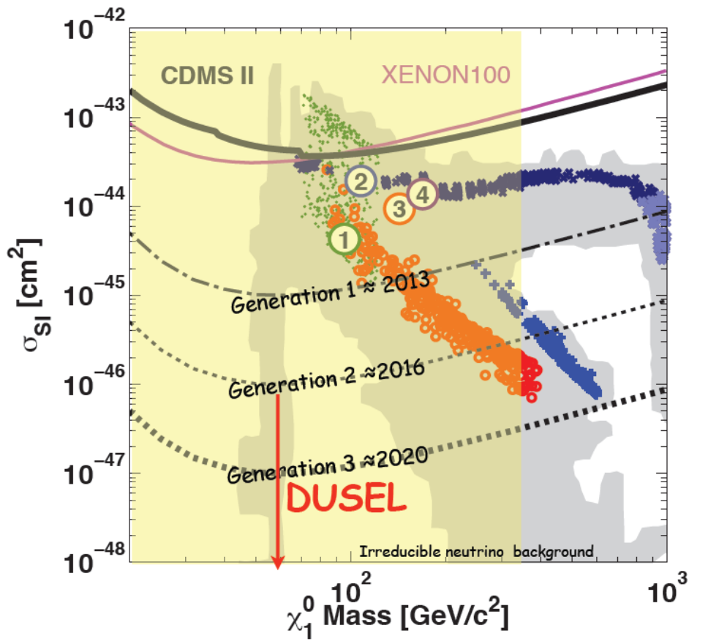
Figure 3.2.1 WIMP current limits (solid lines) from CDMS II and XENON100 and sensitivity and goals for the next three years (dashed-dotted line), G2 (dotted line) experiments (with results in 2016), and G3 (heavy dotted) experiments (yielding results in ≈2020). The shaded regions represent expectation for minimum supersymmetry models. The points indicate the various regions (green = “bulk,” dark blue = “focus point,” red = “co-annihilation,” blue = “Higgs funnel”) of an oversimplified mSUGRA model (A=0, µ>0). Numbers are the benchmarks of Baltz et al. (2006).² The yellow region is accessible to the LHC. ISE experiments in DUSEL will target the Generation 3 (G3) sensitivity level.³
3.2.1.2 Neutrinoless Double-Beta Decay⁴
The consequences of the discovery of neutrino oscillation are far reaching. On one hand, the existence of finite yet peculiarly small neutrino masses and nearly maximal flavor mixing provide a picture of the lepton sector that is very different from that of the quarks. On the other hand, clues to the mechanisms underlying elementary particle masses may emerge from the study of neutrinos, and physics phenomena at very large energy scales—well beyond what is possible with conceivable accelerators—may become accessible through some form of the seesaw mechanism. It is widely recognized that the magnitude of the neutrino mass scale may first become accessible through the observation of neutrinoless double-beta (0νββ) decay, which would simultaneously also provide the first example of a lepton-number violating process and demonstrate that two-component Majorana particles exist in nature. The lepton-violating nature of Majorana neutrinos could provide a means for generating the observed matter/anti-matter asymmetry in the universe through leptogenesis.
In conventional, two neutrino, double-beta decay, the Z of a nucleus changes by two, emitting two electrons and two neutrinos. The neutrinos are undetectable, so that only the two electrons are experimentally accessible. Because some of the energy is carried away by the neutrinos, the energy sum of the two electrons follows a continuous spectrum. If neutrinos are Majorana particles, a second decay mode is allowed in which the neutrino appears as a virtual particle, and no neutrinos appear in the final state. In this case, the electrons carry away the entire available kinetic energy. In a calorimetric experiment, this neutrinoless mode is detectable as a mono-energetic peak at the endpoint of the two-neutrino mode spectrum (see Figure 3.2.2-1). The decay rate scales with the mass of the neutrino. The detection of a neutrinoless double-beta decay peak would therefore not only confirm the Majorana nature of the neutrino, but also simultaneously give a measure of its absolute mass.
Conventional double-beta decay has been observed in a variety of nuclei, with measured half-lives on the order of 10²⁰ years or longer. Present limits on neutrinoless double-beta decay half lives exceed 10²⁵ years. Hence, experiments that aim to reliably detect 0νββ decay in a finite time require:
- Large amounts of source material
- Sufficient energy resolution to identify the 0νββ peak
- Ultralow backgrounds in the region of the 0νββ peak
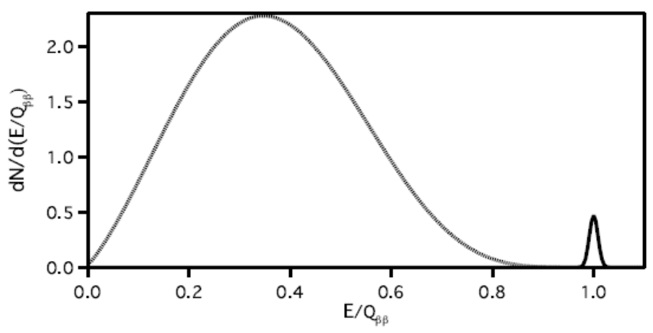
Figure 3.2.2-1 A schematic double-beta decay energy spectrum, as would be measured by a calorimetric detector. The small peak from 0νββ decay is shown here with arbitrary height beside the background from the two-neutrino mode. [Taken from Reference 1]
The half-life of neutrinoless double-beta decay T_{½}^{0ν} depends on a phase-space factor G^{0ν}, a nuclear matrix element M^{0ν}, and an effective double-beta decay neutrino mass m_{ββ} :⁵
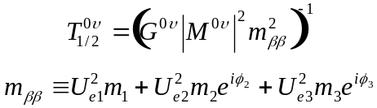
where U_{αi} are elements of the neutrino mixing matrix, m_{i} are the neutrino masses, and φ_{i} are Majorana phases. The parameter space for which 0νββ decay is allowed depends on the neutrino mass hierarchy as shown in Fig. 3.2.2-2. The phase space factor increases with the Q of the decay, and varies from 10⁻²⁵-10⁻²⁶ years⁻¹ eV⁻², depending on the isotope. The nuclear matrix element is also isotope dependent, with different calculations giving values ranging from ~1-5. Reaching m_{ββ} sensitivity corresponding to the atmospheric mass splitting (~50 eV) requires half-life sensitivities above 10²⁷ years; covering the inverted hierarchy parameter space for m_{ββ} requires half-life sensitivities beyond 10²⁸ years.

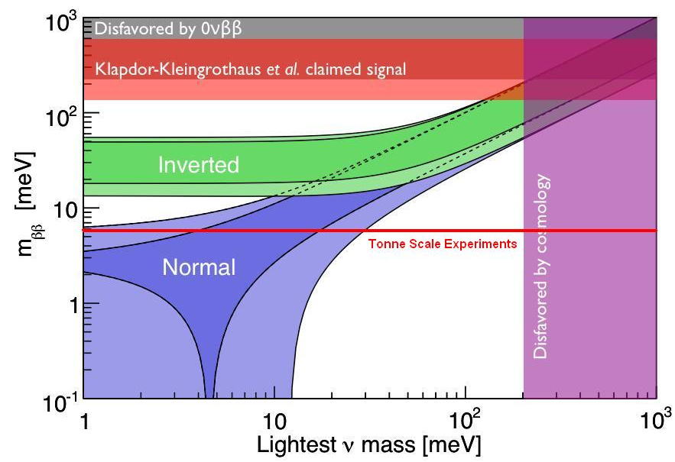
Figure 3.2.2-2 Phase space for neutrinoless double-beta decay shown in terms of the lightest neutrino mass (constrained by cosmology) and the effective double-beta decay neutrino mass (constrained by current 0νββ-decay experiments). Tonne-scale experiments could extend the m_{ββ} sensitivity down to the red line. Also shown is a recent controversial claimed observation of a 0νββ signal,⁶ which will be tested by the generation of experiments prior to the tonne-scale ones proposed for DUSEL.
Fig. 3.2.2-3 illustrates how the sensitivity to m_{ββ} depends on the exposure and the background level of an experiment. Although Fig. 3.2.2-3 is drawn using values of G^{0ν} and M^{0ν} calculated for ⁷⁶Ge, the situation is qualitatively the same for any ββ isotope. In the absence of background, reaching the extreme half-life sensitivity required to definitively test the inverted mass hierarchy will require counting tons of isotope for multiple years. The presence of even a few background counts in the analysis region-of-interest (ROI) for the 0νββ peak search causes rapid degradation of the sensitivity. Hence, experiments that aim to reliably detect 0νββ decay in a finite time require:
- Large amounts of source material
- Ultra-low background in the vicinity of the 0νββ peak
Since most ββ isotopes have a small natural abundance, it is typically advantageous to build 0νββ decay detectors using enriched material.

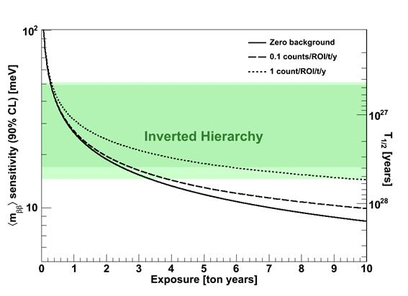
Figure 3.2.2-3 Sensitivity to m_{ββ} as a function of exposure (mass x counting time) under different backgrounds scenarios for ⁷⁶Ge. The nuclear matrix element is taken from reference [Simkovic et al., Phys. Rev. C 79, 055501 (2009)]. The background rate is expressed as a counting rate per unit mass in the analysis region-of-interest (ROI) for the 0νββ peak search. The shaded region corresponds to the allowed values of m_{ββ} for inverted hierarchical masses in the limit m₁ → 0.

Although enrichment can be a major cost driver, the cost and complexity of the required infrastructure can be greatly reduced because less total mass can be employed to achieve the same physics. Further, enrichment can reduce the background per unit active mass, leading to substantial improvements in sensitivity.
Achieving ultra-low backgrounds requires also that the detector be constructed of radio-pure materials using clean techniques. Some materials must be shielded during transport or even produced underground to reduce long-lived cosmogenic spallation products to acceptable levels. External radiation must be attenuated with thick, graded shielding. These experiments are also extremely sensitive to cosmogenic activity, especially inelastic interactions with high-energy spallation neutrons. These considerations drive the desire to build large-scale experiments deep underground in an ultraclean environment.

3.2.1.3 Neutrino Oscillations⁸
Results from the past decade reveal that the three known types of neutrinos have nonzero mass, mix with one another, and oscillate between generations. These facts point to physics beyond the Standard Model. Measuring the mass and other properties of neutrinos is fundamental to understanding the deeper underlying theory and will profoundly shape understanding of the evolution of the universe.
The concept of neutrino oscillations was first put forward by Bruno Pontecorvo in 1957,⁷ considering the possibility of 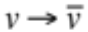 oscillations. Neutrino oscillations imply that neutrinos have small masses and mix between states. A complete review of neutrino oscillations with references can be found in Reference 8. Consider two neutrinos oscillating (adequate for solar and atmospheric neutrino oscillations). The probability of flavor change, for a neutrino of energy E detected a distance L from the source, is given by:
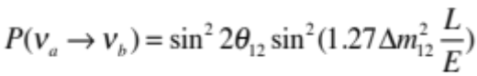
where Δm² is in eV², L is in km, and E is in GeV. Thus neutrino oscillations at a suitable range of (L/E) can give information on Δm² and the mixing angle.
In 1998, the Super-Kamiokande Collaboration announced “Evidence for Oscillation of Atmospheric Neutrinos” based on the observation of a deficit of muon neutrinos as a function of the distance traversed through the Earth.⁹ The data were consistent with two-flavor ν_{μ} → ν_{τ} oscillations with sin²2θ>0.82 and 5×10⁻⁴ < Δm² < 6×10⁻³ at 90% confidence level. This result, along with the decades-long observation of a solar neutrino deficit and subsequent results from the SNO experiment, lead to the solid conclusion that neutrino oscillations had indeed been observed, and in fact with two distinct Δm². The KamLAND experiment confirmed oscillations at the “solar” mass difference via‾ν_{e} disappearance from reactors. The KEK-to-Super-Kamiokande (K2K) and Main Injector Neutrino Oscillation Search (MINOS) accelerator long-baseline experiments confirmed the oscillation phenomena at the “atmospheric” mass difference via ν_{μ}-disappearance. The ongoing OPERA¹⁰ experiment in Gran Sasso, using the CERN Neutrinos to Grand Sasso (CNGS)¹¹ neutrino beam, is attempting to measure oscillations in the ν_{μ} → ν_{τ} appearance channel.
There are known three neutrino flavors and mass states. Their states are related by a 3 × 3 unitary matrix, U:
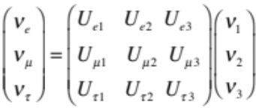
where U is defined by convention, with three mixing angles, θ₁₂, θ₂₃, θ₁₃, and a phase δ, viz:
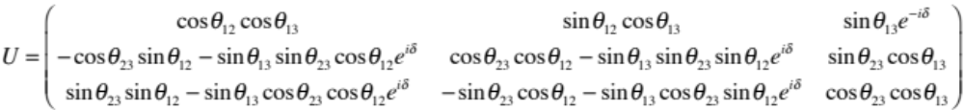
The absolute value of the neutrino mass scale, though known to be very small, is unknown, as is the hierarchical ordering of the mass states—though it has been determined from the solar neutrino data that m₁ < m₂ . There are two hierarchy possibilities:
m₁ < m₂ < m₃
or
m₃ < m₁ < m_{2,}
the “normal” (NH) and the “inverted” mass hierarchy (IH)—see Figure 3.2.3.1. Distinguishing these has important implications for models of neutrino mass. It is also interesting to note that a consequence of an inverted hierarchy is that it predicts a larger rate for neutrinoless double-beta decay than does the normal hierarchy. The predicted rate in the IH is in fact within the reach of the next-generation neutrinoless double-beta decay experiments.
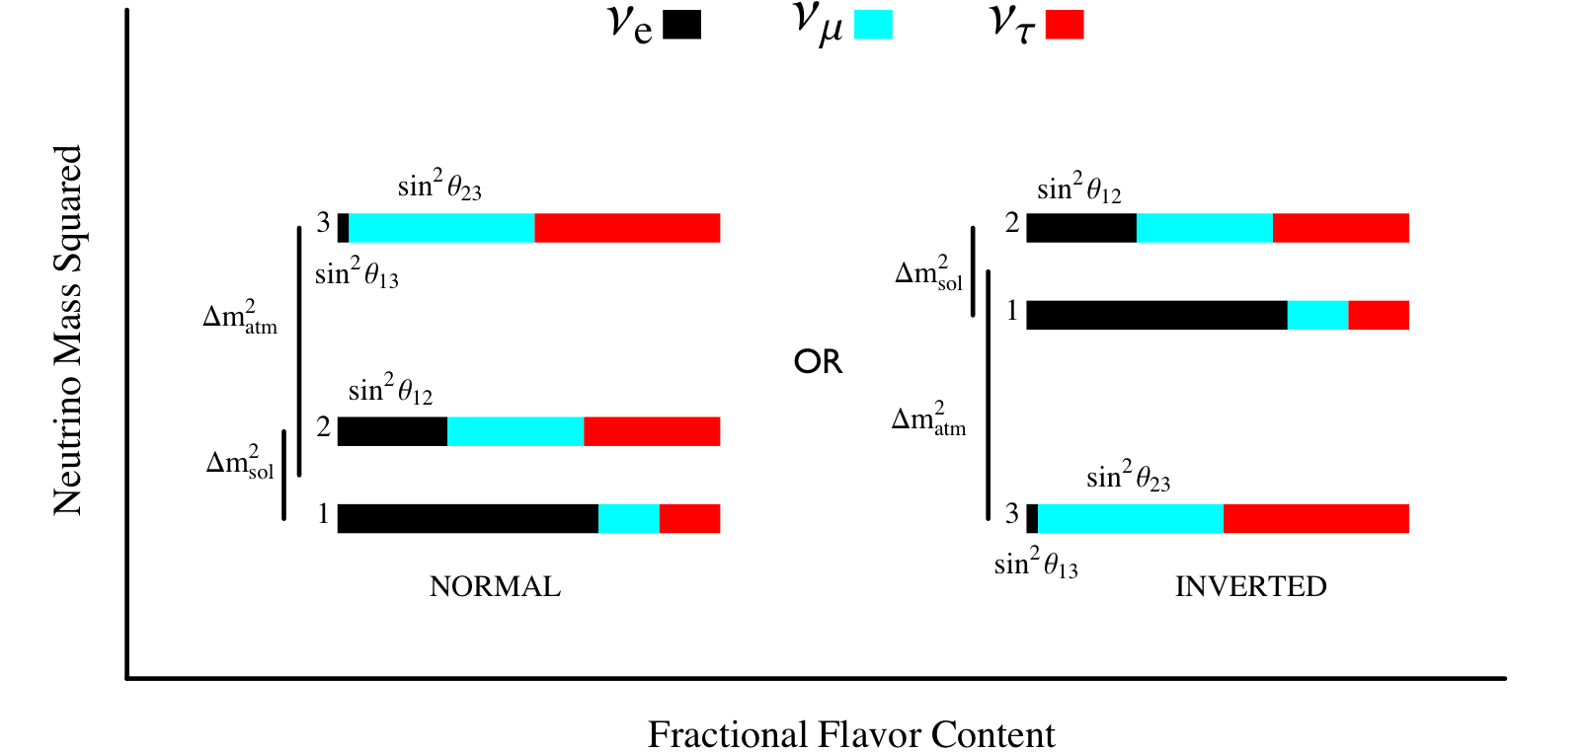
Figure 3.2.3.1 Mass and mixing for the two arrangements of the hierarchy Illustration showing the flavor content of the three neutrino mass states for the NORMAL and INVERTED hierarchy.
The equations that give the probability of flavor transitions among the three neutrino flavors now become quite complicated. Further, should the neutrinos propagate in matter, not vacuum, the oscillation probability for ν_{μ} → ν_{e} is modified by the presence of the electron density in the Earth. The resulting “matter effect” enhances the oscillation probability for neutrinos and suppresses the probability for antineutrinos if the mass hierarchy is normal. The effect is opposite in the inverted hierarchy. The magnitude of this matter effect is governed by the distance the neutrinos travel and their energy. If L is sufficiently long and E sufficiently high, it is possible to distinguish the NH from the IH by measuring the oscillation probabilities for neutrinos and antineutrinos.
The transition probability for muon neutrinos in matter is:
where α represents the small ratio 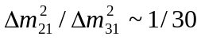, and T₁-T₄ are given by:
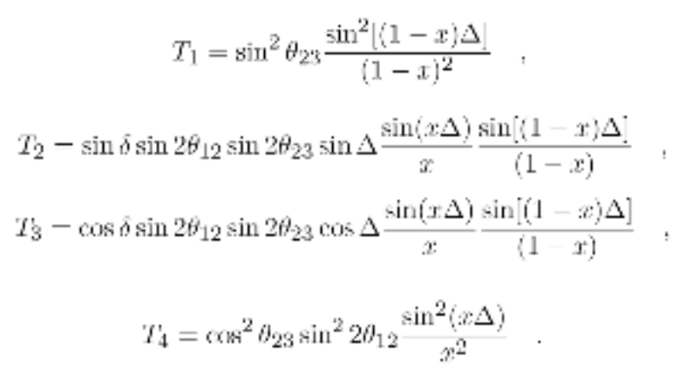
Here 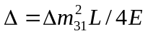 is the oscillation phase of a neutrino of energy E over a path length L; 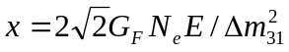 introduces the matter effects, G_{F} is the Fermi constant, N_{e} represents the average number density of electrons along the neutrino path that competes with the CP violating phase δ. The term T1 (T4) corresponds to the atmospheric (solar) oscillation, and T2 (T3) is the CP violating (conserving) term. Values for the various mixing angles and two mass differences are shown in Table 3.2.3.1. For antineutrinos, substitute x→-x, and sinδ→-sinδ. The matter effects compete directly with CP violation via the T₂ and T₃ terms above. Given the typical energy of the LBNE neutrino beam of ~0.1-5GeV, and a path length of L ≥ 1000 km, the matter effects can be used to disentangle the mass hierarchy as inverted or normal.
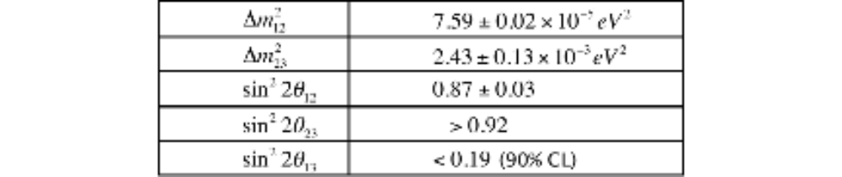
Table 3.2.3.1 Current knowledge⁸ of three mixing angles and two Δm².
To date, only an upper limit on the value of the third mixing angle θ₁₃ is known. It should be noted that if θ₁₃ were identical to 0, there would be no ν_{e} content in the ν₃ mass state and there would be no CP violation possible in the neutrino sector. The dependence on θ₁₃ of the experimentally observable CP asymmetry in ν_{μ} → ν_{e} is not linear. At very small values of θ₁₃, the CP asymmetry is diluted. It reaches a maximum¹² at sin² 2 θ₁₃ = 0.002, and then decreases as θ₁₃ becomes larger. For very large θ₁₃, the CP asymmetry would have been rather small; however, the current experimental bound indicates this is not the case: θ₁₃ is relatively small. This situation poses a challenge: The small value of θ₁₃ already indicates that the event rates will be small and therefore will require very large beam intensities and detector mass (exposure). On the other hand, the asymmetry is expected to be rather large (~30%), observable above background as long as θ₁₃ is not “too” small.
3.2.1.4 Proton Decay
The search for proton decay tests the apparent but unexplained conservation of baryon number. In the Standard Model, baryon and lepton number conservation is basically a consequence of the quarks and leptons being organized in separate multiplets. Grand Unified Theories (GUTs) organize the quarks and leptons into combined multiplets and allow for the conversion of quarks into leptons by the exchange of a force-carrying particle. Indirect evidence for such unification is the predicted meeting of the strengths of the three forces, electromagnetism, weak and strong, found to occur at scales of 10¹⁴ to 10¹⁶ GeV. These energy scales are forever inaccessible to accelerators. Assuming the mass of the force-carrying particle is at these scales, a proton or bound neutron is then predicted to decay to leptons and mesons, but at very slow rates, commensurate with observed stability of matter. Establishing this picture of the violation of baryon-number conservation would have profound implications for understanding of cosmology and particle physics.
When GUTs were first developed in the 1970s, early theories, for example, SU(5), predicted lifetimes as small as 10²⁹ to 10³⁰ years with a principle decay mode of p→ e⁺+πº. This prompted the first-generation searches in kiloton-scale experiments such as Soudan, Frejus, Kamiokande, and Irvine-Michigan-Brookhaven (IMB). No signals were observed in these experiments for a large number of decay modes, ruling out the minimal SU(5) theory and severely constraining and limiting the development of GUTs. Nevertheless, revised theories were developed that evaded the experimental constraints. In particular, GUTs based on supersymmetry were developed that disallowed the decay p → e⁺π⁰, but predicted new principle modes such as p →‾ν K⁺.
If the scale of supersymmetry is just above the EW scale (where it could be observed by LHC), it would predict a very rapid proton decay. A new conservation principle (such as R-parity) is needed to avoid this rapid decay. Decay modes could still occur via exchange of supersymmetric particles in so-called “dimension five” operators. The lifetime of the proton then depends on the mass of the supersymmetric exchange particles and the strength of coupling to “normal” particles. There is therefore great uncertainty in the theoretical predictions.
Following the round of first-generation searches, the 22.5 kton Super-Kamiokande experiment became operational in 1996, and it continues to integrate exposure time. At present, the best limit¹³ on the classic mode, p→ e⁺+πº comes from a 0.17 megaton years exposure of Super-Kamiokande, expected to improve by a factor of ~3 by 2030. The detection efficiency of 45% is dominated by final-state π⁰ absorption or charge-exchange in the nucleus (the efficiency for LAr suffers from the same problem), and the expected background is 1.63 ^{+0.42}_{-0.33} (stat)^{+0.45}_{-.0.51} (sys) events/Mton-yr.¹⁴ The decay mode p→ K⁺‾ν is experimentally more difficult in water Cherenkov detectors due to the unobservable neutrino and the fact that the kaon daughter is below the Cherenkov threshold. The present limit from Super-Kamiokande is the result of combining several channels, the most sensitive of which is K⁺→μν accompanied by a de-excitation signature from the remnant ¹⁵N nucleus. Monte Carlo studies suggest that this mode should remain background-free for the foreseeable future. To date, no significant signature has been observed in numerous modes. The limits placed on the key modes e⁺π⁰ and‾ν K⁺ are currently at a 90% confidence level:
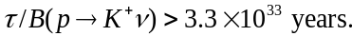
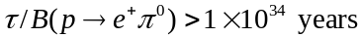
Figure 3.2.4.1 illustrates these limits, along with the predicted lifetime ranges allowed by a wide variety of GUTs. The Super-Kamiokande lifetime limits achieved serve as severe constraints and strict guidance for the development of further theories.
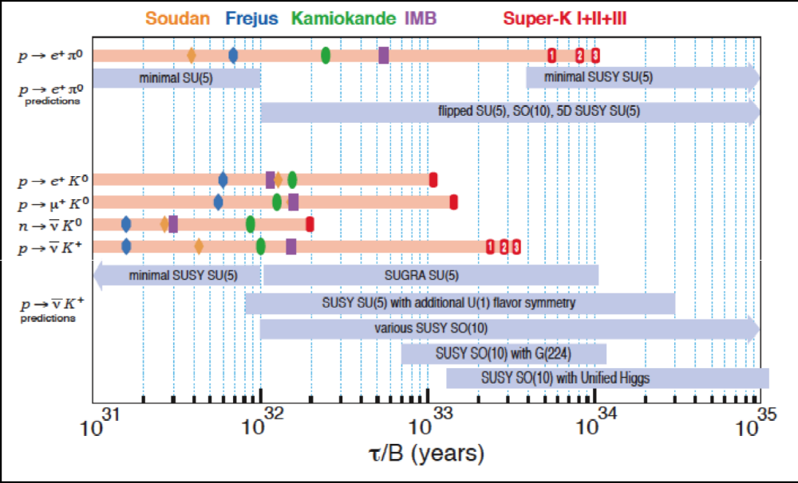
Figure 3.2.4.1 Comparison of present limits with the range of proton and bound nucleon lifetimes supported by various Grand Unified Theories. The top section shows the limits and predictions for p → e⁺π⁰, which are typically favored by the exchange of a heavy force-carrying particle. The bottom section shows the predictions for p → ν K⁺, which is typically favored by supersymmetry. In addition to the experimental limit of this mode, the limits for other modes favored by supersymmetry, which have comparable lifetime predictions, are included. [Courtesy LBNE]
An assessment of early 21st century theories shows that several predict proton decay, but lifetime predictions are not precise and typically vary over two or three orders of magnitude.
Experimental searches now need to be prepared to search for very long lifetimes, indicating the need for very massive detectors and very long exposure times. GUTs based on a minimal supersymmetric model predict a unification energy on order of 10¹⁶ GeV, and push the partial lifetime in the e⁺π⁰, channel to order 10³⁶ years—more than two orders of magnitude beyond present experimental limits. However, some of these models do predict a partial lifetime of order 10³⁴ years in the mode‾νK⁺.
3.2.1.5 Supernovae
A core-collapse of a supernova in our galaxy or a nearby galaxy may provide a wealth of information via its neutrino signal.¹⁵ About 99% of the supernova’s energy is released in an initial neutrino burst that lasts a few tens of seconds, expelling about half the neutrinos in the first second. Supernova neutrino energies range in the few tens of MeV, and their luminosity is divided approximately equally among the three neutrino flavors and between neutrinos and antineutrinos. The following science topics could be addressed by observing a high-statistics core-collapse neutrino signal:
The properties of neutrinos. In particular, neutrino oscillations in the core can provide information on oscillation parameters, mass hierarchy, and θ₁₃, possibly down to very small values (which will be inaccessible to conventional accelerator experiments), provided that systematics of the supernova models and neutrino transport out of the dense supernova are well understood.
The astrophysics of core collapse. The time, energy, and flavor distribution of the detected neutrinos will give valuable information on the explosion mechanism, accretion, neutron star cooling, and possible transitions to quark matter or to a black hole.¹⁶
Early alert. Because the neutrinos emerge promptly after core collapse—in contrast to the electromagnetic radiation, which must beat its way out of the stellar envelope—an observed neutrino signal can provide a prompt supernova alert.¹⁷ This could allow astronomers to find the supernova in early light turn-on stages, which may yield information about the progenitor and its environment.
The observation of 19 neutrino events in two water Cherenkov detectors for SN1987A in the large Magellanic Cloud (55 kpc) confirmed the baseline model of core collapse, but left many questions that will be unanswered until the next supernova neutrino detection.¹⁸
Core-collapse supernova explosions throughout the history of the universe left behind a diffuse background of neutrinos, which should be detectable on Earth. While these supernova relic neutrinos (SRN) undoubtedly permeate the universe, they have thus far evaded detection. The flux and spectrum of these neutrinos contain information about the rate of supernova explosions (and consequently the star formation rate) in the past. Because the existence of such a flux is a robust prediction of most models of stellar formation, observation of this flux would provide a key indication that our general idea of how and in what epoch stars formed is correct. Though valuable information can be obtained from a nearby supernova burst, that is a very rare event and one may not be detected within the next few decades, so that detection of the relic neutrinos is especially important. To date, Super-Kamiokande¹⁹ has set the best limit on their flux- flux(ν_{e}) < 1.2 cm⁻²s⁻¹ for E_{ν} > 19.3 MeV. This limit is tantalizingly close to the majority of modern theoretical predictions. Figure 3.2.4.2 shows the predictions for the flux of SRN from several published models and the Super-K limit.
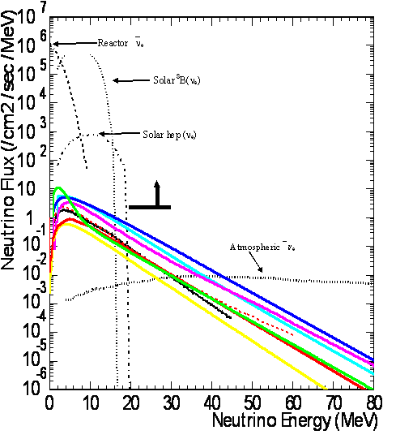
Figure 3.2.4.2 Compilation of theoretical expectations for diffuse neutrinos from relic supernovae. At 40 MeV energy, the curves are (top to bottom): Totani et al., 1996 (dark blue); Kaplinghat et al., 2000 (light blue); Ando et al., 2005 (purple); Fukugita, Kawasaki, 2003 (red dashed); Totani et al., 1997 (green); Hartmann, Woosley, 1997 (solid red); Lunardini, 2006 (black); and Malaney, 1997 (yellow). The reactor neutrino background is shown at the Super-K site. The bold line indicates the Super-K flux limit at 1.2 events/cm²/sec with E_{μ}>19 GeV. At the Homestake site, the reactor background will be much smaller. [Courtesy Super-K collaboration]
3.2.1.6 Other Neutrino Science
A large-volume neutrino detector can be used for more precise measurements of solar and atmospheric neutrino properties. Generally speaking, all of the current Super-K measurements can be repeated with higher precision, since the detector mass is an order of magnitude higher, and the rate of cosmic rays is an order of magnitude lower.
Atmospheric neutrinos can be used to determine some of the neutrino oscillation parameters including sin²2θ₁₃ the mass hierarchy, and the CP-violating phase δ_{CP}. Generally, the study with atmospheric neutrinos will not be as sensitive as an experiment with a neutrino beam, but atmospheric neutrinos will allow the possibility of revealing different physics. This is because the atmospheric neutrino sample covers five orders of magnitude in neutrino energy and three orders of magnitude in baseline, including long paths through matter. The atmospheric neutrino flux is a mixture of muon and electron neutrinos and antineutrinos. One expects 14,000 atmospheric neutrino interactions per 100 ktons of detector mass per year. Most atmospheric-neutrino events occur at neutrino energies under 1 GeV, where both water Cherenkov and liquid argon perform well. A liquid argon detector may have significant capability to identify neutrino versus antineutrino by observing the recoil proton present in charged current neutrino scattering. This large sample of neutrino interactions allows for a comparison of the neutrino oscillation framework under different observational conditions.
3.2.1.7 Nuclear Astrophysics
Nuclear astrophysics is concerned with nuclear processes in stars and stellar explosions through charged-particle, neutron, and weak interaction-induced reactions. Critical questions to answer are associated with the origin of elements during the history of our universe, with the sources of neutrino signals from the core of stars and distant supernova explosions, the energy production during stellar evolution and stellar death by explosion, the lifetime of stars, and the timescale of stellar explosions. Further goals are to identify characteristic new observational signatures associated with stellar processes for neutrino detectors to gamma ray observatories. Experimental nuclear astrophysics is characterized by four major directions: nucleosynthesis processes in stars, which are studied with very low-energy accelerator experiments; explosive nucleosynthesis processes, which require measurements far from stability with radioactive beams; neutron-induced nucleosynthesis in late stellar evolution, which is pursued at reactor and neutron spallation facilities; and neutrino-induced nucleosynthesis processes, which are still largely confined to theoretical prediction and observation. Current stellar model simulations are at a level of precision such that nuclear-reaction rates represent a major source of uncertainty for theoretical predictions and for the analysis of observational signatures.
Solar neutrino sources and the metallicity of the sun. Low-energy nuclear reactions in stellar burning play a critical role for the understanding of the origin of the elements and the processes taking place in the interiors of stars. Proton capture reactions drive stellar hydrogen burning through the pp-chains in low-mass stars like our sun, while proton capture reactions in the CNO cycles and the NeNa cycles dominate hydrogen burning in massive stars.²⁰ These reactions are not only responsible for the energy generation and timescale of the main sequence phase of stellar burning, but also generate the neutrinos that can be used as direct probes for observing nuclear burning in the core of our sun.²¹ The experimental uncertainties in the nuclear-reaction rates associated with these processes translate directly into the uncertainties for the predicted neutrino production from our sun and other stellar-burning scenarios. With high-precision measurements of the neutrino production rates coupled with the observation of the solar neutrino flux cross sections, the metallicity of the solar core can be directly derived.
Carbon-based nucleosynthesis. Alpha capture reactions characterize stellar helium burning in red giant (RG) stars and asymptotic giant branch (AGB) stars. These processes play a key role in stellar nucleosynthesis of first and early star generations, where carbon is formed first by the triple alpha process on primordial helium. Particularly critical are reactions such as ¹²C(α,γ)¹⁶O and ¹⁶O(α,γ)²⁰Ne that define the ¹²C/¹⁶O abundance ratio in the subsequent carbon-burning stage that is driven by fusion processes such as ¹²C+¹²C and ¹⁶O+¹²C. The interplay of these reactions influence the carbon-oxygen distribution in the post-helium burning or post-carbon burning matter, dictate the light element abundance distribution in white dwarf matter, and, therefore, define the ignition and burning conditions for nova explosions as well as type Ia supernova explosions.²² The latter is of particular relevance for modeling type Ia supernovae reliably and interpreting their empirical role as “standard candles” in cosmology studies.
Neutron sources for the production of trans-Fe elements in stars. The s-process nucleosynthesis of heavy elements in stars depends on the neutron flux in stars. The reactions ¹³C(α,n)¹⁶O, ¹⁷O(α,n)²⁰Ne, and ²²Ne(α,n)²⁵Mg are considered the most likely sources for neutron production in a variety of stellar helium burning^{23,24,25} and also carbon burning environments.²⁶ The low-energy cross sections of these reactions determine the neutron flux at the various burning conditions and therefore determine the production of
s-process elements in core helium burning²⁵ and shell carbon burning of massive stars²⁶ as well as in the intershell helium burning region of AGB stars.²³
3.2.2 Biology, Geosciences and Engineering
The DUSEL facility would provide access to a large volume of a dedicated underground laboratory for a variety of potential experiments in biology, geosciences, and underground construction engineering. Among the critical scientific questions and topics to be addressed are:
- What controls the distribution and evolution of subsurface life?
- How deeply does life extend into the Earth?
- How do fluid chemistry, rock mechanical properties, and microbes evolve in fractured crust under changing temperature, stress, and flow?
- Research and development on basic processes relevant to CO₂ sequestration
- Understanding the mechanical response of rock masses on length scales from cm to km and timescales from milliseconds to years
- Advanced seismic and electromagnetic probes and monitoring; precision seismology
- Advanced engineering design for large cavities and other underground construction and monitoring over many years, leading to advances in the design of underground cavities
- Controlled fracture and fault experiments on significant scales
The several cubic kilometers of crystalline rock that exist within the DUSEL facility provide a diverse and varied environment for Earth science investigations. A number of researchers (including geochemists, geophysicists, ecologists, hydrologists, and microbiologists) have recognized the opportunity provided by DUSEL to explore this subterranean environment, and have aligned themselves with seven groups that are developing S4 proposals to establish research facilities within the DUSEL footprint. The multi-disciplinary research that will be addressed through these experiments envelops studies that explore geologic and life processes and how they interact in the deep-subsurface environment. Below, we present an overview of the science that will be addressed by the seven collaborations that are broadly under the purview of Biological, Geological, and Engineering disciplines (and collectively referred to as the BGEs).
3.2.2.1 Geologic Carbon Sequestration.
Geologic carbon sequestration (GCS) is part of the Carbon dioxide Capture and Storage (CCS) process in which CO₂ is injected into deep geologic formations. This strategy is being evaluated for its potential to help mitigate climate change caused by fossil-fuel-based energy sources that currently emit approximately 30 Gt CO₂ per year. This approach to long-term climate-change mitigation will be successful only if the injected CO₂ remains in the intended storage regions. Because of the lower density of CO₂ at all conditions in deep subsurface reservoirs, there is a tendency for injected CO₂ to leak upward out of intended storage reservoirs. Leaked CO₂ could pose environmental hazards, impact subsurface resources, or discharge into the atmosphere, negating the climate-change-mitigation objective and causing potential loss of carbon storage credit. Advancement of GCS requires a sound understanding of the processes controlling CO₂ storage, trapping, and migration in the subsurface environment.
3.2.2.2 Deformation of Large Underground Rock Masses.
Deformation of the Earth occurs on spatial scales from atomic to global, and timescales from instantaneous to millions of years, and involves loads such as the sudden dislocation of a rock burst, Earth tides, and the slow accumulation of tectonic strain. In DUSEL and other large underground facilities, the overarching problem is to predict how the rock mass will respond to different forces in a subsurface environment composed of a complex material that is both heterogeneous and anisotropic and filled with fluid. Predicting the rock response to different types of deformation is important to the safety and longevity of infrastructure on the surface and underground. Many current techniques for measuring deformation are restricted to a small subset of the broad scales of movement in the Earth’s crust. DUSEL presents the special opportunity to access—via many kilometers of drifts, winzes, and boreholes—several cubic kilometers of rock mass of different lithologies for several decades while both natural and anthropogenic loads are imposed. By creating a large underground network for strain monitoring, this experiment is a bridge between small-scale and large-scale deformation-monitoring techniques.
3.2.2.3 Coupled Thermal-Hydrological-Mechanical-Chemical-Biological Processes (THMCB).
Most natural and engineered Earth-system processes involve strong coupling of thermal, chemical, mechanical, and sometimes biological processes in rocks that are heterogeneous at a wide range of spatial scales. One of the most pervasive processes in the Earth’s crust is that of fluids (primarily water, but also CO₂, hydrocarbons, volcanic gases, etc.) flowing through fractured, heated rock under stress. Although rocks and fluids can sometimes be analyzed for physical and chemical properties, it is very difficult to create quantitative numerical models based on fundamental physics and chemistry that capture the dynamic changes as they take place. Initial conditions and history are known roughly at best, and the boundary conditions have likely varied over time as well.
3.2.2.4 Ecohydrology Studies of Deep Fractured Rocks.
The next and perhaps final frontier of ecosystem discovery may lie within the vast, unexplored inner space of continents. The deep subsurface has recently been recognized as an ecosystem that can profoundly influence the way the origin and early evolution of life on Earth is viewed, the search for novel life forms and enzymes, and approaches to future energy production. The assumption is that like surface ecosystems, deep subsurface ecosystems involve complex interactions between life and environmental processes, such as the transport and availability of chemicals and energy, and the extent and distribution of settings that provide suitable habitats. But the ecology of the deep subsurface has yet to be defined because it is much more difficult to make observations at depth than it is in the familiar surroundings of Earth’s surface. Although the deep subsurface comprises a significant fraction of the living carbon on our planet, it is the most poorly understood ecosystem. DUSEL represents a historic opportunity for the controlled exploration of a novel rock-hosted ecosystem that spans the subsurface biosphere from its top at the base of the photosphere to its bottom at the abiotic fringe.
3.2.2.5 Underground Cavern Design.
As the requirements for energy, waste storage, and resources grow, so do the challenges that engineers face to meet societal needs. Tunnels are being built at depths of more than 5,000 feet; mining for resources and drilling for oil extraction are reaching depths of tens of thousands of feet, where rock pressures and temperatures reach record magnitudes that challenge our knowledge of hard rock behavior. The search for new sources of energy is turning toward geothermal energy, where mechanics, temperature, fluid flow, and chemistry must be carefully integrated. The science required to face these and other problems is not yet available. Finding solutions for these questions is one of the great challenges of this century, and also one of the greatest opportunities. DUSEL provides the means, because of its size, depth, and duration of service, to advance the field of rock mechanics and specifically to scale laboratory results to field observations.
3.2.2.6 Fracture Processes.
Fractures and fluids influence virtually all mechanical processes in the crust, but many aspects of these processes remain poorly understood, in large part because of a scarcity of controlled field experiments at appropriate scales. Advancing the understanding of faulting and fracturing processes is critically important to many fields of Earth science and engineering, including seismology, resource recovery, environmental remediation, economic and structural geology, and disposal of radioactive wastes and carbon dioxide in the deep subsurface. In particular, the understanding of processes of earthquake triggering will be improved by data from field-scale experiments on controlled fault initiation. Experiments involving fluid-rock reactions coupled with microbial transport in the deep subsurface have implications ranging from the evolution of rock properties to geochemical cycles to how life evolved on Earth.
3.2.2.7 Subsurface Imaging and Sensing.
Astronomers and astrophysicists can image deep into space to study the formation of the universe, creation and death of stars, collision between stars, and the dynamics surrounding black holes—yet geologists and engineers have great difficulty imaging and studying processes even tens of meters into the Earth surface. The Transparent Earth-Subsurface Imaging and Sensing Group proposes to develop an analog to the Hubble Space Telescope into, not away from, the Earth. Just as physicists use multiple frequencies and physical parameters to study the universe, the Transparent Earth project will develop and refine measurement methodologies and science required to image the Earth at multiple scales. The proposed effort will combine a number of different physical measurement and inversion methodologies to provide complementary information, and strong constraints, for the necessary inversion solutions. This methodology will bring images into sharper focus and will help provide deeper scientific understanding of geological and engineering processes and behavior in the context of a highly stressed geological environment. Geophysical imaging will characterize heterogeneity and anisotropy in the rock mass and illuminate complex phenomena such as the rearrangement of in situ stresses due to excavation. The research program will also examine rock damage process precursors and onset of tremors. .
3.3 DUSEL Research Program
The overall scientific goals and motivation for the DUSEL facility are summarized in Section 3.2. An overview of the candidate experiments is given in this section along with a short summary of the characteristics of the facility. A detailed description of the facility is given in the Facilities volume. An overview of the candidate experiments and the process that has been used to determine critical requirements of the facility is provided here. This is followed by a description of potential experiments that address the major scientific goals of DUSEL with an emphasis on the characteristics of the experiments that guide the requirements and design of the DUSEL facility.
A scientific program at the South Dakota Science and Technology Authority (SDSTA) Sanford Laboratory was initiated in late 2005 through a call for letters of interest from the scientific community. Section 3.4 describes the ongoing experiments that make up the initial science effort at Sanford Laboratory. These projects are pursuing dark-matter detection, neutrinoless double-beta decay and ultra-pure crystal growth as well as endeavors in Biology, Geology, and Engineering (BGE). Information from these experiments along with ongoing experiments at other underground laboratories, has helped define a generic Integrated Suite of Experiments (ISE), which are described in Section 3.5. The requirements for the generic ISE and the resulting DUSEL design requirements to accommodate the ISE are summarized in Sections 3.6-3.9.
3.3.1 Candidate Experiments
Primary input to the scientific requirements that has been used to guide the DUSEL facility design is from the successful awardees from the NSF DUSEL S4 solicitation. This solicitation, Development of Technical Designs for Potential Candidates for the DUSEL Suite of Experiments, was issued in 2008, and the S4 awards were made in fall of 2009. S4 funds provide support for potential candidates for the integrated suite of experiments at DUSEL. Selection for an S4 award constitutes a commitment only to research and development of the design of specific experiments, not for inclusion in the integrated suite. Similarly, future proposals that were not awarded S4 funds are not excluded from the suite of experiments. The S4 awardees are listed in Table 3.3.1.
The Long Baseline Neutrino Experiment (LBNE) project (see Section 3.3.5) was formed in 2008 and received CD-0 approval from the Department of Energy in January 2009. An S4 award for the development of a water Cherenkov detector is a substantial component of the LBNE project. Large liquid argon detectors are also under study. The very large detectors needed at the DUSEL facility to fulfill the scientific mission of LBNE are critical determinants of many aspects of the DUSEL facility design.

Experiment Type | Experiment | Principal Investigator
Dark Matter | MAX | Galbiati
Dark Matter | LZD | Shutt
Dark Matter | GEODM | Golwala
Dark Matter | COUPP | Collar
0νββ | EXO | Gratta
0νββ | 1TGe | Wilkerson
Long baseline ν, proton decay | LBNE-WCD | Svoboda
Nuclear astrophysics | DIANA | Wiescher
Low Background Assay | FAARM | Cushman
Bio/Geo/Eng | Transparent Earth | Glaser
Bio/Geo/Eng | Fiber Optic Array | Wang
Bio/Geo/Eng | Fault Rupture | Germanovich
Bio/Geo/Eng | THMCB (coupled processes) | Sonnenthal
Bio/Geo/Eng | CO₂ Sequestration | Peters
Bio/Geo/Eng | EcoHydrology | Boutt
Bio/Geo/Eng | Monitoring | Bobet
Table 3.3.1 Summary of the NSF S4 solicitation awardees.
A broad program of principally physics experiments at underground sites is under way in Asia, Canada, Europe, Russia, and the United States. The DUSEL facility design has been informed by these experiments and their associated underground facilities. In particular, we have benefitted greatly from the assistance of colleagues at the Laboratori Nazionali del Gran Sasso (LNGS) in Italy and SNOLAB in Canada in establishing the DUSEL facility design.
3.3.2 Overview of the DUSEL Facility
A very brief summary of the proposed DUSEL facility as it relates to housing experiments is presented in this section to provide background information for the description of experiments and requirements in subsequent sections of this volume.
A 3D view of the facility is shown in Figure 3.3.2-1.
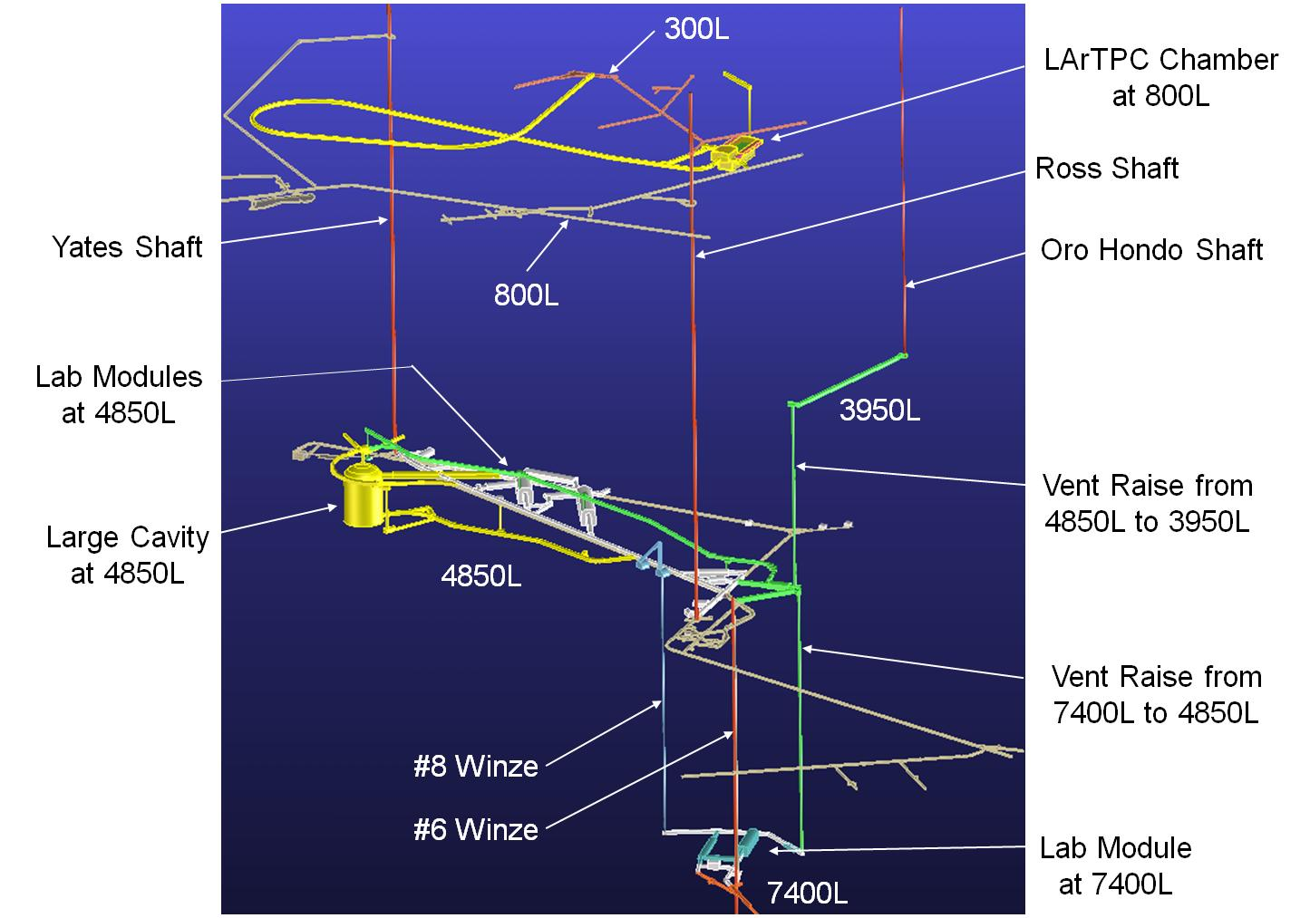
Figure 3.3.2-1 A 3D view of the major elements of the proposed DUSEL facility.
The principal components of the baseline facility to accommodate the scientific program are:
- A surface campus to support operation of the facility and its scientific program
- A Mid-Level Laboratory (MLL) campus at the 4850L
- One large cavity for LBNE at 4850L. The option of locating a liquid argon detector complex at the 800L is also shown.
- A Deep-Level Laboratory (DLL) campus at the 7400L
- Other levels and ramps at a variety of depths to support the operation of the facility, including support of physics experiments and locations primarily for experiments in biology, geology, and engineering (Figure 3.3.2-2)
- Shafts for access (Yates and Ross Shafts) and for ventilation (Oro Hondo) and internal access from the MLL to the DLL via the #6 and #8 Winze
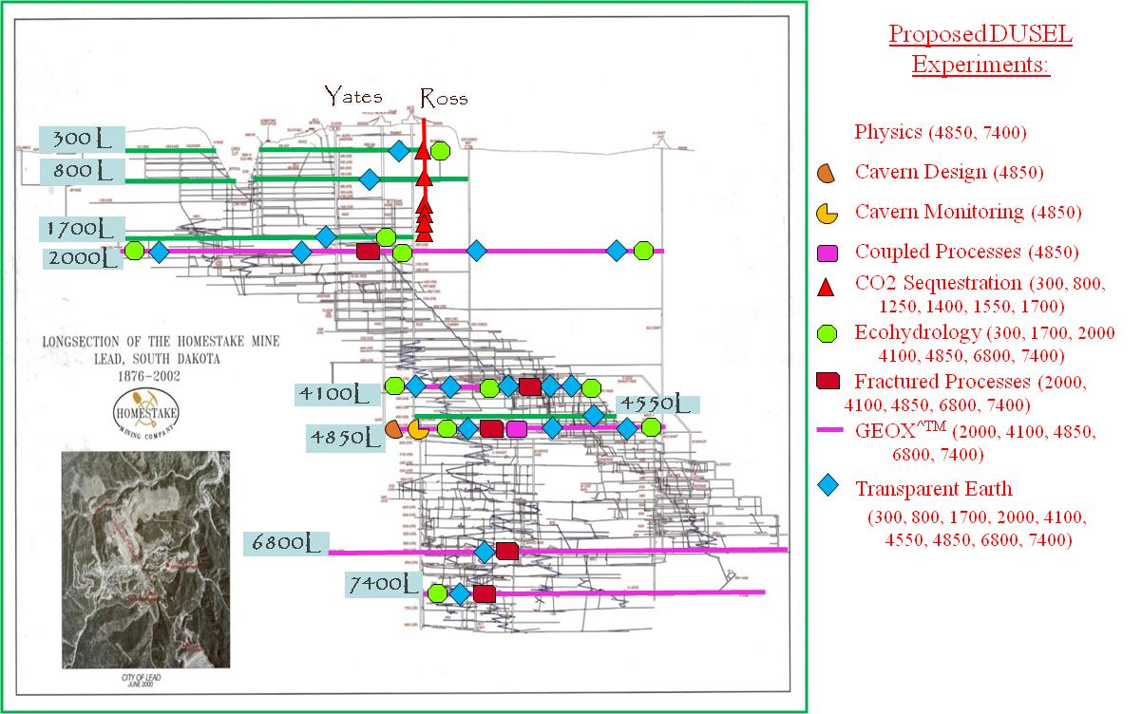

Figure 3.3.2-2 Summary of other levels and ramps to be developed for the potential DUSEL experimental program. The 4850 and 7400 levels at which the major physics experiments will be located are also indicated.
3.3.3 Dark Matter Experiments
3.3.3.1 Overview of Dark Matter Experiments
For more than two decades, experimental groups have sought to detect halo Weakly Interacting Massive Particles (WIMPs) in the laboratory to solve the dark-matter mystery (the experimental evidence for the existence of dark matter and the science motivation of WIMPs as a dark-matter candidate are summarized in Section 3.2.1). With the notable exception of the DArk MAtter/Large sodium Iodide Bulk for RAre processes (DAMA/LIBRA) experiment that reported¹ a signal positive result in the form of an annual modulation in the signal rate in NaI scintillator crystals consistent with halo WIMP interactions, all other efforts have, so far, all efforts have yielded null results. This apparent inconsistency could be due to either a more complex dark-matter particle sector than single heavy WIMPs or to unknown experimental artifacts in the DAMA/LIBRA setup. In either case, further experimentation is warranted.
The pursuit of a WIMP signal has led to the development of a wide range of detection techniques, each with unique strengths and challenges and applicable to different target materials. The current best limits for the WIMP spin-independent (SI) interaction cross section (see Figure 3.2.1-1) at the few times
10⁻⁴⁴ cm² /nucleon (at ~70 GeV/c² WIMP mass) come from Cryogenic Dark Matter Search (CDMSII) and XENON100 experiments, using 4 kg of germanium detectors with ionization and phonon sensing at 50 mK temperatures and 40 kg of xenon in a dual-phase time projection chamber (TPC), respectively. The best limits for the detection of WIMPs for spin-dependent (SD) couplings at the level of 10⁻³⁷ cm² come from the Chicagoland Observatory for Underground Particle Physics (COUPP) and the Project in CAnada to Search for SuperSymmetric Objects (PICASSO), using a bubble chamber filled with superheated CF₃I liquid and a bubble detector with Freon droplets in a gel, respectively. These direct SD limits are substantially less stringent than for SI couplings, as they do not benefit from the A² enhancement factor of coherent scattering. Note that more stringent limits from SuperKamiokande and IceCube exist from indirect WIMP detection.
Additional exposure and extensions of the above experiments and other experiments/targets/techniques such as Large Underground Xenon (LUX), Mini Cryogenic Low Energy Astrophysics with Nobel gases (MiniCLEAN), Argon Dark Matter (ArDM), the WIMP Argonne Programme (WARP), DarkSide, and XMASS, typically with masses in the few hundreds of kilograms, are expected to reach 10⁻⁴⁵ cm² sensitivities for SI couplings within the next one to three years. This class of experiments is known as Generation 1 (G1). Generation 2 (G2) experiments, with sensitivities at or better than 10⁻⁴⁶ cm² and masses in the 100 kg to ton range, are expected to come online around 2013, with full results available in ≈2014-2016. XENON1T, LZS, SuperCDMS at SNOLAB, DEAP 3600, DarkSide-G2, and COUPP 500 kg are some of these planned G2 detectors.
With each significant increase in desired sensitivity come additional challenges, uncertainties, and risks from background events and their suppression. Total background rates must be kept ideally near zero (after discrimination cuts are applied) while the volume and mass increase by factors of ~10. Thus, there is at this moment uncertainty as to what technique/s will successfully achieve the intended sensitivities by the time the first dark-matter experiments are installed in DUSEL.
Irreducible backgrounds from solar, atmospheric, and diffuse supernovae neutrinos begin to contribute below WIMP cross sections of ~10⁻⁴⁸ cm², and will likely determine the ultimate reach of direct dark-matter counting searches.
As stated in Section 3.2.1, an important part of the theoretically well-motivated WIMP parameter space will probably already have been probed by the time DUSEL dark-matter experiments are in operation. If no WIMPs are observed in the pre-DUSEL era, initial DUSEL dark-matter experiments will have a chance to discover dark matter. On the other hand, should WIMPs be discovered in a pre-DUSEL experiment, DUSEL dark-matter experiments will obtain large samples of WIMP events that will confirm the discovery and provide important information about the WIMP nature, its interactions, and its mass.
If eventually WIMPs are discovered in a direct-detection experiment, the ultimate cross-check will be confirming their galactic origin by observing secondary signatures related to the motion of the Earth and solar system as well as the WIMP velocity distribution. Directional WIMP detectors, possibly large volumes of gas imagers currently in the R&D phase, could be deployed in the future at DUSEL for this purpose.
WIMPs could also be observed by direct production at the Large Hadron Collider (LHC) accelerator experiments in the European Organization for Nuclear Research (CERN). Finding the same mass derived from direct detection as reconstructed for LHC events would show unambiguously that the particles produced at the LHC are stable over the age of the universe and would fully justify the use of the relic abundance as a constraint over the theoretical parameters.
The planned construction completions of the 4850L and 7400L laboratories of DUSEL are beyond the planned time scale of G2 experiments. Dark-matter experiments at DUSEL will target sensitivities in the 10⁻⁴⁷-10⁻⁴⁸ cm² /nucleon range (at 70 GeV/c² WIMP mass). These G3 experiments require multi-ton mass targets with large and often sophisticated shield and veto systems against natural radioactivity in the surrounding materials, against residual cosmic ray muon fluxes, and against high-energy neutrons from cosmic ray muon spallation.
The four proposed G3 experiments for DUSEL that received S4 funding are:
- COUPP, 16 tons of CF₃I in bubble chambers
- GEODM, 1.5 ton of Ge detectors with ionization and athermal phonon sensors at mK temperatures
- LZD, 20 tons of Xe in a dual phase TPC
- MAX, two detectors, each a dual-phase TPC with:
    - 20 tons of depleted liquid Ar
    - 6 tons of liquid Xe
Note that the noble liquid TPCs proposed by the LZD and MAX collaboration are similar in structure and scope. The LZD and MAX collaboration have started a preliminary series of discussions, including members of the CLEAN collaboration (another potential G3 experiment described below), to evaluate the possibility of converging toward the proposal for a single experiment at DUSEL. This is in line with the recommendation of the S4 Review Panel (July 2010), which stated: “The MAX and LZD collaborations are encouraged to continue working toward a single DUSEL experiment.”
All these large and challenging G3 experiments proposed for DUSEL represent expansions over pre-DUSEL experiments. As such, they will benefit from the techniques and know-how developed by their respective predecessors, thus reducing the risk and ensuring their optimal designs. In the larger worldwide context, other G3 experiments are in conceptual/planning stages in Canada, Europe, Japan, and China on a similar time scale as DUSEL’s initial experiments.
3.3.3.2 Candidate Experiments
3.3.3.2.1 COUPP
The Chicagoland Observatory for Underground Particle Physics (COUPP) employs ultraclean (and thus indefinitely metastable) CF₃I bubble chambers sensitive to WIMP-induced nuclear recoils. Due to the presence of both fluorine and iodine, this target is sensitive to both SD and coherent SI WIMP couplings. The signature from a WIMP interaction is a single bubble induced by the large energy loss density of the recoil of a nucleus. Neutrons can be efficiently differentiated from WIMP interactions thanks to their large probability of scattering elastically that often produces multiple bubbles from nuclear recoils in the detector volume. Electrons (and consequentially also gammas) are intrinsically rejected at the ~10⁻¹³ level because their energy-loss density is below the threshold required for bubble formation. This important and unique intrinsic rejection is achieved by deliberate selection of the temperature and pressure of the bubble chamber. Alpha particles, on the other hand, can produce bubbles. Such events can be identified and rejected, at a level yet to be determined for COUPP modules, by their distinct acoustic signal pattern. To mitigate this background, the uranium and thorium contents of the target material must be reduced to <10⁻¹⁵ g/g through purification techniques (similar purity levels have been achieved before by neutrino experiments using liquid scintillators) and alpha-particle-induced bubbles must be discriminated from nuclear recoils at the 10⁻³ level by their distinct acoustic signatures.
Large target masses can be easily monitored due to the built-in amplification that the macroscopic phase transition provides. Bubble formation can be detected by monitoring for a pressure rise, the acoustic signal accompanying the initial stage of the nucleation, and/or by video motion detection. A real-time software comparison of video frames taken every ~10 ms triggers the recompression of the chamber before the bubbles grow much larger than a few mm. The use of multiple cameras allows a spatial granularity of about 1 mm.
The proposed experiment for DUSEL consists of 32 identical bubble chambers with 500 kg of target material each—a total of 16 tons. The modules are immersed in a single 20m x 12m x 7m water tank that provides both shielding against external neutrons and functions as a temperature bath to keep the bubble chambers at their ~40-degree Celsius set point. The operating pressure is in the range 0-50 psi when the chambers are in the expanded, superheated state and increases to 200 psi in the compressed state.
Figure 3.3.3.2.1 shows the proposed layout and configuration for the COUPP experiment in the 7400L laboratory. A minimum water shield thickness of 2 m at that depth is required to reduce the fast neutron background from cosmic ray muon interactions (see Section 3.3.10). Alternatively, deployment in the 4850L laboratory would require either ~3 m additional water shielding on all sides or installation of an active neutron tagger in the shield volume, or some combination of both.
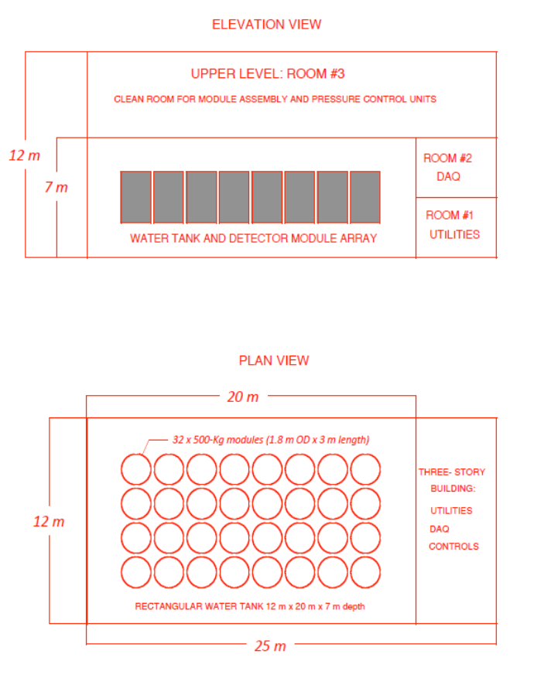
Figure 3.3.3.2.1 COUPP layout at the 7400L laboratory. The 16 tons of active target are contained in 32 identical 500 kg bubble chambers. The bubble chambers are immersed in
a rectangular water tank held at ~40 C.
3.3.3.2.2 GEODM
The Germanium Observatory for Dark Matter (GEODM) uses interdigitated Z-dependent Ionization- and Phonon-mediated (iZIP) detectors. iZIPs employ simultaneous athermal phonon and ionization measurements in germanium substrates operated at approximately 40 mK temperature to reject electromagnetic backgrounds (photons and electrons). Such particles scatter off electrons in the detectors, while WIMPs (and neutrons) scatter off nuclei. In iZIPs, recoiling electrons are more ionizing and thus can be discriminated against using the ratio of ionization to recoil energy. For recoils within the first few micrometers of the detector surface (primarily caused by low-energy electrons), ionization yield provides less discrimination than for bulk events, but such near-surface events can be rejected via the asymmetric ionization signal observed in ionization electrodes on opposite faces of the detector. Further, events near the surface have faster phonon signals than do bulk events, providing additional discrimination
The target mass of 1.5 ton will consist of 300 germanium crystals 15 cm in diameter and 5 cm thick, weighing 5.1 kg each. Each detector will employ a phonon sensor segmented into 32 elements to obtain detailed xyz position information. The phonon signal is measured using photolithographed superconducting phonon absorbers and transition-edge sensors. The detectors will employ a multiplexed phonon readout and a low-power ionization readout to accommodate the large phonon channel count and the large number of detectors. An integrated cryogenic system and shield provide a 40 mK environment for the detector mass (cold volume ≈1 m³), shield the detectors from radiogenic photon and neutron backgrounds, and allow for calibration using insertable photon and neutron sources. The baseline shield design is composed of copper and polyethylene. Specialized production techniques such as electroforming will be used to obtain low-activity cryostat and shield stock materials. The experiment will be housed in a clean room facility, with radon abatement employed when detectors are exposed.
Figure 3.3.3.2.2 shows the proposed layout and configuration for the GEODM experiment in the 7400L laboratory. The central 5.6 m diameter, 5.6 m tall cylinder contains the 100 tons of copper and 125 tons of polyethylene of the passive shield and the cryostat that houses the 1.5 tons of germanium crystals. The dilution refrigerator is sited immediately outside of the shield. An adjacent Class 100 clean room will be used for detector assembly. A 20-ton crane is currently planned to be located inside the 2.3 m³ Class 10,000 clean room that surrounds the detector, shield, and detector assembly areas. Alternatives to utilize the lab module crane will be studied in conjunction with meeting cleanliness requirements.
With a larger and active (instrumented) shield and at increased risk of background events from neutrons and long-lived isotopes from cosmic ray muon activation (see Section 3.3.10), GEODM could also be sited in the 4850L laboratory. For this shallower site and to further suppress the fast neutrons from spallation, an additional thick water shield surrounds the detector. The inside shield/cryostat is not directly immersed in the water.

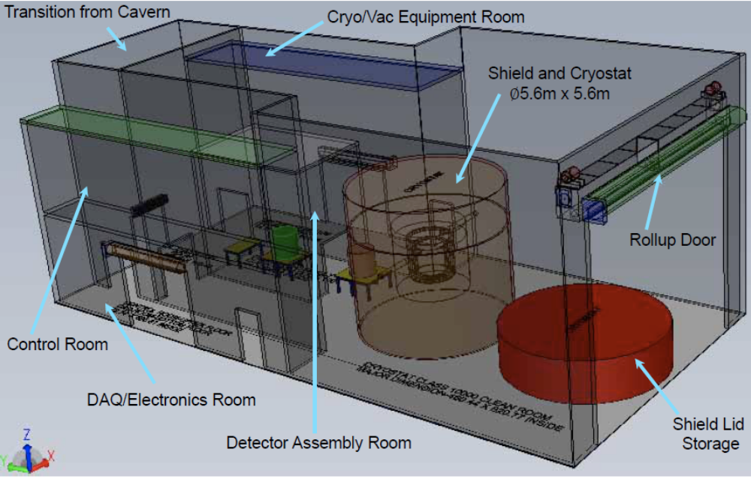
Figure 3.3.3.2.2 GEODM layout at the 7400L laboratory with a 25 (L) x 12 (W) x 10 (H) m envelope.
3.3.3.2.3 LZD
The LUX-ZEPLIN DUSEL (LZD) detector, a dual-phase xenon time projection chamber (TPC), is to be located inside a large-scale liquid scintillator and water shield. Particle interactions in a central cylindrical active region of liquid xenon (LXe) create both prompt scintillation signals (S1) and ionization electrons, the ratio of which is governed by recombination occurring along the recoiling particle's track. An applied electric field extracts a fraction of the electrons from the event site and drifts them up to the liquid surface, where a stronger field extracts them into the gas phase. The electrons are accelerated in the gas by another field and create a large secondary proportional scintillation signal (S2) before being collected on an anode grid. Both S1 and S2 signals are measured with two arrays of photomultiplier tubes (PMTs), the first located below the fully active LXe region and the second just above the gaseous S2-creation region. The ratio of the S1to S2 signals provides discrimination between electron and nuclear recoil. The S2 signal recorded in the top array determines the x-y position of the event with ~1-cm accuracy. The drift time—(difference between arrival of S1 and S2)—measures the event depth to an accuracy also of ~1 cm.
The 20 tons of LXe in LZD is operated at ~175 K in an all-Ti cryostat surrounded by a 1 m thick liquid scintillator to tag neutrons and gammas which, in turn, is placed in an ultrahigh-purity water shield, instrumented with large PMTs to also act as a Cherenkov muon veto. A system of thermosyphons between the detector and a liquid nitrogen (LN) reservoir above the water tank cool the apparatus. The 450 PMTs used in the LXe volume of LZD will be constructed using ultralow-background 7.5 cm metal cans with total activities less than 1 mBq/PMT. The walls of the 200-cm diameter and 200 cm tall cylindrical active volume are lined with a segmented set of PTFE panels whose high reflectivity improve the light-collection efficiency in this geometry. A set of grids and field-shaping rings creates the fields that drift electrons. The primary drift field requires -100 kV voltage applied to the bottom (cathode) grid.
The high Z and density of 20 tons of LXe provide strong self-shielding. This significantly suppresses the event rates of neutrons and gammas (with mean free paths of ~10 cm and 5.5 cm, respectively) that could compete with the dark-matter signal within the fiducial region. The background particles predominantly deposit energy well above the ~10-keV WIMP range, and/or have multiple vertices that are largely rejected by the ~1 cm³ 3D imaging of the TPC. Low-energy single-scatter rates of neutrons and gammas in the central 14 tons are, respectively, at least 10³ and 10⁶ times lower than event rates in the full 20 tons. In addition, electron recoil backgrounds can be discriminated against using the ratio of ionization to prompt scintillation (S2/S1), which provides a further factor of 200-1000 discrimination since electron recoils have less-dense tracks and higher S2/S1 (less recombination) than denser nuclear tracks from WIMPs (and neutrons).
An important internal-background-events source from ⁸⁵Kr, a beta emitter present in commercial xenon, will be reduced to a level of ~0.05 ppt Kr/Xe by a chromatographic separation system whose goal throughput is ~50-100 kg/day.
Figure 3.3.3.2.3 shows the proposed layout at the 4850L laboratory. The 12-m height by 12-m diameter water tank contains the cryogenic liquid scintillator vessel that surrounds the liquid xenon vessel. To provide a safe containment/fallback, in case of prolonged loss of cooling, the full mass of boiled xenon can be captured in four large tanks containing passive charcoal.
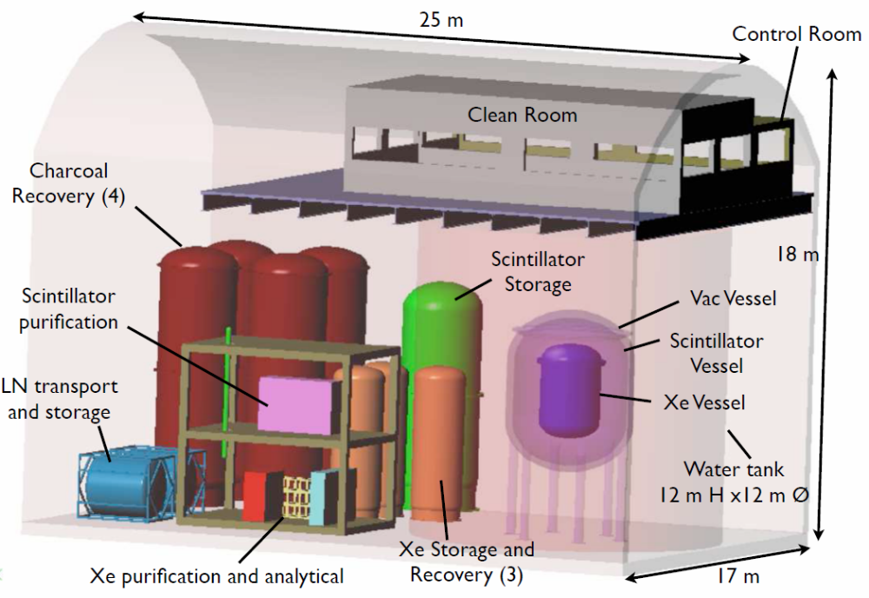
Figure 3.3.3.2.3 LZD layout at the 4850L laboratory with a 25 (L) x 17 (W) x 18 (H) m envelope.
3.3.3.2.4 MAX
The Multiton Argon and Xenon TPCs (MAX) are dual-phase TPCs, one filled with 20 tons of argon depleted of the radioactive ³⁹Ar isotope, and the other with 6 tons of xenon. Each detector is immersed in respective room-temperature liquid scintillator vessels that, in turn, are placed inside two large water tanks. The use of two target materials with matching sensitivity would serve to confirm a putative WIMP signal by verifying the expected A² dependence of the WIMP spin-independent coherent scattering rate and by verifying the consistency of the WIMP mass deduced from the two recoil spectra. It is also due to the A² dependence of the interaction rate that the argon TPC target mass is significantly larger than the xenon TPC. The depleted argon and xenon detectors feature many common core technologies and subsystems.
The principles of detection, fiducialization, and discrimination (using the S2/S1 ratio) between nuclear and electron recoils for the both TPCs are the same as described in the previous section.
To sense the S1 and S2 scintillation light while minimizing the radioactive contamination in the inner volume of the TPCs, the MAX group intends to use a newly developed ultralow-activity Quartz Photon Intensifier Detector (QUPID) with activities significantly smaller than the lowest-activity PMTs. This will help improve light collection, position sensitivity, and lower the energy threshold.
The 6-ton xenon TPC operation principle and the purity requirements are very similar to those of LZD. Cooling is achieved using a system of pulse tube refrigerators. ⁸⁵Kr will be removed by cryogenic distillation, validated with gas chromatography and with an Atom Trap Trace Analysis System, currently under development within the XENON program.
For the argon TPC, an additional discrimination tool is the pulse shape of the S1 primary scintillation signal. This discrimination stems from a very large decay-time difference between the two excimer states (singlet and triplet) responsible for the emission of the vacuum ultraviolet (VUV) scintillation light, which are populated differently by low- and high-density tracks. It should provide an additional 10⁸ rejection of beta- and gamma-induced backgrounds.
One of the main background sources in large argon detectors is ³⁹Ar, a β emitter produced in the atmosphere by cosmic rays. The specific activity of ³⁹Ar (Q=565 keV, τ=388 yr) in conventional argon supplies is ~1 Bq/kg of atmospheric argon, corresponding to a concentration of ³⁹Ar/Ar=8×10⁻¹⁶. Even though for ³⁹Ar in argon the S1 pulse shape discrimination is strong enough to discriminate against the ³⁹Ar activity, the 20-ton unsegmented detector event pile-up demands the reduction of the ³⁹Ar fraction. For this reason, the target material will be obtained from recently discovered underground sources of argon depleted in cosmogenic ³⁹Ar. A common cryogenic distillation plant will purify the underground argon into detector-grade argon and will reduce the Kr contamination in xenon below the part-per-trillion (ppt) level.
Figures 3.3.3.2.4-1 and 3.3.3.2.4-2 show the layout and configuration of the two MAX detectors and ancillary equipment at the 4850L laboratory. The water tanks are 16 m in height by 16 m in diameter. The clean-room area above the water tanks, with a crane to lower the detectors into the scintillator vessels, is shared by both detectors. The current MAX layout exceeds the simple available envelope to allow full bridge crane access in laboratory module #2 with a crown height of 24 m. Monorail crane access would be maintained in the proposed layout but with small clearance. Additional design work is needed to understand the consequences of the proposed layout. The feasibility of increasing the height (and other dimensions) of laboratory module #2 at the 4850L is under study (see Section 3.6).
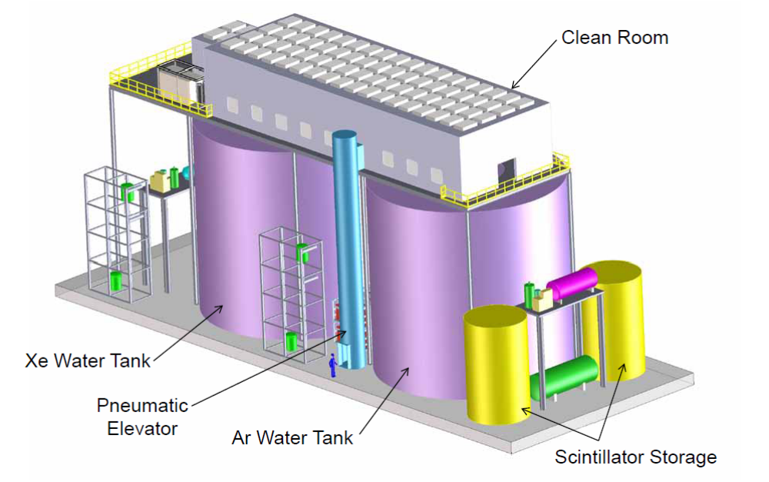
Figure 3.3.3.2.4-1 Layout of MAX, with its two water tanks and respective depleted argon and xenon detectors at the 4850L laboratory in a 50 (L) x 17 (W) x 22 (H) m envelope.

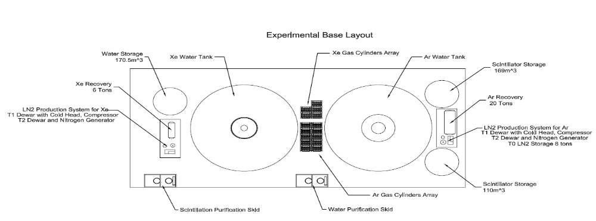

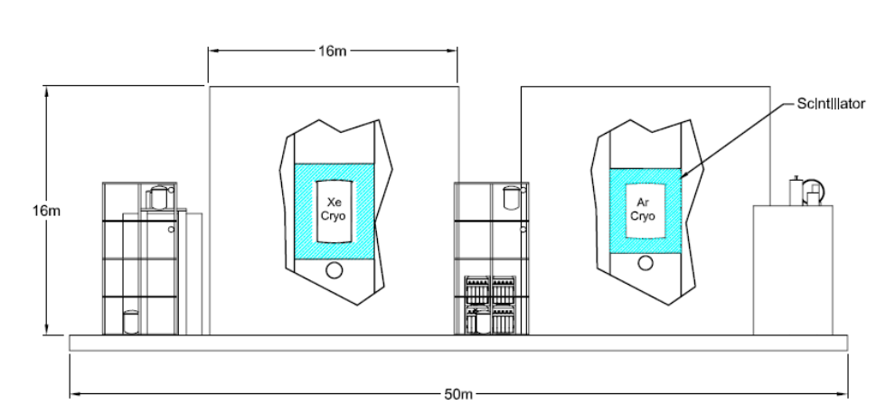
Figure 3.3.3.2.4-2 MAX configuration at the 4850L laboratory.

3.3.3.3 Other Experiments
3.3.3.3.1 CLEAN
The Cryogenic Low Energy Astrophysics with Noble gases (CLEAN) team is studying a single-phase 50-ton (10-ton fiducial) liquid argon detector, which could also be filled with 10 tons of liquid neon. The scintillation light produced by interactions in the target is sensed by an array of phototubes on the envelope area of the active volume. Shielding is provided by water. Discrimination against background is based on the combination of the scintillation pulse shape and the radial position reconstruction. Considerable precautions need to be taken to prevent radon contamination on the outer surface of the target. Currently the team envisions a 15 m diameter x 15 m high water tank.
3.3.3.3.2 DMTPC
The Dark Matter Time Projection Chamber (DMTPC) is a proposed apparatus to detect the direction of WIMP recoils. The WIMP detector is a TPC, consisting of a target gas volume in a strong electric field (1 MV/m). A nuclear recoil in the target volume as it loses energy will ionize the gas; a low-pressure gas is used to extend the ranges of these ionization tracks to a few millimeters for typical WIMP-induced recoil energies (~100 keV). The detector uses CF4 as a target gas, which allows detection via scintillation photons from the electron avalanche, as well as sensitivity to spin-dependent interactions. He-4 is added to increase the fast neutron interaction cross section, allowing an in situ neutron background measurement. The team has also experimented with adding xenon, which would allow a search for excited dark matter with a cubic meter device. A charge-couple device (CCD) camera images the scintillation light caused by the recoiling nucleus to determine its direction of travel.
This technique, which has the potential of confirming the galactic-halo source of a WIMP nuclear recoil signal, is in its development phase. As such, for DUSEL, a 1-2 m³ detector for R&D in a 10 m long by 4 m wide and 3 m height area at the 4850L laboratory could be accommodated.
3.3.3.4 Experimental Requirements
Experimental requirements for the four S4-funded proposed experiments were obtained by means of phone interviews and face-to-face meetings with the teams and by direct entry in a requirements database by the experimental groups themselves. Tables 3.3.3.4-1 through 3.3.3.4-4 show the current state of the main experimental requirements with significant impact on the DUSEL facility design.
Requirement | Value/Description | Comment/Justification
Layout
Depth | 7400L
Footprint | 25m L x 12m W
Height [m] | 12 | Constrained value
Floor Load [kPa] | 100
Utilities
Power [kW] | 100 | Heaters/chillers to keep water temperature at 40 C
Standby Power [kW] ¹ | 5 | Large thermal mass, in emergency-mode only monitoring required
Chilled Water [kW] | 0
Waste Heat to Air [kW] | 100
Purified Water [m³] | 1680 | Entire volume of water shield
Potable Water [lpm] | Nominal use
Compressed Air | Nominal use
Network | 1 Gb/s
Environment
Temp. Min [⁰C] | 20 | Nominal, may be tighter in clean rooms
Temp. Max [⁰C] | 25
Humidity Min [%] | 20 | Nominal, may be tighter in clean rooms
Humidity Max [%] | 50
Rn Background [Bq/m³] | TBD | Experiment provides Rn scrubbing area
Crane
Max. Load [Short Ton] | 5T | Inside COUPP clean room
Occupancy
Peak Installation Occupancy [count] | 24
Installation Duration [months] | 24
Peak Commissioning Occupancy [count] | 5
Commissioning Duration [months] | 9
Peak Operation Occupancy [count] | 10
Operation Duration [months] | 120
Cryogens
LN Storage | 500 L
LN Consumption | 100 L/day boil off | Gas Buffer on top of water shield.
Major Hazards (Other Than Cryogens)
Water Flood Hazard | 1680 m³
Health Hazard | 16 tons of CF₃I, a low-vapor pressure fire-extinguishing compound | Cardiac sensitization at exposures of >0.2% for >1 minute. If one module/tank breaks >0.2% in laboratory.
Assay and Storage
Assay Needs | Nominal
Underground Storage | None
Table 3.3.3.4-1 COUPP Experiment requirements.

Requirement | Value/Description | Comment/Justification
Layout
Depth | 7400L | Alternate design developed for 4850L
Footprint | 25m L x 12m W (7400L)
Height [m] | 10 (7400L)
Floor Load [kPa] | 100
Utilities
Power [kW] | 200
Standby Power [kW] ¹ | 75 | 70kW to keep system cold  5kW for monitoring
Chilled Water [kW] | 160
Waste Heat to Air [kW] | 40
Purified Water [m³] | 140 | Entire volume of water shield
Potable Water [lpm] | Nominal use
Compressed Air | Nominal use
Network | 10 Gb/s
Environment
Temp. Min [⁰C] | 20 | Nominal, may be tighter in clean rooms
Temp. Max [⁰C] | 25
Humidity Min [%] | 20 | Nominal, may be tighter in clean rooms
Humidity Max [%] | 50
Rn Background [Bq/m³] | TBD | Experiment provides Rn scrubbing area
Crane
Max. Load [Short Ton] | 20T | Internal experiment clean room crane nominally used
Occupancy
Peak Installation Occupancy [count] | 24
Installation Duration [months] | 24
Peak Commissioning Occupancy [count] | 5
Commissioning Duration [months] | 9
Peak Operation Occupancy [count] | 10
Operation Duration [months] | 120
Cryogens
LN Storage | Storage dewars, tens of liters in cold traps
LN Consumption | Few L/day boil off
LHe Storage | Several hundred liters
LHe Consumption | 2L/day
Major Hazards (Other Than Cryogens)
Fire Hazard | ~6 m³ of solid plastic scintillator | Plastic scintillator veto
Assay and Storage
Assay Needs | Nominal
Underground Storage | None
Table 3.3.3.4-2 GEODM Experiment requirements.

Requirement | Value/Description | Comment/Justification
Layout
Depth | 4850L
Footprint | 25m L x 17m W
Height [m] | 18
Floor Load [kPa] | 200
Utilities
Power [kW] | 220
Standby Power [kW] | 50 | Enough LN to maintain cold for 12 hours (in the absence of this emergency power)
Chilled Water [kW] | 50
Waste Heat to Air [kW] | 170
Purified Water [m³] | 1400 | Entire volume of water shield
Potable Water [lpm] | Nominal use
Compressed Air | Nominal use
Network | 1 Gb/s
Environment
Temp. Min [⁰C] | 20 | Nominal, may be tighter in clean rooms
Temp. Max [⁰C] | 25
Humidity Min [%] | 20 | Nominal, may be tighter in clean rooms
Humidity Max [%] | 50
Rn Background [Bq/m³] | TBD | Experiment provides Rn scrubbing area
Crane
Max. Load [Short Ton] | 10T | Outside clean room (penetrates into clean room)
Occupancy
Peak Installation Occupancy [count] | 24
Installation Duration [months] | 24
Peak Commissioning Occupancy [count] | 5
Commissioning Duration [months] | 9
Peak Operation Occupancy [count] | 10
Operation Duration [months] | 120
Cryogens
LN Storage | 3000 L
LN Consumption | 200-500 L/day | For cooling are generated in situ
LXe | 20T
Major Hazards (Other Than Cryogens)
Water Flood Hazard | 1400 m³
Oxygen deficiency | Large volumes of cryogenic liquids, 20 tons LXe, and few tons LN | Approach is fail-safe recovery of xenon, vessel engineering to prevent LXe mixing with water.
Fire hazard | 100 tons of organic scintillator (possibly isohexane) and 100 tons of charcoal | Charcoal is contained in stainless steel vessel
Assay and Storage
Assay Needs | Nominal
Underground Storage | None
Table 3.3.3.4-3 LZD Experiment requirements.

Requirement | Value/Description | Comment/Justification
Layout
Depth | 4850L
Footprint | 50m L x 17m W
Height [m] | 22
Floor Load [kPa] | 200
Utilities
Power [kW] | 260
Standby Power [kW] | 44
Chilled Water [kW] | 70
Waste Heat to Air [kW] | 190
Purified Water [m³] | 6500 | Entire volume of both water shields
Potable Water [lpm] | Nominal use
Compressed Air | Nominal use
Network | 1 Gb/s
Environment
Temp. Min [⁰C] | 20 | Nominal, may be tighter in clean rooms
Temp. Max [⁰C] | 25
Humidity Min [%] | 20 | Nominal, may be tighter in clean rooms
Humidity Max [%] | 50
Rn Background [Bq/m³] | TBD | Experiment provides Rn scrubbing area
Crane
Max. Load [Short Ton] | 40T | Centerline Crane
Max. Load [Short Ton] | 10T | 2 flat-beam cranes
Occupancy
Peak Installation Occupancy [count] | 24
Installation Duration [months] | 24
Peak Commissioning Occupancy [count] | 5
Commissioning Duration [months] | 9
Peak Operation Occupancy [count] | 10
Operation Duration [months] | 120
Cryogens
LN Storage | 9T
LN Consumption
LXe Storage | 6T
LAr Storage | 20T
Major Hazards (Other Than Cryogens)
Water Flood Hazard | 6500 m³
Oxygen deficiency | Large volumes of cryogenic liquids, 20 tons LAr, 6 tons LXe, and 9 tons LN | Approach is double-walled cryostat with leak detection in intermediate vacuum region. If break detected, rapid drain of warm-side liquid (water or scintillator) and full recovery of the cryogen liquid.
Fire hazard | 200 tons of organic scintillator
Assay and Storage
Assay Needs | Nominal
Underground Storage | 100m²
Table 3.3.3.4-4 MAX Experiment requirements.
For the DMTPC proposed R&D area, basic requirements were captured in the database and are expected to have no impact (besides the area required) on the facility interface.
3.3.3.5 Schedule
For the large dark-matter G3 experiments expected for DUSEL, about three to four years of procurement, construction, and preparation will be needed before starting installation underground.² Therefore, for a timely deployment in DUSEL, selection among the G3 candidates would need to be made about four years before the scheduled completion of the respective 4850L laboratory module(s) and/or the 7400L laboratory module. Additional discussion of the selection process and timescale is in Section 3.10.
3.3.4 Neutrinoless Double-Beta Decay Experiments
3.3.4.1 Candidate Experiments and Requirements
Two experiments have received S4 funding from the NSF to develop proposals to be located in DUSEL. The 1TGe experiment would look for 0νββ decay in approximately 1 tonne of high-purity germanium (HPGe) detectors isotopically enriched in ⁷⁶Ge. The Enriched Xenon Observatory (EXO) experiment would search for 0νββ decay in a TPC containing 1 to 10 tonnes of enriched ¹³⁶Xe. These experiments will be sensitive to effective Majorana neutrino ββ masses on the order of 10-20 meV after 5+ years of running. Both experiments are investigating multiple configurations for the detector design: 1TGe is evaluating passive lead shielding versus a large liquid-phase active shield, while EXO is developing designs for both a liquid-phase and a gas-phase Xe TPC. Both experiments are assuming occupancy at the 7400L. 1TGe and EXO are discussed in detail in the following sections.
In addition to 1TGe and EXO, several other groups have expressed interest in the future use of DUSEL. These groups include current members of the Cryogenic Underground Observatory for Rare Events (CUORE) and the Neutrino Experiment with a Xenon TPC (NEXT) collaborations. CUORE is an Italian-led experiment that is constructing a 750-kg array of (unenriched) TeO₂ bolometers in the Gran Sasso National Laboratory to search for the 0νββ decay of ¹³⁰Te. The NEXT collaboration is performing R&D toward a 100 kg enriched xenon high-pressure gaseous TPC design to be installed in the Canfranc Underground Laboratory, Spain. Both collaborations have mentioned DUSEL as a potential location for future experiments deploying larger masses of ββ-decay isotopes.
Requirements of a neutrinoless double-beta decay experiment at DUSEL have been set based on conceptual designs of the 1TGe and EXO experiments. A facility that is designed to accommodate either 1TGe or EXO 9or both) would be suitable for other types of neutrinoless double-beta decay experiments.
3.3.4.1.1 1TGe
The 1 Tonne Germanium (1TGe) collaboration aims to conduct a 0νββ decay search with 1 tonne of germanium isotopically enriched in ⁷⁶Ge.¹ The apparatus would consist of a large array (~1000) of HPGe diodes. Several advantages of HPGe detectors are:
- They are a well-established technology.
- Enrichment from the natural abundance of 7.6% up to 86% in active isotope has been demonstrated.
- The source is the detector (minimizing mass and space requirements).
- They have excellent energy resolution (less that 0.2% at 2039 keV, the endpoint of the ⁷⁶Ge double-beta decay spectrum).
- They are extremely pure (providing a substantial reduction in radioactive backgrounds).
Exploring the critical design features of a tonne-scale ⁷⁶Ge detector is the topic of current R&D work by the Majorana (U.S.-led effort) and GERmanium Detector Array (GERDA) (European-led effort) collaborations, which are currently constructing ⁷⁶Ge-based detector systems. The construction and successful operation of the Majorana Demonstrator and GERDA detectors will not only address the key technical challenges of the 1TGe experiment, but will also definitively test the claim of an observed 0νββ decay signal in ⁷⁶Ge by Klapdor-Kleingrothaus et al.²
The Majorana Demonstrator, a 40-60 kg array of novel p-type point contact HPGe detectors, is scheduled for operation of its first module (20 kg of ^{nat}Ge) in 2013 at the 4850L of the Sanford Laboratory, as described in Section 3.4. The Demonstrator uses a conventional vacuum-cryostat design in which electroformed copper is used as the primary structural component. The cryostat is surrounded by passive and active bulk shielding composed of electroformed copper, lead, polyethylene (as a neutron moderator), and a plastic scintillator muon veto. The Demonstrator’s p-type point-contact detectors offer background rejection capabilities that are optimal for double-beta decay searches, and its scalable, modular design readily permits future upgrades of the experiment. Furthermore, the Ge crystals can be reconfigured into different cryostat or shielding designs if such a need is identified.
The GERDA experiment, scheduled to begin taking first data in 2011 using 18 kg of enriched ⁷⁶Ge detectors at the Gran Sasso Laboratory, is investigating a novel approach of immersing the Ge diodes directly in a liquid cryogen. In the GERDA approach, the degree of background shielding can be scaled easily, and if a scintillating cryogen (e.g., liquid Ar) is used, the scintillation would provide an additional tag for external background rejection.
The two collaborations have signed a letter of intent to join together to construct a tonne-scale Ge detector array with a Majorana mass sensitivity below 50 meV using the best techniques demonstrated in the current phase. The 1TGe collaboration consists of the Majorana collaboration along with scientists from the Max Planck Institute in Munich, most of who are also members of GERDA. The objective of the 1TGe collaboration is to develop a realistic design of a 1-tonne ⁷⁶Ge detector, using the knowledge and experience gained from the Majorana Demonstrator and GERDA experiments.
Within the limits of available funding, the goal of the 1TGe project is to develop the basic elements of a Preliminary Design for an experiment that could be implemented at DUSEL. If required for design development, specific R&D will be conducted to mitigate high-risk technical elements of the project and to provide a realistic schedule for risk retirement. In particular, R&D will be conducted to better understand the recycling options that need to be implemented to maximize the use of the enriched ⁷⁶Ge material. The collaboration will also build upon R&D that is already under way as part of the Majorana Demonstrator and GERDA projects. The final implementation of the 1TGe experiment will only be determined after the data from the Majorana Demonstrator and GERDA experiments have been analyzed and technical choices have been made. The 1TGe collaboration has been interacting with the DUSEL Project Team to define a set of requirements for both possible implementations of the shield (Cu/Pb shield or LAr shield).
The Cu/Pb shield option. The copper-lead shield option would be based on the Majorana Demonstrator design, which is scalable in a straightforward manner. A crucial need for this design is a large amount of electroformed copper grown underground to avoid activation by cosmic rays. One of the goals of the Demonstrator is to show that electroformed copper can be successfully grown and processed underground to result in the extremely low levels of radioactivity (less than 1ppt U/Th) that are required for the experiment.
The LAr shield option. The liquid argon shield option is based on the configuration of the GERDA experiment. Liquid argon scintillates and can be instrumented for use as an active shield. The volume of liquid argon could be contained within a large water shield to further attenuate neutrons and provide additional active veto capability against muons. The 1TGe collaboration is also exploring similar options in which the detectors are enclosed in a vacuum cryostat that is immersed in a large LAr, water, or liquid scintillator shield. Results from the Demonstrator and GERDA experiments will help to understand the size of shielding that will be required for a tonne-scale experiment that uses this design.
3.3.4.1.1.1 Depth
The 1TGe collaboration has submitted a detailed justification for location at the 7400L of DUSEL—to reduce backgrounds. For the experiment to be successful, background levels of the order of less than 1 count/tonne/year in a 4-keV region of interest around the 2039-keV 0νββ peak are required. The background budget is essentially consumed by the materials that compose the experiment, and requires that backgrounds from cosmic rays be negligible. The reduction in muon-induced neutrons is about a factor of 20 when going from the 4850L to the 7400L. They conclude that locating at the 4850L carries large risks, especially due to the uncertainties associated with calculating neutron production rates. They comment that locating the experiment at the 4850L would entail substantial simulations and use of the R&D data from the Majorana Demonstrator to establish if there exists a shielding configuration that could still produce the desired reduction in cosmic ray-induced backgrounds. If this were the case, it would presumably look like a larger version of the liquid argon shield design. Further discussion of the arguments for the 7400L is given in Section 3.3.10.
3.3.4.1.1.2 Layouts
The 1TGe experiment has provided DUSEL with conceptual layouts for the 7400L lab module for both shield configurations (see Figures 3.3.4.1.1.2-1 to 3.3.4.1.1.2-2). The Cu/Pb layout is based on scaling up the Demonstrator experiment; and the LAr shield layout is based on scaling up the GERDA experiment. Neither layout fits in the current lab-module footprint guideline that was provided to the collaboration; the Cu/Pb version is too long (41 m compared to 25 m guideline) and the LAr version is too wide (by 4 m) and too tall (by 2 m). The Cu/Pb layout could be optimized to better match the constraint, and some of the space (gowning area, control and break rooms, etc.) could be shared with another experiment in the module. The LAr-shield would require a larger module if the shielding requirements remain unchanged; this has prompted a trade study (Section 3.8.5) examining the costs of re-dimensioning the 7400L module. At present (late-2010), neither of the R&D versions of the experiment have acquired physics data, and one should take these design options as being at the conceptual level. In all likelihood, the final implementation of the tonne-scale experiment will look quite different from either of the prototypes, having been informed by simulations of the possible shielding configurations for the tonne-scale detector and construction and operation of the prototypes.
No layout has been provided for the copper electroforming facility. However, it is expected that the copper electroforming will be done using the facilities installed for the Demonstrator in the Sanford Lab (4850L). The Demonstrator will use 16 baths to grow the parts it needs. Based on preliminary estimates, the addition of four baths (of slightly larger diameter) will be sufficient to satisfy the needs for the 1TGe experiment. A plan for the evolution of the Demonstrator lab space will be developed once better estimates of the achievable copper growth rates become available.
In addition to electroforming space, the 1TGe experiment will require the capabilities of a clean underground machine shop. The machine shop that is planned for the Majorana Demonstrator will most likely be too small to accommodate the needs of the 1 tonne experiment and the space will likely have to be expanded.
It should be noted that the underground machine shop and electroforming facilities do not require as much depth as the experiment. Either could be installed at shallower levels in DUSEL (300L, for example).
Finally, the Center for Ultra-low Background Experiments at DUSEL (CUBED) collaboration (which includes some Majorana collaborators) is investigating the underground production of the HPGe detectors—zone refining, crystal growing, and detector fabrication. The CUBED collaboration (discussed in Section 3.4) would also require space underground. As the decay of cosmogenic isotopes produced in the Ge detectors while they are aboveground presents a potentially-significant source of background to 1TGe, underground Ge detector fabrication would benefit the 1TGe experiment.

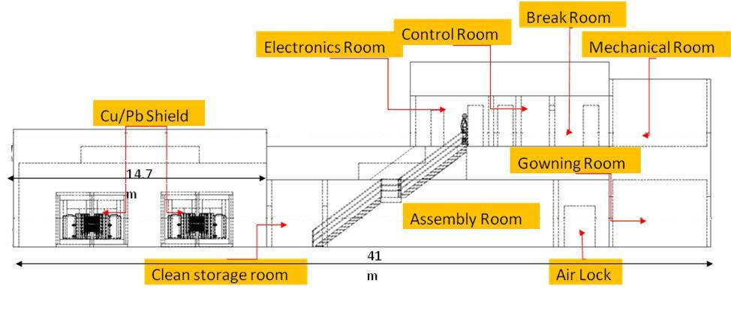
Figure 3.3.4.1.1.2-1 Side view of Cu/Pb shield layout for the 1TGe experiment. The footprint of this design has a length of 41 m, a height of 11 m, and a width of 11.6 m. The current design fits into the 7400L lab module; however, it is too long and would infringe on the space for any other experiment deployed in the same lab module unless some of the infrastructure (control room, gowning area, break room) can be shared.

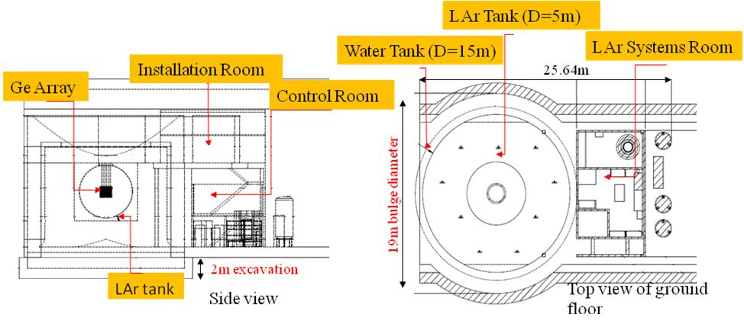
Figure 3.3.4.1.1.2-2 Side and top view of the layout for the 1TGe LAr shield option. The design does not fit into the current configuration of the 7400L lab module as it is too wide and would not provide enough overhead clearance for installation. This design would require a 2-m excavation for the floor of the water tank and an additional 2-m bulge to accommodate the diameter of the tank. The trade studies in Section 3.8.5 quantify the costs that would be involved in having a larger lab module.
3.3.4.1.2 The EXO Experiment¹
In 2000, the Enriched Xenon Observatory (EXO) collaboration started a program to push the sensitivity for 0νββ decay using ¹³⁶Xe as a source and detector. ¹³⁶Xe is particularly appropriate for a very large experiment for a number of reasons:
- The use of a material in the form of a liquid or gas allows for easy transfer of the enriched isotope from one detector to another. In addition, the possibility of using the material either in gas or in liquid phase, with complementary properties, opens a broad set of possibilities for a program of experiments in which a large fraction of the cost is the isotopic enrichment. Indeed, the possibility of using different types of detectors is integral part of the EXO program.
- ¹³⁶Xe, being a gas at STP and hence easy to process in ultracentrifuges, is particularly economical to enrich from the natural fraction of 8.9%.
- Xenon can be used at the same time as a source and as a homogeneous detector, either in gas phase (GXe) or in liquid phase (LXe). In either case, Compton scatterings of γ rays (the main source of background) can be readily distinguished from “single site” events produced by the ββ decay. The energy resolution in an LXe or GXe time projection chamber (TPC) is known to be sufficient to separate the standard-model two-neutrino (2νββ) decay from the 0νββ decay for Majorana mass sensitivities below 10 meV.
- In a large detector, the xenon can be continuously extracted and re-purified, if necessary, during the lifetime of the experiment. This is important, as the background requirements for the next generation of ββ-decay experiments are so extreme that the final detector is essentially the only device with sufficient sensitivity to verify the purity of the source.
- Xenon, being a noble element, is particularly easy to purify from all chemically active elements. Contaminations of ⁸⁵Kr (a fission fragment injected in the atmosphere by nuclear reactors) and ⁴²Ar (bred in atmospheric nuclear testing) produce decays with low Q-value not relevant for the 0νββ decay mode. In addition, ultracentrifugation greatly reduces the contamination of these substantially lighter isotopes.
- No long-lived isotopes of Xe exist. Hence, after a short “cooldown” period underground and chemical purification, no contamination should remain in the gas or liquid.
- The ¹³⁶Xe Q-value of 2457.8 keV is among the largest of the candidate double-beta isotopes
- The ββ decay of ¹³⁶Xe produces a barium ion (¹³⁶Ba²⁺) that can in principle be detected by optical spectroscopy on the ion Ba⁺, using the shelving technique.³ The possibility of “tagging” the chemical species of the final state of the decay would provide a new variable to be used for background suppression. This technique, only applicable to the case of xenon, could drastically improve the quality of ββ decay detection and make extremely large experiments possible.
The EXO collaboration manages a diverse program, including the construction of a large detector (EXO-200); R&D on LXe and GXe technologies; an isotope-enrichment program; and barium-tagging R&D employing techniques from AMO and radioactive beam physics. As of late-2010, the EXO-200 detector is in the final phase of preparation for data-taking at the Waste Isolation Pilot Plant (WIPP) near Carlsbad, New Mexico. It is expected that EXO-200 will have a relatively short technical run with 150 kg of natural Xe, followed by a run of three to five years with xenon enriched to 80% in the isotope 136 (the enrichment grade chosen by the collaboration). The technical run of the largest liquid xenon TPC ever built will provide a wealth of information essential for the design of a multi-tonne EXO, while the subsequent physics run is expected to measure the 2νββ decay in ¹³⁶Xe and substantially improve the sensitivity to Majorana neutrino masses through the 0νββ decay mode.
3.3.4.1.2.1 Depth
The EXO baseline assumes that the experiment will be located at the 7400L of DUSEL. The EXO collaboration is evaluating the depth requirement for a multi-tonne EXO detector. This requires balancing the technical risk of backgrounds larger than expected with the practical inconvenience of the deeper site and of the smaller cavity that will likely be available. EXO will be measuring the background rate induced by cosmic radiation in the upcoming runs of EXO-200 located about 1590 mwe underground at the WIPP site, having started in late 2010. The data may be used as a basis for the extrapolation of backgrounds to larger depths. Further discussion of the arguments for the 7400L is given in Section 3.3.10.
3.3.4.1.2.2 Layouts
The EXO baseline design for a multi-tonne installation at DUSEL includes a LXe TPC, using between 1 and 10 tonnes of xenon, enriched to 80% in the isotope 136. As for EXO-200, the TPC will have charge and scintillation readout, the latter used both to provide a start time for the drift time measurement and to improve the energy resolution. The detector’s physical properties will be similar to those of EXO-200, and the light readout will probably employ large-area avalanche photodiodes of similar nature to those used in EXO-200. The detector will localize candidate events in real time and trigger a mechanical system capable of inserting a grabber tip in the LXe and bring it to a distance of ~1 cm from the decay site in a time of the order of tens of seconds. It is assumed that the ion trap and the optics related to the fluorescence detection will be built out of conventional (i.e., not low-radioactivity) components and will be housed in a special lab outside of the detector shield. Depending on the total volume sought, two or more double drift spaces (each with a central cathode at high voltage) will be required. The vessel containing the LXe will be cooled and shielded with the same HFE7000 fluid used in EXO-200, contained in a vacuum-insulated cryostat of cylindrical shape and vertical axis.
Because of the large volume of the full EXO detector and the thick shielding required by the higher radioactivity of hard rock compared to salt at WIPP, it is assumed that the shielding will, for the most part, be water. The cryostat will be housed in a radio-quiet chamber, surrounded in all directions but the top by ~5 m of water. A water tank of this size can accommodate a TPC containing 1 to 10 tonnes of LXe without a significant change in footprint. After the installation of the cryostat, the volume above it will be outfitted as a Class 100 clean room, similar in quality to the innermost part of the EXO-200 clean rooms. The top of the shielding is at present thought to be made of 50-cm thick lead to provide a relatively thin layer to be penetrated by the ion grabber probe. The lab housing the ion trap and the optics will be located above the top shield. A concept of the detector within one of the DUSEL standard laboratories is shown in Figures 3.3.4.1.2.2-1 and 3.3.4.1.2.2-2. An additional advantage of the water shielding is the possibility of instrumenting it with photomultiplier tubes to use it as a cheap and hermetic cosmic-ray veto detector. The current configuration of the 7400L module is too narrow to accommodate EXO’s water tank configuration. A trade study quantifying the costs of resizing the module is described in Section 3.8.5.
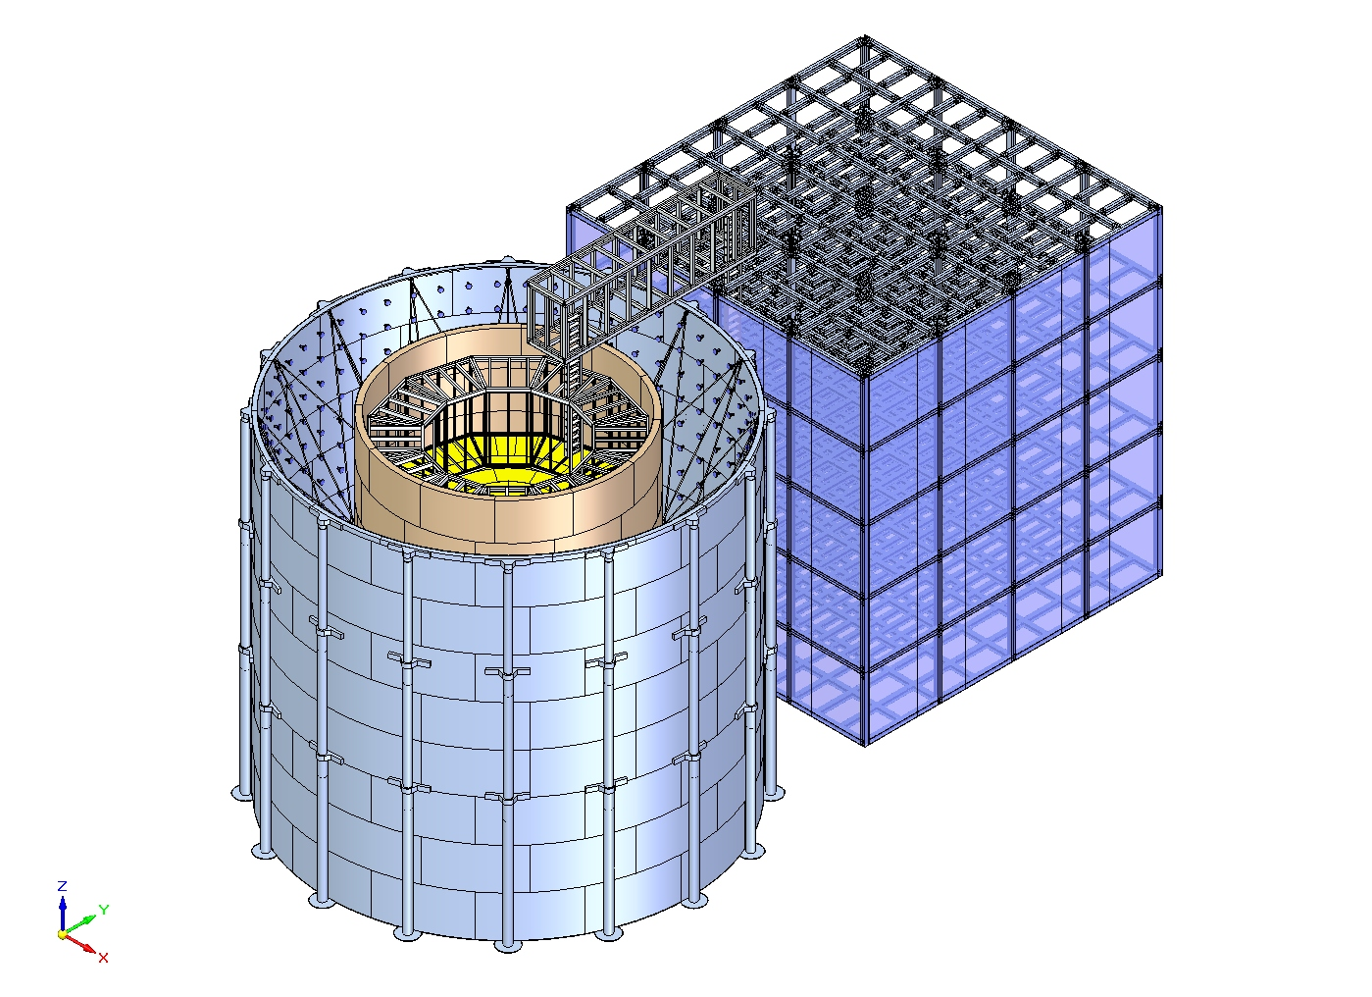
Figure 3.3.4.1.2.2-1 3D view of the EXO baseline design for a 1 to 10 tonne LXe TPC surrounded by a water Cherenkov veto. Next to the tank is a five-story support building containing clean rooms, offices, Xe/cryogen/refrigerant and water handling, UPS/electrical utilities, and a machine shop. The water tank has a 17-m diameter and a height of 15.5 m (not including the walkway linking to support building). The support building has a 15-m height and a 14 m x 14 m square footprint.
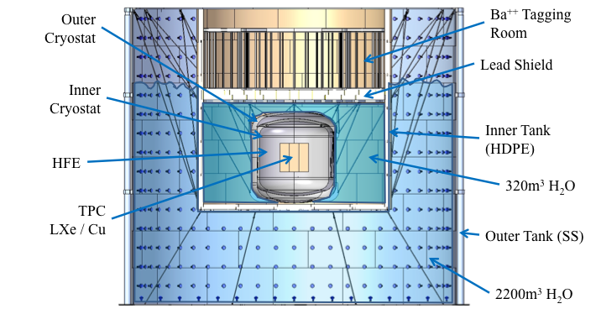
Figure 3.3.4.1.2.2-2 Schematic of the EXO detector. The water tank has a 17-m outer diameter and a height of 15.5 m. The diameter of the tank is too large for the current design of the 7400L module and the height may not give adequate clearance to an overhead crane system in the lab module. Section 3.8.5 details a trade study quantifying the costs of changing the size of the 7400L module.
3.3.4.1.2.3 GXe Option
While a high-pressure gas-phase TPC was used in the early conceptual description of EXO, it was later decided that because of the finite resources, priority would be given to a liquid phase 200 kg prototype. At the same time, R&D on high-pressure GXe versions of the detector continued and are in progress within the EXO collaboration. The tradeoff between the GXe and the LXe options can be summarized as follows. A GXe detector is expected to be superior in terms of energy resolution and topology. Depending on the density, topological information should result in better background rejection and push the requirement for Ba tagging to higher fiducial masses. At sufficiently low density, the ββ correlation may become measurable, providing insights on the underlying physics. On the other hand, for a very large detector, low density implies very large size and, at the extreme, unmanageable costs. At a pressure of 10 atm, a chamber in the shape of a square cylinder filled with 3 tonnes of Xe would have an active diameter and length of ~4.4 m. An LXe detector would be substantially smaller and trade a large pressure vessel for some modest cryogenics. The large size of a GXe detector increases the channel count and dimensions of the readout wires or other gas-gain structures and of the γ ray shielding. In addition, a larger detector requires a larger amount of clean materials for its construction. Structural engineering issues related to the very large pressure vessel are also a concern. Ba tagging would require rather different techniques in the two cases, and at the present state of R&D it is unclear which technique would be simpler.
Nevertheless, R&D on a GXe 0νββ detector is an important investment regardless of the technology choice for EXO because of the flexible nature of ¹³⁶Xe for ββ searches. Should a positive signal be found in EXO, using whatever technology will be accepted for the detector, a cross-check measurement with a very different detector will probably be desirable, making the advancement of both LXe and GXe detectors very appropriate.
3.3.4.2 Experimental Requirements
The 1TGe and EXO collaborations have provided a list of requirements they would need from DUSEL in order to operate successfully. These are summarized in Tables 3.3.4.2-1 to 3.3.4.2-3. In most cases, for 1TGe, a Cu/Pb shield experimental configuration was assumed, while for EXO, a liquid-phase TPC configuration was assumed. A few comments are given after the tables summarizing the requirements.
Summary tables
Requirement | Value/Description | Comment/Justification
Layout
Footprint | 41m L x 11.6m W | For Cu/Pb-shield at 7400L
Height | 11 | For Cu/Pb-shield at 7400L
Footprint | 25m L x 19m W | For LAr-shield at 7400L, includes 2m of extra width in module
Height [m] | 14.5 | For LAr-shield at 7400L, includes 2m excavation to provide overhead clearance
Floor Load [kPa] | 24
Utilities
Power [kW] | 70
Standby Power [kW] | 70
Chilled Water [kW] | 0
Waste Heat to Air [kW] | 70
Purified Water [m³] | 2600 | Water shield volume
Potable Water [lpm] | Nominal
Compressed Air |  | Used for lifting in Cu/Pb configuration, can be brought down in bottles
Network | 1 Gb/s
Environment
Temp. Min [⁰C] | 20
Temp. Max [⁰C] | 25
Humidity Min [%] | 20
Humidity Max [%] | 50
Rn Background [Bq/m³] | 3 | Experiment to provide Rn scrubbing area
Crane
Max. Load [Short Ton] | 5.5
Occupancy
Peak Installation Occupancy [count] | 20 | Estimate
Installation Duration [months] | 36
Peak Commissioning Occupancy [count] | 12 | Estimate
Commissioning Duration [months] | 24 | Begins year 2 of construction
Peak Operation Occupancy [count] | 6 | Estimate
Operation Duration [months] | >60
Cryogens
LAr Storage | 21000 L | 1T Ge GERDA style. 30 T used in GERDA
LAr Consumption | NA
LN Storage | 10000 L | Assume 5 days storage—tied to consumption rate
LN Consumption | 2000 L/day | Based on 2L/day per 1000 detectors
Major Hazards (Other Than Cryogens)
Oxygen Deficiency Hazard (ODH) | From cryogens
Failure in LAr Vessel | Rapid boil off of LAr could present ODH hazard
Chemical Hazards | Chemicals used in electroforming lab, issues will be addressed by the Majorana Demonstrator at Sanford lab.
Water Flood Hazard | 2600 m³
Assay and Storage
Assay Needs | Nominal
Storage | 5m x 6m x 3m at 4850 | Needed for crystal storage
Table 3.3.4.2-1 1 TGe experiment requirements. .

Support Area at 4850L Requirements (Electroforming)
Dimensions (W x L x H) | 14m x 9m x 3m electroforming lab at 4850L, will reuse current Majorana facility  6m x 10m x 3m cleaning and passivation lab, will reuse current Majorana facility
Network Connection Bandwidth | 1 Gb/s
Telephone Connection | Yes
Temperature Min-Max | 20-25 (C)
Humidity | 15-60%
Purified Water | 250 gal/month
Maximum Radon Activity | 1 (Bq/m³), experiment to provide Rn exclusion area
Access Control | Yes
Clean Room | Electroforming to have Class 100 area
Table 3.3.4.2-2 1 TGe electroforming requirements.
Requirement | Value/Description | Comment/Justification
Layout
Footprint | 32m L x 17m W | Based on 17 diameter tank and 14m x 14m x15m support building
Height [m] | 17.5 | Based on a 2m height from a walkway on top of 15.5m tank
Floor Load [kPa] | 1670 | Lead shield option
Utilities
Power [kW] | 300
Standby Power [kW] | 60
Chilled Water [kW] | 250 | For refrigeration system
Waste Heat to Air [kW] | 50
Purified Water [m³] | 3500 | Water shield volume
Potable Water [lpm] | Nominal
Compressed Air | Nominal
Network | 1 Gb/s
Environment
Temp. Min [⁰C] | 20
Temp. Max [⁰C] | 25
Humidity Min [%] | 20
Humidity Max [%] | 50
Rn Background [Bq/m³] | 1 | Experiment to provide Rn scrubbing area
Crane
Max. Load [Short Ton] | 20
Occupancy
Peak Installation Occupancy [count] | 20 | Estimate
Installation Duration [months] | 42
Peak Commissioning Occupancy [count] | 15 | Estimate
Commissioning Duration [months] | 12
Peak Operation Occupancy [count] | 6 | Estimate
Operation Duration [months] | >60
Cryogens
LXe Storage | 3400L | 10T
LXe Consumption | N/A
Major Hazards (Other Than Cryogens)
Pressure Vessel | For GXe
Lasers | Lasers used in Ba-tagging room (minor hazard)
Chemical hazards | Chemicals used during construction (minor hazard)
Assay and Storage
Assay Needs | Nominal
Storage | TBD
Table 3.3.4.2-3 EXO experiment requirements.
The LAr option for 1TGe would require significant additional power for cryo-coolers and refrigeration, but this has not been estimated at this time. Neither group’s requirements include power for clean room HVAC. UPS power would be primarily needed to control shutdown of detector electronics, and for keeping the cryogens cold. This is critical for EXO, whose enriched xenon cryogen represents the bulk of the cost of the experiment. The same would be the case for 1TGe if the LAr shield employed ³⁹Ar-depleted argon. For both experiments, sufficient amounts of LN₂ can be stored underground to keep the cryogens cold during an emergency to alleviate the risk of venting.
The 1TGe electroforming lab would use a significant amount of purified water; this could be provided from the LBNE water-purification plant or other sources. For EXO and for the 1TGe LAr option, the water-tank shield would need ~1 kton of pure water and a purification plant to re-circulate it.
Ventilation will also have to take into account exhaust from LN₂ boil-off as well as venting chemicals from the electroforming lab (see Major Hazards, below).
Cryogen Needs
Substantial amounts of cryogen will have to be transported to the 7400L for the 1TGe experiment to keep the HPGe diodes cold. The #6 Winze limits the size of transport dewars that can be used and can be an issue.
EXO will use refrigeration for its liquid xenon and hence has limited need for liquid cryogens.
Other Requirements
Compressed air will be needed for the machine shops and, for 1TGe, the electroforming labs. The Cu/Pb shield option for 1TGe additionally requires compressed air for lifting and moving around part of the shield; these needs are, however, temporary, and could be accommodated by bringing in compressed air in tanks.
Both experiments will require IT support (data line, phone, intercom). 1TGe requires a >100 Mbps data line, while EXO requires >10 Gbps to handle very high-calibration data rates. The 1TGe electroforming lab will also require IT support to implement slow controls for the process.
Major Hazards
The main hazards involved in 1TGe are those associated with the use of large amounts of cryogen (oxygen depletion). Of most concern would be a failure of the vessel containing the LAr in the liquid cryogen option of 1TGe. Such a failure would result in a thermal coupling of the LAr to the large water tank, and would induce a rapid boil-off of the liquid argon; the GERDA experiment has developed a scheme to rapidly evacuate the water tank if such a failure occurred.
Chemical hazards associated with 1TGe electroforming should not be a big concern, as relatively small quantities would be involved in a spill. These hazards will be addressed as part of the scope of the Majorana Demonstrator.
Laser hazards associated with the EXO barium tagging can be handled with standard controls. High-voltage hazards will be similar to those encountered with very low-current, high-voltage power supplies employed in large drift chambers.
3.3.4.3 Assembly Study
A study was performed to examine aspects of material transport from the surface to the 7400L lab module for assembly and installation of EXO. Although the study was performed specifically for the EXO experiment because of its high level of complexity, the conclusions apply generically to any experiment of similar size at the deep level.
The route to the 7400L module is from the surface to the 4850L using the Yates Shaft, transporting the materials to the #6 Winze for lowering to the 7400L lab. Table 3.3.4.3-1 shows the size and load capacities that were assumed at the time of this study for both shaft cages; these values are slightly conservative, although consistent with the baseline design described in the Facilities Volume. The #6 Winze is the limiting factor for size and payload for transport from the 4850L to the 7400L. Experimental hardware must be designed to be transported in planned load geometries and/or by weight to be assembled by bolting or—in the case of cryostats, water tanks, and structures—welding into the required subassemblies.

Access | Height [m] | Length [m] | Width [m] | Max. Payload [kg]
Yates Super-cage | 3.5 | 3.8 | 3.2 | 18,100
#6 Winze cage | 2.1 | 3.7 | 1.4 | 5,400
Table 3.3.4.3-1 Lift cage size and load capacity.
The trade study also considered the use of the ramp system for transport from the 4850L to the 7400L. Although the rehabilitation of the ramp system is not part of the DUSEL Project baseline, it is interesting to consider possible means to circumvent the bottleneck from the #6 Winze. In particular, the ramp system would provide a larger cross section for the transport of materials and could reduce the number of sub-assemblies.
The result of the study is a WBS-based list of planned load designs and quantities for each subassembly requiring in-module fabrication. The overall transport timeline can then be estimated when coordinated with winze schedules and transit times. A preliminary comparison of the required number of trips using the #6 Winze or the ramp system is shown in Table 3.3.4.3-2, below. For example, trips for the detector reduce from 294 to 125 by using the ramps. Assumptions used for this table are as follows.
- Ramp transport allows planned loads of larger-size construction material pieces. This results in fewer trips, with the additional benefit of possible reduced fabrication time, for example, in weld assembly of subassemblies.
- Ramp transport would also be used for larger surface-assembled subassemblies such as the TPC. This would allow fabrication and assembly of more critical hardware in a more controlled environment.
- Ramp travel is likely to be the rougher of the two modes of transport so, if there is a transport choice, delicate items like PMTs would be transported in the #6 Winze.
- Incidental fabrication items and possible day-to-day needs could be transported in the #6 Winze, which would be a faster “delivery” system.

Component | Total number of trips
Component | #6 Winze only | Ramp only
EXO Detector | 294 | 125
Shielding Assembly | 237 | 86
Barium Tagging | 20 | 10
Cryostat | 16 | 8
TPC | 1 | 1
PMTs | 20 | 20
Walkway | 20 | 10
Support Building | 256 | 100
Total | 570 | 235
Table 3.3.4.3-2 Trips to the 7400L for #6 Winze or ramp.
At present, there are a considerable number of perceived challenges for installation of experiment hardware in the 7400L lab module. Many of these may be mitigated during the evolution of the present Conceptual Design to the Preliminary and Final Designs.
Installation of the experiment will require a well-thought-out process plan developed as an integral part of experiment equipment design, transport planning, and constrained-space fabrication. Transport and staging must include not only experiment hardware but also fabrication equipment and fixtures. The fabrication equipment and fixtures will have to be set up prior to start of fabrication or stored nearby for use as needed.
Module crane hook height may be close to the tall experiment containment water tank’s 17-m height, possibly limiting over-the-wall installation of contained equipment. Consequently, fabrication of contained hardware may need to take place inside the partially built inner and outer water tank walls or fabricated and sub-assembled outside the outer wall and lifted into place and supported in position. The completion of the inner and outer water tanks would be a closing-up fabrication process. Figure 3.3.4.1.2.2-1 shows the Conceptual Design for the detector.
3.3.4.4 Schedule
1TGe
The Majorana Demonstrator is expected to start taking data in 2013 and to run until at least 2015, possibly into 2017. The GERDA experiment started commissioning in 2010 and is expected to run into 2015. It is expected that plans for a Preliminary Design of 1TGe could start in 2015 and lead to a Final Design within three years. Procurement (particularly for the enriched Ge) could start before the Final Design is complete. Electroforming operations could start before beneficial occupancy at the 7400L and it is expected that construction could begin in line with beneficial occupancy at the 7400L. For a Cu/Pb-shield option, the modular design would allow for a subset of the array to begin operating within the first two years of construction. The full construction of the experiment is expected to take about three years; the entire array would then be operated for at least five years.
EXO
The EXO-200 experiment started commissioning in 2010 and is expected to run into 2015. The design of the “full” EXO apparatus is anticipated to require three years to complete, with construction activities beginning as early as one year before beneficial occupancy. Fabrication, procurement, assembly, and installation are expected to take 3.5 years after beneficial occupancy. Initial operation will follow a short commissioning period expected to last about one year after final construction. The detector will then be operated for a minimum of five years.
3.3.5 Neutrino Oscillations and Proton Decay
In its 2008 report, the Particle Physics Project Prioritization Panel (P5) recommended a world-class neutrino physics program as a core component of the U.S. particle physics program. Included in this report is the long-term vision of a large detector in DUSEL and a high-intensity neutrino source at Fermi National Accelerator Laboratory (FNAL).
On January 8, 2010, the Department of Energy (DOE) approved the Mission Need for a new Long Baseline Neutrino Experiment (LBNE) that would enable this world-class program. DOE has provided engineering and design funds for the LBNE project, and the NSF has awarded an S4 grant for the water Cherenkov detector R&D. An active scientific collaboration of ~250 physicists from more than 50 institutions has been formed to participate in the research. Together, DOE and NSF have planned to fund two 100 kT water Cherenkov “equivalent” detectors, and have encouraged foreign participation for a third. Here “equivalent” is used because Monte Carlo (MC) estimates having indicated a liquid argon (LAr) detector has a higher efficiency for neutrino oscillation physics: A smaller LAr detector (measured in terms of kT of mass) may have the equivalent performance of a larger water Cherenkov detector.
The goal of the neutrino part of the program is to make precise measurements of neutrino oscillation parameters, search for charge and parity (CP) violation in the neutrino sector, determine the neutrino mass hierarchy (normal or inverted), and measure the value of the third mixing angle. See Section 3.2.
Because neutrino interaction cross sections are very small, the detectors tend to be very massive, tens of kTonnes. Therefore, the reference configurations of the LBNE with a large neutrino detector located deep enough underground (or with an explicit, very efficient muon veto at shallower levels) to remove cosmogenic background have a natural synergy with research in proton decay as well as the detection of neutrinos from astrophysical sources.
Additionally, the large-mass detectors can detect supernovae from as far away as the Andromeda Galaxy, and according to current theories, have the sensitivity to see the diffuse neutrino flux from relic supernovae above background.
3.3.5.1 Measuring ν_{e} Appearance in LBNE
Plots of the ν_{μ} → ν_{e} probability versus energy for a 1,300-km baseline from FNAL to DUSEL are shown in Figure 3.3.5.1. The four plots show the results for antineutrinos in the right column, and neutrinos in the left column. The figure shows an example of the rate of (unoscillated) ν_{μ} charged current events (black histogram, left vertical scale) versus log₁₀(energy(GeV)) from a wide band beam from Fermilab on a 100 kT water Cherenkov detector at DUSEL after 10 x 10²¹ protons on parget (POT). Approximately 20,000 charged current events would be collected for this exposure, assuming no oscillations. The colored curves show the probability of ν_{e} appearance events for sin²2θ₁₃ =0.04, and three different values of δ_{CP,} and one curve (light blue) where sin²2θ₁₃≡0. The rate of appearance events can be obtained by multiplying the charged current event rate by the appearance probability. This calculation does not account for detector efficiency due to event selection cuts. Comparing the colored curves for ν_{e} appearance, one observes that to differentiate the various curves for different values of δ_{CP} it is important that the incident neutrino beam cover a substantial portion of the oscillations between 0.5 and 5 GeV. At lower energies, the oscillation probability starts increasing due to the effect of the solar term; at the same time, the effect of matter is substantially decreased. It is experimentally very challenging to obtain a sufficient number of events below 1 GeV; nevertheless, if possible the observation can put important constraints on all of the oscillation parameters, including the solar parameters.
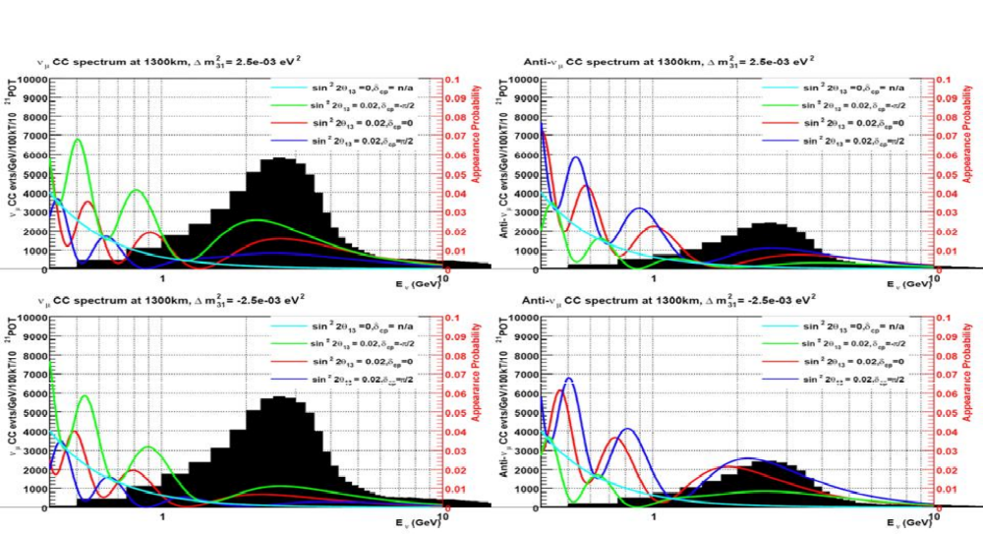
Figure 3.3.5.1 (top left) This figure shows an example of the rate of (unoscillated) ν_{μ} charged current events (black histogram, left vertical scale) versus log₁₀(energy(GeV)) from a wide band beam from Fermilab on a 100 kT WCh detector at DUSEL after 10 x 10²¹ POT, normal hierarchy. Approximately 20,000 charged current events would be collected for this exposure without oscillations. Plotted in color is the probability of ν_{e} events from oscillations (right vertical scale), assuming sin²2θ₁₃ =0.04, and one line (light blue) for sin²2θ₁₃ =0. The top right figure is the same as the left, except for antineutrinos. The two bottom figures are the same as the corresponding pictures in the top row, except for the inverted hierarchy.
3.3.5.2 Sensitivity Reach in LBNE
3.3.5.2.1 θ₁₃, Mass Hierarchy and δ_{CP}
This section describes the sensitivity for measuring θ₁₃, determining the mass hierarchy and measuring the CP phase for LBNE. Figure 3.3.5.2.1-1 shows the measurement ellipses and sensitivity limits for neutrino oscillation parameters. These limits are calculated for a total exposure of 60 x 10²⁰ POT for neutrino running and an equivalent period of antineutrino running. Because the live time of the experiment is ~100 sec per year (10 μs pulse × ~10⁷ pulses/year), the background from cosmic ray events is negligible. At the 1000 mwe depth, the number of cosmic ray events in a 100 kT water Cherenkov detector is about equal to the number of charged current events (see Table 3.3.5.2.1-1) and can be eliminated from topological considerations. At the 4850L, the number of cosmic ray events is negligible. Liquid argon detectors, because of their higher granularity, could operate closer to the surface for this physics measurement; however, full simulations are needed to determine the minimum acceptable depth.

Rate(Hz) | In-time  cosmic/yr | Depth  (mwe)
500 kHz | 5× 10⁷ | 0
3kHz | 300,000 | 265
400 Hz | 40,000 | 880
5Hz | 500 | 2300
1.3 Hz | 130 | 2960
0.60 Hz | 60 | 3490
0.26 Hz | 26 | 3620
0.09 Hz | 9 | 4290
Table 3.3.5.2.1-1 The rate¹ of cosmic ray muons in a 50-m height/diameter detector assuming a cos²θ distribution (there will be a small correction at the deepest levels). The second column is the number of cosmic rays in 10-microsecond-long pulses for 10⁷ pulses, corresponding to approximately one year of running, versus depth in meters-water-equivalent (mwe). The 4850L is equivalent to 4290 mwe.
Figure 3.3.5.2.1-1(a) shows the one- and two-sigma measurement ellipses for δ_{CP} and sin²2θ₁₃, as compared to the MC input value (“×”). Note that the error ellipses are roughly the same size independent of the value of sin²2θ_{13.} This is because as the value of sin²2θ₁₃ increases, the number of events increases, but the asymmetry decreases. These effects roughly cancel, so the sizes of the error ellipses do not change as a function of sin²2θ₁₃.
Figure 3.3.5.2.1-1(b) shows the three- and five-sigma sensitivity limits for sin²2θ₁₃≠0. This plot is made by calculating the number of events seen at the detector for each value of sin²2θ₁₃ and δ_{CP}, and comparing this number to the result where sin²2θ₁₃=0, for all δ_{CP}. One set of scatter plots is made for each of the two mass hierarchies, and the three- and five-sigma exclusion limits are drawn. The three- or five-sigma limit is taken as the minimal value of sin²2θ₁₃ that excludes both mass hierarchies at the desired level. Figure 3.3.5.2.1-1(c) is for the three- and five-sigma exclusion of the mass hierarchy, and is calculated in an analogous way to (b). Finally, (d) shows the exclusion plots for δ_{CP} as a function of sin²2θ₁₃. The two-lobed structure results, as there is no CP violation for δ_{CP} equal to zero or π. For comparative purposes, the sensitivity is usually quoted as the minimum value of sin²2θ₁₃ that excludes 50% of the δ_{CP} axis (0 ≤ δ_{CP} ≤ 2π). In the example shown, this occurs at sin²2θ₁₃= 0.01. Figure 3.3.5.2.1-2 shows the same limits for a 50-kT liquid argon detector.
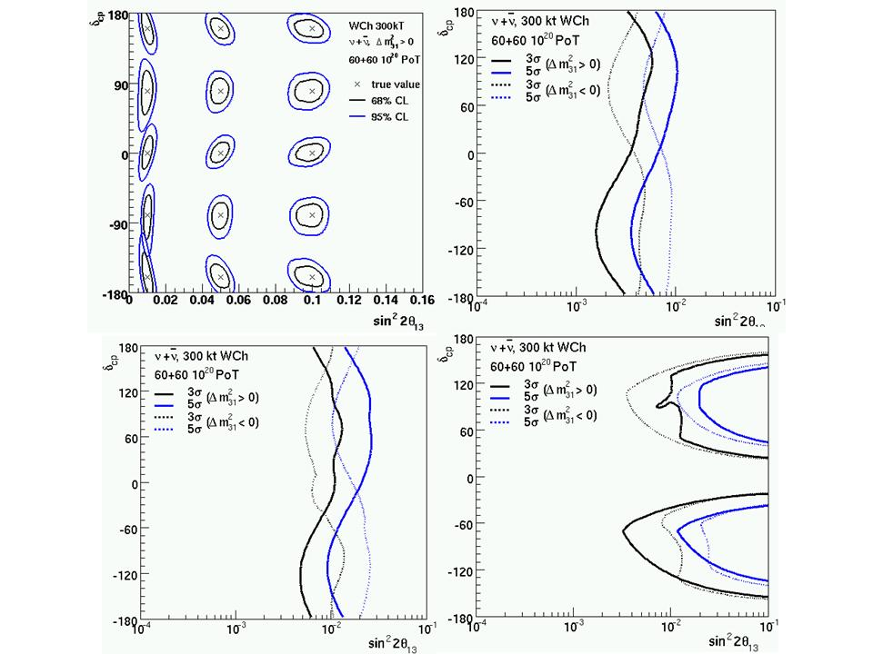
a
b
c
d
Figure 3.3.5.2.1-1 Discovery and sensitivity limits for neutrino oscillation parameters. a) One- and two-sigma measurements limits for δ_{CP} and sin²2θ₁₃ for a water Cherenkov detector. The “x” indicates the MC input value, and the one- (black) and two- (blue) sigma error ellipses are shown. b) The three- and five-sigma sensitivity limits for sin²2θ₁₃ ≠0. The three-sigma limits for both mass hierarchies are indicated. The solid set of lines is for the normal hierarchy, and the dotted set is for the inverted hierarchy. The three-sigma limit for either solution is indicated. c) Three- and five-sigma limits for measuring the mass hierarchy. The solid and dotted lines have the same meaning as in b). d) The three- and five-sigma exclusion limits for δ_{CP} as a function of sin²2θ₁₃ for both mass hierarchies. The line indicates where 50% of the δ_{CP} axis is excluded. The exposure is 60 (ν_{μ}) + 60 (‾ν_{μ}) x 10²⁰ POT for a 300 kT water Cherenkov detector. The limits on δ_{CP} for a water Cherenkov detector are similar, see Figure 3.3.5.2.1-2
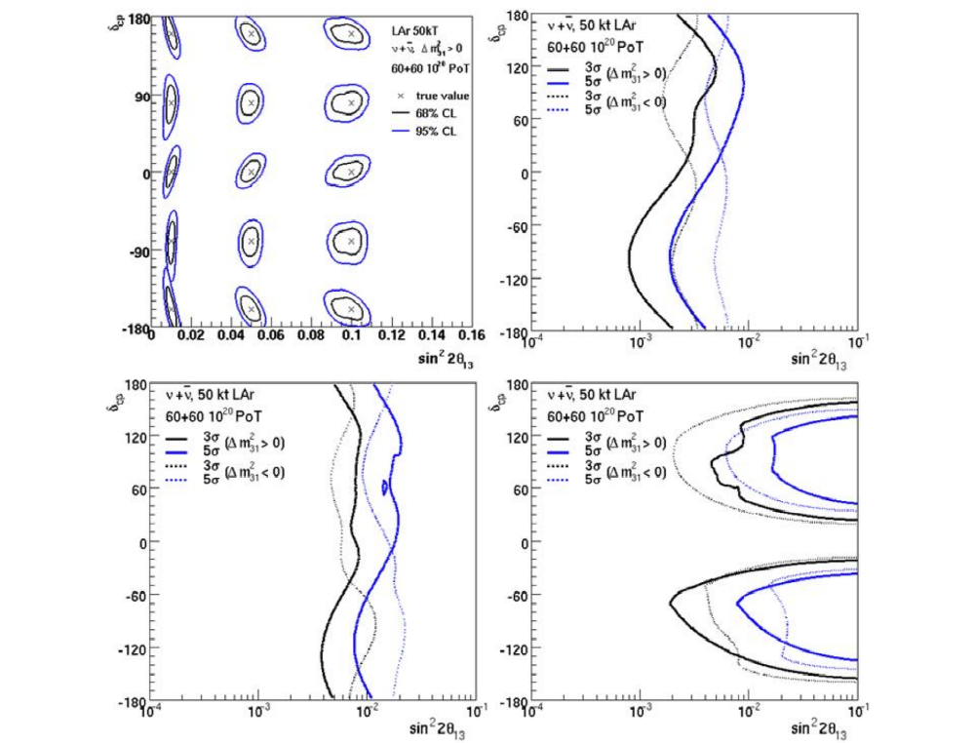
a
b
c
d
Figure 3.3.5.2.1-2 Sensitivity plots for a 50Kt liquid argon detector. The plots a-d are constructed in the same way as Figure 3.3.5.3.1-1, but for a LAr detector.
Table 3.3.5.2.1-2 shows a comparison of the sensitivity of the experiment for several different exposures and configurations. The results shown in Figures 3.3.5.2.1-1 and -2 correspond to the last two lines of Table 3.3.5.2.1-2. As can be seen by comparing these lines, for the purposes of measuring neutrino oscillation parameters, a 50-kT LAr detector is roughly equivalent to a 300-kT water Cherenkov detector.
Finally, Figure 3.3.5.2.1-3 shows the sensitivity of water Cherenkov and LAr detectors as a function of exposure, compared to two proposals from the past, a large liquid argon detector (100 kT) at Ash River in the United States (with an upgraded NuMI beam from FNAL), and the T2KK proposal, with large water Cherenkov detectors at Kamioka and in Korea. At this time, there are no proposals for neutrino oscillation experiments at nearly the same advanced stage of sophistication as LBNE.

Detector Size (kT) | POT (x10²⁰)  @120 GeV  (1 MW = 10²¹ POT/yr) | Years  ν ‾ν | 3 σ Sensitivity  Minimum value of sin²2θ₁₃
Detector Size (kT) | POT (x10²⁰)  @120 GeV  (1 MW = 10²¹ POT/yr) | Years  ν ‾ν | sin²2θ₁₃≠0 | Mass Hierarchy | CPV (50% of  δ_{CP} coverage)
H20 100  (Bishai) | 30+30 | 3+3 | 0.014 | 0.031 | >0.1
H20 300  (Bishai) | 30+30 | 3+3 | 0.008 | 0.017 | 0.025
H20 600  (Bishai) | 30+30 | 3+3 | 0.005 | 0.012 | 0.012
H20 300  (Bishai) | 60+60 | 3+3 | 0.005 | 0.012 | 0.012
LAr 50  (Dierckxsens) | 60+60 | 3+3 | 0.005 | 0.011 | 0.010
Table 3.3.5.2.1-2 Examples of the sensitivity to neutrino oscillation parameters for a variety of detector and beam configurations. The results shown in Figure 3.3.5.2.1-1 & 2 correspond to the last two lines of this table. As can be seen by comparing the last two lines, a 300 kT water Cherenkov detector has approximately the same sensitivity as a 50 kT LAr detector for these measurements. [Courtesy LBNE]
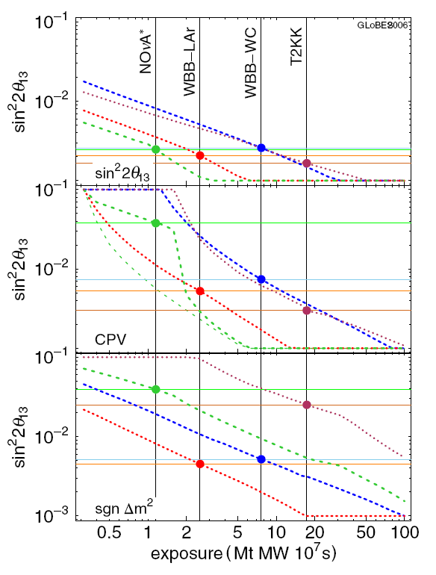
100kT LAr
Item | 100kT  LAr | WWB  LAr | WWB  WCh | T2KK  WCh
POT/yr x10²⁰ ( ν ) | 10 | 22.5 | 22.5 | 52
POT/yr x10²⁰ (‾ν ) | 10 | 45 | 45 | 52
Yrs ν +‾ν | 3+3 | 5+5 | 5+5 | 5+5
Power (MW) | 1.13 | 1 ( ν )  2 (‾ν ) | 1 ( ν )  2 (‾ν ) | 4
Baseline (km) | 810 (Ash River) | 1290 | 1290 | 295 + 1050
Mass (kT) | 100 | 100 | 300 | 270 + 270
Duty cycle | 0.54 | 0.54 | 0.54 | .32
Exposure: (Mt-MW- 10⁷ s) | 1.15 | 2.55 | 7.65 | 17.85
Figure 3.3.5.2.1-3 Sensitivity² for various detectors as a function of exposure, measured in terms of MT of target mass, MW of beam power, and 10⁷ seconds of live time. The parameters of the four proposals shown are listed in the table on the left, and their 3σ sensitivity is plotted on the right. The three sets of curves are for (top to bottom) sin²2θ₁₃≠0, δ_{CP}, and the sign of the mass hierarchy.
3.3.5.3 Nonaccelerator Physics and LBNE
The following sections discuss the capability of the proposed LBNE detectors to extend the search for proton decay and detection of other neutrinos
3.3.5.3.1 Detector Performance
Table 3.3.5.3.1 displays the efficiencies for two modes of proton decay detection for the water Cherenkov and LAr detectors and the estimated background for each detector and decay channel. The efficiency for the p→e⁺π⁰ channel is equal in the two detector technologies and is dominated by π⁰ absorption on the nucleus. The background for the water Cherenkov detector is estimated from the Super-K experience.

 | Water Cherenkov |  | Liquid Argon TPC
 | Efficiency | Background | Efficiency | Background
p→ π ⁰ e⁺ | 45% | 0.2 | 45% | 0.1
p→ νK⁺ | 14% | 0.6 | 97% | 0.1
Table 3.3.5.3.1 Summary of efficiency and background for the two decay modes for water Cherenkov detector and LAr. Background is quoted in terms of events per 100 kT/yr. The background for water Cherenkov is evaluated from Super-K experience and data for depth similar to or greater than Super-K (~2300 mwe). For liquid argon, the background is evaluated for ~300-800 mwe with large uncertainties.
In p→νΚ⁺ the efficiencies of the two technologies are quite different. In the water Cherenkov detector the charged kaon being below Cherenkov threshold in water is invisible. This mode is predominantly detected via the coincidence of a gamma cascade from the remnant ¹⁵N nucleus, and the detection of the μ⁺ and e⁺ daughters from the K decay. In the LAr detector, the kaon and its entire decay chain are visible, and the efficiency is estimated to be significantly higher, but background estimates are less certain because of the lack of experimental experience with a liquid argon detector, and the lack of a full simulation of a veto for cosmic background at shallow levels (300L-800L).
3.3.5.3.2 Sensitivity versus Time
To determine the sensitivity as a function of time, for a given detector mass (or evolution of mass) the needed inputs are: 1) signal detection efficiency, 2) background rate, 3) exposure starting date, 4) detector mass as a function of time, and 5) live-time assumptions. For a third-generation search such as LBNE, one needs to compare the potential reach to the integrated exposure that could be achieved by Super-K on the same time scale. Assuming no candidate events are found, by 2020 the Super-K exposure could be approaching 0.5 Mton-years, resulting in a limit on the proton lifetime of ≥ 2 ×10³⁴ years¹². Figure 3.3.5.3.2 shows the evolution of sensitivity, beginning in 2020, for several possible LBNE far detector configurations at DUSEL.
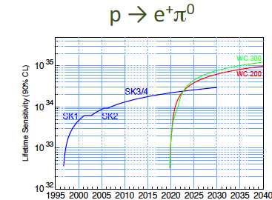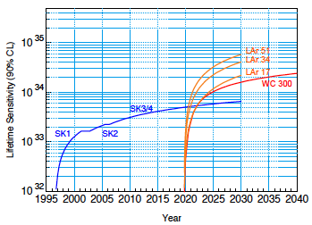
Figure 3.3.5.3.2 Proton lifetime sensitivity for two different decay modes. (Left) Proton lifetime sensitivity for the p→e⁺+π⁰ mode for Super-K (SK1-4), a 200 (WC200) and 300 (WC300) kiloton water Cherenkov detector. For this decay channel, a liquid argon detector must have the same mass as a water Cherenkov detector for the same sensitivity. (Right) Proton lifetime sensitivity for the decay p →‾ν K⁺ for the Super-K experiment, and a water Cherenkov detector of 300 kT or LAr detectors from 17 kT to 51 kT fiducial mass. [Courtesy LBNE]
3.3.5.3.3 Conclusion—Proton Decay
There are two potential “game changers” in the search for proton decay. The first is a discovery of supersymmetry (SUSY) particles at the Large Hadron Collider (LHC). This would provide extremely strong motivation to search for the modes involving kaons, in particular‾νΚ⁺. Second would be the emergence of candidate events in Super-K. This would clearly motivate a confirmation in a larger detector. With a 300-kT water Cherenkov detector, the limits on the p→e⁺+π⁰ increase by an order of magnitude. For the p → ‾ν K⁺ decay, a 300 kT water Cherenkov detector improves the Super-K limits by a factor of two to three over 10 years, and a 50-kT LAr detector by a factor of eight based on the assumption that it would have higher kaon efficiency. The addition of gadolinium to water could allow tagging of backgrounds that might appear with long-term running.
3.3.5.3.4 Galactic Supernova Bursts
A general description of the science goals related to detecting neutrinos from a nearby supernova has been provided in Section 3.2.4.2. For a supernova burst in the galaxy, there is a huge signal in the LBNE detector, as shown in Table 3.3.5.3.4. A 300-kT water Cherenkov detector is sensitive to supernova in the Andromeda Galaxy, with about 10 events in a 30-second interval.¹

Event type | Expected number of Events
Charged Current ‾ν_{e} |  | 60,000
Neutral Current ν_{x} |  | 3,000
Elastic Scattering ν_{e} |  | 3,000

Table 3.3.5.3.4 Rate of observed neutrino events in a 300 kT water Cherenkov detector for a supernova 10 kpc distant.
Note that the elastic scattering events indicate the direction of the supernova and allow comparison of the ν_{e} and‾ν_{e} flux. Both inverse beta decay and elastic scattering cross sections are known to better than 1% in this energy range on water (hydrogen), and the observed positron energy for inverse beta decay is a near-exact mirror of the spectrum of the parent neutrino flux. For elastic scattering, the outgoing electron energy is a simple convolution of the parent ν_{e} spectrum. Thus, flavor-resolved spectra can be extracted.
3.3.5.3.5 Diffuse Neutrinos from Relic Supernova
The goals for detection of supernova relic neutrinos (SRN) were given in Section 3.2.4.2. Though SRN models vary, according to one widely accepted modern analysis,¹ a 300-kT water Cherenkov detector located deep underground would permit a sensitivity limit of about 0.02 cm⁻² sec ⁻¹ (see Figure 3.3.5.3.5). The addition of Gd loading to the water would allow LBNE to tag the inverse beta decay events using the final state neutrons. This tagging will lower background from atmospheric neutrinos and other sources. As can be seen by the figure, the sensitivity limit of the water Cherenkov exceeds all theoretical predictions, and should be able to distinguish between several of them. These data would undoubtedly stimulate new theoretical (and perhaps even experimental) developments in the neutrino and cosmology communities.
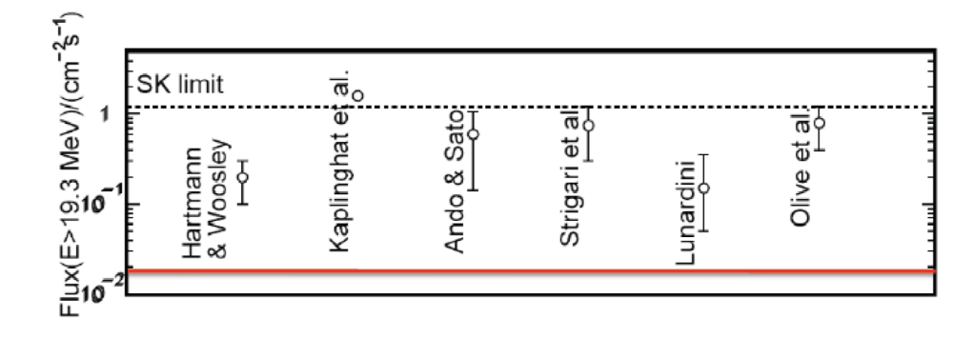
Figure 3.3.5.3.5 Comparison⁷ of the Super-K limit with theoretical estimates for the diffuse flux of neutrinos from relic supernovae. The solid (red) line at the bottom represents the expected sensitivity of a 300-kT water Cherenkov detector with a threshold of 15.5 MeV, compared to the Super-K threshold of 19 MeV.
3.3.5.3.6 Other Neutrino Science
The goals for future studies of solar and atmospheric neutrinos was described in section 3.2.4.3.
As an example, consider the predicted day-night asymmetry of neutrinos from the sun. These neutrinos pass through the dense core of the Earth at night, and the difference between the forward scattering amplitude of ν_{e}’s and the other flavors leads to a flavor transformation similar to that which occurs within the solar interior. As the beam from the sun arrives at the Earth, it is nearly a pure ν₂ state and therefore its flavor content is only 1/3 ν_{e}. The flavor transformation within the Earth thus leads to a net gain in ν_{e} content—the sun “shines brighter” in ν_{e}’s at night than during the day. A measurement of the day-night asymmetry can take several forms. At its simplest, an integral asymmetry measurement can be made:
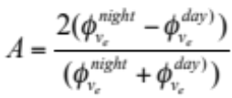
Currently, the measurements by the Super-Kamiokande and SNO collaborations on this integral asymmetry have found A = 0.021±0.02+^{0.013}_{−0.012} ¹⁵ and A = −0.037±0.063±0.032,⁸ respectively, each within 1σ of A = 0 when both statistics and systematics are included. For a 300-kton water Cherenkov detector, the event rate in the detector is roughly 130/day, and consequently the statistical precision on this asymmetry after a year should be significant, ~0.005, depending on the achievable analysis energy threshold. For the current best-fit large mixing angle (LMA) parameters, the integral asymmetry is expected to be near 0.02. More sophisticated analyses, involving fits to the energy and zenith-angle dependent survival probabilities, have already provided noticeably better measurements of the asymmetries in both Super-Kamiokande and SNO, and could be applied to a larger detector as well. The day-night asymmetry is expected to manifest itself at very low energies (<5 MeV in scattered electron energy). This measurement might require additional photosensors to have been installed.
Generally, the study with atmospheric neutrinos will not be as sensitive as the neutrino beam experiment, but atmospheric neutrinos will allow the possibility of revealing different physics. This is because the atmospheric neutrino sample covers five orders of magnitude in neutrino energy and three orders of magnitude in baseline, including long paths through matter. The atmospheric neutrino flux is a mixture of muon and electron neutrinos and antineutrinos. One expects 14,000 atmospheric neutrino interactions per 100 kton of detector mass per year. The majority of the atmospheric neutrino event rate occurs at neutrino energies below 1 GeV, where both water Cherenkov and liquid argon perform well. A liquid argon detector may have significant capability of identifying neutrino versus antineutrino by observing the recoil proton present in charged current neutrino scattering. This large sample of neutrino interactions allows for a comparison of the neutrino oscillation framework under different conditions than those presented by the long-baseline neutrino beam experiment.
3.3.5.4 Detector Depth Requirements
In 2008, the LBNE science collaboration made a detailed study of the depth requirements for the main physics topics of interest with large detectors—The Depth Document.⁹ The topics considered were accelerator-generated neutrinos, supernovae, solar and atmospheric neutrinos, and nucleon decay. The requirement on the depth of the detector is guided by the rate of the desired signals and the rate of backgrounds from cosmic rays over a very wide range of energies from solar neutrino energies of 5 MeV to high energies in the range of hundreds of GeV). Table 3.3.5.4 shows the overburden required for different physics processes for both technology options. Since this study was carried out, placement of the liquid argon detector at a relatively shallow depth such as 800 feet overburden has become a serious option, and inclusion of a veto around the detector may be successful to reject background at the shallower depth for proton decay and other non-accelerator physics.

Physics | Water | Argon
Long-Baseline Accelerator | 1,000 | 0-1,000
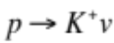 | >3,000 | >3,000
Day/Night ⁸B Solar | ~4,300 | ~4,300
Supernova Burst | 3,500 | 3,500
Relic Supernova | 4,300 | >2,500
Atmospheric | 2,400 | 2,400
Table 3.3.5.4 Depth requirements for physics measurements. The depth requirements in meters-water-equivalent (mwe) for different physics measurements and the two technologies being considered.⁸ For the LAr detector, the depth for proton decay assumes NO active muon veto. With an active cosmic ray veto, the LAr detector can be as shallow as 800L. Given the average rock density of about 2.7 T/m³ at Homestake, 1 mwe ~ 1 ft. overburden.
3.3.5.5 The LBNE Project
The LBNE project will comprise an intense neutrino source pointing toward a distant large detector and a much smaller detector located close to the source. The far detector must be a long distance (>1,000 km) from the neutrino source to increase sensitivity to neutrino oscillation parameters. A nearby detector close to the neutrino source is necessary to measure the initial composition of the beam.
LBNE’s target scope is to build a neutrino facility that uses a proton beam to produce a beam of neutrinos directed toward near and far detectors.
The preferred alternative for the neutrino source and near detector site is FNAL, as it has already developed the expertise for construction of neutrino beams as part of the Neutrinos at the Main Injector/Main Injector Neutrino Oscillation Search (NuMI/MINOS) project. The 700-kW upgrade of the FNAL proton source, a component of the current NOνA¹⁰ project, offers a platform from which to launch a new neutrino beam for a long-baseline detector. DUSEL is located at an optimum distance of 1,290 km from FNAL to detect neutrino oscillations.¹
The LBNE science collaboration currently consists of more than 250 scientists and engineers from 54 institutions that have come together to carry out an experiment using the facilities currently being designed for the LBNE Project at Fermilab and DUSEL. The collaborators come from universities and national laboratories, both from the United States and around the world. The collaboration encourages and anticipates further international participation.
The collaboration is in the process of putting together a science report to evaluate the scientific sensitivities and costs for potential variants of the experiment—what type of beam and detectors to use. The collaboration’s science report will provide input to the LBNE Project’s conceptual design.
3.3.5.5.1 The LBNE Beamline
The components of the LBNE neutrino beamline are designed to take a proton beam extracted from the Fermilab main injector and transport it to a target area, in which a neutrino beam is generated and aimed toward the far detectors. The neutrino beam will have sufficient intensity and a specific energy spectrum to meet the physics goals of the LBNE oscillation experiment.
The primary proton beam is extracted from the main injector at the same location where the beam is extracted for the presently active NuMI beam to MINOS. A short distance from the main injector extraction enclosure, the LBNE primary proton beam will be directed along a trajectory pointed west toward the DUSEL site.
The LBNE primary beam uses only conventional magnets with an optics design based on the FNAL main injector. The magnets are designed to transport the beam to the target with very low losses and an energy range of 60 to 120 GeV. Although the NuMI (and NOνA) beam operates at 120 GeV, the lower energy of 60 GeV may be preferred in some scenarios, depending on the level of background processes seen at the far detectors. To reach the far detectors, the generated neutrino beam must be aimed downward into the Earth at an angle of approximately 5.6 degrees, or 10% slope relative to the surface. Figures 3.3.5.5.1-1 and 3.3.5.5.1-2 show a plan view and a cross-sectional view of the beamline, respectively.
The primary proton beam is directed at an actively cooled target, whose interaction products are focused by a set of two horns. The focus provided by the horns maximizes the number of pions that can emit a neutrino in the direction of the far detectors. The pion decay volume in LBNE is a circular cross-section pipe, 4 m in diameter and 250 m long, with its axis pointing toward the far detectors. The preferred design has this pipe filled with air, although an alternative design uses a helium-filled pipe.
Non-interacting protons (~15%) and the non-decayed pions (or kaons) are absorbed in a specially designed aluminum and steel pile protecting the rock from beam-activated nuclides. The absorber occupies an excavated enclosure at the end of the decay pipe.
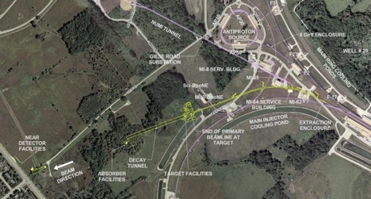
Figure 3.3.5.5.1-1 Aerial view of the Fermilab site showing the LBNE beam line (yellow) from the main injector to a target hall near the center of the figure. This is followed by a 4-m diameter decay pipe pointed at DUSEL. The near detector is at the lower left side of the figure close to the Fermilab west property line.

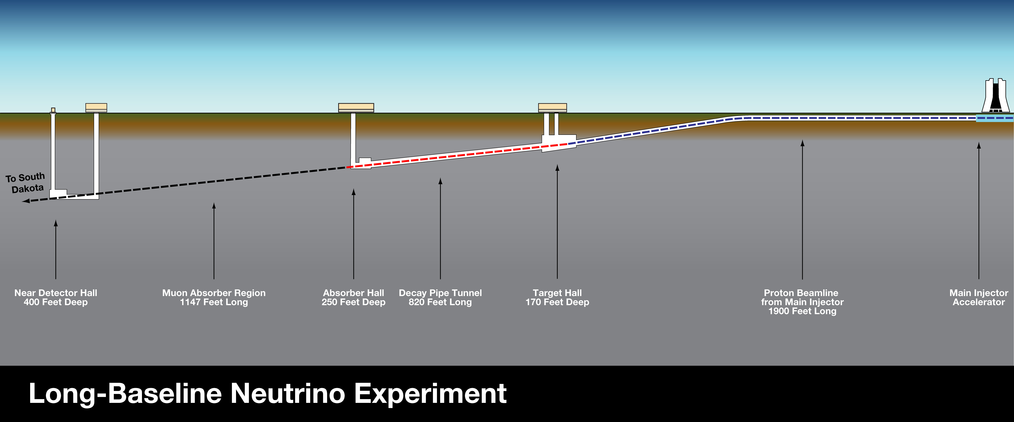
Figure 3.3.5.5.1-2 Vertical cut through the Fermilab site showing (right to left) the downward slope of the beamline, the target hall, decay pipe, and near detector complex.
3.3.5.5.2 The LBNE Near Detectors
The purpose of the near detector complex is to make measurements that are needed or useful for LBNE’s long-baseline oscillation physics analysis. Because the neutrino flux at the near detectors is greater than the flux at the far detectors, the near detectors can be much smaller than the far detectors and still be much more precise in their measurements.
The near detector complex has two primary goals: to measure the neutrino flux coming from the target before the neutrinos oscillate, and to measure the rate of background processes that might contaminate electron neutrino oscillations. The flux of muon neutrinos, electron neutrinos, and antineutrinos must be measured with very high precision. Whatever target material is chosen for the far detectors—hydrogen and oxygen (a water Cherenkov detector) or argon (liquid argon detector)—must be included in the near detectors so that accurate measurements of the fluxes and interactions with the target nuclei can be made.
Much is still unknown about how exactly the near detectors will be designed, and many parameters for the detectors must still be optimized. For DOE Critical Decison-1 (CD1), a cost and schedule range will be generated for several options. A fine-grained tracker is necessary to study backgrounds in detail. Designs being considered for that tracker are a scintillating tracker, like Main INjector ExpeRiment for v-A (MINERvA),¹¹ and a straw-tube tracker with transition radiation detectors. A Liquid Argon Time Projection Chamber (LArTPC) will be a necessary component of the near detectors if that technology is chosen for the far detectors. There are two options for an LArTPC for the near detectors: using Micro-Booster Neutrino Experiment (MicroBooNE)¹² or building a smaller magnetized LArTPC. To measure the flux, Michel decay detectors could be used, with the option of placing them in the alcoves or in the absorber. A threshold Cherenkov counter is also necessary for measuring the post-absorber muon flux—both its absolute rate and energy spectrum.
3.3.5.5.3 The Far Detector Technology
Three alternatives are being considered for the far detector configuration: two modules of water Cherenkov, two modules of liquid argon, or one of each. Figure 3.3.5.5.3 illustrates events from both technologies.
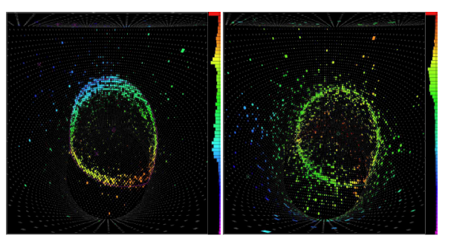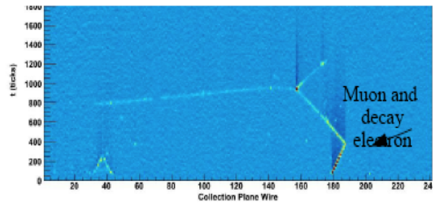
Figure 3.3.5.5.3 (Left) Response of a water Cherenkov detector to a muon track. Each dot represents a PMT, and the dot size indicates the number of photoelectrons per PMT. The colors represent the signal’s time of arrival, with a maximum time separation of ~150 ns. (Center) A Cherenkov ring from an electron passing through a water Cherenkov detector. The electron ring is “fuzzier” than the muon ring because of scattering of the electron as it passes through the water. [Courtesy of Super-K Collaboration] (Right) Muon decay in the ArgoNeuTt LAr detector. [Courtesy LBNE]
Some virtues of water Cherenkov as a technology for massive detectors are the relatively low cost, relative simplicity of design, and ease of operation. The active target medium is water, a very abundant, very cheap, easy-to-handle source for the target material with which to build the massive detectors. The wall of the water container is instrumented with photomultiplier tubes (PMTs) whose signals are read out with well-understood electronics, which includes charge to digital converters and time to digital converters. The PMT readouts are then used to analyze the arrival time and the number of photons produced by the Cherenkov radiation of charged-particle tracks in the water and detected by the PMTs to reconstruct vertex, direction, and energy of the track.
LArTPC is a newer technology under development for future beam-based neutrino research. This technology promises precise event reconstruction and particle identification, as well as potential scalability to large detectors. Preliminary simulations have indicated that liquid argon detectors perform with higher efficiency and better background rejection than water Cherenkov detectors. It has been suggested that a 50 kT liquid argon detector would have similar performance to a 300 kT water Cherenkov detector for some physics processes, e.g., neutrino oscillation physics. If this is accurate, one can build smaller liquid argon detectors to achieve similar results to larger water Cherenkov detectors for neutrino oscillation physics. Smaller detectors would require less excavated volume, which would potentially reduce costs. The advantages of smaller size are offset by the need for a cryogenic vessel and cryogenic liquid transport, the large channel count, ~1 M channels per 17 kT detector—and safety issues related to the large cryogenic liquid inventory. Significant additional work is required to demonstrate the performance ratio and cost comparison between the two technologies.
The LBNE project will develop conceptual designs, cost estimates, and construction schedules for both the water Cherenkov and the liquid argon detectors. For both technologies, it is assumed that the desired detector mass required to achieve the science goals of the experiment will need to be reached by modular construction, and a reference detector module has been specified for each. For water Cherenkov, the reference detector has a fiducial mass of 100 kT or a total mass of about 130 kT. Water Cherenkov detector modules will be sited at the 4850L. For liquid argon, the reference detector will have a fiducial mass of about 17 kT, or a total mass of about 25 kT. The preferred depth for liquid argon is 800 feet.
3.3.5.6 A Water Cherenkov Detector (WCD) for LBNE
3.3.5.6.1 Detector Elements
The size of a water Cherenkov detector is determined by three factors. First is the maximum transverse dimension allowed by the rock properties and appropriate ground support. Second is the maximum depth of the water, currently limited by the pressure tolerance of the PMTs to ~60 m depth. Finally, the maximum transverse distance between any two PMTs is limited by the clarity of the water to ~80-100 m. The good uniformity of rock stress in the horizontal plane leads to the current reference design of a cylindrical cavern, with a water diameter and depth of 53 m and 60 m, respectively. The total mass of water is 130 kT, and with a 2.5-m fiducial cut around the boundaries (including PMTs and their mounting), the total fiducial volume is 100 kT. Studies are under way to understand if different cavern geometry is more cost effective than the current reference design for a fixed total mass. Studies include a larger-diameter cavern, a different shape to minimize excavation cost, and increasing the cavern depth by a suitable PMT enclosure.
The scientific goal is to have a total of about 300 kT of detector fiducial mass. This total fiducial mass is best achieved with multiple detectors because:
- It would be technically challenging to excavate a single cavern of 300 kT volume.
- Excavating multiple chambers in parallel is considerably faster than excavating a single enormous chamber, even if that were technically feasible.
- Construction of these multiple modules can be phased as funding evolves.
- Multiple chambers permit at least one detector to be active all the time. While one detector is taking data, any other single detector can be running calibrations, down for scheduled maintenance or occasional nonscheduled maintenance. By staggering scheduled calibrations and maintenance between detectors, one can ensure that only one detector is “off the air” at any given time. This is essential for supernova detection, for example.
- Each of the detector modules can be optimized for different scientific investigations while still maintaining sensitivity to the basic items listed above. For example, one of the detector modules can be instrumented for low-energy sensitivity with an increased photocathode detection area and/or Gd loading or with a veto region to allow a lower trigger threshold.
The DUSEL LBNE water Cherenkov reference design consists of two very large excavated cavities in a very strong and stable rock formation, each cavity lined with a smooth, watertight liner and then filled with extremely pure water. Each PMT will be connected via single cable carrying both high-voltage (HV) and signal to readout electronics above the water.
An extensive water-purification plant has been designed to fill the detector in about three months, and to repurify one volume of water in about one month. The system includes features to remove the heat from the water as shown in Table 3.3.5.6.1-1. Adding insulation on the deck at the 4850L can significantly reduce the thermal load on the water-cooling system.
Item | Value
Ambient rock temperature | 33.4 deg C at 4850L
Water temperature | 13 ± 2 deg C
Heat influx from rock | 53 kW
Heat influx from PMTs | 15 kW
Heat influx from dome (no insulation) | 33 kW
Estimated total heat inflow | ~100 kW
Table 3.3.5.6.1-1 Temperatures and thermal flux in the water Cherenkov reference design.
Excavation and Liner. Table 3.3.5.6.1-2 lists the physics and safety requirements for the water Cherenkov detector. Various design assumptions and the dimensions of the chamber are shown in Tables 3.3.5.6.1-3 and 3.3.5.6.1-4, respectively. The excavation diameter is determined by the strength of the rock that encloses the cavity. For our reference design, LBNE has assumed a 55-m diameter excavation as shown in Figure 3.3.5.6.1-1.
Item | Value | Reason
Total volume of WCh detector (assumes foreign participation for 100 kT WCh equivalent) | ≥300 kT | Neutrino oscillation parameter measurement, proton decay
Minimum fiducial volume (FV) per cavity | ≥100 kT | Scientific competiveness
Maximum distance between cavities | 5 km perpendicular to neutrino beam | Neutrino beam opening angle
Maximum depth of water above lowest PMT | 60 m | PMT collapse under water pressure
Depth of cavity below surface | 4850L | Cosmogenic background to proton decay
Maximum distance between any two PMTs | 80 m | Water attenuation length at peak PMT wavelength sensitivity when convoluted with Cherenkov light spectrum
FV cut | 2 m from PMT photocathode, top bottom and sides | Cosmic ray rejection
Cavity lifetime | ≥30 years | Proton decay, neutrino oscillation parameter measurement
Egress | Dual egress from drifts and cavities during all phases of construction and operation | Personnel safety
Water management | Inherently protect the remainder of the DUSEL facility from catastrophic failure of the water containment | Personnel, equipment, or facility safety
Water temperature | 13 deg C ± 2 deg C | Reduce biological growth
Temperature and humidity of dome air | ~22 deg C ± 4 deg C, 40% ±10% RH. | Standard DUSEL ventilation air temperature
Code requirements | DUSEL Doc. EHS-29-200-L5-01 | Personnel, equipment, or facility safety
Table 3.3.5.6.1-2 List of requirements for the water Cherenkov detector.
Assumption | Value
FV | 100 kT
Shape, based on Homestake rock properties and Super-K experience | Right cylinder
Minimum diameter of water | 53 m
Buffer size, PMT +FV cut (radially and axially, based on Super-K experience) | 2.5 m
Allowance for drainage and liner (sides and bottom) | ~1 m
Allowance for freeboard and deck (top only) | 2 m combined
Top of deck | Level with 4850L
Table 3.3.5.6.1-3 Assumptions used to design water Cherenkov detector excavation volume.
Item | Specification
Shape | An unobstructed right cylindrical volume free of rock outcroppings or ground support *
Free diameter | 55 m*
Top of right cylindrical | Level with the 4850L
Free height from (possibly virtual) flat floor to 4850L | 64.3 m*
FV | 48 m diameter by 55.3 m high, 100 kT FV
Lifetime | >30 years
Water temperature | ~13 deg C ± 2
Dome air temperature & relative humidity | ~ 22 deg C ± 4 deg C, 40% ± 10% RH
* Follows from assumptions
Table 3.3.5.6.1-4 Water Cherenkov cavern physics specifications.
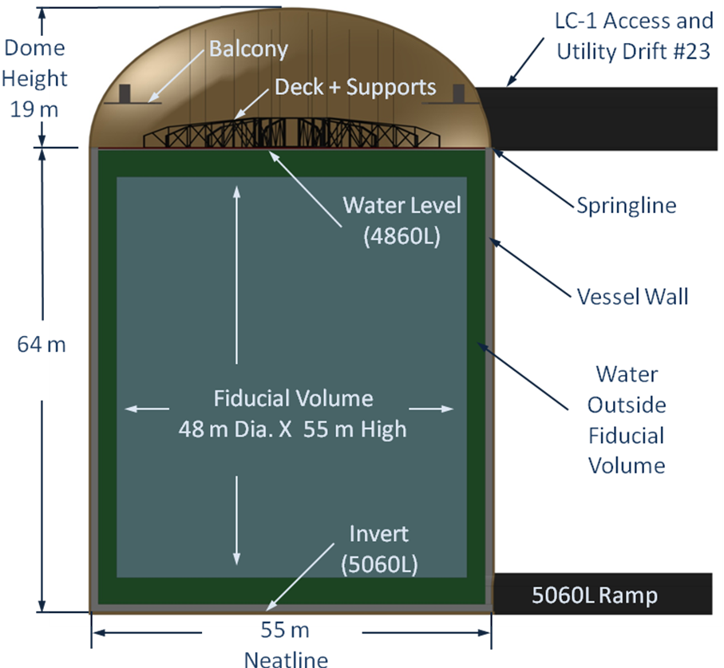
Figure 3.3.5.6.1-1 Drawing, corresponding to the physics specification of Table 3.3.5.6.1-4, showing the cross section through the water Cherenkov detector for the reference design. The dimensions are in meters. [Courtesy LBNE]
The main function of the watertight liner is to provide an absolute barrier between the highly purified water (ASTM Type 1, ultra purified water) in the detector and any underground water that might seep into the excavations.
Two liner concepts have been explored: a liner that is directly mounted on the inner rock of the excavation or a self-supporting structure independent of the rock. The liner attached to the rock has been defined as the reference design as it maximizes the fiducial volume for a constant excavation size, and is cheaper to build.
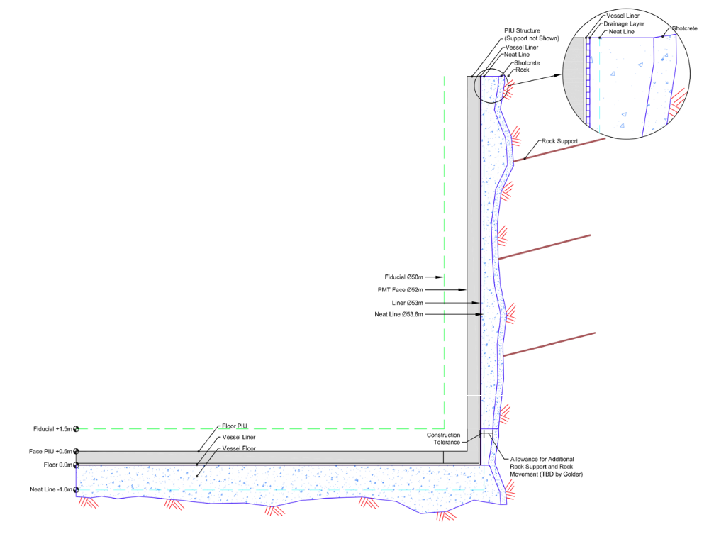
Figure 3.3.5.6.1-2 Preferred vessel design integrated with rock. [Courtesy CNA Consulting]
Photodetectors. Recent Cherenkov detectors have used photomultipliers of various diameters, ranging from 20 cm to 50 cm. LBNE is focused on tubes in the 25-30-cm diameter range. This range seems to provide the maximum signal-per-unit cost, considerably reduced risk of implosion compared to the 50-cm diameter tubes used by Super-Kamiokande, and a reasonable number of tubes per module. The base design calls for 50,000 photomultiplier tubes (with high quantum efficiency photo-cathodes) per 100-kton fiducial mass module. This design corresponds to photocathode coverage sufficient to collect 5% of light emitted by events in the fiducial volume. However, this number will ultimately be adjusted as more information is obtained about PMT performance achievable by the various potential vendors and how it relates to cost.
Photomultiplier mounting and signal cables. The natural mounting structure for the photomultiplier tubes is the watertight liner. Using this liner avoids the construction of a separate costly and space-consuming framework while providing a strong, rigid, and stable support. The most attractive approach is to mount a number of tubes onto one frame and then attach that frame to the liner. The number of tubes per frame will depend on the tube spacing and a reasonable weight and size frame. Typical numbers of tubes per frame unit are six to nine. Ideally, the tube mount will avoid torques on the tube due to the buoyancy of the spherical section and the long power/signal cable at the end of the tube.
One of the critical issues is to minimize the risk of tube implosion and to prevent propagation of the implosion to adjacent tubes in case one tube does implode. There are a number of approaches to a solution, ranging from total tube enclosure, encasement in a shock-wave-dampening shield, to a shock-wave deflector between tubes. The choice of approach will depend on the results of various implosion shock-wave studies now under way and on the pressure resistance of the tubes of the various vendors.
Readout electronics. There are two possible approaches to the readout electronics. One is to locate electronics for batches of tubes (e.g., 16 tubes per batch) underwater, adjacent to the tubes. This reduces the cable length between tube and readout electronics but makes access to the electronics and maintenance extremely difficult.
The other approach is to locate the electronics on a deck directly above the water detector and link each tube to the electronics with a cable. The most distant tubes—those in the center of the bottom of the detector—will require a cable of 80-100 m. In previous detectors, all tube-to-readout electronics cables were of equal length. Using the equal-length cable approach for this detector will generate several thousand kilometers of cable slack. The storage of that amount of cable can become a major space issue. The reference design for the detector assumes equal-length cables. This option remains under study. A black sheet separates the active volume of the water forward of the PMTs from the annular volume that contains the PMT supports. This will prevent reflections from the supports from creating false hits in the detector. This annular volume behind the PMTs is being considered as a “thin veto” for cosmic rays or through-going particles. We are studying whether this would allow using more of the fiducial volume for the LBNL physics by allowing us to tag rock interactions versus contained muons originating from ν's in the beam.
Water fill, recycling, and cooling. The surface-water processing system has been designed to purify about 1,000 liters/minute of fill water, resulting in a total fill time of several months. In addition, the system will recycle the detector water through a repurification system at a rate about five times higher. Figure 3.3.5.6.1-3 shows a 3D-CAD isometric drawing of the repurification plant located on the 4850L near the detector. The purification requirements for this detector are within the normal range of commercial systems, similar to those of previous water Cherenkov detectors.
The planned temperature of the water is about 13°C. This will reduce the photomultiplier electronic noise and inhibit biological growth in the detector. This water temperature requires both that the initial fill water be cooled from its surface temperature and that the recycled water be cooled to remove the thermal energy due to heat flow from the rock and heat input from the photomultiplier bases. The internal rock temperature prior to excavation at the 4850L is about 33°C. As the excavation proceeds and increasing cavity surface area is exposed to air, the near-surface rock will cool with the surface rock approaching the ventilation air temperature. Reasonable estimates are that by the time the detector is filled with water, the heat flow from the rock will be between 50 and 100 kW. The photomultiplier bases are likely to add another 10-20% to this heat flow (see Table 3.3.5.6.1-1). A significant heat flow into the detector will come through the top surface from the room air contact. Insulation at this surface may be necessary.
Veto counters. Although the cosmic-ray-muon flux is very low at the depth of this detector, about four muons per day per m², the large aperture of each module, about 2 ×10³ m², will still result in a significant muon flux through each 100 kT module—approximately 0.1 Hz, the muons very peaked in the vertical direction. Thus, a veto counter placed directly above the top set of photomultiplier tubes and directly beneath the top deck of the detector can veto a significant fraction of the incident cosmic-ray muons.

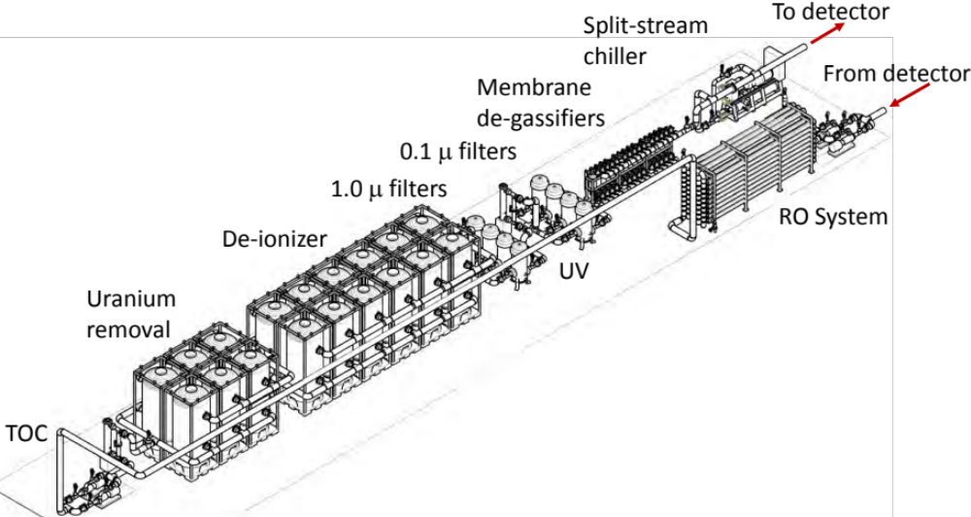
Figure 3.3.5.6.1-3 Drawing of ~4500 lpm water recirculation system. [Courtesy LBNE collaboration]
Fiducial volume definition. The photomultiplier-tube-mounting structure will include a black-light shield at the equatorial plane of the photomultiplier tubes, that is, at the largest diameter of these tubes. That light barrier will separate any Cherenkov light generated in the outer annular region of the detector from light that is generated in the central detector cylinder. The present plan is to then define the fiducial-volume limit to be 2 meters radially inward from this light barrier. Since this is a software definition, it can be dynamically varied once the detector is in operation and events are being reconstructed. It is even possible to define different fiducial volumes for different signals.
Calibrations and monitoring. The energy scale and linearity, energy resolution, directional dependencies of energy scale and resolution, and the stability of the energy calibrations must all be well understood in order to achieve the physics goals. The goal for energy scale uncertainty is 2% or better in all energy regions (MeV to GeV). The energy calibration can be accomplished by a combination of naturally occurring events inside the detector as well as dedicated sources deployed at various locations inside the detector volume. Cosmic-ray muons can be used in the energy range of hundreds of MeV to several GeV. For low-energy calibration, radioactive gamma and beta sources, a low-energy linac (5-16 MeV) as well as Michel electrons can be used as sources. A novel laser-wake electron accelerator is being considered for high-energy calibration in the range 100 MeV to 1 GeV.
A centrally located LED diffuser ball will be used for timing and charge calibration. The PMT timing should be calibrated to better than 1 ns over a pulse height range of 1-1000 photoelectron (PE). After charge calibration, the uncertainty in number of PE in each PMT over the range of 1-1000 PE should be <10%.
The water transparency needs to be continuously monitored. An attenuation length of 100 m or more must be measured to 5-10%. Muons or LEDs inside the detector could be used. Alternatively, the attenuation length could be measured for samples of water in an external system, specially designed or commercially available.
Other environmental variables that will require monitoring include water temperature, the flow rate and pattern of water circulation, water level, pH, resistivity, total dissolved solids, radon, magnetic fields, and biologics.
Computing. The computing requirements can be divided into three categories: online, offline, and infrastructure. Online computing includes processing the raw data received from data acquisition (DAQ) system, run control, and detector monitoring.
The offline computing group will take care of simulations, reconstruction software, and official production data processing. Infrastructure supports the efforts of the online and offline groups by providing a software framework and data archive, and assuring adequate hardware and network connectivity.
Installation and integration. Coordination of the construction of the chamber and the installation of the detector components will be challenging. The laboratory hoist system imposes constraints on the mass and volume of materials that can be brought underground. The underground detector-staging area and detector-chamber entrance require careful coordination and sequencing of the lowering of detector components. There are concerns about interactions of dust associated with chamber excavation, installation of the chamber liner, drilling of holes for the photomultiplier mounts, and the protection of the “clean” components of the detector, photomultiplier tubes, electronics, and water-handling system. Fortunately, simulations of the installation sequence and process can easily be carried out and optimized. A clean surface-staging area will be required. It will also be necessary to specify the degree of cleanliness required by each of the detector components and what restrictions these requirements impose on the installation process.
3.3.5.6.2 Alternatives and Options
Electron antineutrinos are products of supernovae, and background rejection at the low-energy cutoff imposed by solar neutrinos can be improved via the double coincidence of inverse beta decay reaction: 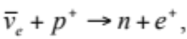 with the prompt positron detected through its Cherenkov radiation, and the neutron via delayed capture (~30 μs) on gadolinium (probably in the form of gadolinium sulfate, ~0.1% Gd by weight) in the water, releasing a cascade of photons with total energy ~8 MeV of energy of which ~6 MeV is detected by the PMTs. The successful detection of inverse beta decay depends on the Gd doping of the water. Neutron capture on a proton only releases a single 2.2 MeV photon, which is not detectable in the water Cherenkov detector.
There are two main technical issues regarding the Gd doping of the water:
Water recirculation and purification. The recycling of the water through the purification system will remove the Gd salt, so the system will have to remove the Gd before the water reaches the purifier and then redissolve the Gd after purification. Also, there may be light attenuation due to Gd and questions about materials of construction that are in contact with the Gd. A test system that will address these questions is now under construction at Kamioka. Although Gd is not in the baseline detector design, it would be desirable to avoid materials in the detector construction that interact with the Gd salts to preserve this option for the future.
Larger photocathode coverage. Based on Super-Kamiokande’s experience, LBNE believes at least 20% photocathode coverage with normal quantum efficiency tubes is desirable to realize the major physics goals of the experiment. However, the possibilities for low-energy physics (e.g., solar and supernova neutrinos) would be greatly enhanced by increased photocathode coverage.
Increased fiducial volume. The single-most critical parameter of the DUSEL water Cherenkov detector array is the total fiducial volume. There are two issues here. One is the maximum volume of rock that can be safely excavated at reasonable cost. The second is the maximum number of such modules that can be constructed. The goal is to get as close to 300-kton fiducial mass as possible. For example, an increase of 10 m in the excavated diameter of a chamber results in a 44% increase in fiducial mass for that chamber. Since the excavations for these detectors are already the largest deep-underground excavations, this question must be approached with considerable caution. A study by Golder Associates on alternative cavern designs indicates that maximum allowed cavern diameter from geotechnical considerations is 65 m. Mail box style caverns with flat walls are discouraged. A 65-m diameter cavern would allow a 150-kT fiducial volume detector as a single, right, vertical cylinder, meeting all other technical specifications for the detector (maximum PMT depth in water, transmission length underwater, etc). Current and planned R&D on the PMT implosion, including PMT enclosures to protect them from implosions of adjacent PMTs, could allow the depth of the water to increase, permitting 65-m diameter caverns as large as 200-kT fiducial mass. The Golder alternative cavern shape document is currently being considered at by the collaboration to understand how to best optimize the cavern shape and size, the distribution and coverage of PMTs in the fiducial volume and value engineering studies to minimize the overall cost for the equivalent physics reach.
3.3.5.6.3 Overall Underground Layout and Facility Resource Requirements
Figure 3.3.5.6.3-1 shows a plan view of the 4850L and 5060L large cavity and related spaces. Explicit space has been provided to accommodate the water-purification plant, including maintenance considerations. Apart from the large cavity (LC), there is about 1,300 m² of other space on the 4850L related to LBNE activities. Figure 3.3.5.6.3-2 is an isometric view of the dome area, showing the cable penetrations and electronics racks and magnetic compensation for the Earth’s magnetic field. The magnetic field compensation maximizes the PMT efficiency and also reduces the asymmetries in the detector efficiency. If the Earth’s field is not compensated, there is a 10-15% efficiency loss per PMT.
The utility drift holds the electrical room for the LC, the HVAC room, the control room, and calibration storage room. Not shown in the diagram is a radon-abatement system (or LN2 plant) for suppressing radon between the deck and the water.
On the 5060L, sumps are needed to collect native and detector water, and pumps to recirculate the water to the purification system. In the event Gd is added to the water, there will be a small Gd recovery plant at this level to remove Gd from water leaking from the detector volume. Table 3.3.5.6.3 lists the facilities requirements for one water Cherenkov detector.

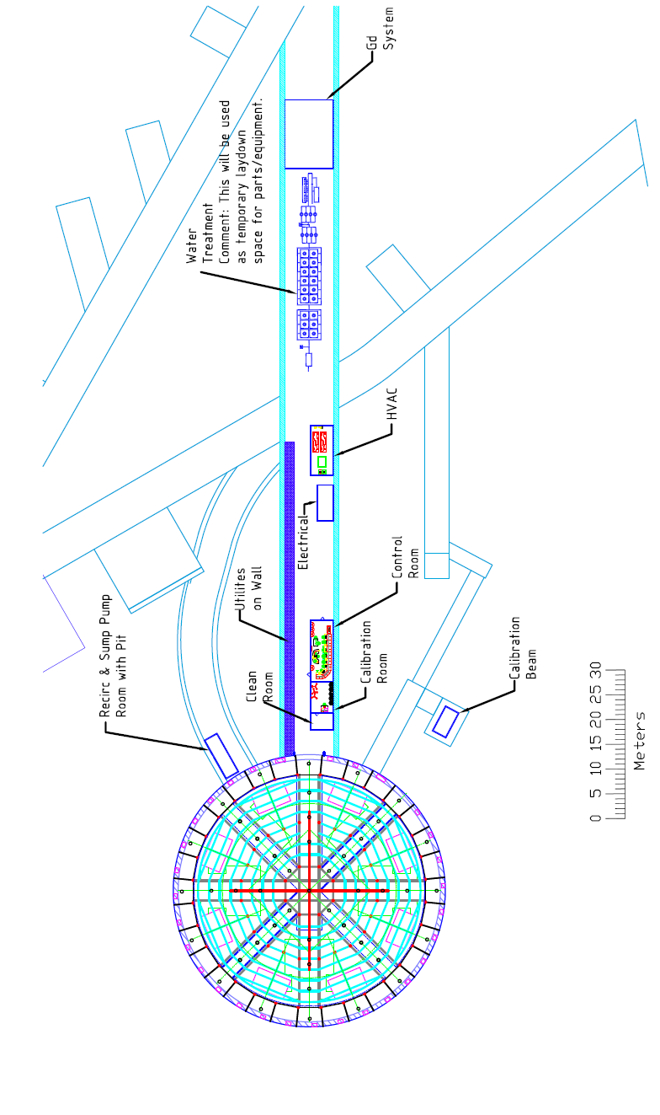
Figure 3.3.5.6.3-1 Plan view of the 4850L and 5060L appropriate for the LC1 and related facilities. The water-purification room shows the known layout of the purification/recirculation plant. The utility room shows the HVAC room, electrical room, control room, and calibration source room. Not shown in this area is a clean room next to the LC1 and a radon-abatement plant or LN2 plant for suppressing radon under the deck.

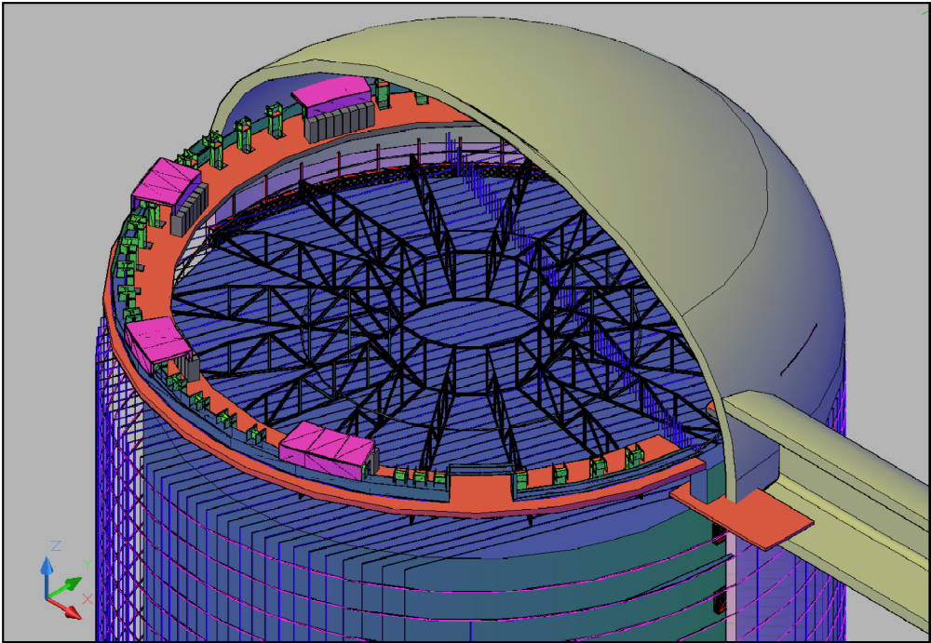
Figure 3.3.5.6.3-2 Isometric view of the dome of the LC1. There is a “balcony” (red) around the perimeter of the cavity about 3 m above the 4850L. The balcony supports the cable penetrations around the perimeter (green) and the eight sets of electronics racks. The deck is supported by large trusses that are in turn mostly supported from the rock above the dome. The total load on the rock above the dome is ~ 600 T. The trusses are oriented so as not to obscure the entrance from the utility drift, the calibration drift, or calibration ports in the deck itself. The narrow, circumferential black lines and the black lines running down the side of the cylindrical volume represent the magnetic compensation cables for canceling the Earth’s magnetic field within the cavern.

Requirement | Value/Description | Comment/Justification
Layout
Depth | 4850L at deck top, base at 5060
Footprint [m²] | 2206 | 53-m diameter water, excavation is to 55 m, area is for one LC only, without utility or H₂0 purification areas
Height [m] | 83 | Top of dome at 83 m above bottom neat line; springline at 4850L, 64 m above bottom neat line
Floor Load [kPa] | 1667
Total Underground Area, including LC1 [m²] | 4267
Total Surface area [m²] | 3181
Utilities
Power [kW] | 2248 | Underground power only--does not include surface power requirements. Power for 1 LC only.
Standby Power [kW] | 110 | Sump pump + partial control system.  Power for 1 LC
Chilled Water [kW] | 1411 | Sump pumps are assumed to reject 85% of heat into the sump water, 15% heat to HVAC. Heat for one LC.
Waste Heat to Air [kW] | 691 | Heat for 1 LC
Purified Water [m³] | 138,000 | LBNE owns this system, quantity is for 1 LC
Surface Power [kW] | 771
Industrial Water | 600 gallons / minute on the surface | To feed the surface water purification system
Potable Water | Not defined
Compressed Air | Not defined
Network [Gb/s] | 10 | 1 dedicated line per cavity
Environment
Temp. Min [⁰C] | 18
Temp. Max [⁰C] | 25
Humidity Min [%] | 30
Humidity Max [%] | 50 | Guidance given that humidity is key requirement with 50% as target and minimum to be 30% with temperature secondary consideration
Rn Background [Bq/m³] | TBD
Occupancy
Peak Installation Occupancy [count] | 50
Installation Duration [months] | ~24
Peak Commissioning Occupancy [count] | TBD
Commissioning Duration [months] | 6
Peak Calibration Occupancy [count] | 5
Average Calibration Occupancy [count] | 2
Calibration Duration | 1 day/month
Operation Duration [months] | >360
Cryogens
LN Storage | 100 kg dewar | For calibration
LN Consumption | 100 liter/week
Transportation Quantity  per dewar [kg] | TBD
Transportation Frequency [shipments per week] | 1
Major Hazards (Other than Cryogens)
 | Flooding, ultrahigh-purity water is toxic, gadolinium is possible additive that might be considered toxic, falls, drowning, rock collapse, fire, electrocution
Assay and Storage
Assay Needs | TBD
Underground Storage | NA
Table 3.3.5.6.3 Facilities requirements for the water Cherenkov detector.
3.3.5.7 The Liquid Argon Detector
3.3.5.7.1 Liquid Argon Technology
The very large water Cherenkov detector included in the conceptual design for LBNE is an extension of current technology, particularly of Super–Kamiokande. This section describes a different technology: Liquid Argon Time Projection Chamber (LArTPC). While at least one 600 T LArTPC exists (Imaging Cosmic and Rare Underground Signals [ICARUS]), it does not have the same level of operational experience as Super–Kamiokande. A LArTPC features notable strengths. First, it enables detailed, reconstructed images of neutrino-scattering events, which leads to a high level of background rejection. Second, it allows for comparatively localized event topologies, which lets the detector simultaneously measure multiple events from, for example, cosmic rays, and distinguishes between them. More specifically, LArTPC technology provides:
- Highly accurate differentiation of electrons vs. photons by high-resolution measurements of electromagnetic shower development in the vicinity of the interaction vertex
- High-resolution reconstruction of the recoil hadronic shower, including nuclear debris
- Excellent sensitivity to low-energy hadrons that are below Cherenkov threshold in water
Current understanding indicates that a LArTPC detector can be located at a moderate depth (∼800 feet) and still achieve sufficient rejection of cosmic-ray-induced background, even for non-beam-event related studies, such as the searches for proton decay and supernova neutrinos. In addition, LAr pattern-recognition capabilities make this technology more efficient. The physics observational capabilities of a LAr detector for neutrino oscillation studies may be comparable to those of a much larger water Cherenkov detector, which provides less-detailed information about events. Although the exact equivalence factor between LAr and water Cherenkov technologies depends on specific event topologies, simulation studies suggest that a LAr detector has equivalent physics reach (for neutrino oscillation studies), to a water Cherenkov detector approximately six times larger in mass.
While LArTPC technology is promising because of its likely high spatial resolution and excellent measurement of deposited ionization along isolated tracks, it clearly requires development and operational experience. It is also important to assess the scalability of this technology to masses of as much as 10⁵ tons that may be required for future neutrino experiments. Currently, only simulations are available that show LBNE can do νK⁺ proton decay channel at 800 feet and trigger the LAr detector for SN or proton decay. There is no information at all on spallation product backgrounds. No large-scale LAr detector has yet given actual numbers on these important issues.
3.3.5.7.2 A LArTPC Implementation for LBNE: The LAr20 Detector
The LBNE Conceptual Design Report describes a particular LArTPC implementation, the LAr20 Detector. The LAr20 conceptualization has a total mass of 25 kT and a fiducial mass of 16.7 kton. High-purity LAr serves as both the neutrino target and the tracking medium for the particles produced in the interaction. The overall dimensions of the active volume are 15.0 m wide (in x) by 14.0 m high (in y) by 71.1 m long (in z, the beam direction).
The LAr20 Detector will identify neutrino events through the observation of the outgoing charged particles resulting from neutrino interactions in the LAr. A uniform electric field in the LAr volume will cause ionization electrons produced by the passage of these charged particles to drift to three wire planes. The electric potentials of the three wire planes will be arranged such that the electrons will pass through the first two planes, and be collected on the third. The passage of electrons through the first two planes will produce induced, bipolar signals on those wires. The deposition of electrons on the third plane will produce negative unipolar pulses. “Cold” electronics within the LAr20 vessel will amplify the signals on each wire and continuously digitize the amplified waveforms at 2 MHz. The proposed LAr20 wire pitch in all planes is 3 mm; therefore, LAr20 position resolutions will be at the millimeter scale. The trajectory of particles in the detector will be reconstructed from the known wire positions and the arrival times of electron signals on the wires, combined with the time the interaction took place in the detector. The amplitude of the ionization electron signals measures the energy loss of the particles, which enables an estimate of their momentum and particle type.
The main features of the LAr20 Detector are shown in Figure 3.3.5.7.2. Selected parameters are given in Table 3.3.5.7.2. Major sources of power and cooling are listed in this table. However, the design of the LAr detector lags with respect to the water Cherenkov detector: Many of the detailed parameters and impact on the DUSEL facility have not yet been developed.
Parameter | Value | Unit | Note
Wire Spacing | ~3 | mm | Typical
No. of Wire Planes | 3 |  | Wire orientations per module
Stereo Angle | 0, +45, -45 | deg
Drift Distance | 2.47 | m
Wires per Module | 5520
Readout Channels | 30 |  | 128 times multiplexed
Module Size | 5 x 7 x 2.5 | m³ | (X x Y x Z)
UV Wire Length | 9.9 | m
UV Wire Capacitance | 238 | pf | In LAr
Electric Field | 500 | V/cm | X direction
Max. Drift Voltage | ~125 | kV
Maximum Drift Time | ~1.5 | ms
Module Volume | 87 | m³
Module Active Mass | 0.122 | kT
X,Y Fiducial Cut | 0.3 | m
Z Fiducial Cut | 1.5 | m | End modules
Module Fiducial Volume | 73 | m³
Module Fiducial Mass | 0.102 | kT
Number of Modules | 3 x 2 x 28 = 168 |  | (X x Y x Z)
Total Fiducial Mass | 16.4 | kT
Total Readout Wires | 645120
Total Readout Channels | 336 |  | 2 optical fibers per APA
Cryostat Dimensions | 16 x 16 x 74 | m³ | (X x Y x Z) [15 x 14 x 71.1 m³, active volume only]
Total Mass LAr | 25 | kT
Cryostat Insulation Thickness | ~1 | m
Cryostat Insulation Heat Loss | 36 | kW
Max Recirculation Rate | 163 | m³/hr
LAr Volume Turnover | 5 | days
LN2 Refrigeration Plant Capacity | 59 | kW | ARUP conceptual report
LN2 Storage Dewar | 50 | m³ | ARUP conceptual report
LN2 Backup Capacity | 40 | hours | ARUP conceptual report
Table 3.3.5.7.2 Selected parameters of the LAr detector reference design. The X direction is horizontal and perpendicular to the beam, Y is vertical, and Z is horizontal near the beam direction. This design is the preferred current design of different concepts.
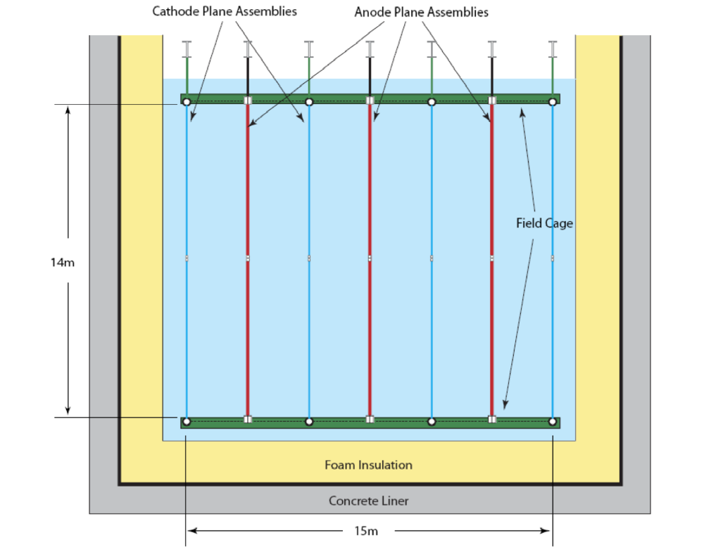
Figure 3.3.5.7.2 Cross section through the LAr cryostat, indicating the foam liner, field cages, anode plane assemblies, and cathode plane assembles.
Figure 3.3.5.7.2 shows the overall layout of the LAr Time Projection Modules (TPM). Each TPM will consist of two cathode planes and a central Anode Plane Assembly (APA) of the same size. The maximum drift distance will be 2.5 m. The TPMs will be arranged to share cathode planes, so that in the “x” direction, there will be four cathode planes interleaved by three APAs to form three TPMs. Thus, in all, the LAr20 Detector will have 168 APAs and 224 cathode planes.
The LAr20 cathode planes will be held at an electric potential of ~ -125 kV to create an electric field of 500 V/cm between the cathode and anode planes. This field will produce an electron drift velocity in the LAr of 1.6 mm/μs. Each APA will contain four planes of wires in a wrapped configuration. The wire planes are: the grid plane, induction plane 1, induction plane 2, and collection plane. The purpose of the grid plane is solely to improve the effectiveness of induction plane 1; it will not be instrumented with readout electronics. In total, LAr20 will have 654,065 readout wires and 282,240 grid wires.
A “field cage” constructed of copper-plated circuit-board material will surround each row of cathode planes and APA. The purpose of the field cage is to shape the electric field in the LAr to ensure uniform electron-drift trajectories near the detector edges. A resistor chain between the cathodes and anodes will establish the electric potential of the field.
A major feature of LAr20 will be the use of cryogenic, or “cold,” electronics. Signals from each wire channel will be amplified, shaped, and digitized by the analog section of integrated electronics, mounted directly on the APA and within the cryogenic volume. The digital section of these same electronics will provide zero-suppression and 128-fold multiplexing. Multiplexed signals will be routed by optical fibers through cryogenic feedthroughs, located at the top of the cryostat. A local computer cluster will provide triggering and event selection. Data will be stored at the detector location and also transported to Fermilab and other collaborating institutions for archival storage and offline analysis.
A single cryostat will house all the TPMs, containing the LAr at a temperature of 87 K and insulating it from external heat. Conceptual design studies resulting in this report suggest that the optimal choice for cryostat design is a single “membrane cryostat.” The most notable feature of a membrane cryostat is the use of a thin metallic liner to contain the liquid argon. The metallic liner will be constructed of 1.2 mm-thick stainless steel, corrugated in both directions to enable thermal expansion and contraction. The liner will attach to insulation units constructed of plywood boxes filled with polyurethane foam. The plywood will be “marine grade,” typically used for the construction of boats. The hydrostatic load of the liquid argon will transfer through the liner and insulation to the walls of the cavern, resulting in a highly efficient use of the excavated cavern volume. A secondary liner will provide an annular space for argon gas purges. A tertiary liner will prevent groundwater infiltration. Membrane cryostats have been used for ocean transport and onshore storage of liquefied natural gas for several decades.
The LAr in the membrane cryostat will be cooled by a cryogenics system located primarily on the surface. Insulated cryogenic piping will connect the surface refrigeration plant with the underground cryostat and LAr purification system that must be located adjacent to the cryostat. A surface location simplifies installation and maintenance and minimizes Oxygen Deficiency Hazard (ODH) because of the enhanced possibilities for air circulation and venting. Redundant LAr pumps, located inside the cryostat, will be used to recirculate the LAr through the purification system.
Drifting electrons over several meters requires minimizing electronegative contaminants in the liquid argon. Water vapor and oxygen are the major sources of electronegative contamination. The maximum design electron-drift time is 1.54 ms. The design electron lifetime is 1.4 ms. The design equivalent-O₂-contamination is 214 ppt. Contaminants will be removed by recirculating liquid argon through molecular sieves and copper filters. Purity monitors at the filter outlets will monitor their effectiveness. Argon flow will be diverted to a second set of filters when the first set is saturated. Circulating a 95% argon-5% hydrogen gas mixture through them at elevated temperature will regenerate saturated filters. Argon gas boil-off from the top of the detector will be reliquefied by a condenser and purified before it is returned to the cryostat.
The detector electronics will be configured to enable both continuous and triggered data acquisition. A trigger may be initiated by either a beam-spill signal from Fermilab or a signal from a scintillation light-detection system. A beam spill will trigger data acquisition from the entire detector. Upon initiation of a photon-detector trigger, only wires in the vicinity of the source of the scintillation light will be read out. Signals from some processes of physics interest (e.g., relic supernovae) may be below threshold for the light-detection system. Continuous readout of the detector will enable the study of such processes, given sufficient computing resources to store and offline-analyze the large amount of data that will be generated in a continuous readout mode.
3.3.5.7.3 LAr20 Detector Location
The depth for the LAr20 Detector location represents a trade-off between physics background and detector size and cost. For a fixed-dollar budget, LBNE must choose between a larger detector at shallower depth (due to lower cost per ton), or a smaller one placed deeper underground. The former offers higher potential measurement capability due to size, whereas the latter offers minimization of cosmic-ray-induced backgrounds due to depth. For detector optimization, the layout of the Homestake mine suggests strong consideration of three possible depths:
- 300 feet. At this shallow depth, approximately horizontal access is possible by constructing tunnels from the canyon east of the Yates Shaft. However, cosmic ray background, including from both the east and west sides, is likely to complicate non-neutrino beam measurements.
- 800 feet. At this moderate depth, cosmic ray background is reduced from that at the 300-feet level by about a factor of 10, by both increased vertical overburden and a depth profile that in percentage terms is more flat and less like a mountain. Adding an active shield to the LAr20 detector at this depth may provide physics sensitivity for a range of beam and nonbeam experiments competitive with the same detector at 4850 feet. Primary access to the LAr20 Detector Laboratory would be through a decline road tunnel, thus mostly isolating LAr20 from shaft contention with other DUSEL activities.
- 4,850 feet. This location at DUSEL’s most active level would significantly limit the rate of background events and remove the necessity for an active shield. The LBNE executive board concluded that the ~$100 million necessary to install the LAr detector at the 4850L was not justified by the physics benefit. It will not be pursued further.
The conceptual design process concluded that the most favorable depth for LAr20 is the 800L. Compared with the 4850L, the preferred 800L simplifies both access and the cryogenics system design, and reduces the possibility of shaft-access contention with DUSEL and its other experiments.
Figure 3.3.5.7.3-1 shows possible locations of the LAr surface facilities with respect to the DUSEL campus structures. The main access would be via an adit near the Kirk Portal that descends via a 12% grade to the 800L in a spiral. Two LAr caverns could be located not far from the Ross Shaft at this level. Figure 3.3.5.7.3-2 is an isometric view of the caverns and ramp system. Two caverns are shown, but one or two could be constructed depending on the technology choice for the experiment. Finally, Figure 3.3.5.7.3-3 shows a cross section, approximately perpendicular to the beam direction, through a single LAr cavern. The membrane cryostat is located below the normal access/working level, and the ~1-m thick insulating cryostat walls are supported from the rock. Figure 3.3.5.7.3-4 is an isometric view of a cross section through the membrane cryostat.
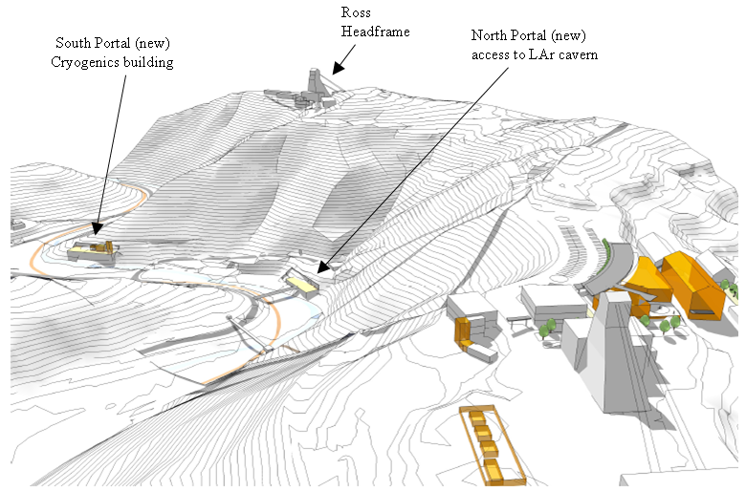
Figure 3.3.5.7.3-1 Isometric view of the DUSEL campus showing a possible layout of the LAr surface buildings on the DUSEL campus. The caverns are accessed by a spiral ramp system with a portal at the Kirk fans (300L) that connects to the 800L, and from there to the Ross Shaft for secondary. [Courtesy LBNE collaboration]
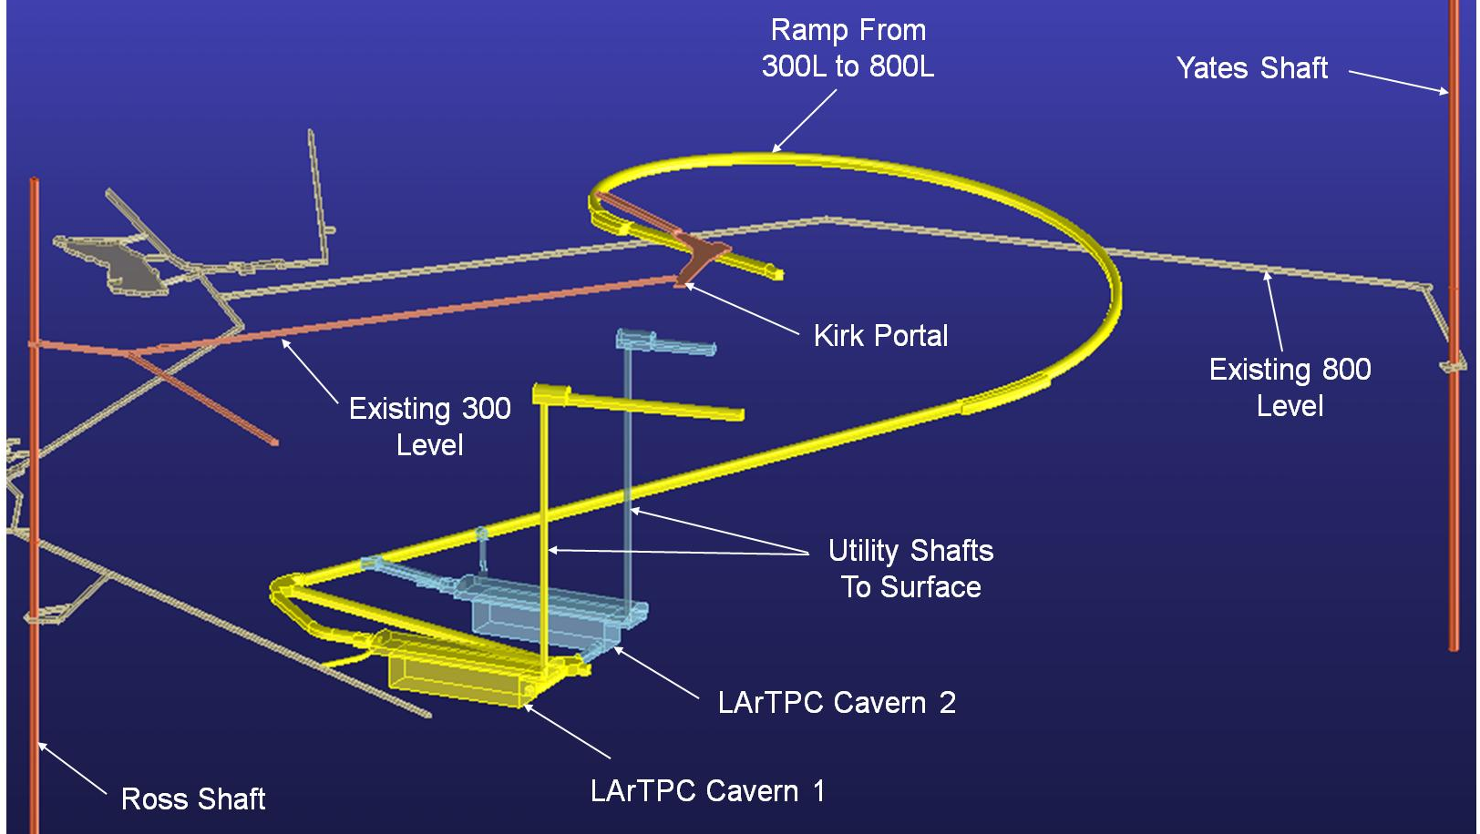
Figure 3.3.5.7.3-2 Isometric view of two caverns for liquid argon detectors. Shafts from the caverns connect to new drifts at the 300L for utilities and venting. The ramps to the upper (right) side of the caverns are for normal experimental access. The ramps connecting to the bottom of the caverns are for construction access and would be plugged prior to operations. The connection to the 800L allows the Ross Shaft to act as an emergency access. [Courtesy LBNE]
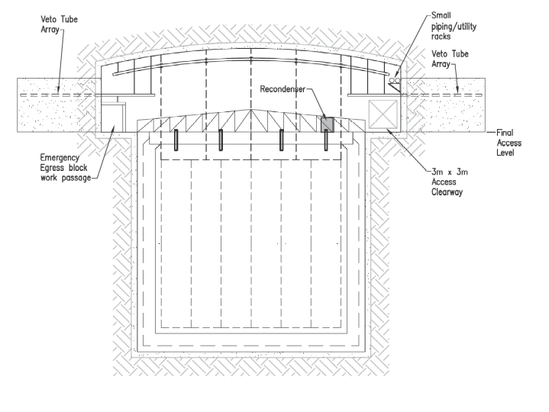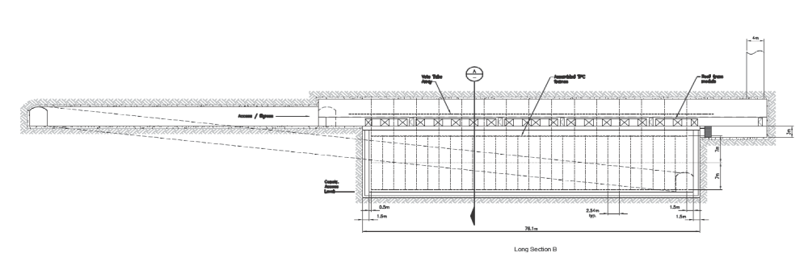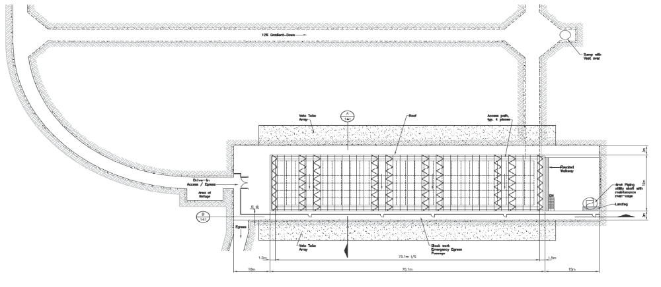
Figure 3.3.5.7.3-3 (Top) Cross section through a LAr cavern, approximately perpendicular to the beamline. The detector is in a pit below the normal access level (i.e., working level) of the cavern, and the membrane cryostat walls are supported from the rock. (Middle) Long section of the LAr cavern, showing the main access at floor level, the vent borehole on the right side, and construction mucking drift (dotted diagonal lines). (Bottom) Plan view of a LAr detector, showing the top of the cryostat and the emergency-egress pathways. An emergency-access corridor along one long side of the cavern (lower edge of cavern in this view) with doors every ~20 m allows sheltered evacuation of workers to the ramp system in event of a catastrophic failure of the LAr containment. [Courtesy LBNE]
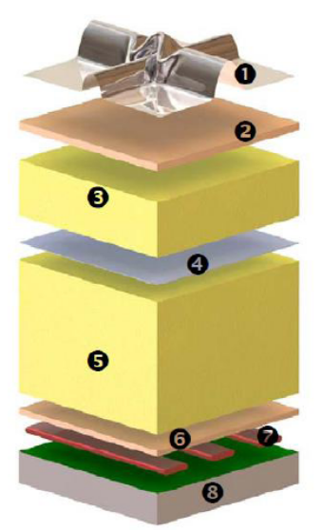

Figure 3.3.5.7.3-4 Isometric view of one possible construction for the membrane cryostat. The parts, from top to bottom are:
1) stainless steel primary membrane,
2) plywood board,
3) reinforced Polyurethane foam,
4) secondary barrier,
5) reinforced polyurethane foam,
6) plywood board,
7) load-bearing mastic, and
8) concrete covered with moisture barrier.
[Courtesy LBNE]

3.3.5.8 Detector Options
The ultimate physics goals of the LBNE Science Program cannot be met with a single detector module of either water Cherenkov detector (WCD) or liquid argon (LAr). This leads to the consideration of several options for the configuration of detector modules that can meet the project’s physics goals. Configurations being considered range from two to three water Cherenkov modules with a total fiducial mass of 300 kT, up to three liquid argon modules with a total mass of around 50 kT, or a hybrid arrangement of modules. The LBNE Project has been advised by the JOG Working Group¹³ that the anticipated level of U.S. funding for the LBNE project would potentially support the construction of two detector modules, each of a size equivalent to the performance of a 100-kT fiducial mass water Cherenkov detector. With this constraint, there are three configurations being pursued between the DOE CD-0 and CD-1milestones. Each row of Table 3.3.5.8 shows a possible configuration with either one or two detector types:
Number of WCD Detectors | WCD Fiducial Mass (kT) | WCD  Depth (ft) | Number of LAr Detectors | LAr Fiducial Mass (kT) | WCD LAr  Depth (ft)
1 | 100 | 4,850 | 1 | 17 | 800
0 | n/a | n/a | 2 | 17 | 800
2 | 100 | 4,850 | 0 | n/a | n/a
Table 3.3.5.8 The three possible detector location options for LBNE funded from DOE/NSF. A third detector is possible with foreign contribution. .
The additional cost (~$100 million) of locating a LAr detector at 4850L was not considered worth the physics benefit; however, a shallow location for the LAr detector means an extensive veto system to combat background from cosmic rays in proton decay, particularly neutral kaons produced in the adjacent rock, that undergo charge exchange in the LAr to produce an isolated K⁺, mimicking the p → K⁺‾ν decay chain. The LBNE science collaboration is developing reference detector configurations. These configurations include three 100 kt equivalent detector modules and take into account various combinations of technology, and energy thresholds (for water Cherenkov) via photomultiplier coverage (15 to 30%), as well as the possibility of adding gadolinium to the water to enhance neutron capture rates.
Determining what makes the most sensible arrangement for the experiment depends on the results of determining the cost and construction schedule for each technology, and it is planned that a down-select be made on the timescale of CD1.
3.3.5.9 Schedule
Advancing the schedule for LBNE and DUSEL will require close coordination between the LBNE project office and the DUSEL facility in order to carefully choreograph the work necessary for both projects. In this vein, it is important that technological decisions by the LBNE project be made in close coordination with the DUSEL schedule so that delays and extra costs are minimized.
To this end, the LBNE scientific collaboration has organized a set of working groups to document¹⁴ the physics reach and sensitivity for a complete collection of science goals versus each configuration choice (water Cherenkov, water Cherenkov detector with Gadolinium added, LAr, etc.) at the depth believed appropriate for each technology. The science topics include neutrino oscillation physics, proton decay, supernova detection, diffuse neutrinos from relic supernovae, solar neutrinos, ultra-high energy neutrinos, and neutrinos from other astrophysical sources. Using this information, the collaboration, in conjunction with LBNE project management, will make a recommendation on the down-select among the various options, with the expectation of making a configuration choice on the time scale of CD-1.
Clearly it is to the advantage of LBNE to make a technology and depth selection in a timely way so that the progress of both LBNE and DUSEL are not compromised, and the optimum utilization of shared resources can be realized. It is anticipated that the geotechnical work for the large cavities can begin in FY 2011, after the configuration choice is made, including the drilling of boreholes and related laboratory work to assess the rock quality in the vicinity of the proposed location of the large cavities. For siting of the LAr detectors at the 800L, the geotechnical investigations would begin in late FY 2011 or FY 2012.
If water Cherenkov detectors are selected, the excavation of LC-1 begins in FY 2016 and outfitting ends in FY 2018, after which installation of the water vessel, its liner, and the deck can proceed. From the schedule, the long lead item is PMTs, and their procurement begins in 2013, assuming DOE approves CD-3a together with CD-2. Ongoing value engineering studies are considering the possibility of installation of the water vessel in parallel with the cavern excavation. For the two caverns listed in the schedule, commissioning of the experimental equipment for the first would begin in 2021 and the second in 2022.
If a LAr detector is selected, excavation could begin in 2015 after CD-3 approval. The excavation and outfitting duration is about 2.5 years. This would be followed by three years of detector installation with installation of the cryogenic systems, followed by detector installation and filling with liquid argon. Commissioning of the experimental equipment would begin in 2020.
3.3.6 Nuclear Astrophysics
Nuclear astrophysics is concerned with nuclear processes in stars and stellar explosions through charged-particle, neutron, and weak interaction-induced reactions. Critical questions are associated with the origin of elements during the history of our universe, with the sources of neutrino signals from the core of stars and distant supernova explosions, the energy production during stellar evolution and stellar death by explosion, the lifetime of stars and the timescale of stellar explosions. Experimental goals are to identify characteristic new observational signatures associated with stellar processes for neutrino detectors to gamma ray observatories. Experimental nuclear astrophysics is characterized by four major directions: nucleosynthesis processes in stars, which are studied with very low-energy accelerator experiments; explosive nucleosynthesis processes, which require measurements far from stability with radioactive beams; neutron-induced nucleosynthesis in late stellar evolution, which is pursued at reactor and neutron spallation facilities; and, finally, neutrino-induced nucleosynthesis processes, which are still largely confined to theoretical prediction and observation.
The Dakota Ion Accelerators for Nuclear Astrophysics (DIANA) facility proposed for DUSEL is a next-generation underground nuclear astrophysics accelerator laboratory designed to overcome the experimental limitations of existing state-of-the-art experiments (e.g., the Laboratory for Underground Nuclear Astrophysics [LUNA] at the Gran Sasso Laboratory).^{1,2} Once completed, the DIANA facility will take the leading role in the measurement of critical nuclear-reaction processes at or near stellar-temperature burning conditions. The requirements for the accelerators have been derived from the scientific objects developed by the international astrophysics community.³ In particular, the described underground accelerator facility will address three fundamental scientific issues in stellar nucleosynthesis: 1) solar neutrino sources and the metallicity of the sun; 2) carbon-based nucleosynthesis; and 3) neutron sources for the production of trans-Fe elements in stars. These are three long-standing, potentially transformational questions of relevance for the understanding of our sun and the chemical evolution of our universe, as outlined in the following section.
3.3.6.1 Nuclear Astrophysics Experiments
Low-energy proton capture and alpha capture reactions have been the focus of intense experimental studies for many decades. However, at the low stellar temperatures associated with these environments, the reaction cross sections are extremely small because of the high Coulomb barrier. This has handicapped all the experimental studies so far and only one of the critical processes, the ³He(³He,2p)⁴He reaction in the pp-chains, has been successfully measured in the solar energy range,⁴ in its Gamow window. Nearly all of the “experimental” stellar reaction rates are based on the extrapolation of experimental data, which have been measured at significantly higher energies into the Gamow range.³ These extrapolations often carry enormous uncertainties, since they require a detailed knowledge of the nuclear structure of the compound nucleus near the particle threshold, as well as a detailed knowledge of the reaction mechanism, different reaction components, and interference effects near the thresholds. These uncertainties often span many orders of magnitude and translate into substantial uncertainties for nucleosynthesis simulations as well as simulations of stellar evolution scenarios.
The experimental difficulties in determining the low-energy cross sections are caused by large background rates associated with cosmic ray-induced reactions, background from natural radioactivity in the laboratory environment, and the beam-induced background on target impurities.⁵ An underground location has the advantage that the cosmic ray-induced background is reduced by several orders of magnitude, allowing the measurements to be pushed to far lower energies than now possible. This has been clearly demonstrated at LUNA by the successful studies of critical reactions in the pp-chains⁴ and first reaction studies in the CNO cycles.⁶
LUNA is currently the only operating underground facility in the world² but there are initiatives for future underground accelerator laboratories in India, Romania, and Spain. An upgrade of LUNA is being discussed in Italy, since the facility has been extremely successful and has convincingly demonstrated the importance and the advantages of underground accelerator experiments. However, the present LUNA facility is small and limited to the measurement of proton capture reactions below 400 keV with typical proton beam currents between 90 and 400 μA.² This is sufficient for capture measurements at low Z target nuclei, but higher beam currents are necessary to extend these measurements into the higher Z range, which is important for stellar burning in massive stars and even in explosive Mg-Al burning in novae. Alpha capture measurements require substantially higher energies than available at LUNA.
The key novel features of this new facility compared with existing ones will be:
- The facility will consist of two accelerators that will cover a wide range of ion beam energies and intensities, with sufficient energy overlap to consistently connect the results to measurements above ground.
- The facility beamlines will provide beam to the target stations from both the low and the high energy accelerators. This will allow a particular reaction to be measured with both accelerators in complementary energy ranges with identical target and detector setups. This feature will overcome a major experimental limitation of the currently conducted experiments² and will allow DIANA to provide consistent high-precision data over a wide energy range.
- Additional independent target stations are planned for the 3MeV accelerator for conducting two experimental campaigns simultaneously or preparing the next experimental campaign. This feature will greatly enhance the ability to carry out the planned science program timely and efficiently, and addresses one of the current limitations at the LUNA facility, which has only one target station available, since the experimental setups are difficult and time consuming.
- Both accelerators are designed to be able to incorporate ECR ion sources to increase the beam energy or to vary the accelerated ions (from hydrogen to heavier elements). This unique feature will allow expansion of the scientific goals in the future.
- The 400-keV low-energy accelerator will be a major technology advance with regard to ion-beam intensity on target in order to address the low count rates close to the Gamow window energies. Advanced target and detector technology will be developed in order to take advantage of its high beam currents.
3.3.6.2 Nuclear Astrophysics Candidate Experiments
DIANA, the only candidate experiment, has been proposed by a U.S. collaboration whose goal is to install and operate a deep underground nuclear astrophysics accelerator facility. Led by the University of Notre Dame (UND), it includes the Colorado School of Mines (CSM), Lawrence Berkeley National Laboratory (LBNL), University of North Carolina at Chapel Hill (UNC), Regis University (RU), Michigan State University (MSU), and West Michigan University (WMU), all having long, distinguished histories in nuclear astrophysics experimentation. They have combined their expertise to develop a state-of-the-art next-generation facility, designed to support a long-term (30+ year) rich and versatile nuclear astrophysics program at DUSEL.
The infrastructure requirements for the DIANA underground accelerator facility at DUSEL are shown in Table 3.3.6.2.
Requirement | Value/Description | Comment/Justification
Layout
Depth | 4850L
Footprint | 45m L x 17m W | Area usable by experiment
Height [m] | 15 | 19 m max usable height at high-energy accelerator dome, see text for details
Floor Load [kPa] | 12 | Live load, 3,000 lb concrete requested
Utilities
Power [kW] | 1500
Standby Power [kW] | 100
Chilled Water [kW] | 1200
Waste Heat to Air [kW] | 300
Purified Water [m³] | 0
Potable Water [lpm] | Nominal use
Compressed Air | Nominal use
Network [Gb/s] | 1
Environment
Temp. Min [⁰C] | 20
Temp. Max [⁰C] | 25
Humidity Min [%] | 20
Humidity Max [%] | 30
Rn Background [Bq/m³] | 30 – 100 | Experiment to provide Rn scrubbing to achieve
Crane
Max. Load [Short Ton] | 10
Occupancy
Peak Installation Occupancy [count] | 20
Installation Duration [months] | 24
Peak Commissioning Occupancy [count] | 12
Commissioning Duration [months] | 18
Peak Operation Occupancy [count] | 6
Operation Duration [months] | >360
Cryogens
LN Storage | 200 L
LN Consumption | 100 L/day | Access to a LN₂ refilling station is requested (ideally at the 4850L)
Major Hazards (Other Than Cryogens)
High Voltage | 400 kV  60 V  5 kV | Low-energy accelerator power supply  Magnets power supply  Detector power supplies
Compressed Gases | H, He, N, Ne, Ar | Small quantities, <1L at STP, injected into ion sources
Pressure Vessels | SF₆ 4700L at 6 bar | High-energy accelerator tank, SF₆ storage tank
Asphyxiation | SF₆ 4700L at 6 bar
Radioactive Sources | Low activity sealed types
Assay and Storage
Assay Needs | Nominal | Access to Low Counting Facility for material and detector selection
Underground Storage | TBD | Low Rn storage area during installation (short term)
Table 3.3.6.2 Summary of the DIANA facility requirements.
3.3.6.2.1 Location and Space Requirements
The minimum depth required to achieve successful science goals for an underground nuclear astrophysics accelerator facility should be at least similar to the 3100 mwe depth at LNGS,⁵ where the LUNA accelerator facility has been operating since 1994.^{1,2,4,6} Therefore, the 4850L (4300 mwe) at DUSEL will be adequate for the cosmic ray-induced background reduction into detectors. Low-radioactivity concrete (comparable to the radioactivity of the natural rock) in the construction of the walls and floor of the laboratory module (comparable to the natural rock radioactivity) would be beneficial. Air ventilation with low Radon content would also be beneficial within the cavity (ideally, at least like the LNGS, maximum 30-100 Bq/m³), together with epoxy sealing to prevent Rn permeation through walls and floor. However, low-radioactivity concrete and low Rn (surface air) ventilation are not part of the current baseline facility design but are recognized as improved scope options for the facility.
The DIANA accelerator cavity dimensions shall be 20 × 50 × 20 m³ (W × L × H, S4 proposal) and shall have an underground control room of 8 × 8 × 3 m³ (W × L × H) usable dimensions, placed outside the accelerator cavity, along the DIANA entrance drift, as close as possible the entrance on the east-side access drift (Figure 3.3.6.2.2-1). A summary of the control room requirements are given in Table 3.3.6.2.1.
The high-energy accelerator tank will require special handling due to its size and weight—3 m diameter, 6.5 m length, 8-10 ton weight. It will be split into subparts to fit cage size limitations and assembled underground.
The required height for the high-energy accelerator tank installation and operation is 19 m, and shall be placed between two shielding walls as shown in Figure 3.3.6.2.2-1. The required height for the low and high energy areas (left and right sides of Figure 3.3.6.2.2-1) is compatible with the proposed 15 m hook height of LM-1.
The analyzing magnets will require special handling because of the weight. The DIANA accelerator cavity shall have cranes with at least 10 t load capacity to accommodate the installation of heavy equipment. The cranes should cover the cavity extension.
Requirement | Value/Description
Layout
Depth | 4850L, as close as possible to the accelerator cavity egresses (see Figs. 3.3.6.2.2-1 and 3.3.6.2.2-2)
Footprint | 8 × 8 m² (W × L, usable area)
Height | 3 m (usable height)
Floor Loading | 100 psf live load, 2,000 lb conc.
Utilities
Power [kW] | 15
Standby Power [kW] | 15
Waste Heat to Air [kW] | 15
Network | At least 1 Gb/s
Environment
Temperature [⁰C] | Standard office environment
Humidity [%] | Standard office environment
Table 3.3.6.2.1 Summary of the DIANA underground accelerator control room requirements.
3.3.6.2.2 Shielding Requirements: Water Doors and Mazes
Although the deep underground site will reduce the cosmic ray background rate, it must be anticipated that gamma and neutron radiation from decay and reaction processes in the natural underground environment will generate a fairly high background level in the DIANA facility detector systems.⁷ Since the experimental count rate will be extremely low at the energies of astrophysical relevance, the detectors will have to be shielded against the environmental background. This passive shielding will be part of the detector design but also will be advantageous to shield against beam-induced radiation at higher beam energies and is designed to reduce the level of beam-induced radiation below the natural radiation level of the underground environment
The DIANA collaboration carried out initial simulations making use of the neutron spectrum produced by the ¹³C(α,n)¹⁶O, ¹⁷O(α,n)²⁰Ne, ²²Ne(α,n)²⁵Mg, reactions belonging to the DIANA scientific program, assuming high beam intensities (1 mA at 3.0 MeV beam energy E_{nmax} = 5.2 MeV). In addition, the amount of beam-induced radiation that could occur at higher energies if the beam interacts with beam slits or apertures was evaluated. Prompt gamma-ray emission from a beam dump in a high beam-current intensity run can be shielded with relatively simple passive elements, such as a lead shield. DUSEL experimental cavities will be separated by at least 40 m of rock, which effectively shields any beam-induced gamma or neutron fields to negligible levels. However, neutron scattering can occur in the entrance drifts, and needs to be mitigated. For this purpose, the cavity will be designed to include water-shielded doors and specially shaped egresses to effectively reduce any beam-induced radiation outside the DIANA cavity to below the natural radiation levels of the rock walls in the drifts. To verify and optimize the geometry of the shielded doors and egress shape for the DIANA facility, GEANT4 simulations have been carried out (Fig. 3.3.6.2.2-2). During the operation of the DIANA High Energy Accelerator, the water-shielded doors are to stay closed when performing experiments with non-negligible radiation production.
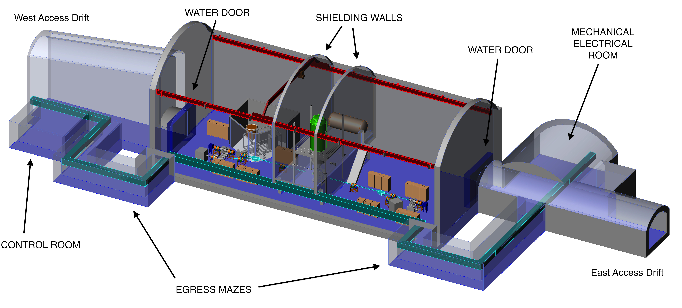
Figure 3.3.6.2.2-1 Drawing of the required water-shielded doors, and egress mazes that will guarantee that the natural radiation field will be unaffected outside the DIANA facility cavity.
Since the space available at LM-1 is consistent with DIANA space requirements, it has been considered as a possible DIANA location. The proposed experimental layout is shown in Figure 3.3.6.2.2-1. Some modifications to the generic design of LM-1 will be necessary to meet the shielding requirements of the DIANA facility, if DIANA were selected to be among the initial experiments at DUSEL. The modified plan view of LM-1 with water-shielded doors and the secondary egress mazes is shown in Figure 3.3.6.2.2-2.
In addition, the installation of the water-shielded doors will require routing of the utilities through the secondary egress mazes. Where the utility routing intersects any personnel access drift, the utilities will need to be routed overhead or below grade to prevent possible safety hazard (Figure 3.3.2.3.2-2). The nominal cross section of these drifts is 3 × 3 m². The roof of these drifts may be crowned at discretion.
In the following, the deviations between the DIANA layout and the generic design of LM-1 are summarized.
- Egress drifts added on both ends of LM-1 as discussed above and as shown in Figures 3.3.6.2.2-1 and 3.3.6.2.2-2.
- Western access drift offset 2 m south from the LM-1 center-line as shown in Figure 3.3.6.2.2-2. This is to enable the 8 m wide shielding door to clear the western access drift opening. The current design has the door obstructing the opening, even when slid to the maximum open position.

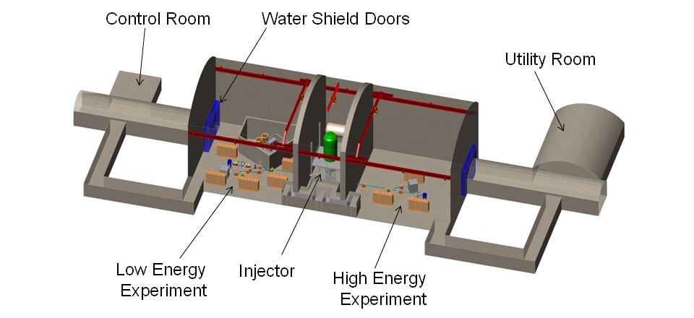
Figure 3.3.6.2.2-2 Footprint of the required shielded doors, mazes, and control room.
- Mechanical Electrical Room (MER) for LM-1 moved eastward by 2 m. In the current design, the western wall of the MER is collinear with the eastern end wall of LM-1. Also in the current design there is a chamfer in the corner between the MER and LM-1 that has been removed. These changes were made so the shielding door can close adequately to provide the intended shielding.
- In elevation, the 4-m excavation for the entire LM-1 floor is not required for DIANA and has been removed. In other words, both western and eastern access drift floors, the LM-1 floor (with the exception noted in deviation 5 below), and the control room floor are all at the same elevation.
- In elevation, the area of the LM-1 floor inside the low-energy accelerator shielding room needs to be excavated 1 m deep with respect to the remainder of the LM-1 floor for high-voltage standoff. This represents approximately 64 m³ of excavated material. The location and exact shape of the low-energy accelerator shielding room are still approximate.
- The height of LM-1 has been reduced from 24 m to 20 m. The reduced 20-m height is also contingent on the requested 1 m local excavation described in deviation 5 above, and a 15 m minimum hook height for the bridge crane.
- The excavation sequence for the generic LM-1 yields a ramped ceiling for the western access drift. This, however, leaves a very tall opening adjacent to LM-1. The size and cost of the shielding door required to cover this opening would be excessive. An alternate solution is needed to return the opening for the western access drift to the size of the eastern access drift, approximately 6 m wide by 5 m high. One potential solution is to backfill the top of the western access drift opening with concrete, to form a 2 m thick plug.
- A small local control room (8 × 8 × 3 m³, see Table 3.3.6.2 and Figures 3.3.6.2.2-1 and 3.3.6.2.2-2) is requested outside the main cavity to house the local control room of the accelerators and data-acquisition systems. Its location is not critical but it does need to be spaced the minimum distance from the egress drift, as shown in Figure 3.3.6.2.2-2.
Reducing the DIANA cavity height (deviation 6) will offset costs associated with the additional excavation for the secondary egress mazes.
It should be noted that, since the DIANA project is in progress, further changes to the cavity layout might be necessary.
3.3.6.2.3 Schedule and Installation
DIANA will develop preliminary design documents for the astrophysics accelerator facility by end of FY 2012. That effort is currently funded by an NSF S4 grant. The ion optics (physics) design together with the conceptual engineering design of the facility will be completed by mid-FY 2011.
The DIANA collaboration is in a unique situation regarding its project maturity. Previously, the low-energy accelerator section had already been designed in fair detail—funded by internal LBNL laboratory-directed research funds before the official DUSEL project start. In addition, main project components, e.g., the beamline magnets and the high-energy accelerator, will be procured through commercial companies based on existing technology. Therefore, the DIANA detail engineering effort is minimized and is primarily focused on installation and integration planning.
After completion of the NSF S4 project, DIANA staff would be able to immediately phase into the final engineering planning stage. Based on S4 engineering work, the beamline magnets and the high-energy accelerator procurements can be placed immediately. The low-energy accelerator fabrication could start a few months after completion of the S4 project.
The DIANA collaboration could initially install the low-energy accelerator aboveground while waiting for the underground hall to be completed. This would reduce project risks and at the same time allow for the establishment of a productive science program well in advance of first operation at the DUSEL facility. The location for early deployment of the low-energy accelerator remains to be determined but would not be at the DUSEL site. The high-energy accelerator is planned to be directly installed in the underground cave.
3.3.7 Biology, Geology, and Engineering (BGE) Experiments
A general overview of the science goals of experiments in biology, geology and engineering has been presented in Section 3.2. In this section potential BGE experiments based on the approved S4 proposals are described
3.3.7.1 Facility for the Study of Geologic Carbon Sequestration
This proposed facility is currently the only deep underground laboratory in the world being designed for the controlled study of geologic carbon sequestration. The findings from this experimental facility will advance carbon-management technology worldwide and help reduce global greenhouse gas emissions.
3.3.7.1.1 Overview of Proposed Research Facility
The proposal is to build an underground experimental facility to study the vertical flow of CO₂ through porous media over realistic length scales that mimic deep sedimentary formations. The facility is dubbed LUCI, for Laboratory for Underground CO₂ Investigations. LUCI is being designed to include three pressure vessels, each with a length of 500 m and a diameter of 1 m. The vessels will be supported within a 3m x 3m vertical shaft and will have an inner column that will be used for housing sensors. The annular space between this column and the outer vessel wall will be filled with brine and sand or other relevant geological material that mimics the strata encountered in sedimentary basins prior to CO₂ injection. Thermal and pressure gradients along the length of the columns will mimic real subsurface conditions.
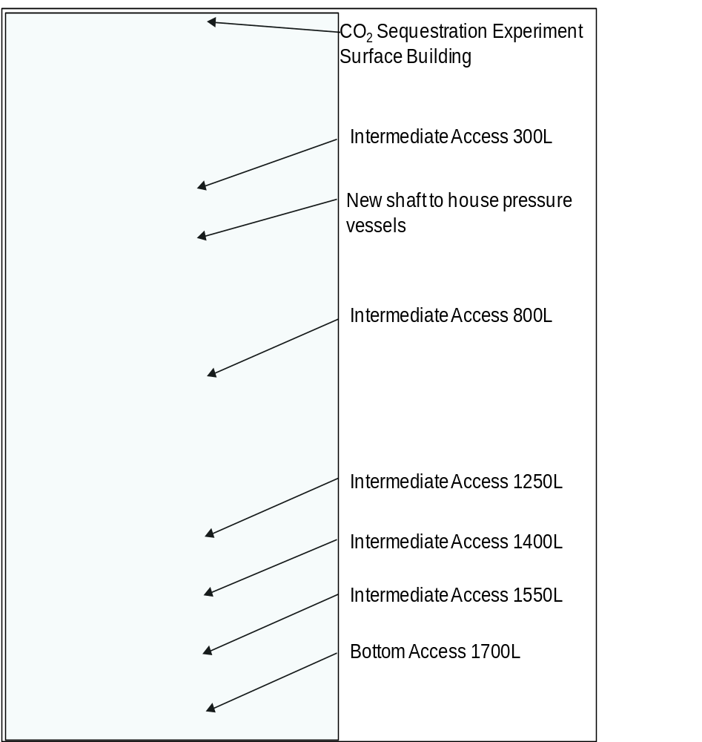
Figure 3.3.7.1.1 Proposed layout of the LUCI Facility at DUSEL.
Within DUSEL, a new vertical shaft will be located ~150 m from the Ross Shaft and will extend from the surface down to the 1700L (Figure 3.3.7.1.1). Key to the experimental design is the ability to make measurements and sample fluids along the length of the flow columns. The location of the shaft was selected to allow intermediate access to the pressure vessels from the 300L, 800L, 1250L, 1400L, and 1550L. At these levels, new excavations will connect existing drifts with the new shaft. In addition, access to the columns will be possible from an Alimak vertical transporter, which will climb and descend along a track attached to the wall of the shaft.
A Final Design could be completed by mid-2012. Assuming funding availability for construction, the work on the surface building and site could begin then, and be completed in six months. The next step would be the excavations, which would take six months to complete. This could start after the refurbishment of the Ross Shaft. After the excavations, the remaining procurement, fabrication and assembly of the CO₂ experimental facility would take two years.
3.3.7.1.2 Proposed Experimental Investigations
The LUCI facility will test critical hypotheses needed to understand CO₂ vertical flow in the deep subsurface. A goal is to simulate a leak in which CO₂ changes from a supercritical fluid to a subcritical gas as it flows up the column. The acceleration in CO₂ flow due to increasing buoyancy will be measured, and the extent to which this acceleration is mitigated by Joule-Thomson cooling will be determined. In other experiments involving rock matrices and well cements, CO₂-water-rock interactions will be examined and it will be determined whether CO₂ will enlarge flow pathways (mineral dissolution) or cause self-sealing (mineral precipitation). Finally, the effects of anaerobic, thermophilic bacteria on CO₂ conversion to methane and carbonate will be investigated.
Sensors will monitor governing thermal, physical, and chemical processes. Each vessel will have an inner fluid-filled tube (0. 25-m ID) that serves as a proxy well to accommodate a variety of existing well-logging technologies. For example, a combinable nuclear magnetic resonance tool will be used to discriminate between water- and CO₂-filled pores; similar measurements will be conducted using a reservoir saturation tool. Sonic and ultrasonic tools will also be used to image fluids, using differences in acoustic impedance to distinguish liquid from gas phases. These measurements will be used to construct a vertical saturation profile, and to determine how it changes over time as the CO₂ plume moves upward. Distributed temperature and pressure sensors will also be deployed outside of the inner tube to provide continuous in situ data. The various data and interpretations from the suite of technologies deployed during the experiments will collectively be used to develop a better understanding of CO₂ migration and trapping processes over realistic vertical length scales, to calibrate models that predict the vertical flow of CO₂ and brine in porous media, and to compare the spatial resolution and sensitivity of different monitoring tools.
The requirements from DUSEL anticipated for the LUCI facility are summarized in Table 3.3.7.1.2
Requirement | Value/Description | Value/Description | Value/Description
Layout
Depth | Surface | 300, 800, 1250, 1400, and 1550 Levels | 1700L
Footprint [m²] | 30 x 30 | 6 x 20 | 10 x 20
Height [m] | 15 | 5 | 8
Floor Load [kPa] | 3900T (Total Load) | 98 | 98
Raise Bore | 3m diameter,  Surface to 1700L | 3m diameter,  Surface to 1700L | 3m diameter,  Surface to 1700L
Utilities
Power [kW] | 60 | 60 | 60
Standby Power [kW] | 10 | 10 | 10
Potable Water [lpm] | 40 | 40 | 40
Compressed Air | Nominal use | No | Nominal use
Network [Gb/s] | 1 | 1 | 1
Environment
Temp. Min [⁰C] | 20 | 5 | 5
Temp. Max [⁰C] | 27 | 40 | 40
Humidity Min [%] | 5 | 0 | 0
Humidity Max [%] | 95 | 100 | 100
Crane
Max. Load [Ton] | 400 | 0 | 0
Occupancy
Peak Installation Occupancy [count] | 20 | 5 | 8
Installation Duration [months] | 28 | 8 | 6
Peak Commissioning Occupancy [count] | 10 | 0 | 2
Commissioning Duration [months] | 6 | 2 | 2
Peak Operation Occupancy [count] | 2 | 0 | 0
Operation Duration [months] | 60 | 60 | 60
Major Hazards (Other Than Cryogens)
CO₂ | 600,000 l | 600,000 l | 600,000 l
Pressure Vessel | 10MPa | 10MPa | 10MPa
Assay and Storage
Underground Storage | Storage Tanks | 0 | Storage Tanks
Table 3.3.7.1.2 Requirements for the LUCI facility.

3.3.7.2 Facility for Monitoring Deformation of Large Underground Rock Masses
Large-scale deployment of fiber-optic sensors appears to be an ideal technology for multi-spatial and multi-temporal measurement of rock-mass response to loading. Fiber-optic monitoring along kilometers of drifts within DUSEL presents a unique opportunity to address questions regarding the mechanical and hydrologic response of rock masses. This effort will result in the world’s largest and deepest underground network of fiber-optic strain and temperature sensors, and tiltmeters.
3.3.7.2.1 Overview of Proposed Research Facility
Fiber-optic strain and temperature sensors have been used successfully in civil engineering applications for the structural-health monitoring of bridges, highways, dams, and buildings. They are recognized as a relatively inexpensive, lightweight, versatile, and long-lasting way to monitor structures. Fiber-optic sensors also have great geotechnical potential for monitoring the safety and stability of mines, tunnels, and caverns. This facility represents the first comprehensive installation of fiber-optic strain and temperature sensors to measure deformation and temperature in a large volume underground. A central component of the effort is to develop underground applications of fiber-optic sensors for scientific and structural health monitoring applications. The main reason for using this emerging fiber-optic technology lies in the cost and efficiency advantages for over-kilometer-length deployments, long-term stability, flexibility of incorporating many types of sensors on a single data-acquisition cable, and a future promise for the methods becoming even better, cheaper, and faster. The fiber-optic network will be supplemented with long-baseline tiltmeters and borehole extensometers.
3.3.7.2.2 Proposed Experimental Investigations
Induced—dewatering, drift and cavity construction, meter-scale loading—and natural—self-weight, earth tides, seismicity—loading will be monitored at spatial scales ranging from centimeters to hundreds of meters and temporal scales ranging from milliseconds to decades. The deformation-monitoring network consists of installations of Fiber Bragg grating (FBG) sensors, Distributed Strain and Temperature (DST) sensing fiber-optic cable, Distributed Temperature Sensing (DTS) fiber-optic cable, and water-level tiltmeters. Sensors will be installed in the drifts of deeper accessible levels, specifically at 2000L, 4100L, 4850L, 6800L, and 7400L. Each installation of the various sensor sets is designed to work with pre-existing or planned spaces within DUSEL. Sensors will also be installed near planned excavations to record rock deformation before, during, and after construction of large cavities and other Laboratory modules to understand how tunnels and large rooms redistribute stress and contribute to straining, activation of sudden failures, and seismicity within the mine.
The DST fiber will be installed over large areas of drifts within the Laboratory to measure convergence and pillar deformation (Figure 3.3.7.2.2). Continuous fiber will be tensioned with anchors every 0.5 to 2 m along its length. These anchors can be attached to existing rock bolts or to newly installed bolts. The DTS fiber will be placed in winzes down to 8,000 feet, in shorter-length boreholes, and along drift walls to monitor water inflows and air movement. The tiltmeter array consists of water-level sensors installed within the drifts connected by water and air tubing to measure micrometer-level displacements over a baseline of tens to hundreds of meters.
The combination of different types of sensing techniques will create a network for monitoring strain from the centimeter scale to lengths exceeding 1 km. The tiltmeter arrays will measure deformation over length scales between 30 and 1,000 m. The measurement of rock-mass properties over many spatial and temporal scales requires sensors and instruments that are embedded and stable. The sensing array will take advantage of deformations induced by natural forces such as Earth tides and distant earthquakes, as well as dewatering of the mine and construction within the Laboratory. In addition, active experiments on the scale of several meters will be performed using different types of jacks and fluid injection.
Because these fiber-optic sensors have not previously been installed in intact rock, part of the experiment will examine various installation methods for FBG and DST sensors to establish viable mounting techniques that accurately record deformation in the intact rock mass not near-surface deformation of stress-relieved drift wall or artifacts of the installation procedure. In addition to the methods described above, different embedding technologies will be used, including pliable rock strain strips and instrumented rock bolts and cable bolts. To address objectives of this project, the sensor and tiltmeter arrays will be monitored continuously for changes in strain and temperature. The data from the sensors will be combined with laboratory deformation experiments and finite element modeling to determine the elastic moduli of the rock mass and how they vary over spatial and temporal scales. The deformation- monitoring array will utilize sensors overlapping in their spatial coverage to check for the accuracy and repeatability of these results.
Requirements from DUSEL anticipated for the Rock Deformation facility are summarized in Table 3.3.7.2.2.
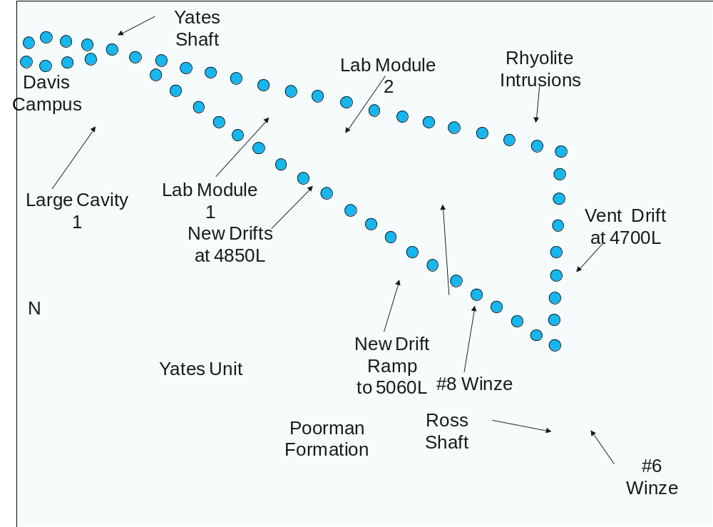
Figure 3.3.7.2.2 Proposed layout of Distributed Strain and Temperature (DST) fiber-optic sensors (blue dots) within the general area of the lab modules, to monitor convergence and deformation of rock.
Requirement | Value/Description
Layout
Depth | 2000, 4100, 4850, 6800 and 7400 Levels
Footprint [m²] | 2.1 x N
Height [m] | 3
Floor Load [kPa] | 10
Utilities
Power [kW] | 2.5
Standby Power [kW] | 0
Potable Water [lpm] | 16
Compressed Air | Nominal use
Network | 1 Gb/s
Environment
Temp. Min [⁰C] | 5
Temp. Max [⁰C] | 40
Humidity Min [%] | 0
Humidity Max [%] | 100
Crane
Max. Load [T] | 0
Occupancy
Peak Installation Occupancy [count] | 10
Installation Duration [months] | 24
Peak Commissioning Occupancy [count] | 2
Commissioning Duration [months] | 6
Peak Operation Occupancy [count] | 0
Operation Duration [months] | 96
Table 3.3.7.2.2 Requirements for the Deformation Monitoring facility.
3.3.7.3 Facility for Studying Coupled Thermal-Hydrological-Mechanical-Chemical-Biological Processes (THMCB)
A large-scale THMCB experimental facility at depth (4,850 to 7,400 feet) will allow researchers to quantitatively probe the range of coupled THMCB processes taking place at the pore scale, in meter-scale fractures, and within decimeter-scale fluid flow and convection regimes, for time periods of several to tens of years.
3.3.7.3.1 Overview of Proposed Research Facility
The purpose of the DUSEL THMCB experimental facility is to investigate a range of natural and engineered processes by creating a volume of heated rock and fluid that will be instrumented with sensors (mechanical, thermal, hydraulic) and ports for collecting fluid samples (chemical, biological) as a function of space, time, and temperature (Figure 3.3.7.3.1). It is expected that observation/measurement boreholes will be sited to traverse different regions of the heated rock, which are packed-off to isolate a particular fracture or fracture set, into which fluids, gases, or nutrients can be injected to perturb the local THMCB environment. Monitoring ports will be sited along fractures to capture fluids that have been injected elsewhere along the same fracture. In addition to geochemical and isotopic (stable and radiogenic) analyses on sampled fluids, gases and solids, state-of-the-art in situ sampling and monitoring sensors will be employed. The experiments performed at the THMCB facility at DUSEL would be carried out in a phased approach. The working-group team, with external input and peer review, will refine the necessary initial data, experiments, and modeling that should be performed, prior to starting experiments.
3.3.7.3.2 Proposed Experimental Investigations
Over 4850 to 7400 feet depths, lithostatic pressures are significantly greater than those encountered by other experiments that have probed coupled THMCB processes. The metamorphic mineral assemblages making up the rocks at DUSEL are different from the rhyolitic tuffs and granites that have been the host rock of these tests. At DUSEL, rocks are much more anisotropic and are chemically and structurally more heterogeneous. The Fe-rich carbonates and mafic silicate minerals have typically higher dissolution rates than quartz and feldspars in granitic rocks and devitrified tuff. Reaction rates are also highly dependent on reactive surface areas, which in turn are a function of the hierarchical scale of fluid flow, geologic structure, and mineral fabric. Hence, the well-developed metamorphic fabric of the Homestake iron formation and the adjacent lithologies will provide a unique system in which to monitor directional fluid flow and reaction-transport processes under a well-controlled thermal environment. The abundance of ore minerals is an added benefit for the study of the transport, precipitation, and sorption of metals under variable temperature conditions and in fractured rock.
The transport and interaction of fluids, heat, and chemical reactants within a stressed geologic host result in complex feedbacks at a variety of length and time scales. These interactions produce patterns of reaction and mineral redistribution that in turn modify porosity and permeability and are strongly scale dependent. Well-controlled injection/extraction experiments in particular regions of the heated block can be interrogated by in situ probes and sampling, with supporting laboratory experiments, isotopic and (bio)geochemical measurements and reactive transport modeling. This collaboration proposes to address a variety of questions related to these interactions. These include:
- What are the effective reaction rates between minerals and fluids in fractured rock, and how are they controlled by the evolution of the fracture-fluid interface as a function of reaction progress?
- How does the chemistry of fluids and minerals affect the mechanical behavior of fractures, sealing, and permeability evolution under stress?
- At what rates under specific flow and temperature conditions are metals mobilized through water-rock interaction, transported, and concentrated through sorption and/or mineral precipitation (relevant to ore deposition and contaminant transport/immobilization)?
- How do microbiological communities in rocks evolve and migrate in fractured rock undergoing changes in temperature and geochemical environment?
- How does mineralogical and permeability heterogeneity at small scales affect the composition of fluids at a larger scale and how can the effective reaction rates be interpreted from the fluid compositions?
Requirements from DUSEL anticipated for the THMCB facility are summarized in Table 3.3.7.3.2

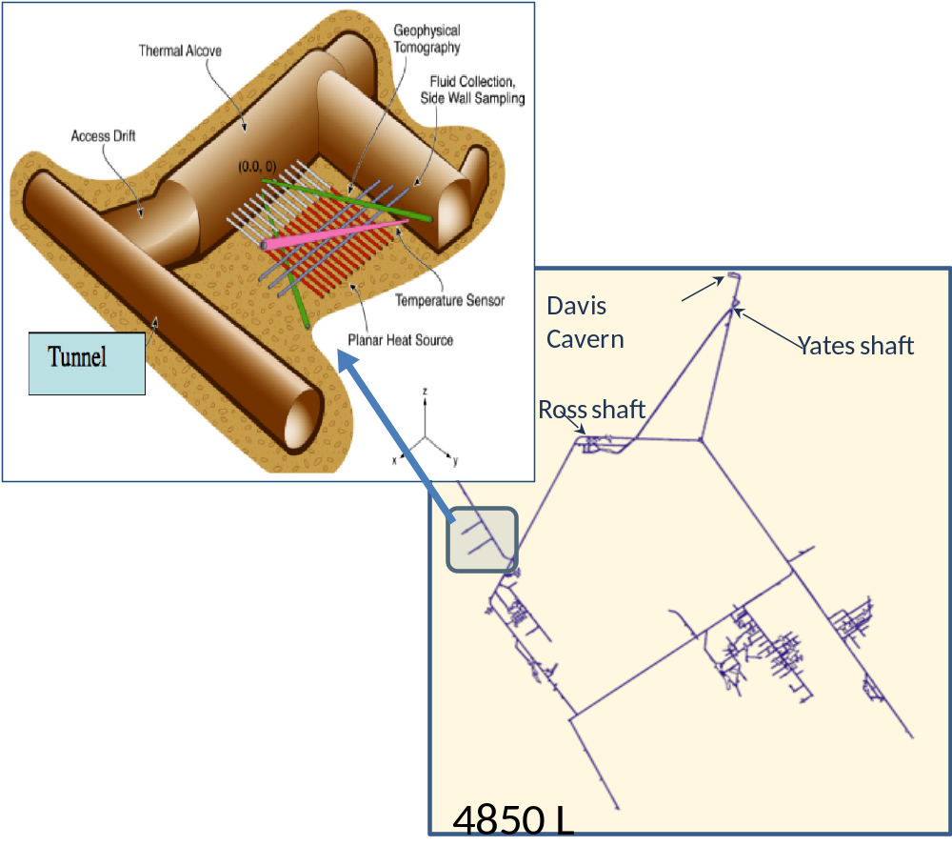
B
A
Figure 3.3.7.3.1 A) conceptual layout of the THMCB Experimental Facility and B) Location of a potential site for the facility at the 4850L.

Requirement | Value/Description
Layout
Depth | 4850L
Footprint [m²] | 80 x 60
Height [m] | 60
Floor Load [kPa] | 98
Utilities
Power [kW] | 300
Standby Power [kW] | 1
Purified Water [m³] | .016
Potable Water [lpm] | 16
Compressed Air | Nominal use
Network | 1 Gb/s
Environment
Temp. Min [⁰C] | 20
Temp. Max [⁰C] | 30
Humidity Min [%] | 80
Humidity Max [%] | 98
Crane
Max. Load [T] | 0
Occupancy
Peak Installation Occupancy [count] | 10
Installation Duration [months] | 12
Peak Commissioning Occupancy [count] | 4
Commissioning Duration [months] | 4
Peak Operation Occupancy [count] | 2
Operation Duration [months] | 48
Major Hazards (Other Than Cryogens)
Electrical | 300kW
Assay and Storage
Underground Storage | Storage Tanks
Table 3.3.7.3.2 Requirements for the THMCB facility.
3.3.7.4 Facility for Ecohydrology Studies of Deep Fractured Rocks
DUSEL offers a unique opportunity for integrated geo-biological research because of its enormous span of depth and because the host formation comprises a diverse assemblage of minerals and rock. Although groups in other countries are actively researching the subsurface, none has access to a deep, dedicated science facility.
3.3.7.4.1 Overview of Proposed Research Facility
The facility will provide a platform for precise, systematic drilling into the biosphere of a deep continental environment where meteoric water flow is the primary mixing mechanism. With kilometer-scale access in three dimensions and a multi-decade observational lifetime, it will provide an in situ laboratory for the development of detailed hydrologic and geomechanical conceptual models in complex rock.
The facility will enable access to groundwater of diverse ages (Figure 3.3.7.4.1). On the south side of the former mine, water flows from the surface to 1-km depth in less than a year. Water reaching the lower depths of the north side of the mine emanates from rock pores and may be millions of years old. The potential capture footprint extends outward for kilometers from current mine workings and could provide access to about 100 km³ of rock for hydrologic, geomechanical, and microbial biogeographic studies.
The facility will consist of a series of distributed boreholes drilled/cored sequentially from the surface to ~5-km depth. Drill-site locations have been selected to allow multiple boreholes that will interrogate large volumes of minimally impacted fractured rock in generally north and south directions from the former mine. Cavities designed to require minimal expansion of existing drifts will accommodate a drill rig and associated supplies. Scheduled activities at each site will be mobilization, drilling/coring, installation of instrumentation, demobilization, and long-term experimentation and monitoring (sporadic visits, months to years). Coring will rely on state-of-the art quality-control procedures for geobiological sampling, including a steam-cleaning station for the drill rods, on-site reverse-osmosis filtration system for the drilling water, a single-pass reverse-flow system for the drilling water, and multiple tracers for potential drilling contamination.
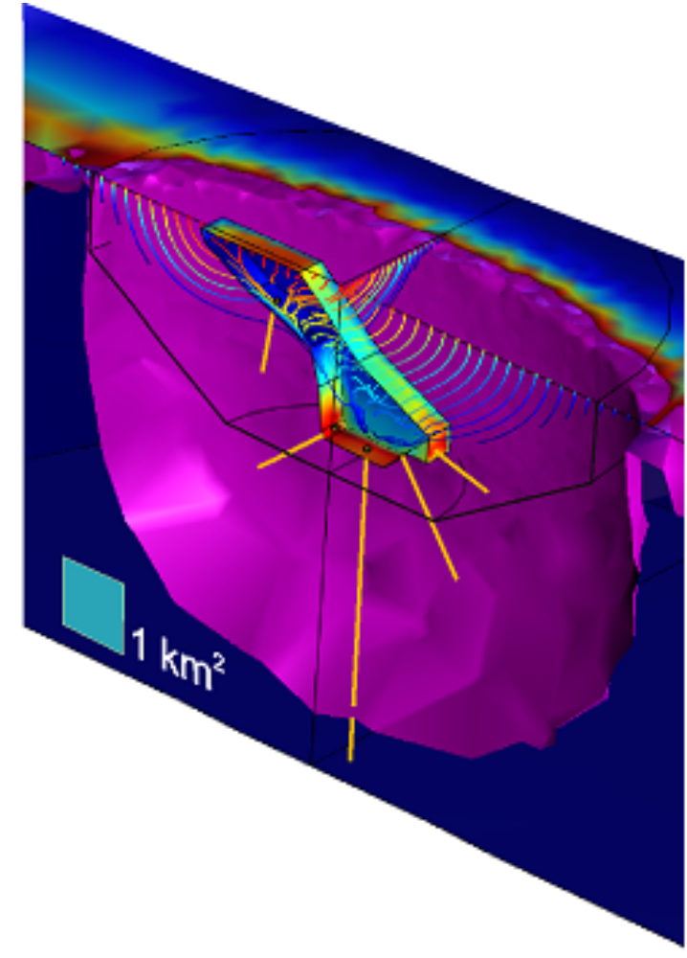
Figure 3.3.7.4.1 Perspective view of mine workings (polygonal area at center of diagram) showing simulated particle-flow paths from surface to depth during the excavation period of the mine to present day. Color shading shows the water flux into the workings. The purple area bounds the region where groundwater has been captured by the mine, according to the simulation. Yellow lines are potential cored boreholes for future microbiology and hydrology experiments.
3.3.7.4.2 Proposed Experimental Investigations
Large-diameter boreholes will be extended an additional 2-3 km from existing infrastructure at the 7400L, to reach the 121°C isotherm and explore the upper-temperature limit of life. Beyond their use for fluid withdrawal, the boreholes will become experimental stations for conducting in situ transcriptomic and proteomic experiments with mobile underground laboratories, push-pull experiments within the packer-sealed fractures, and cross-borehole experiments—hydraulic, geophysical, and geomechanical—using multilevel packers and induced fluid flow.
The proposed investigations will be guided by the overarching question: What controls the distribution and evolution of subsurface life? The hypothesis being tested is whether these controls are dominated by processes related to geology, geomechanics, and hydrology. The investigation will consist of field studies supported by numerical simulations. The experimental activities will include extending characterization efforts to great depths using deep drilling deployed from the lowest accessible reaches of the facility. The use of the flooding/dewatering event as a tracer and the hydrologic and mechanical stressor is a theme that cuts across many of the experimental activities.
Requirements from DUSEL anticipated for the Rock Deformation facility are summarized in Table 3.3.7.4.2
Requirement | Value/Description | Value/Description
Layout
Depth | 300, 800, 2000, 4100, 4850 and 7400 Levels (Exploratory Sites) | 4850 and 7400 Levels (Observatory)
Footprint [m²] | 10 x 10 | 16 x 11
Height [m] | 5 | 12
Floor Load [kPa] | 98 | 98
Utilities
Power [kW] | 1 | 1
Standby Power [kW] | 0 | 0
Purified Water [m³] | 0 | .016
Potable Water [lpm] | 16 | 16
Compressed Air | Nominal use | Nominal use
Network | 1 Gb/s | 1 Gb/s
Environment
Temp. Min [⁰C] | 5 | 5
Temp. Max [⁰C] | 40 | 40
Humidity Min [%] | 0 | 0
Humidity Max [%] | 100 | 100
Crane
Max. Load [T] | 0 | 0
Occupancy
Peak Installation Occupancy [count] | 5 | 5
Installation Duration [months] | 1 | 2
Peak Commissioning Occupancy [count] | 2 | 2
Commissioning Duration [months] | 1 | 1
Peak Operation Occupancy [count] | 0 | 1
Operation Duration [months] | 4 | 36
Table 3.3.7.4.2 Requirements for the Ecohydrology facility.
3.3.7.5 Facility for Studying Cavern Design
The proposed facility will help transform the fields of rock mechanics and rock engineering by improving existing capabilities in ensuring safety and the satisfactory performance of large caverns and other excavations.
3.3.7.5.1 Overview of Proposed Research Facility
The proposed large underground caverns at DUSEL will need to be fully operational for an extended period of time under demanding conditions pertaining to deformation and safety. This challenges current knowledge of rock-mass behavior. The science vision for the Cavern Design facility is to determine spatial and temporal characteristics and behavior of rock masses, and to estimate the uncertainty and risk associated with large underground excavations. The results of experiments associated with this facility will benefit the design, construction, and long-term performance of caverns and other underground structures, thereby contributing to enhanced safety, reduced costs, and completion of the DUSEL facility.
3.3.7.5.2 Proposed Experimental Investigations
The experiments proposed involve large volumes of rock subjected to complex loading and include monitoring over extended periods of time (Figure 3.3.7.5.2). The experiment will integrate a number of closely related tests associated with the construction and performance of large caverns at the 4850L. They are also relevant to other underground structures at DUSEL and elsewhere.
The experiments include:
- Assessment of the rock-mass characteristics, specifically fracture patterns and fracture behavior (mechanical, hydraulic) as well as petrographic/mineralogic characteristics
- Evaluation of the performance of caverns, mine-by tunnels and large rock pillars performance during construction and operation
- Development of novel construction techniques for faster and safer excavation
Integrating all this will be a risk analysis procedure in which in situ data will be analyzed using advanced modeling techniques and the risks associated with performance (safety), as well as construction cost and time, will be determined.
Requirements from DUSEL anticipated for the Cavern Design facility are summarized in Table 3.3.7.5.2.
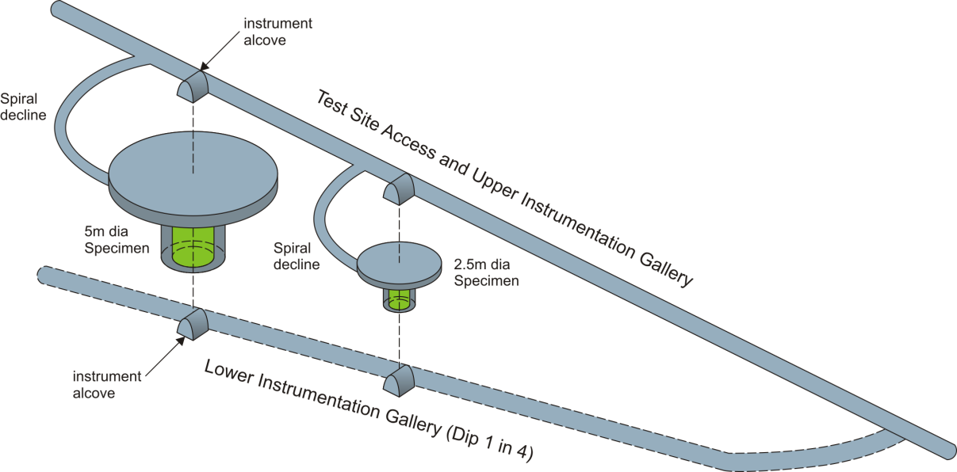
Figure 3.3.7.5.2 Conceptual diagram of a mine pillar facility for investigations of complex loading.
Requirement | Value/Description
Layout
Depth | 4850L
Footprint [m²] | Adjacent to Large Cavity
Height [m]
Floor Load [kPa]
Utilities
Power [kW] | 250
Standby Power [kW] | 0
Potable Water [lpm] | 16
Compressed Air | Nominal use
Network | 1 Gb/s
Environment
Temp. Min [⁰C] | 15
Temp. Max [⁰C] | 25
Humidity Min [%] | 0
Humidity Max [%] | 100
Crane
Max. Load [T] | 0
Occupancy
Peak Installation Occupancy [count] | 5
Installation Duration [months]
Peak Commissioning Occupancy [count] | 2
Commissioning Duration [months]
Peak Operation Occupancy [count] | 0
Operation Duration [months]
Table 3.3.7.5.2 Requirements for the Cavern Design facility.
3.3.7.6 Facility for the Study of Fracture Processes
The fracture processes facility will address fundamental problems of rock rupture. It will provide access to intact rock, large natural faults and those created at scales of 1-100 m.
3.3.7.6.1 Overview of Proposed Research Facility
At DUSEL, configurations for heating or cooling will be developed to manipulate in situ stresses and create faults. A robust implementation approach will circulate chilled fluid through arrays of subparallel boreholes drilled along vertical planes. This will reduce the horizontal compression normal to the planes of the boreholes while the vertical stress remains unchanged. Borehole arrays have been developed for use at DUSEL that would manipulate stresses at scales from less than 1 m to approximately 10 m. The boreholes in each array would be drilled from common rooms built as stepped cavities to simplify logistics. Instrumentation for monitoring the faulting process will be deployed in additional holes flanking the borehole arrays. The slip patch is expected to span 1 to several meters before it becomes unstable and propagates dynamically along a fault surface. As a result, an experiment to characterize dynamic fault slip may require dimensions larger than 10 m. To accommodate this scale, a patch nucleation experiment has been designed using two thermal panels at different levels along a pre-existing fault (Figure 3.3.7.6.1). A large fault—referred to as the Homestake Fault by the collaboration—has been located in the facility. There is evidence that the fault is present on multiple levels. The fault is subparallel to the local foliation in the Poorman Formation and extends at least 1.5 km along strike and dip, with a center ~1.5 km deep along the western side of the mine. It strikes ~320-340° N, dips ~45-70° NE, and is recognized by a ~0.3-0.5 m thick distinct gouge that contains crushed host rock and black material that appears to be graphite. Although there is no clear evidence for fault displacement, secondary features suggest that it is a normal fault. The size and distinct structure of this fault make it a promising target for in situ experimentation of fault strength, hydrological properties, and slip nucleation processes.
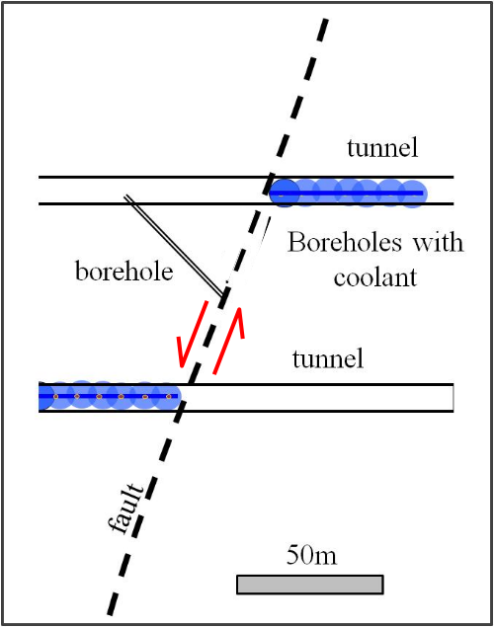
Figure 3.3.7.6.1 Conceptual design of a dynamic fault slip experiment. A natural fault is loaded by means of cooling/heating of two thermal panels (arrays of parallel cooling/heating boreholes). Fluid is injected at a given location on the loaded part of the fault to promote slipping.
3.3.7.6.2 Proposed Experimental Investigations
Experiments proposed by the Fracture Processes collaboration are aimed at providing critical data to constrain the extent to which widespread upscaling is valid. This effort will quantify rupture mechanisms in both intact and faulted rock, including the sizes of the smallest frictional slip event, mechanisms of slip triggering and slip nucleation, mechanisms of strength-gain and fault-healing promoted by reactive fluids and other agents, and the role of velocity weakening in the transition between quasistatic and dynamic fault rupture.
The key to experiments associated with this facility is the creation of carefully controlled faults in crystalline rock. Thermal techniques will be used to locally alter in situ stresses enough to cause faulting in rocks. The general process involves heating to increase compressive stresses, or cooling to reduce them. Because the temperature field can be finely controlled, the stress field can be finely controlled, too. Scaling and numerical analyses show that thermal technique can create differential stresses sufficient to induce faulting within a period of several weeks. Besides being used to study how new faults form in intact rock, the thermal techniques will also be applied in the vicinity of existing faults, to explore the possibility of slips along faults. This is important because most earthquakes are thought to be the result of unstable slip on existing faults. The slip process is likely to be initially localized on a growing patch (or series of patches) that is either weaker than the rest of the fault, or that sustains a locally elevated shear stress. Growth of the slipping patch moderated by the background stress rate may lead to an instability that results in a dynamic shear rupture propagation—this phenomenon is recognized to be related to the triggering of earthquakes.
Requirements from DUSEL anticipated for the Fracture Processes facility are summarized in Table 3.3.7.6.2.
Requirement | Value/  Description | Value/  Description | Value/  Description | Value/  Description
Layout
Depth | 2000L | 4100L | 4850 and 6800 Levels | 7400L
Footprint [m²] | 36 x 2.1 | 198 x 2.1 | 108 x 2.1 | 18 x 5
Height [m] | 2.5 | 12 | 8 | 12
Floor Load [kPa] | 10 | 10 | 10 | 10
Utilities
Power [kW] | 400 | 600 | 400 | 600
Standby Power [kW] | 0 | 0 | 0 | 0
Potable Water [lpm] | 80 | 80 | 80 | 80
Compressed Air | Nominal use | Nominal use | Nominal use | Nominal use
Network | 1 Gb/s | 1 Gb/s | 1 Gb/s | 1 Gb/s
Environment
Temp. Min [⁰C] | 0 | 0 | 0 | 0
Temp. Max [⁰C] | 30 | 30 | 30 | 30
Humidity Min [%] | 0 | 0 | 0 | 0
Humidity Max [%] | 100 | 100 | 100 | 100
Crane
Max. Load [T] | 0 | 0 | 0 | 0
Occupancy
Peak Installation Occupancy [count] | 8 | 8 | 8 | 8
Installation Duration [months] | 6 | 6 | 6 | 6
Peak Commissioning Occupancy [count] | 4 | 4 | 4 | 4
Commissioning Duration [months] | 3 | 3 | 3 | 3
Peak Operation Occupancy [count] | 2 | 2 | 2 | 2
Operation Duration [months] | 21 | 31 | 21 | 17
Table 3.3.7.6.2 Requirements for the Fracture Processes facility.
3.3.7.7 Transparent Earth—Observatory for Subsurface Imaging and Sensing
This observatory will be unique in that the mine volume is surrounded (sides and bottom) and penetrated by hundreds to thousands of boreholes suitable for instrumentation.
3.3.7.7.1 Overview of Proposed Experimental Facility
The Transparent Earth collaboration proposes installing and operating a permanent and portable geophysical observatory to illuminate the volume of DUSEL. The instrument system will be designed, much like a telescope, to look into particular directions and volumes within the mine using different excitation mechanics (e.g., strains, vibrations, electromagnetic field diffusion and propagation, density contrasts).
3.3.7.7.2 Proposed Experimental Investigations
Through this effort, imaging methodologies and procedures will be developed to pursue a variety of fundamental science and engineering objectives. Multiple modalities of geophysical instrumentation within and surrounding the mine volume will allow passive and active source measurements of various geo-activities, including rock-mass re-stressing caused by the lowering of the water table, fluid injection and hydraulic fracturing, drilling and excavations during construction of the Laboratory, earth tide and barometric effects, and daily operations. The deployment of multiple modes of geophysical measurement modalities will provide a large number of constraints for inversions leading to new discoveries. One possibility is the development of new measures for in situ stress, with the possibility of applying these methods to predict rock fracture and pore fluid pressures. Another is the development of new linkages between seismic and electromagnetic Earth science. Further, the proposed large-volume microseismic array will provide the tools needed to study the connection between the rock damage and the seismic waves generated during the geological and engineering processes. This knowledge will be applicable to all geophysics arrays, and provide strong evidence for answering some important questions concerning the energy budget of fracture growth and dynamics, local frictional behavior within a rock mass, seismic scaling laws, and the interpretation of seismic moment tensors.
To complement these activities, the Transparent Earth instrumentation system will perform a wide variety of scientific and engineering experiments. The permanent large-scale seismic array, combined with double-difference tomography, will provide an ongoing measure of mine stability required for occupant safety and the well-being of the experimental facility. Many of the proposed techniques will be easy to mobilize and operate near new workings, changes in geo-behavior and by new experimental teams.
The nature of extended free-field scattering will be studied. Electromagnetic sensors will be designed to monitor different emission mechanisms and processes at different temporal and volumetric scales. Electrical resistivity, low-frequency electromagnetic and induced polarization methods will be used to image hydrogeological processes in the mine. Portable high-resolution gravity meters will be used to map the mine and to evaluate the formation distributions and processes related to lowering water table and surface water changes. The locations of installed and proposed stations are given in Table 3.3.7.7.2-1.
Tables 3.3.7.7.2-2 includes requirements anticipated from DUSEL by the Transparent Earth collaboration.

Level | 2000 (1) | Level | 2000 (2) | Level | 2000 (3) | Level | 2000 (4)
Northing | 500 | Northing | -2500 | Northing | -4800 | Northing | -8500
Easting | -2800 | Easting | -500 | Easting | 3500 | Easting | 5500
Level | 4100 (1) | Level | 4100 (2) | Level | 4100 (3) | Level | 4100 (4)
Northing | -5000 | Northing | -10400 | Northing | -12000 | Northing | -5500
Easting | -1200 | Easting | 1000 | Easting | 1700 | Easting | 4000
Level | 4100 (5) | Level | 4100 (6) | Level | 4100 (7) | Level | 4550 (1)
Northing | -7000 | Northing | -3500 | Northing | -1500 | Northing | -7000
Easting | 5000 | Easting | 4000 | Easting | 5500 | Easting | 1000
Level | 4850 (1) | Level | 4850 (2) | Level | 7400 (1) | Level | 7400 (2)
Northing | -13000 | Northing | -8400 | Northing | -10300 | Northing | -9300
Easting | 2150 | Easting | 6000 | Easting | 2500 | Easting | 4000
Level | 7400 (3) | Level | 7400 (4) | Level | 7400 (5) | Level | 8000 (1)
Northing | -10500 | Northing | -8500 | Northing | -8800 | Northing | -8000
Easting | 6500 | Easting | 5700 | Easting | 7800 | Easting | 2000
Table 3.3.7.7.2-1 Installed and proposed seismic and E/EM stations.

Requirement | Value/Description
Layout
Depth | 2000, 4100, 4550, 4850 and 7400 Levels
Footprint [m²] | 1 x 3
Height [m] | 2.5
Floor Load [kPa] | 20
Utilities
Power [kW] | 2.2
Standby Power [kW] | 0
Potable Water [lpm] | 16
Compressed Air | Nominal use
Network | 1 Gb/s
Environment
Temp. Min [⁰C] | 10
Temp. Max [⁰C] | 25
Humidity Min [%] | 0
Humidity Max [%] | 100
Crane
Max. Load [T] | 0
Occupancy
Peak Installation Occupancy [count] | 6
Installation Duration [months] | 6
Peak Commissioning Occupancy [count] | 2
Commissioning Duration [months] | 2
Peak Operation Occupancy [count] | 0
Operation Duration [months] | 84
Table 3.3.7.7.2-2 Requirements for Tier-1 facility for subsurface imaging and sensing.

3.3.7.8 Rationale for Access to the 7400L
Five of the seven BGE collaborations (i.e., Ecohydrology, THMCB, Transparent Earth, Deformation Monitoring, and Fracture Processes), have proposed to develop experimental facilities at the 7400L. For the Ecohydrology and Fracture Processes collaborations, access to the 7400L provides an enhanced opportunity to extend their experimental activities to deeper environments. For the rest, access is integral to planned activities.
A strong case has been made during and since the DUSEL S1 process that probing the deepest limits of the biosphere constitutes a high priority for subsurface science. An emerging consensus is that access to the deep biosphere is likely to generate major scientific discoveries and transformational science in the coming decade. To this end, the Integrated Ocean Drilling Program (IODP) has funded three drilling legs that will, in the next five years, investigate microbial activity within the sub-seafloor biosphere. Two of these expeditions will probe the hottest and deepest depths where life exists. For the Ecohydrology collaboration, a drilling station at the 7400L will allow partnership with the Intercontinental Scientific Drilling Program (ICDP) to reach the deepest limits of life.
DUSEL will provide the best opportunity in the United States for studying the deepest regions of the biosphere. It offers the deepest-available platform for initiating drilling. Holes drilled from the 7400L can be extended to great depth, i.e., to the ~121°C isotherm that is hypothesized to be the absolute limit of the biosphere. DUSEL has a geothermal gradient of 20-21°C/km, a value that is typical for continental crust. This contrasts with most environments previously investigated for thermophilic and hyperthermophilic life, (i.e., hot springs at Yellowstone, Kamchatka, and the deep-ocean spreading centers, where the geothermal gradient is ≥100°C/km). DUSEL is thus likely to be more representative of widespread deep-earth microbial ecosystems. The highest reported temperature for microbial life from deep-sea hydrothermal vents is 122°C and for detectable subsurface microbial activity is ~85°. Given the average annual surface temperature of 7°C and the estimated range in the geothermal gradient, the temperatures correspond to target depths of 5.5 to 5.8 km for 122°C and 3.7 to 3.9 km for 85°C at DUSEL. It is between these two depth estimates that it is expected the transition from biology-dominated geochemical processes to abiological processes, or pressure-sensitive life forms, that have yet to be detected, will be seen.
A key question is whether drill-holes originating from the surface can achieve the same scientific goals as those originating deep within a mine. While drilling can be done from the surface, it comes at great cost and with significant impacts to the quality of the sampled environment. Estimates of drilling costs from the surface, and from a deep-mine platform, based on DOE’s Deep Subsurface Science Program and those from mining companies and drilling contractors, show a clear advantage to drilling from within a mine (Figure 3.3.7.8). These estimates suggest that drilling from the surface would be 10 times more expensive than drilling from the 7400L. Even with the cost of excavating the cavity and ancillary preparation of the drill site, safety equipment, and a surface laboratory, the difference between surface and deep-mine drilling is substantial.
Drilling from the surface requires large-diameter collars for the boreholes, and use of re-circulated drilling mud with additives to maintain down-hole pressure above the hydrostatic gradient, and borehole stability. This drilling mud is enriched with microorganisms from the surface structures, holding tank, atmosphere, and shallow formations, where biomass concentration is high. The composition of the microbial community changes with increasing drilling depth, as new formations are encountered, and any indigenous populations are mixed in with the contaminants. In addition, increasing temperature and pressure can select thermophilic bacteria from the contaminating pool of surface organisms. Drilling from depth with smaller-diameter coring tools can reduce the use of contaminating drilling fluids. Further, by initiating drilling at the 7400L, the ambient formation temperature (~ 50°C ) acts as an effective geological barrier against surface mesophilic microorganisms that have entered the rock through mining operations or from groundwater penetration. A single one-pass drilling fluid system can be used because the normal infrastructure of the mine enables pumping and disposal of large quantities of drilling water, thereby eliminating contamination of deeper levels of the borehole from shallower levels. Deep drilling
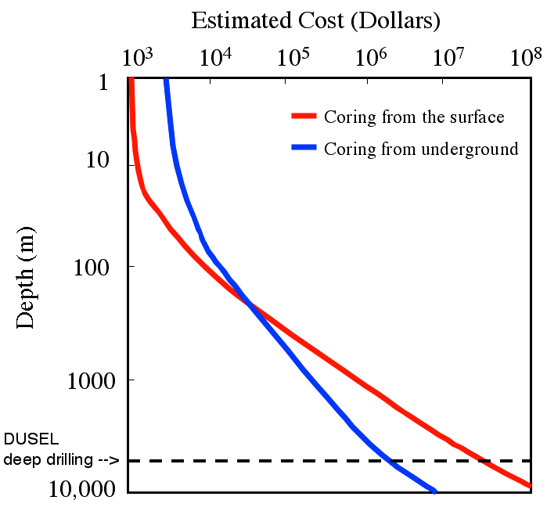
Figure 3.3.7.8 Comparison of costs for coring from the surface and from a mine platform at the 7400L.
from underground, therefore, affords the best opportunity to obtain pristine samples for microbial investigations of the deep subsurface.
Shortening the length of the borehole by drilling from 2.3-km depth also lowers the cost and increases the feasibility of using multilevel samplers. Further, in situ biogeochemical reaction experiments can be set up utilizing various fluorescent, enriched isotopic, and radiolabeled compounds. The use of such down-hole assemblies to cleanly access deep fracture is essential to achieving the research goals of Ecohydrology. By having a laboratory set up at the drill site on the 7400L and using insulated, high-pressure tubing, the deep borehole water can be brought into the laboratory at ambient temperatures and pressures with shorter transit times than would be the case for surface operations. This greatly enhances the likelihood of growing hyperthermophiles and barophiles from great depth, and the ability to measure short-lived reactive species and metabolites.
Investigating the nucleation and propagation of dynamic shear rupture (earthquake slip) on a natural fault or plane of weakness in the rock mass is critical to the proposed Fracture Processes experimental facility. With the recent discovery of the Homestake Fault, which likely extends to the 7400L, there is now a unique opportunity to study fault properties at large spatial scales and depths. The size and distinct structure of this fault make it a promising target for in situ experimentation of fault strength, hydrological properties, and slip nucleation processes. Further, dewatering of the mine is expected to affect displacements in the fault vicinity. This poroelastic effect provides additional opportunities to characterize the fault better.
Studies of faults are enhanced as the facility size increases and dimensions of the nucleation patch decreases, as this makes it easier to track both stable and unstable stages of patch development in the same fault slip. The use of the deep DUSEL facility (7400L) would minimize the size of the nucleation patch, thereby significantly increasing the collaborations’ chances of observing the evolution of the dynamic slip patch. Conducting experiments at different proposed depths (4850L and 7400L) would allow comparisons to be made of the phenomena of slip activation, transition to dynamic slip, and the dynamic slip arrest in the shallow crust. Presence of the Homestake Fault through all proposed facility levels presents an unparalleled opportunity to sample.
Investigations of the THMCB collaboration would benefit from access to the 7400L, as this would help validate various proposed experiments. At this deeper level, the vertical borehole convection model can be tested, with the higher fluid pressures and stresses than those at the 4850L. This is a unique opportunity because of the near-vertical dip of the units. Heaters placed in the deep boreholes will allow for continuous monitoring of deep microbiological activity from ambient temperatures to those approaching or exceeding the current known limits for life, with comparison to deeper borehole observations at those same limits. Further, because there are higher fluid and rock temperatures at these depths, it is likely that the system is closer to chemical equilibrium. This is an excellent starting point for comparing water-rock reactions as a function of initial disequilibrium. In addition, because elevated temperatures and stresses are closer to those expected for typical enhanced geothermal systems, reaction rates and stress effects on permeability will tend to be higher and more representative. More generally, detailed hydrochemical and hydrological studies at the 7400L would help set better boundary conditions on the system at shallower depths (i.e., 4850L) and help evaluate the fluid-flow pathways in the system.
In summary, the Ecohydrology, Coupled Processes, Transparent Earth, Deformation Monitoring, and Fracture Processes collaborations have plans to access the 7400L. For the Ecohydrology group, a drilling station at this depth will greatly facilitate attempts to reach the deepest limits of life. For the Fracture Processes group, the higher stresses at the 7400L minimize the nucleation patch for fault slip and maximize the potential for observing dynamic fault slip. For Coupled Processes, Transparent Earth, and Deformation Monitoring collaborations, access to the 7400L provides an opportunity to extend the volume of investigations, and to validate results from shallower levels.
3.3.7.9 Schedule of Activities
From information gathered from the seven S4-funded BGEs, the DUSEL Project now has a broad picture of the requirements associated with each of the research facilities. However, as the design of these facilities matures, the requirements will also be better defined, and the project will need to keep abreast of these evolving requirements.
Two of the seven S4-funded BGE collaborations—Transparent Earth and Deformation Monitoring—are currently evaluating various measurement techniques as part of the Initial Science Program at Sanford Laboratory. They will continue this effort from now until the MREFC begins. This will involve interactions with the DUSEL Project for access to the underground and defining utilities such as power and cyber-infrastructure. During this period, the LUCI, Ecohydrology, THMCB, and Fracture Processes collaborations will require periodic access to the underground for surveying and sampling potential locations of their research facilities.
The Transparent Earth, Deformation Monitoring, and Cavern Design collaborations are interested in monitoring rock movement associated with excavations as the DUSEL Final Design is developed. As such, these collaborations will need to participate in the development of the excavation schedules.
There will be increasing interactions over the next three years with each of these seven collaborations as the design for their research facilities matures. These periodic exchanges will include updates on collaboration requirements and the DUSEL design. During this period, it is likely that some of the R&D effort associated with the collaborations will require underground access for testing prototypes. In addition, new proposals for BGE research are likely. These will be evaluated by the DUSEL Project and the DUSEL PAC.
DUSEL Project engineers and science liaisons will engage in dialogue with the collaborations, understanding their evolving requirements while updating them as the facility design matures. In addition, the project will need to provide underground access to the collaborations as they develop the design of their research facilities. While a detailed schedule cannot be realistically outlined at this time, it is clear that these tasks will iteratively proceed through the construction phase of the MREFC.
3.3.8 Low Background Counting
Many important physics results have been obtained by “rare event search” type of experiments during the last couple of decades, including solar and reactor neutrinos properties, neutrinoless double-beta decay, dark-matter searches, etc. (Section 3.3.3). These experiments were designed to observe extremely small physics signals, in the presence of a huge—typically several orders of magnitude—background, that are primarily due to natural radioactivity. Low-background counting is a necessary process to assure the success of these experiments—by assaying and selecting materials of sufficiently low radioactivity for detector construction.
Besides the embedded natural radioactivity, cosmic-ray exposure can lead to in situ production of short- or long-lived isotopes from materials making up the experimental devices. In this case, being able to store the raw material for detector fabrication deep underground as early as possible, and/or to carry out the detector fabrication process underground could potentially improve the experimental sensitivity.
For the success of the next generation underground scientific programs, it is important to design and construct an underground low-background facility at DUSEL for screening, production, and storage of radiopure materials. The advantages of a deep on-site low-background facility are many: It could enhance the synergy among the Integrated Suite of Experiments, especially in the area of material assay and radioactivity control, before and during construction; provide spaces for stockpiling ultrapure materials; and make available a platform for developing underground fabrication techniques for ultra-radiopure materials. It could also provide a general-purpose and well-shielded underground laboratory space (with efficient R&D infrastructure) for prototyping new detectors for future experiments. Such a facility would also satisfy many of the radio-assay needs from other DUSEL biological and engineering experiments.
3.3.8.1 Overview
Traditionally, the radiometric assay of material samples is performed by using α, β, and γ screeners in environmentally controlled (e.g., radon-suppressed) and heavily shielded counting stations. With the advancement of neutron activation analysis (NAA) techniques and inductively coupled plasma mass spectrometry (ICPMS), the achievable assay sensitivity for certain materials, (e.g., Teflon, copper, etc.) can be lower than those obtained from direct counting alone.
- Gamma Counting and Neutron Activation Analysis (NAA). Low-background γ-ray spectroscopy using high-purity germanium detectors (HPGe) is a well-developed, mature technology that has served as the prime tool for material selection. Sensitivities down to a few hundred ppt of U and Th are routinely achieved using commercially available large-volume, low-background packaged P- or N-type detectors. The outstanding energy resolution makes them an excellent choice for counting applications where radioisotope identification is important. All current solar neutrino, dark matter, and double-beta decay experiments have been relying heavily on this detection technique. The best sensitivity (~10⁻¹²g/g U/Th) thus far has been achieved by several of the “GeMPI” class detectors,¹ with special choice of construction materials and an elaborate shielding-enclosure design.
By combining γ counting and neutron activation analysis, one can increase the assay sensitivity significantly in many cases. Depending on the radioisotope of interest and material composition of the sample, one can place the sample in a flux of neutrons (e.g., inside a reactor) to induce additional characteristic radioactivity that could be gamma counted after the sample has cooled down. Even higher sensitivity can be achieved by chemically separating the unwanted radioisotopes from the sample after neutron activation.
- Alpha and Beta Counting. While direct γ counting generally provides superior diagnostic screening information, direct α or β counting is sometimes the only means to screen against surface contamination, provide isotope dating, or determine the amount and location of a suitable radiological tracer. A particularly dangerous contamination for a number of experiments is the deposition of radon daughters from the atmosphere, which decay to the long-lived ²¹⁰Pb, a low-energy beta emitter, and then to the alpha-emitting ²¹⁰Po, with no penetrating radioactivity signature. An ultra-low-background drift chamber (the BetaCage²) optimized for detection of <200 keV electrons and alpha particles is under construction as a DUSEL R&D project. An ultrasensitive large-area alpha counter has been developed by the XIA company, the sensitivity of which is only exploited when run underground.
- Inductively Coupled Plasma Mass Spectrometry (ICPMS). The sensitivity of radioactivity assay could be improved significantly by isolating the minute quantity of ions of interest from the entire sample material. One such approach is ICPMS—by utilizing a plasma to ionize the sample with the resulting ions analyzed by a sensitive mass spectrometer. One advantage of this method is that the original sample mass can be exceedingly small. Depending on the sample preparation process and actual material composition of the sample, ICPMS could achieve a sensitivity range of down to ~10⁻¹²g/g or better.
- Ultra-Sensitive Customized Large-Scale Assay Systems. The next-generation low-background experiments will need to reach background levels far below what can be screened in even the best HPGe counters. An advanced direct-counting capability with orders of magnitude improvement in sensitivity is therefore needed. Currently, the only type of counting technology that can access such low counting rates are large liquid-scintillator-based detection systems (e.g., CTF/Borexino³ and KamLAND⁴). These systems can accommodate large objects to maximize the counting rate. Bulk assay of large amounts of material can be done with a targeted sensitivity at the 10⁻¹³-10⁻¹⁴ g/g U/Th level. An advanced direct-counting capability with orders of magnitude improvement in sensitivity can be modeled after these installations. At such sensitivities, it would either have to be housed at the deepest DUSEL level or equipped with a sophisticated shield able to reject background muons, neutrons, and gammas, if run at the 4850L.
3.3.8.1.1 Pre-Screening Program for DUSEL Science Support
The proposal for a large scale and multipurpose on-site underground assay facility, Facility for Assay and Acquisition of Radiopure Materials (FAARM), will be described in detail in the following section (3.3.8.2). However, it is equally important to support early material assay needs from the ISE before the underground laboratory modules would be ready. The research community, led by the AARM (Assay and Acquisition of Radiopure Materials) Collaboration, has proposed a strategy to address this situation—by establishing a DUSEL Low Background Counting Facility (DULBCF) Consortium for early screening support. This plan will be based on screeners located both in the Sanford Lab Davis Cavern counting laboratory and other existing low-background counting sites in the United States and possibly facilities abroad.
Besides developing the on-site capability, AARM plans to actively utilize other existing underground sites for early screening support, but integrated under the DUSEL umbrella. This includes the building up of a coherent team and staff, establishing a surface main campus at the University of South Dakota (USD), enhancing capabilities at existing low backgrond counting sites, as well as developing a scheduling tool for multiple-site operations. It is expected there will be close collaboration among the committed sites, such as USD, Soudan Underground Laboratory, Soudan, and Lawrence Berkeley National Laboratory (LBNL). It is also agreed that all the enhanced off-site equipment will eventually move to FAARM when it is ready.
Figure 3.3.8.1.1 shows a layout of the on-site underground Davis Cavern counting laboratory (green shaded area) at the 4850L, next to the Large Underground Xenon (LUX) experiment (Sanford Laboratory Early Science Program). This counting laboratory will support AARM’s early screening plan. Gamma-counting stations labeled as “CUBED-I” and “Others” will be installed by the Center for Ultralow-Background Experiments at DUSEL (CUBED) collaboration, to support its planned site characterization program. These stations are expected to be in service about six months after the Davis Cavern would be accessible. Two additional gamma-counting stations, DUSEL-A and DUSEL-B, each made up of a large (~2.5 kg) HPGe detector, will be added afterward to enhance the overall capability. The laboratory will be partially operated by on-site staff. It is expected that DUSEL-B will have an assay sensitivity comparable to the GeMPI detectors.
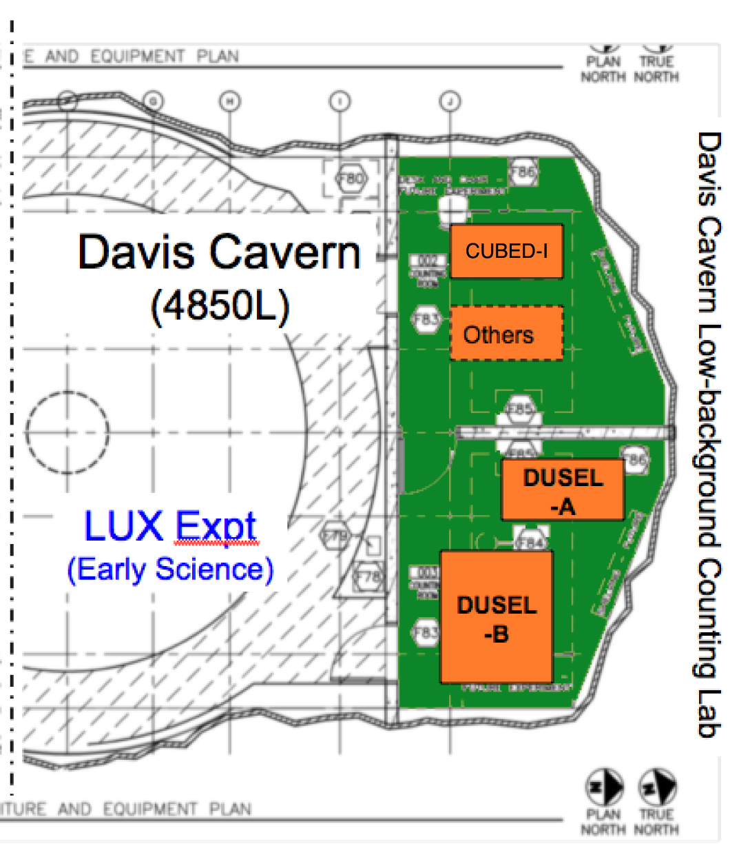
Figure 3.3.8.1.1 Layout of the Davis Cavern counting laboratory at the 4850L. It shares the same cavern but is separated from the LUX experiment.
3.3.8.2 Low Background Counting Facility—FAARM
A candidate to provide the required capability for DUSEL is FAARM, a proposal from the AARM collaboration. The FAARM proposal seeks resources for the design and implementation of a facility on the DUSEL site for screening, production, and storage of radiopure materials. Since the first Homestake National Underground Science Lab (NUSL) studies seven years ago, such a facility has been identified as a priority. The design of the facility was explored in the NUSL White Paper⁵ and was mapped into the infrastructure matrix⁶ during the DUSEL Solicitation 1 (S1) process, with its own technical chapter of the Deep Science Report.⁷ Its importance was reaffirmed during the November 2007 Town Meeting by the B1 Cross-Cutting Group on Low Background. The clear consensus was that DUSEL must have world-class facilities capable of providing assay and ultraclean materials support for the ISE, as well as integration tools to share data; exchange equipment; train personnel; optimize screening throughput (both on site and off site); foster new collaborations in areas of geology, biology, and homeland security; and identify new users in other research fields. There are other on-site and off-site activities that are potentially associated with the FAARM facility, such as underground storage of ultrapure materials, underground ultrapure material production facilities, clean machine shops and ICPMS, NAA facilities, as well as special fabrication tools such as electrical discharge machines (EDMs) and laser welders.
3.3.8.2.1 The FAARM Proposal
Design of FAARM will optimize economy of scale—combining ultrasensitive and production screening in the same area—and take advantage of common infrastructure (such as purification plants and water-shield engineering at DUSEL). There are four major components in the design (Figure 3.3.8.2.1-1): 1) an active shared water shield for the identification of muons and neutron activation products as well as passive attenuation of external gammas and neutrons; 2) a laboratory space inside the water shield for housing alpha, beta, and gamma screeners; 3) an ultrasensitive immersion-tank system capable of performing large-sample counting; and 4) the provision of a well-shielded space (inside the same water shield) for R&D and prototyping of detectors for future DUSEL experiments.
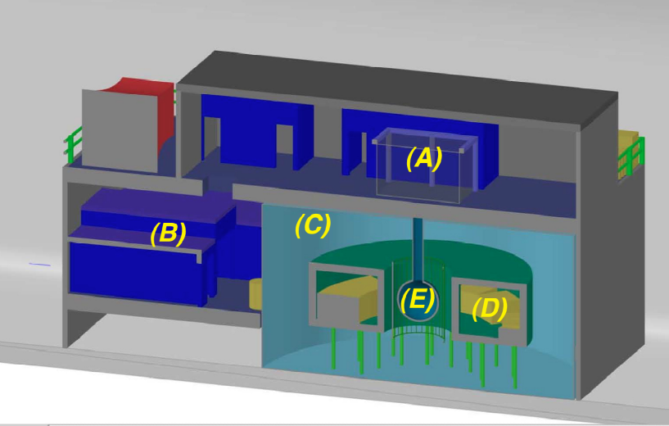
Figure 3.3.8.2.1-1 A conceptual sketch showing the major components of the FAARM design: (A) clean room with sample preparation, (B) clean machine shop and assembly areas, (C) the water shield, (D) the inner toroidal laboratory, and (E) the ultrasensitive immersion detector system (center).
- The Large Water-Shield System. The purpose of the water shield is to tag muons and attenuate the external background gamma rays and neutrons from the cavern walls (rock and shotcrete), and to provide an inexpensive common shielding for all the moderate-sensitivity and GeMPI-style screeners, while creating ultimate shielding for the innermost ultrasensitive immersion inside. It can thus share common water-purification infrastructure with other DUSEL experiments that are planning dedicated water shields. Simulations indicate that a minimum water shield thickness of 2.3 m is needed to establish the required sensitivity of the immersion-tank detector. The present shield engineering design is based on a large-diameter stainless steel cylindrical tank filled with processed ultrapure water. The size of the shield is ~15-m diameter and ~8-m height, but the final dimension will depend on the radioactivity level of the surrounding rock and concrete construction materials. The required water is expected to come from the Long Baseline Neutrino Experiment water system at the 4850L but there will be local processing to improve and maintain the cleanliness of the water. The inner surface of the shield is instrumented with photomultiplier tubes to create a muon veto and to provide additional rejection of neutron-induced processes in the water and electromagnetic fragments from showers induced by muons in the wall. The option of replacing the water with liquid scintillator or introducing gadolinium or boron to improve rejection efficiency will be explored with dedicated studies over the next two years. If this option is too expensive, the shield will be designed to accommodate this as a later upgrade.
- The Inner Screening Laboratory. Sensitive screeners will be located inside a toroidal inner screening laboratory that forms a tunnel within the water shield (Figure 3.3.8.2.1-1). The exact geometry was optimized and the overall facility cost cut in half by taking advantage of standard steel tank engineering for the water shield and creating a toroidal screening lab that reserves a central shared water space for the most sensitive detector. This saves valuable space, uses the same water system and photomultiplier tubes (PMTs), and avoids the cost of an additional containment tank. The walls of the torus laboratory, especially the inner one that faces the immersion-tank system, need to be constructed of radiopure material. Acrylic tunnel design is a staple of large public aquariums and this expertise is being tapped. Several (~ 8 to 10) α, β, and γ screeners can be installed inside the torus laboratory. Besides the external water shield, conventional shielding material such as low-background lead or copper could be added to the screener systems if needed.
- The Ultra-Sensitive Immersion Tank System. Designs of such a large-scale screener have been formulated by many groups, and usually consist of a tank made of stainless steel or a cavern lined with a radon-impermeable plastic. It can be filled with liquid scintillator or with doped pure water (~10⁻¹⁴ g/g U/Th). It is then accessed by a hermetic top deck and has a nitrogen purge between the liquid surface and deck for handling and insertion of counters and samples into the active volume. To quantify the footprint, cost, placement, and safety issues, the FAARM design (Figure 3.3.8.2.1-2) is modeled after the Borexino Counting Test Facility (CTF)³ detector, with modifications and improvements (such as low-radioactivity photosensors and new scintillator or water-soluble fluors, etc.) to be designed over the next couple of years. A 2-m diameter transparent nylon vessel filled with liquid scintillator will occupy the central portion of the water shield. To have a more compact detector, low-radioactivity Quartz Photon Intensifying Detector (QUPID) tubes will be immersed in the water shield in a frame surrounding the central scintillator volume.
- General R&D Space. Space will be allocated inside the inner screening laboratory for detector R&D and prototyping for future experiments. This provides a unique shielded underground space for new technologies that otherwise would be unable to afford the type of shielding required to extend their sensitivities and determine their feasibility.
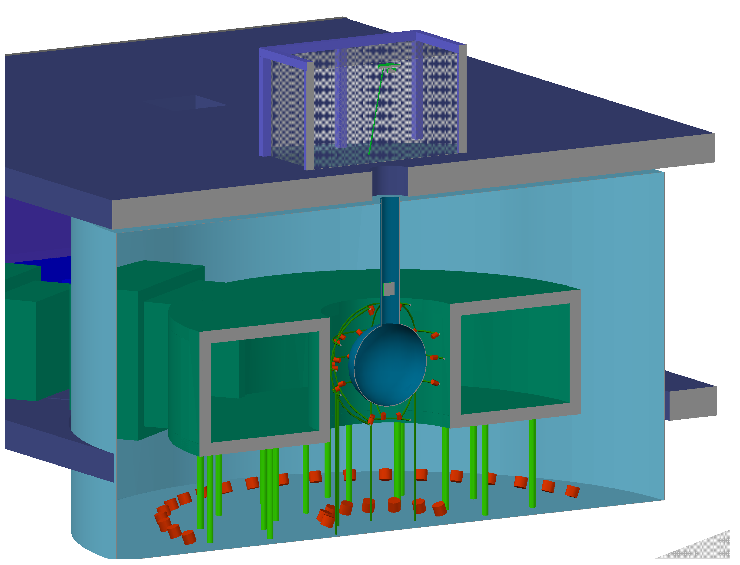
Figure 3.3.8.2.1-2 The immersion tank system shown with photosensors and upward-looking muon veto photomultiplier tubes.
3.3.8.2.1.1 FAARM Location and Space Requirements
The FAARM facility will be located at the 4850L. The facility will have two levels, with the main water shield and screening laboratory (including the control room) at the ground level, and a clean room with an assembly area, a small mechanical shop, radon scrubber, local water-processing system, and HVAC support room, etc., situated at the second floor level (see layout drawings, Figure 3.3.8.2.1.2 in the following section). The general requirements for power, utility, air, etc. are summarized in Table 3.3.8.2.1.1, below.
Requirement | Value/Description | Comment/Justification
Depth | 4850L
Footprint | 25m L x 17m W | Constrained value
Max. Height [m] | 13.25m | Actual value
Floor Load [kPa] | 78 | Corresponds to 8 m high water tank
Utilities
Power [kW] | 350
Standby Power [kW] | 25 | Radon mitigation, emergency lights, some air handling
Chilled Water [kW] | 100
Waste Heat to Air [kW] | 250
Purified Water [m³] | 1500 | FAARM water polishing of purified water to 18Mohm
Potable Water [lpm] | Nominal
Compressed Air | Nominal
Network | 1 Gb/s | Nominal
Environment
Temp. Min [°C] | 20
Temp. Max [°C] | 25
Humidity Min [%] | 20
Humidity Max [%] | 50
Rn Background [Bq/m³] | 200 | FAARM radon mitigation to acceptable level
Crane
Max. Load [Short Ton] | 20
Occupancy
Peak Installation Occupancy [count] | 15 | Installation and commissioning are simultaneous
Installation Duration [months] | 30
Peak Commissioning Occupancy [count] | Same as installation
Commissioning Duration [months] | Same as installation
Peak Calibration Occupancy [count] | 10 | Installation of new screeners, R&D studies
Calibration Duration [months] | 0.5
Calibration Frequency | 4/yr
Peak Operation Occupancy [count] | 6 | 6 Peak/ 2 Avg
Operation Duration [months] | Continuous
Cryogens
LN Storage [L] | 50 | In transportable dewars
LN Consumption [L/day] | 4 | Boil-off for pure low radon nitrogen
Major Hazards (Other than Cryogens)
Chemistry Lab Operation Waste | Acids, bases, solvents | From sample preparation and processing
Water Flood Hazard | 1500 m³
Assay and Storage
Assay Needs | Assay for others
Underground Storage | FAARM clean storage | Some storage at shallower levels, possibly
Table 3.3.8.2.1.1 Summary of general FAARM requirements.
3.3.8.2.1.2 FAARM Layout
A proposed FAARM floor plan is shown in Figure 3.3.8.2.1.2. The overall footprint of the facility is 25 m x 17 m, in compliance with guidelines for fitting into the DUSEL lab modules at the 4850L.

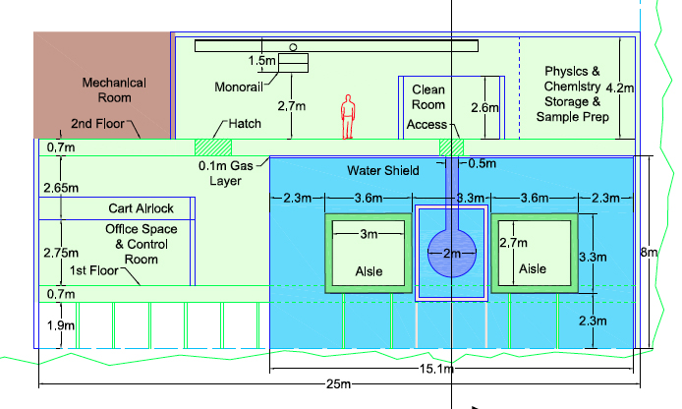

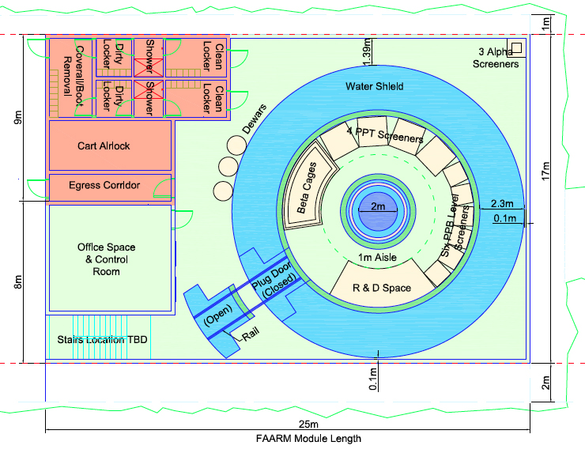
Figure 3.3.8.2.1.2 Elevation (top) and plan (bottom) views of FAARM.
3.3.8.2.1.3 Major Hazards
There will be a significant volume of scintillation liquid (LAB, linear alkylbenzene) inside the immersion-tank system. A water-containment plan needs to be in place in case of a major leakage from the main water shield, so as not to affect neighboring experiments in the shared DUSEL lab module.
3.3.8.2.1.4 Schedule and Installation
The overall FAARM schedule includes a strategy to establish a DUSEL Low Background Counting Facility (DULBCF) consortium for early screening using the Sanford Lab and multiple sites. The transition from the Davis Cavern to full screening at FAARM ensures uninterrupted screening from 2012 onward. The longer-term FAARM schedule has been planned in accordance with DUSEL guidance, with completion of the conceptual design expected by 2013 and start of construction in 2017, when the DUSEL 4850L lab modules are expected to be available for beneficial occupancy. The DUSEL installation schedule must account for the earliest-possible deployment of FAARM as a service facility for all the experiments. As FAARM is expected to remain in place for the duration of the DUSEL scientific program, its placement within the laboratory module must take this into account.
3.3.9 Other Potential Physics Experiments
3.3.9.1 Introduction
We provide short descriptions of two examples of potential physics experiments not described in previous sections of this section. Both examples demonstrate unique possibilities at DUSEL so far not available in other underground laboratories. These examples have not been used yet to establish facility requirements. Further review is needed to determine if their requirements, or those of other experiments that may be proposed, should be included in the process for defining facility requirements. The DUSEL Program Advisory Committee (see Section 3.10) will be consulted over the next few years as part of this process.
3.3.9.2 DAEdALUS
The DAEdALUS (Decay At rest Experiment for δ_{CP} studies At the Laboratory for Underground Science)¹ proposal describes a complementary approach to the Long Baseline Neutrino Experiment (LBNE) science goal to measure charge and parity (CP) violation in the neutrino sector. The DAEdALUS concept was proposed in early 2010, and was not submitted as part of the S4 process.
The physics of neutrino oscillations has been described in Section 3.2, Accelerator Neutrino Oscillations. Where LBNE has a fixed source of neutrinos at Fermilab, and near and far detectors between which neutrino oscillations are measured, DAEdALUS proposes to use an ensemble of near (1.5 km), mid (8 km), and far (20 km) cyclotrons on the surface to produce neutrinos from pion decay at rest that are detected in the LBNE water Cherenkov detector (see Figure 3.3.9.2). Timing between the accelerator beam batches allows the experiment to determine the neutrino source among the near, mid, and far cyclotrons.
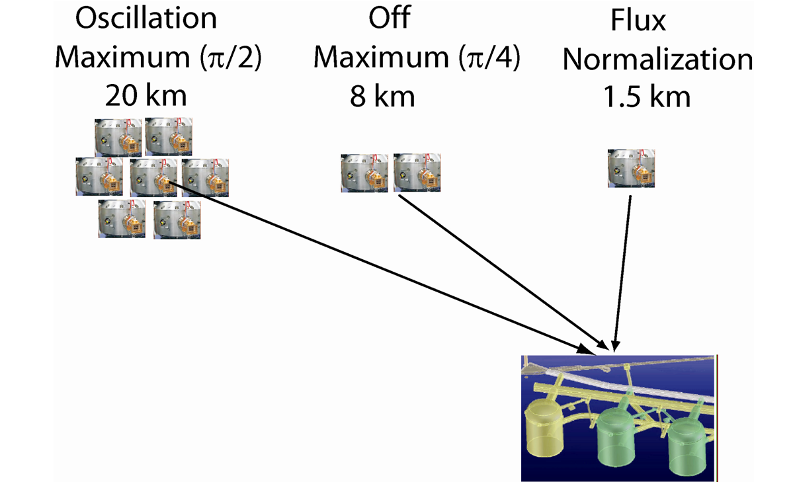
Figure 3.3.9.2 Schematic diagram showing the relationship of the LBNE water Cherenkov detectors to three complexes of cyclotrons at 1.5 km, 8 km, and 20 km. The oscillation maximum refers to a‾ν_{μ} energy of 40 MeV. The flux is determined from the near accelerator on the surface at 1.5 km from the detector. In this cartoon, the mid and far neutrino flux is increased by adding accelerators, where each cyclotron drawn indicates ~1 MW of beam power. The actual experiment would be phased, and the ultimate design would depend on cost, sensitivity, and choice of cyclotron technology.
A well-defined spectrum of neutrinos from pion decay at rest is produced by the cyclotrons.
Oscillations of ‾ν_{μ} to‾ν_{e} are detected in the water Cherenkov detector via inverse beta decay: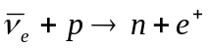. Because π⁻ are mostly captured before decay, the fraction of‾ν_{e} background in the beam is less than ~ 4 x 10⁻⁴. Since the neutrino source is near the detector, there is no interference between the CP violation and matter effects. Hence, DAEdALUS is sensitive only to CP violation, and not the mass hierarchy. As in the case of electron antineutrinos from supernovae, the products of the inverse beta decay for this experiment are also detected as a double delayed-coincidence signal, with the prompt positron detected through its Cherenkov radiation, and the neutron via delayed capture (~30 μsec) on Gd in the water, releasing a cascade of photons with total energy ~8 MeV of energy of which ~ 4-5 MeV is detected by the photomultiplier tubes (PMTs).
The CP measurement sensitivity of DAEdALUS running alone as a function of exposure and a 300 kT water Cherenkov detector can be found in Reference 1. The DAEdALUS results could be combined with LBNE measurements to improve the sensitivity for LBNE measurements of sin²2θ₁₃ and δ_{CP} by statistically combining the results for both neutrino and antineutrino running. Since DAEdALUS uses antineutrinos only, better sensitivity could be realized by running the LBNE experiment with a neutrino beam only. Sensitivity results are also given in Reference 1.
The neutrinos from the DAEdALUS targets are in the same energy range and use the same inverse beta decay detection method (water with gadolinium doping) as diffuse neutrinos from relic supernovae. Whether DAEdALUS operations are compatible with this measurement in LBNE is under investigation.
It is proposed to build the DAEdALUS experiment in three phases. The construction is dependent on current research in high-intensity cyclotrons, currently under way at several institutions.¹
3.3.9.3 NNbar
Recent theoretical and experimental developments² in the field of neutrino physics provide reasons for the possible existence of neutron-antineutron transformations or oscillations (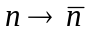 or NNbar). In many seesaw models for neutrino masses, neutrino mass breaks lepton number and, since the true symmetry of nature is B-L (baryon number minus lepton number), Majorana neutrinos necessarily imply the existence of NNbar oscillations. Therefore, an improved NNbar experimental sensitivity would shed light on the scale of violation of B−L. Discovery of NNbar oscillations would reveal a new force of nature beyond the Standard Model and would shed light on one of the fundamental mysteries of the Universe- the origin of matter.
The concept for the NNbar search experiment at DUSEL is illustrated in Figure 3.3.9.3. The source of the neutrons is at or near the surface and it is followed by a cold moderator and a neutron-focusing device. The neutrons then fall inside a 300 m to 1 km long and 4-5 m wide vertical vacuum flight tube (with vacuum better that 10⁻⁵ Pa) where the Earth’s magnetic field is cancelled down to ~1 nT to satisfy the quasi-free condition for NNbar transformation. The vertical configuration avoids the detrimental effects of the gravitational force on the subthermal neutron transport. Neutrons transformed in-flight to antineutrons are detected by an annihilation detector.³ The unique signature of antineutron annihilation makes this experiment background-free and, as such, a single detected event will be a discovery of the transformation.
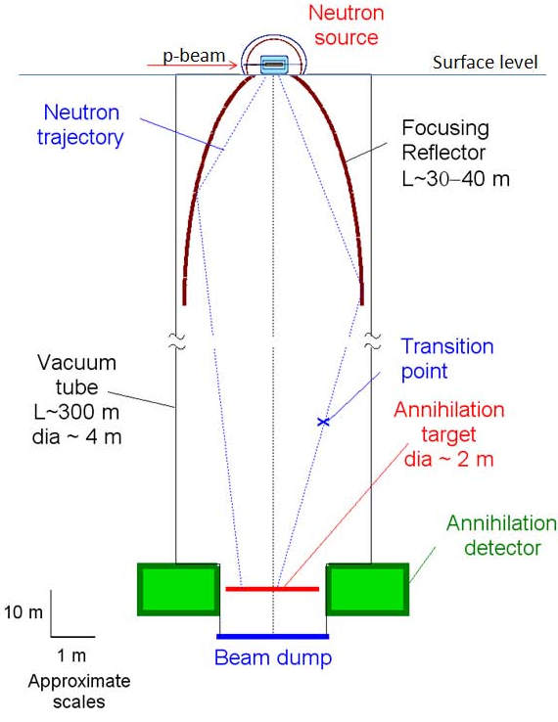
Figure 3.3.9.3 Schematic view of the NNbar oscillation experiment in a vertical shaft of DUSEL.
The goal of the proposed NNbar experiment at DUSEL is to increase the sensitivity for transformation by a factor of ~ 10⁴ with respect to the existing intranuclear and free-neutron experimental search limits.^{3,4} The same experimental setup at DUSEL⁵ with small modifications can be also used for a search for mirror matter (an alternative to supersymmetric WIMP dark matter) by measurement of the neutron flux disappearance.
The experiment would require an environmentally clean and safe neutron source. Possible neutron sources include recently proposed compact accelerators¹ with a spallation target, arrays of d-d or d-t generators, or commercially available research nuclear reactors. The high neutron flux requires a cooling system at the power level of ~1 MW. Also, a 20-30 kW cryogenic system for the moderator will be required at the surface.
3.3.10 Cosmogenic Backgrounds and Depth Requirements for Physics Experiments
The depth requirements for the physics experiments proposing to go into DUSEL are based predominantly on the need to achieve sufficient overburden to reduce cosmogenic backgrounds to acceptable levels. As part of the Preliminary Design process for DUSEL, S4 recipients in physics were asked to respond with specific statements detailing the requested location for their experiment, whether at the 4800L or at the 7400L Campus. Experiments interested in the deployment at the 7400L Campus were asked to submit additional calculations justifying their requests.¹⁻⁶ The two experimental areas with the highest sensitivity to cosmogenic backgrounds are neutrinoless double-beta (0νββ) decay and dark-matter searches. These experiments drive the need for space at the greatest depths.
A variety of cosmogenic processes can result in backgrounds in physics experiments. These include direct muon interactions, muon capture and decay, muon-induced hadronic and electromagnetic showers, and spallation products. Fast spallation neutrons are particularly troublesome, especially those generated within the rock by muons that never traverse the experimental hall to trigger a veto. The energy spectrum of the fast neutrons extends up into the hundreds-of-MeV range, which makes them highly penetrating, and makes a large number of interaction channels available. For dark-matter searches, the dominant background arises from neutron-nucleus elastic scattering, mimicking the low-energy recoils of Weakly Interacting Massive Particles (WIMP) interactions. In 0νββ decay, typically of greater concern are high-energy inelastic neutron interactions, which can result in events in the energy region of interest where the 0νββ peak is to be found. Decays of long-lived unstable nuclei formed by muon-induced spallation are also a concern.
To decrease these backgrounds to tolerable levels, the two primary strategies are to go deep enough to reduce the neutron flux, and to moderate the remaining neutrons down to harmless energies. In DUSEL, the fast neutron backgrounds at the 7400L are predicted to be roughly a factor of ~20 lower than at the 4850L. Additional rejection can be obtained from event discrimination and vetoing capabilities, such as the detection of neutron multiple scattering in detectors, the vetoing of electromagnetic and hadronic showers typically accompanying the neutrons, or the detection of the neutrons themselves in active scintillator vetoes. Generally speaking, depth can be traded against a more complex shield design. In their base design, the various S4 experiments have made different choices based on a combination of factors, including perceived uncertainties and risks of a particular shield configuration, design heritage from previous-generation experiments, technology-specific constraints, shield complexity, and costs. Facility-related factors such as access to the two DUSEL levels, timing of the availability, and size of the cavities also played a role.
A critical element in estimating accurately the performance of a particular design is the detailed modeling of the background, which needs to be based on experimental measurements of the neutron yield, energy spectrum, and multiplicity at various depths, and of the correlation with hadronic and electromagnetic cascades. Such data are still very sparse, in particular for the high-energy tail of the neutron distribution that typically dominates the background. Neutrons above 50 MeV not only interact with the detector material but also produce a large number of additional neutrons in the relatively high Z materials needed for support, enclosures, and shields. Because of the rapidly falling neutron-proton cross section, they are unfortunately difficult to moderate. It is not clear yet that the detailed Monte Carlo simulations including GEANT3,⁷ Geant4,⁸ and FLUKA⁹ are sufficiently accurate—the relevant neutron nuclear cross sections are often uncertain—or whether they include all the important physics processes—some may still be unknown. As a result, simulations tend to disagree with the existing data and among each other.¹⁰⁻¹⁴
The DUSEL low-background community is forcefully engaged in trying to understand in more detail the complex physics processes at play, to use existing data and undertake new measurements to validate Monte Carlos, and to compare simulations among the various groups. A working group, involving in particular the double-beta decay and dark-matter S4 collaborations, is being assembled to build on the work already conducted by the individual collaborations, with the goal of reducing present uncertainties and apparent contradictions, and of quantifying the level of uncertainties. New experimental results from existing setups at various depths as well as from dedicated experiments worldwide should be available within the next two years. Much will also be learned during the pre-DUSEL program, which will result in decreased risk of the proposed experimental designs.
The 1TGe collaboration provided a detailed breakdown of the cosmogenic backgrounds expected for the Majorana Demonstrator prototype experiment that is scheduled to start data taking in Sanford Laboratory in ~2013. The background is dominated by inelastic (n, n’γ) interactions with the detector, shield, and support materials (Ge, Cu, Pb). The total predicted background, ~1 count in the region of interest per ton per year (c/ROI/t/y), is at the upper limit of allowed background levels for a ton-scale ⁷⁶Ge 0νββ experiment of similar design to have sufficient sensitivity to cover the phase space corresponding to the inverted neutrino mass hierarchy (see Section 3.2.2). Additional reductions are judged by the 1TGe collaboration to be essential to the experiment’s success, especially considering that non-cosmogenic backgrounds in the 1TGe detector already contribute ~1 c/ROI/t/y themselves. Alternative shielding designs are under consideration for 1TGe; however, even if prompt fast neutron backgrounds can be moderated, other cosmogenic backgrounds remain problematic. For example, the 1TGe collaboration estimates that the in situ production of ⁷⁷Ge at the 4850L is higher than acceptable, given current uncertainties. Until those uncertainties can be addressed or further rejection techniques can be developed, 1TGe is assuming occupancy of the 7400L Lab Module in its design activities.
The EXO collaboration makes a similar argument to that made by 1TGe. They are currently in the midst of commissioning a prototype experiment, EXO-200, at the Waste Isolation Pilot Plant in New Mexico. They plan to investigate cosmogenic backgrounds at the shallower overburden (1585 mwe) provided by this site, but don’t expect to have sufficient information to make siting (depth) decisions for DUSEL until the end of the S4 process. In the meantime, given the penetrating nature of the fast neutrons, which they suspect will dominate their cosmogenic backgrounds, the collaboration is reluctant to rely on shielding alone at the 4850L to achieve sufficiently low background, and is assuming occupancy of the 7400L Lab Module in their planning activities.
To reduce neutron-nucleus elastic scattering, which may mimic WIMP-nucleus interactions, the various S4 dark-matter experiments have made different baseline choices based on the designs of previous-generation experiments and the experience gained so far in those configurations. LZD and MAX have chosen to operate at the 4850L with large water shields and/or active liquid scintillator vetoes, and to mitigate the uncertainties in the background by including an ample safety margin in the shield design. GEODM and COUPP are baselining for the 7400L, where the shields can be simpler and much more compact.
The LZD and MAX collaborations intend to use low-mass cryostats and low-Z instrumented water shields. The collaborations’ evaluations led to a conclusion that sufficient suppression of cosmogenic activity at the 4850L, with a substantial safety factor, can be achieved using these design features combined with event characterization and fiducial-volume selection. With 4-5 m of water shielding surrounding their inner vessel, the LZD collaboration estimated that fast neutron backgrounds would be more than an order-of-magnitude lower than expected photomultiplier tube backgrounds before any cuts are applied. Further rejection of these backgrounds is enhanced by the large, monolithic nature of the LZD and MAX liquid-noble time projection chambers. The LZD collaboration estimated that by applying a fiducial volume cut and by rejecting interactions that deposit energy at multiple locations simultaneously within the detector, additional background reduction by over two orders of magnitude can be achieved. The LZD collaboration has also evaluated an option to add a 1 m thick active liquid-scintillator veto inside the water shield. It is not necessary to reach the baseline background goals, but would provide a significant additional safety margin. The MAX collaboration already has as part of its default option the use of an active, liquid scintillator-based neutron and muon veto.
GEODM does not take this approach, primarily because the shielding requirements for its cryogenic design demand more high-Z material close in to the target material. High-Z material regenerates low-energy neutrons, reducing the effectiveness of instrumented water shields and liquid scintillator vetoes. GEODM estimates that, even with minimal amounts of copper close in to the target and use of a water shield, the raw rate of events due to high-energy neutrons would degrade the experiment's sensitivity by up to an order of magnitude. Rejecting such events via event characterization and detection of high-energy neutrons and their associated secondary particles in an instrumented water shield and possible liquid scintillator veto could provide the safety factor necessary to achieve GEODM's intended sensitivity at the 4850L. However, this would be a significant deviation from the Cryogenic Dark Matter Search design heritage, and therefore would demand a significant testing program, entailing additional costs and risks.
The problem of cosmogenic backgrounds is of course not limited to 0νββ decay and dark-matter experiments. It should be kept in mind that for some types of experiments, such as p-p solar neutrino experiments, which were not retained for S4 studies, the issue of cosmogenic spallation products (such as the production of ¹¹C in liquid scintillator) would demand a deep location. It is likely that future investigations of yet-unknown physics would have similar requirements.
To summarize, the issue of depth is a multidimensional problem, encompassing the complex and possibly unknown aspects of the physics contributing to the backgrounds, the quantitative uncertainties in the background levels in specific configurations, and the associated scientific risks. Other factors include costs, technological risks, and facility-related aspects, such as space available at a given depth, access, and timing. It is therefore essential that the facility design be flexible enough to allow the best experimental strategies to be implemented by providing experimental space at the 7400L, and large-enough halls at the 4850L to be able to accommodate the more complex shields needed at those depths. In parallel, it is important that the experiments further analyze the experience of existing setups, collect additional data, and develop the simulation tools needed to reduce the background uncertainties as much as possible.
3.4 Research Activities at the Sanford Underground Laboratory
3.4.1 Introduction
Building on the legacy of the Ray Davis chlorine solar-neutrino experiment that began in 1965 at the Homestake Mine, 19 initial science groups are currently active at Sanford Laboratory. Experiments are being conducted on 12 levels, ranging from the surface to the 1,480-m (4,850-ft) level to investigate topics in physics, geology, biology, and engineering. Table 3.4.1 shows the list of initial science groups and corresponding levels on which activities are taking place.
Three large-scale physics projects are in process at Sanford Laboratory: the Large Underground Xenon (LUX) dark-matter experiment; the Majorana Demonstrator neutrinoless double-beta decay experiment; and the Center for Ultralow Background Experiments at DUSEL (CUBED), which will be investigating the development of ultrapure crystal-based detectors. However, most of the current projects under way at the Laboratory are smaller in scale and many are associated with the biology, geology, and engineering (BGE) disciplines, performing characterization measurements that will be useful for future projects.
In addition to existing areas available for researchers, Sanford Laboratory is developing new areas. A former warehouse building on the surface has been renovated to provide laboratory space for LUX to exercise its deployment procedures and to commission detector systems before moving the experiment underground. The LUX collaboration has had beneficial occupancy since December 2009. Excavation work started in September 2009 and is now complete on the 4850L Davis Campus, which includes the original Davis Cavern space and the Davis Transition Area. Outfitting is expected to begin in early 2011 and be completed approximately 10 months later by the end of 2011, followed by beneficial occupancy of the experiments.
The total space at the Davis Campus is roughly 745 m² (8,000 square feet), with approximately 455 m² (4,880 square feet) available for scientific activities and equipment. Figure 3.4.1 shows the plan view of the Davis Campus and the two separate areas: the Davis Transition Area (a large portion of which will be dedicated for the Majorana Demonstrator) in a new access drift and the Davis Cavern that will be slightly enlarged to accommodate a large water shielding tank for LUX. Prior to the completion of the Davis Campus, a temporary space is being developed near the 4850L Ross Shaft to allow the Majorana Demonstrator project to begin electroforming copper components for its detector.
The Sanford Laboratory Science Liaison Department provides logistics support and oversight for the initial science research groups. The Science Liaison Department coordinates closely with Sanford Laboratory Operations, as well as the EH&S Department and the DUSEL science integration team.
Experiment | Description | Levels
Physics
LUX-350 | Dark matter using Xe | Surface, 4850L
Majorana Demonstrator | Neutrinoless double-beta decay using Ge | 4850L
CUBED | Crystal growth (Ge; possibly NaI, CdWO₄) | TBD
Background Characterization (also part of DUSEL Low Background Counting Facility in future) | Muon, neutron, gamma, radon | 800L, 2000L; many levels for Rn; previous incl. surface, 4550L
Vertical Facility (magnetic field background) | N-Nbar, others (e.g., gravity) | Surface, Ross/Yates Shafts
Geology
CO₂ Sequestration | Environment characterization | 800L, 2000L, 4850L (removed)
Deep Underground Gravity Laboratory- DUGL | Seismic characterization for gravity-wave research | Surface, 300L, 800L, 2000L, 4100L
Fiber Sensors | Extensometers, temperature | 4100L
Hydrogravity | Dewatering effects on local gravity | Surface
Hydrology/Microclimate | Aquifer characterization, groundwater monitoring | Surface, 1250L, 2000L, 2600L, 4850L
Petrology, Ore Deposits, Structure- PODS | Core archive and logs, geologic mapping | Surface, 800L
Tiltmeter | Rock deformation | 2000L
Transparent Earth | Seismic monitoring | 2000L, 4100L
Biology
SDSM&T/BHSU | Microbiology | Surface, 300L, 2000L, 4100L, 4850L
SDSU | Lignocellulose | 1700L, 2000L
Princeton/UTKnoxville | Manifold sampling | 2000L, 4550L, 4850L
SDSM&T | Microbiology/Cellulose | 4550L
Engineering
Signal Propagation | Electromagnetic transmission | 300L
Submersible | Autonomous vehicle navigation, magnetic field background | 1250L
Table 3.4.1 Initial science research groups at the Sanford Underground Laboratory.

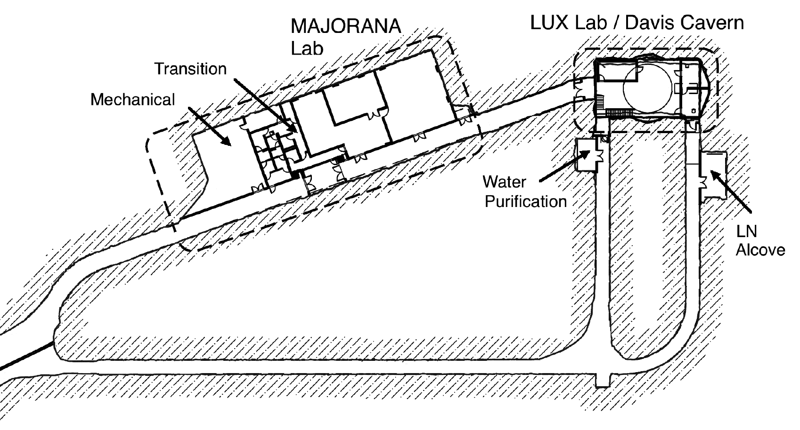
Figure 3.4.1 Sanford Laboratory 4850L Davis Campus near the Yates Shaft.
3.4.2 Physics Experiments
3.4.2.1 LUX and Dark Matter
The LUX collaboration is composed of 13 universities and two U.S. laboratories.¹ The LUX concept is illustrated in Figure 3.4.2.1.
The collaboration is currently deploying the LUX detector at a surface facility at Sanford Laboratory. Detector deployment on the surface allows full-scale integration and testing of all final detector subsystems before underground deployment. This will allow test commissioning and characterization of the detector in an environment closely emulating the final underground laboratory. This facility will be reconfigured for use by future DUSEL experiments and will become part of the complex of surface buildings in support of the DUSEL scientific program.
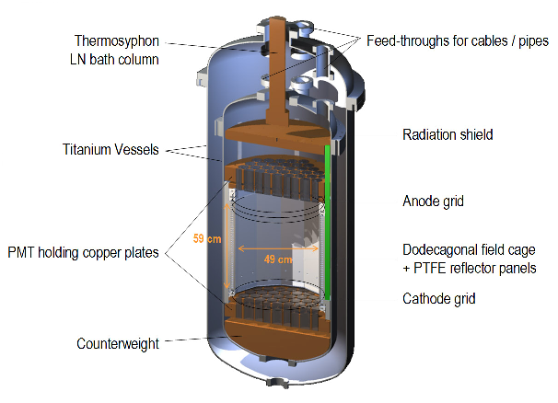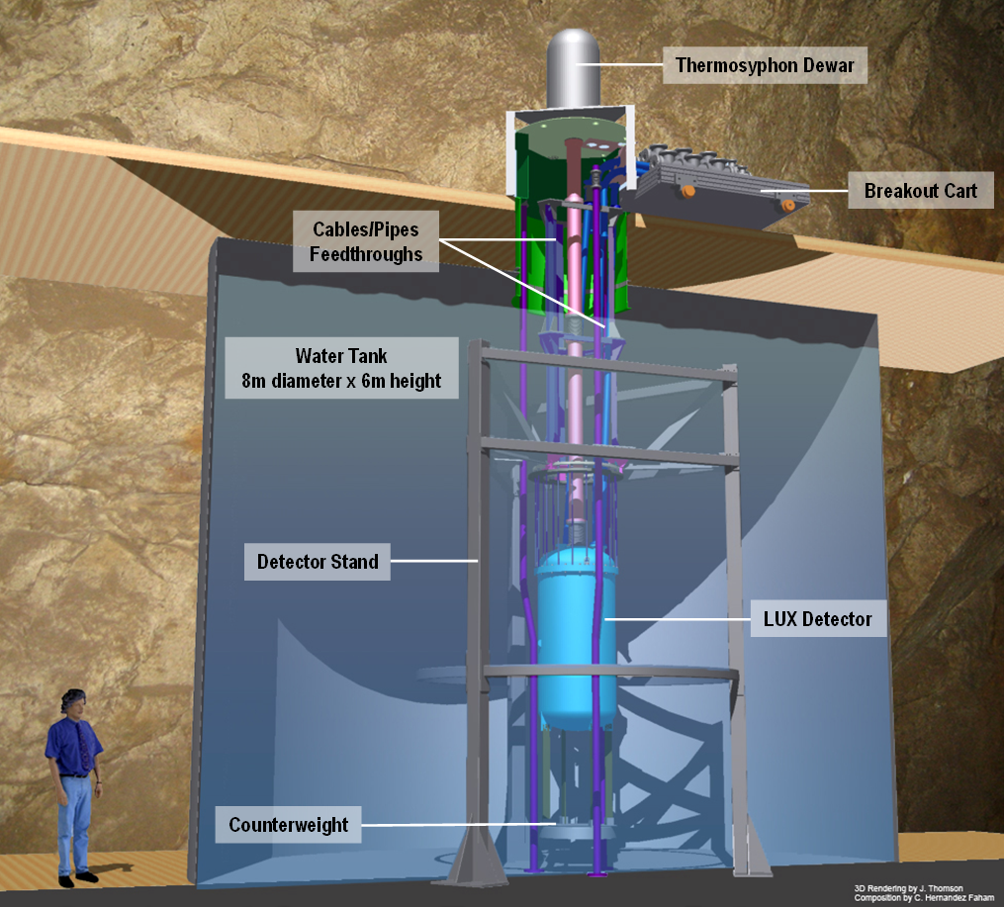
Figure 3.4.2.1 The LUX detector concept (left) and envisioned in place in the Davis Cavern (right).
The surface facility has been designed to closely emulate both the vertical and horizontal layout of the underground laboratory space (Davis Cavern). The building provides finished laboratory space comprising approximately 190 m² (2,040 square feet). A vertical shaft descends three stories from the upper floor. The shaft contains a 4-m high/3-m diameter water shield, designed to be a more modest copy of that being placed in the Davis Cavern (8-m diameter). The detector will be mounted in the water shield to reduce surface radioactive backgrounds, allowing for detector calibrations as well as providing a direct test of the detector hardware in a water environment. A Class-1000 clean room is maintained for detector assembly and services.
The collaboration gained beneficial occupancy of the surface facility in December 2009. Water-tank construction was then completed. Transferring and integration of all LUX subsystems that have been fabricated by the collaboration has been taking place since January 2010. The precision fit of the fully assembled internal structure (that defines drift space, PMT array, and internal plumbing) has been achieved within the titanium cryostats. All mounting and fitting procedures test hardware that will be used in the underground lab, allowing for a characterization of their effectiveness during their final deployment.
The first cryogenic runs of the detector are projected for early 2011, and will be followed by test-filling with liquid xenon. Subsequent runs in early 2011 will include the full 350 kg xenon payload, as well as all 122 photomultiplier tubes and the full complement of internal hardware and sensors. Data collection and detector-response characterization is expected to begin in the first quarter of 2011, continuing until deployment underground in late 2011. LUX-350 expects to reach a dark-matter cross-section sensitivity of 3x10⁻⁴⁶ cm², at a WIMP mass of 60 GeV/c², which is a factor 100 more sensitive than the best result currently published.
3.4.2.2 The Majorana Demonstrator
In neutrinoless double-beta decay searches, the 1 Tonne Germanium (1TGe) experiment will be the primary endeavor using the ⁷⁶Ge isotope. The ultimate experiment will provide unprecedented sensitivity: It is expected to raise the lifetime limit for the 0νββ process to the 10²⁷ year scale or better. The technological complexity of the experiment demands that smaller-scale tests be successfully completed, identifying the best technological approach and experiment design prior to proceeding with the expensive procurement of the full amount of separated isotope. Two coordinated efforts are under way: the Majorana Demonstrator,² to be sited at Sanford Lab, and the GERmanium Detector Array (GERDA), at Gran Sasso. Both use a smaller amount (~40 kg) of germanium, with only a portion enriched, and each tests different approaches to the shielding and detector configuration for the experiment. GERDA places bare germanium crystals directly inside an active liquid argon veto shield, while the Demonstrator will test a configuration in which arrays of germanium crystals are deployed in large vacuum cryostats surrounded by lead and copper shielding. Both efforts will proceed toward a decision point in a few years, after which both groups will collaborate using the best-proven technology to mount the 1 Tonne experiment.
Background suppression is the key element of both preliminary experiments; the goal necessary to achieve maximum scientific potential for the 1 Tonne experiment is less than 1 count per tonne-year in the 4 keV window around the double-beta decay Q value (2.039 MeV).
The critical path for the Demonstrator experiment is the production of ultrapure copper for fabrication of the cryostats to hold and cool the germanium crystals. Cosmogenic activation of copper on the surface renders material unacceptably contaminated for certain critical parts within a few days to weeks of surface exposure at sea-level. Plans are to electroform the most critical copper components in an underground environment, shielded from muons and muon-induced neutrons. In the electroforming process, impurities are left in the baths, providing exceptional purification potential for underground fabrication of the material. However, deposition rates are slow, requiring typically several months to produce a mandrel with sufficient material for machining.
To expedite progress and allow commencement of electroforming activities prior to the completion of the Davis Campus, one of the Homestake Mine’s shop areas at the 4850L close to the Ross Station has been designated as the site for a temporary electroforming facility. Preparations for the temporary clean-room area began in December 2009 with the removal of old materials and debris, followed by the installation of new ground support (rock bolts and wire mesh screen). Shotcrete was applied to the walls and ceiling in August 2010. A modular clean room has been assembled in the renovated space, with utilities and a fire suppression system to be installed by the end of 2010. Rehabilitation work on the Ross Shaft and other underground infrastructure was completed in early September; underground access by experimenters will be available following safety reviews in winter 2010. Operation of the Majorana Demonstrator electroforming baths is expected to begin in February or March 2011.
Once the Davis Campus construction is complete, the Demonstrator experiment will be mounted in the Davis Transition Area, the new space designated to house the air-handling and electrical equipment for powering and maintaining the needed cleanliness in the Davis Campus, as well as the dirty-to-clean transition infrastructure for allowing personnel and equipment to move into and out of the Davis Campus. Approximately 280 m² (3,000 square feet) of space in this in the Transition Area will be dedicated to the Demonstrator experiment. Included will be additional electroforming baths, a machine shop, clean (Class 100) assembly hoods, and space for the roughly 2 m x 2 m enclosure of lead and copper to house the two cryostats containing the germanium.
Data-taking with the first modules is anticipated to begin in mid-2012. Full-scale operation will begin in 2014 and is expected to continue for approximately 2-5 years. In addition to verifying the techniques for achieving necessary background levels, the Demonstrator is expected to reach a lifetime sensitivity of 10²⁶ years, sufficient for definitively testing the claimed observation of 0νββ decay by Klapdor-Kleingrothaus et al.
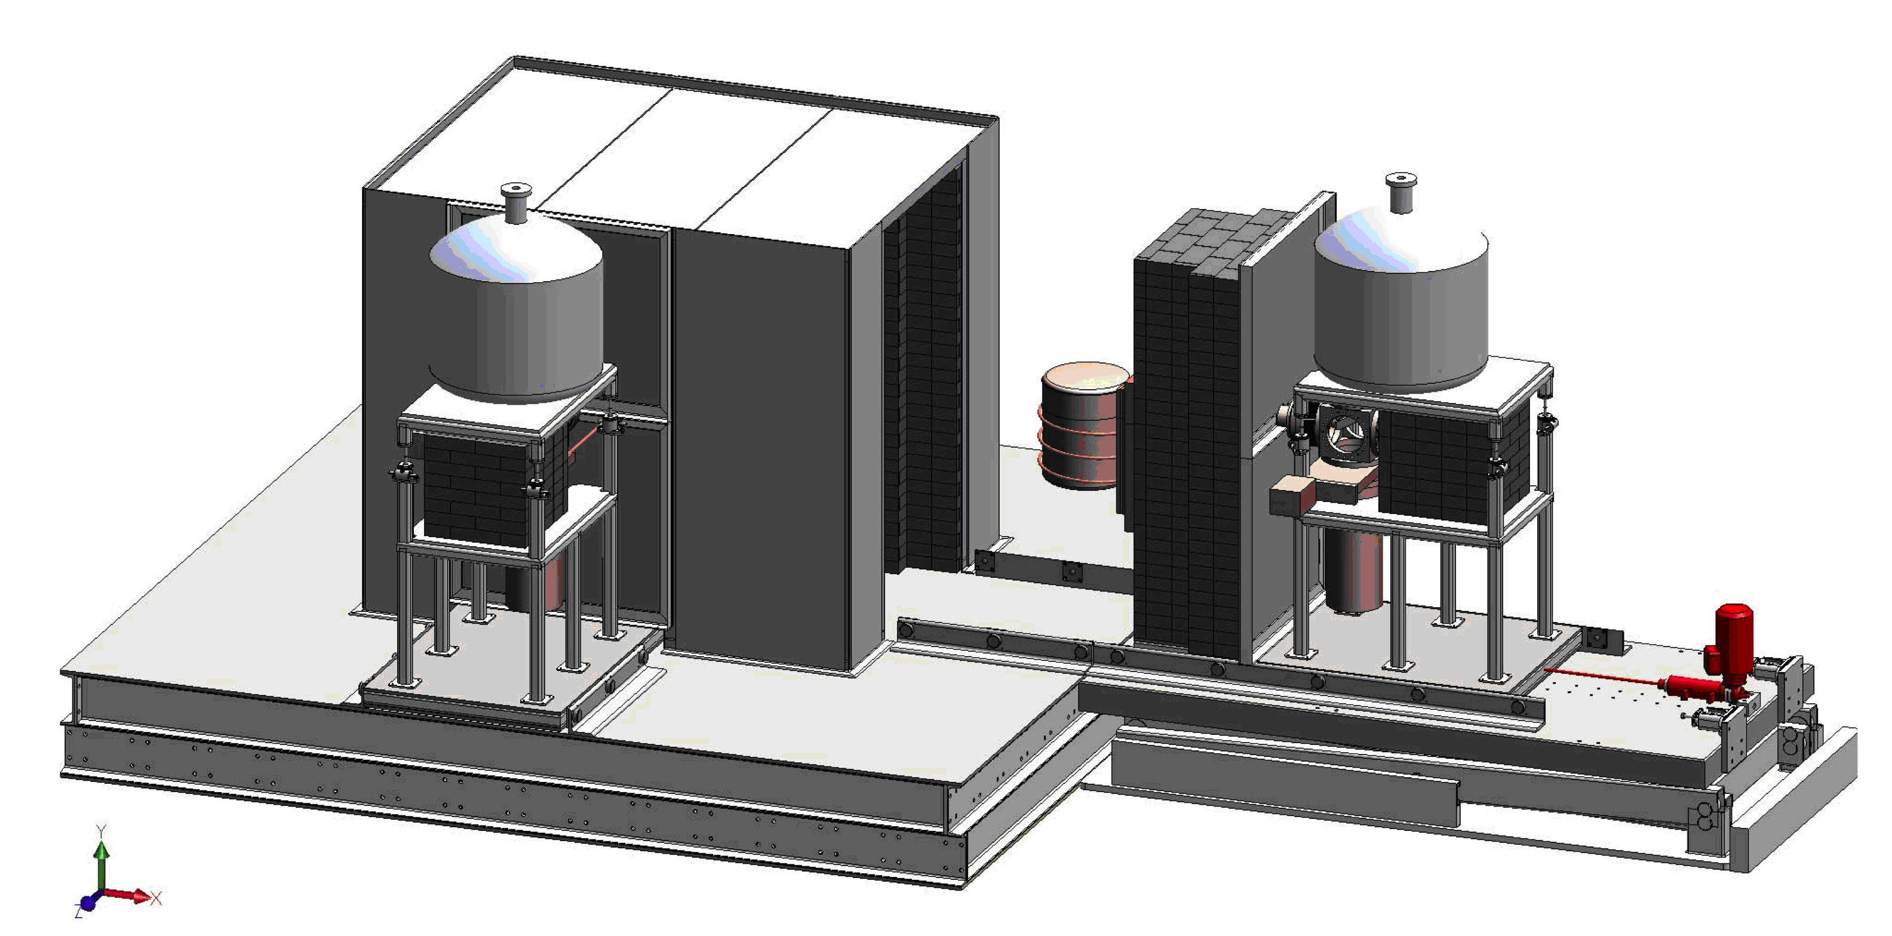
Figure 3.4.2.2 Majorana Demonstrator apparatus. Two cryostats each containing 20 kg of germanium point-contact detectors mounted in assemblies of ultrapure electroformed copper sit inside a shielded enclosure 2 m on a side of lead and copper. Muon veto counters cover top and bottom surfaces of the shielding. Positive nitrogen flow from the inside of the shield assembly will mitigate radon contamination.
3.4.2.3 CUBED and Crystal Growth Underground
The Center for Ultralow Background Experiments at DUSEL (CUBED)3 is supported by the State of South Dakota’s 2010 Initiative. One of its initial research focuses is to explore the science and technology for underground material purification and crystal growing. The center, with seven member universities from the state, has been funded by DOE EPSCoR program to develop an underground laboratory to grow detector-grade crystals such as germanium for future experiments at Sanford Underground Laboratory and DUSEL. It has been shown4 that cosmogenically-produced isotopes in germanium crystals manufactured on the surface can create backgrounds for next-generation neutrinoless double-beta decay and dark matter experiments. To mitigate this problem, it is important for experiments aiming at extremely low background levels (e.g., <~1 count/kg/ton/year) to have as many detector components as possible (including the detector crystals themselves) manufactured and assembled underground to minimize the total integrated cosmic-ray exposure time. Table 3.4.2.3 shows the estimated rate of cosmogenic radioactivity production in a natural germanium crystal on the surface.5
Natural Germanium  (atoms/kg/day) |  |  |  |  | Enriched Germanium  (atoms/kg/day)
Cosmogenic isotopes | Lal model | Hess model | Mei et al. | Experiment | Lal model | Hess model | Mei et al.
³H | ~178 | ~210 | 27.7 | - | 113 | 140 | 24
⁵⁴Mn | 0.93 | 2.7 | 2.7 | 3.3 ± 0.8 | 0.37 | 1.4 | 0.87
⁶⁰Co | - | - | 2.0 | - | - | - | 1.6
⁶⁵Zn | 24.6 | 34.4 | 37.1 | 38 ± 6 | 3.12 | 6.4 | 20.0
⁶⁸Ge | 22.9 | 39.0 | 41.3 | 30 ± 7 | 0.54 | 0.94 | 7.2
Table 3.4.2.3 Calculated and experimental cosmogenic production rates in natural Ge. Calculated production rates in enriched Ge assume 86% ⁷⁶Ge and 14% ⁷⁴Ge.
The technology for growing large-volume detector-grade high-purity germanium (HPGe) crystals was developed in the 1970-80s. The growth of HPGe crystals is a very demanding process, requiring the combination of contamination-free equipment, fast-responding diagnostic instrumentation, technological know-how, skilled personnel, and process optimization. Two crystal pullers have been purchased and CUBED researchers are currently developing their skills at surface laboratories based at the University of South Dakota (USD) and the South Dakota School of Mines & Technology (SDSM&T).
The CUBED proposal describes an underground crystal-development laboratory comprising roughly 150 m² (1,500 square feet). The laboratory is made up of three rooms for mechanical handling and zone refining, crystal growing—equipped with crystal pullers, expected to be developed and finalized during the R&D phase aboveground—and a crystal diagnostics instrumentation and detector-preparation room. The rock overburden required for underground crystal growth could allow for the laboratory to be located at a depth shallower than the 4850L, but there may be advantages to consolidating the initial-science laboratories on that level. Approximately two years of development at surface facilities is planned before underground deployment could begin.
3.4.2.4 Other Physics Groups
In addition to the large physics projects described above, several groups are performing fundamental measurements to characterize the Homestake underground environment. One collaboration interested in developing a vertical facility collected an initial set of magnetic field measurements in July 2009 that will be useful for the design of any such laboratory.
Physics backgrounds such as fluxes of gamma rays,⁶ muons,⁷ neutrons (including muon-induced neutrons) and concentrations of radon are being quantified and will be of interest to sensitive neutrino and dark-matter experiments. A group of scientists led by USD, including Regis University, have been working on the radioactive background characterization at different levels (surface, 800L, 2000L, 4550L) since 2008 and they expect to begin measurements on the 4850L starting in early 2011.
Researchers from USD and Black Hills State University (BHSU) are assisting with the radon-monitoring program at Sanford Laboratory that is currently under way. A number of measurements have been taken over different time periods and at various locations; however, the most useful data are obtained from detectors deployed at a given location for several months. Average radon concentrations at the 4850L ventilation supplies are in the range 200-650 Bq/m³—see Figure 3.4.2.4
Airborne radon daughters from the U and Th chain can be plated out on surfaces of solid components or dissolved in the liquid media during detector construction and could contribute to long-term experimental backgrounds. A well-known case is ²¹⁰Pb from ²²²Ra, which has a long enough half-life to be present for the duration of a typical experiment. There are OSHA regulations about permissible radon levels for the work environment as well. The radon level at Homestake has been continuously monitored by Sanford Laboratory at different depths and drift locations underground. Due to the work-in-progress status of the ventilation system, many of the measurements described above are not conclusive. Experiments that are critically sensitive to the airborne radon background could install local scrubbers to reduce the level down to a few tens of mBq/m³ if required. DUSEL is exploring options for introducing small quantities of surface air (~few Bq/m³) by ducting systems such as those employed by the Super-Kamiokande experiment at Kamioka.⁸
The gamma background for the experiments depends in part on the intrinsic U, Th, and K content in the underground rocks surrounding the laboratory. Extensive shielding is required to attenuate these gammas.
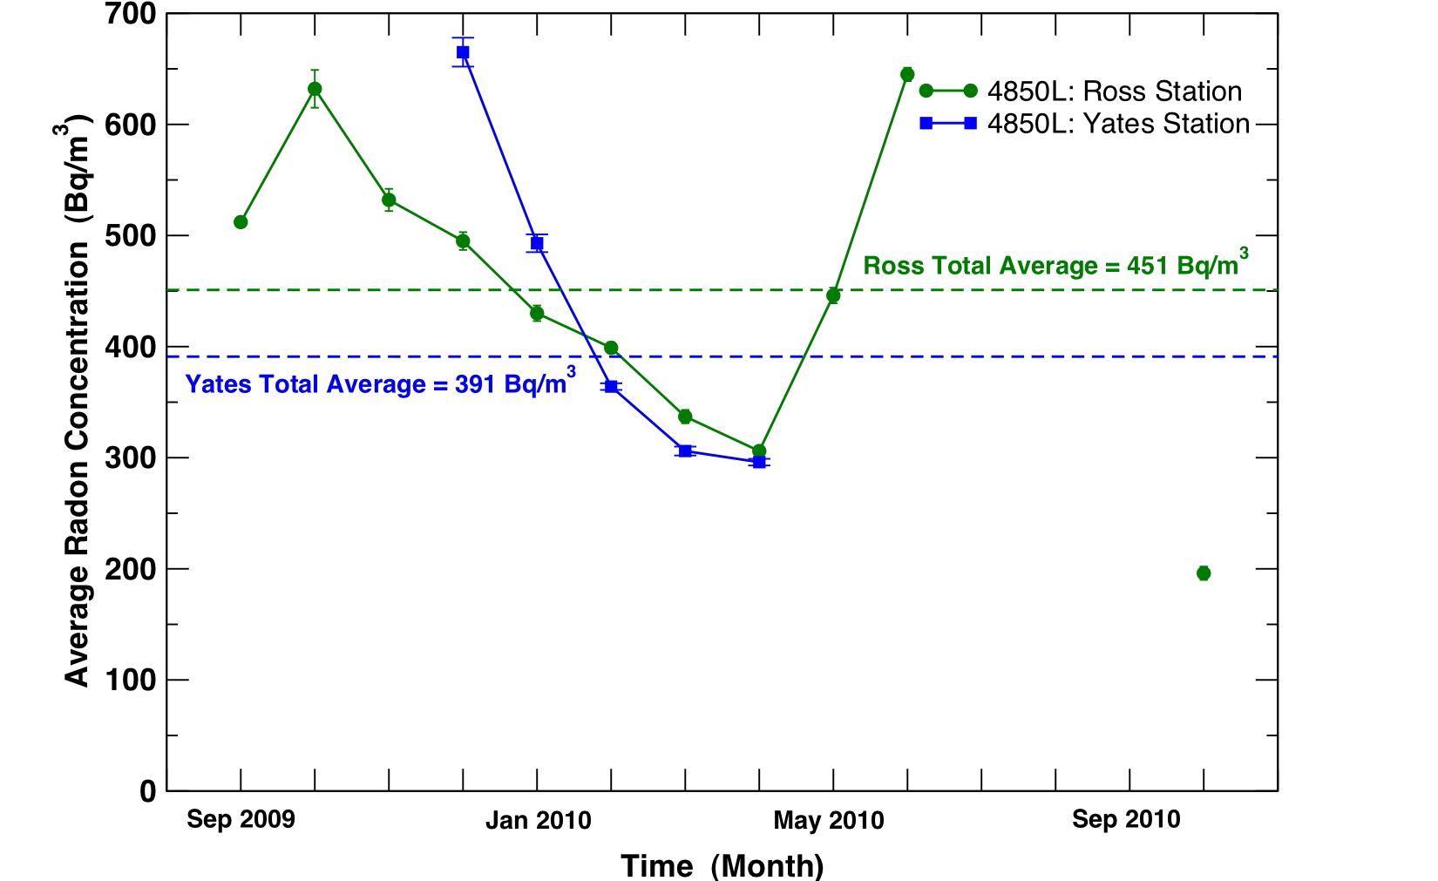
Figure 3.4.2.4 Sanford Laboratory average monthly radon concentration as a function of time. Measurements are taken at the two main ventilation supplies for the 4850L (data for the Yates Station measurement covers a shorter period of time due to equipment maintenance and construction activities).

 | Uranium (ppm) | Thorium (ppm) | Potassium (%)
Low-Activity Bulk Rock | 0.059-0.091 | 0.24-0.30 | 0.18-1.94
Rhyolite Intrusion | 4.42-10.9 | 8.76-11.4 | 2.49-7.6
Typical Local Shotcrete | 1.62-2.61 | 1.99-3.92 | 0.36-1.28
Table 3.4.2.4 Summary of radiometric results for recent Homestake samples (Low Background Facility, LBNL⁹).
A program of radiometric study of rock samples from the mine and core library has been carried out at the Low Background Facility at LBNL with data analyzed and summarized in several reports.⁹ One finding was that while most of the bulk rocks are radioactively clean (with U/Th in the sub-ppm scale), there are certain rock intrusions, usually localized, such as rhyolite that are found to have a much higher U/Th content (Table 3.4.2.4).
Due to civil construction needs, a layer of concrete or shotcrete is typically applied to the exposed drift or cavern surfaces underground. These materials also contain U, Th, and K, and depending on the total mass, their contributions to background could be significant. Potential candidate samples of concrete components and aggregates have been assayed (Table 3.4.2.4) and additional measurements are anticipated. These results will be used to guide the material selection and construction planning of the facility.
3.4.3 Biology, Geology, and Engineering
3.4.3.1 Geology
Characterization of the geological environment is under way, with several groups engaged in ongoing research.
The CO₂ Sequestration group visited the Laboratory in June 2009 to identify potential locations for the proposed geologic carbon sequestration experimental facility at DUSEL. Part of this effort involved the temporary installation of instruments for environmental monitoring of temperature, pressure, and relative humidity at three different sites (800L, 2000L, and 4850L). This information was then used to identify suitable locations for the CO₂ Sequestration facility along the depth profile.
Another application of geological characterization involves collaborators from the Laser Interferometer Gravitational-wave Observatory (LIGO) project, who are mounting an initiative called the Deep Underground Gravity Laboratory (DUGL) to study seismic noise levels in the frequency range of interest to gravity-wave observations (< 10 Hz). This effort may help establish the Homestake environment as a suitable site for the next generation of gravity-wave observatories.¹⁰
Collaborators from the University of Wisconsin-Madison and Montana Tech associated with the GEologic Optical eXtensometer and Tiltmeter (GEOXTM) DUSEL project are investigating applications of fiber-optic cable on the 4100L as part of a set of optical extensometer arrays as well as monitoring drift temperature gradient. The full scope of GEOXTM also involves the research with tiltmeters described below, allowing the group to study different deformation and temperature sensors over different length scales. Distributed fiber-optic sensors can extend over kilometers of distance and are highly stable over long times. The objectives of the initial experiments with fiber-optic cable are to develop installation techniques, cross-calibrate them against conventional extensometers, measure rock mass properties at a scale of several meters, and establish its potential for structural health monitoring (SHM) of DUSEL on the scale of the laboratory volume.
One of the earliest groups to collect data from the Homestake site after re-entry was a team from the South Dakota and Arizona U.S. Geological Survey (USGS) offices. The group uses a very sensitive gravimeter to measure microgravity at particular locations in order to understand the hydrology and groundwater in the Northern Black Hills and more specifically to understand and monitor the Laboratory dewatering process.
Researchers from the South Dakota School of Mines and Technology (SDSM&T) in conjunction with Sanford Laboratory personnel are studying water flow along with temperature and humidity dynamics on several levels (surface, 1250L, 2000L, 2600L, 4850L). One aspect of this project involves monitoring the declining water table as the mine is dewatered to better understand rock deformation processes. This monitoring is also useful to experiments like the LBNE that are interested in knowing water pressure in areas surrounding the proposed large cavities and laboratory modules.
The Petrology, Ore Deposits, and Structure (PODS) group is combining access to the Homestake drill-core archive and other records with some underground mapping (800L) to pursue topics related to the deposition and mineralization of the gold deposit in Lead. Members of the PODS group continue, as they have in the past, to play a leading role in the stewardship of the drill-core archive.
One of the most synergistic groups that has participated in research at Sanford Laboratory is the Tiltmeter group, comprising personnel from SDSM&T, Fermilab, and the University of Wisconsin at Madison. Combining the hydrology data mentioned above with rock-deformation data measured by tiltmeters will lead to a more complete picture of the dewatering process. The group is also interested in testing different tiltmeter technologies and the most feasible methods to install them. To achieve this, three arrays of two different types of tiltmeters have been installed on the 2000L according to two different methods.
The Transparent Earth collaboration has instrumented three boreholes (2x 2000L, 4100L), each with three accelerometers to allow high-frequency seismic signals to be detected and analyzed when the signal exceeds a defined amplitude level. In addition to the accelerometer instrumentation, each of these sites has an associated tiltmeter. Ultimately, this group intends to deploy a large number of these types of seismic monitoring stations throughout the DUSEL Laboratory.
3.4.3.2 Biology
Biological sampling of life forms found underground is very active: Several new strains have been encountered.
Biologists from BHSU and SDSM&T have collected many samples in the course of their research on metagenomic analysis and bioprospecting of the microbial communities at Homestake following mine dewatering.¹¹ Sample collection sites include surface, 300L, 2000L, 4100L, and 4850L. Interaction with researchers familiar with manifold sampling techniques led to the establishment of the 4100L site, where a borehole packer is being used to pressurize groundwater to sample for micro-organisms through various filters, some of which are used to perform subsequent DNA analysis.
Researchers from South Dakota State University (SDSU) are investigating the enrichment and isolation of lignocellulose-degrading micro-organisms from selected sites at Sanford Underground Laboratory. To date, 13 filamentous fungal cultures have been isolated as well as have 32 unicellular bacteria. Eight of the 32 unicellular bacteria so far examined are able to hydrolyze a form of cellulose at two specific temperatures. Strains that have been identified include three Bacillus pumilus strains, two Bacillus licheniformis strains, and three Bacillus subtilis-subtilis strains. More isolates are being sought.
A workshop was organized by biologists from Princeton University and the University of Tennessee at Knoxville in June/July 2009 to demonstrate manifold sampling techniques that have been used with success in deep South African mines. Researchers from BHSU, SDSM&T, SDSU, University of Tennessee at Knoxville, and Oak Ridge National Laboratory attended the workshop, in which sources of water on the 2000L, 4550L, and 4850L were used to illustrate the sampling methods.
The first publications^{12,13} reporting research following the mine closure detailed the discovery by an SDSM&T team of a cellulosic-degrading bacterial strain living in soil-like samples collected in May 2008 that were found in the Yates and Ross Shafts as well as in the #6 Winze at the 4550L.^{14,15} The results also have strong implications for biological conversion of cellulosic agricultural and forestry wastes to commodity chemicals, including sugars.
3.4.3.3 Engineering
Two engineering groups from SDSM&T are active at Sanford Laboratory, testing various applications for use in the underground environment.
Data were collected on the 300L by a group from the SDSM&T Electrical and Computer Engineering Department in August 2009 regarding electromagnetic signal propagation in a tunnel environment. The measurements were conducted with multifunctional antennas that the group developed for cryospheric applications at NASA’s Goddard Space Flight Center and provided estimates of the tunnel wall material properties up to a depth of a few centimeters.
An SDSM&T group comprising several engineering fields that is developing an autonomous submersible vehicle visited the Laboratory in December 2009 to understand environmental field conditions for a possible future deployment. Two locations were investigated, the 1250L sump near the pump room and the 4850L #6 Winze. Magnetic field measurements were taken to gauge how well the navigation system on the vehicle would work in the underground environment.
3.4.4 Early Science and DUSEL Construction
The DUSEL MREFC project is anticipated to begin in early 2014, and underground construction will start later in 2014. Rehabilitation activities in the Ross Shaft and elsewhere will take place prior to 2014. The Majorana Demonstrator anticipates continued operation through 2017. A Generation-2 dark-matter experiment located in the 4850L Davis Campus could be implemented after completion of the LUX experiment and possibly operate into 2017. The CUBED collaboration expects to begin development in surface facilities in the next two years and then, if successful, move operations into an underground area where it may operate for some years. Their activity is also closely connected with the production of Ge for potential future DUSEL experiments. The biology, geology, and engineering (BGE) activities described above are expected to continue, at least in part, well into the period when DUSEL construction begins. New activities in BGE may also arise in the next few years. The DUSEL construction schedule will be devised to preserve the operation of the early science experiments consistent with meeting overall project critical milestones. Some interruptions in the operation of LUX, Majorana Demonstrator, and CUBED may be required to switch electrical, water, and IT infrastructure during the DUSEL construction period. Every reasonable effort will be made to minimize the disruptions, and these periods will be included in the DUSEL Project schedule.
3.5 Integrated Suite of Experiments
Potential experiments for the DUSEL facility have been described in Section 3.3. The ongoing and planned scientific programs at Sanford Laboratory were presented in Section 3.4. The initial experimental program at the completed DUSEL facility remains to be determined. We anticipate that the dark matter and 0νββ experiments under construction and soon to be installed at Sanford Laboratory will continue operation into the period of the construction of the DUSEL facility for as long as justifiable by their scientific output. In addition, biology, geology, and engineering (BGE) experiments already under way or anticipated at Sanford Laboratory will continue. It is likely that additional investigations or scientific directions prior to the completion of the DUSEL facility will be proposed. Those will be reviewed by the DUSEL Program Advisory Committee (see Section 3.10) and the integrated management of Sanford Laboratory and the DUSEL Project. All future experiments proposed to be housed in the DUSEL facility will be similarly reviewed. The proposed means for selection and management of the experimental program are summarized in Section 3.10.
The design of the DUSEL facility is driven essentially by the needs of the experimental program. Although this program has not yet been defined in detail—indeed, it will take some years to establish a specific set of first experiments—the preliminary requirements needed for the design of the civil construction aspects of the facility are being, indeed must be, established now. The requirements for the civil construction of the facility are guided by our expectations and goals for a generic Integrated Suite of Experiments (ISE). The process for obtaining these requirements and a summary of the requirements are given below in Sections 3.6-3.8. In the present chapter, we provide an overview of the key elements of the generic ISE as it pertains to obtaining the facility requirements for underground civil construction. Science-driven requirements for the projected first experiments at DUSEL that guide the definition of the generic ISE were described in Section 3.3.
3.5.1 Long Baseline Neutrinos
A long-baseline neutrino experiment (LBNE) will be included in the ISE. The selection among the options for implementation of this experiment (Section 3.3.5) will ultimately determine the facility requirements. The current baseline design for the DUSEL facility describes in detail the requirements and implementation of one large cavity and associated infrastructure for a water Cherenkov detector. Options—the addition of an additional cavity for a water Cherenkov detector, a cavity of larger size than the baseline, and facilities and infrastructure for a liquid argon detector (or detectors)—have been described, and requirements for the options gathered but at a less-detailed level at this time. A selection among the possible options is anticipated to be made by mid-2011 prior to the start of the Final Design of the facility, currently anticipated to begin in early 2012.
3.5.2 Proton Decay
The ability to search for proton decay will be an integral part of the LBNE detectors and thus will be included in the ISE. Separate detectors aimed solely at proton decay searches are not currently included in the ISE. Specific requirements that enable the proton-decay search will be included in the facility design.
3.5.3 Detection of Other Neutrinos
The detection of solar neutrinos and neutrinos from supernovae and the Big Bang are possible goals for the large detectors for long-baseline neutrinos and proton decay and thus part of the ISE. Separate detectors aimed solely at detection of these neutrinos are not currently included in the ISE. Specific requirements that enable detection will be considered in the facility design.
3.5.4 Dark Matter Experiments
At least one Generation Three (G3), see Section 3.3.3, dark-matter experiment will be included in the ISE, chosen from those to be proposed.
3.5.5 0νββ Decay
At least one 0νββ experiment , see Section 3.3.4,will be included in the ISE, chosen from those proposed. Designs are being evaluated at the 7400L that include a variety of shielding configurations (Cu/Pb, LAr, water) so that the facility can be designed while retaining the flexibility to accommodate different designs.
3.5.6 Nuclear Astrophysics
The Dakota Ion Accelerators for Nuclear Astrophysics (DIANA) (Section 3.3.6) is currently the only proposal for this area of science. The final facility design at the 4850L will allow aspects of DIANA to be implemented if it is selected to be one of the first DUSEL experiments.
3.5.7 Low Background Counting and Materials Assay
Basic aspects of infrastructure for low-background counting and materials assay will be included in the design of the DUSEL facility in support of the experimental program. More advanced R&D and a facility in this area are represented currently by the Facility for Assay and Acquisition of Radiopure Materials (FAARM) proposal (Section 3.3.8). The facility design at the 4850L will allow aspects of FAARM to be implemented if it is selected to be one of the first DUSEL experiments.
3.5.8 Biology, Geology, and Engineering
BGE experiments, as currently proposed, and the related facility requirements are described in Section 3.3.7. The facility design will accommodate a subset of the proposed experiments (or experiments proposed in future). The number and type of experiments will be determined later, based on reviews of scientific merit, funds available, and appropriateness to the facility (see also Section 3.10).
3.5.9 Support Activities and Staging Areas
The underground facility will provide areas for machining, low-activity materials fabrication, and other support activities for the experimental program. An initial scope for such areas will be part of the baseline facility design.
Staging areas for assembly and installation will be included in the ISE requirements. An initial scope for such areas will be part of the baseline facility design.
3.5.10 Research and Development
Areas for R&D of new concepts for physics and BGE experiments are an important aspect of the experimental program. An initial scope for such areas, both above- and below-ground, will be part of the facility design.
3.6 Integrated Suite of Experiments (ISE) Requirements Process
Integral to development of a Preliminary Design for the Homestake DUSEL facility is an understanding of the infrastructure required to implement the ISE. DUSEL science and engineering staff have determined requirements of potential experiments via workshops, meetings with experiment collaborations, and through a web-based system in which experimenters specify the necessary infrastructure required to implement their proposed experiments.
The development of a Preliminary Design for the DUSEL facility has proceeded in parallel with the development of proposals for experiments to be incorporated into the ISE. However, the development of the facility design has proceeded on a different time line than the experiments. In particular, the project schedule requires that the facility Preliminary Design Report (PDR) is complete before the final ISE is selected and, in fact, before experiment designs are fully matured. The strategy for accomplishing this has been based on developing a detailed understanding of proposed experiments and to develop facility designs to accommodate a generic ISE, as described in Section 3.5.
3.6.1 Science Liaison Organization and Activities
The DUSEL Science Liaison Group consists of scientific specialists corresponding to the various disciplines represented by the proposed experiments. Engineers experienced with science integration are assigned to work with the scientists. Table 3.6.1-1 shows the organization and assignments.
Several ISE workshops have been held, providing opportunities for the science liaison staff to interact with potential experimenters. These included two workshops organized by the DUSEL Experiment Development and Coordination (DEDC) Committee, held April 21-26, 2008, and September 30-October 3, 2009. The workshops were organized around work groups focusing on areas of experimental interest. These meetings provided the opportunity for direct discussion with potential experimenters about their facility infrastructure requirements.
A Web-based database system for experimenters’ entry of infrastructure requirements was created following the April 2008 ISE workshop. This system was upgraded and linked to the DUSEL document management system in December 2009. The database, along with direct interactions between experiments and the science liaison staff, have provided the basis for the experiment-specific requirements tables contained in Sections 3.3.3 through 3.3.8.
Much of the information supplied to DUSEL from the experiments has been accomplished through a formal schedule of deliverables, outlined in Table 3.6.1-2. Following the last of the three formal deliverables, one-on-one detailed meetings were held with each experiment, starting in April 2010. The meetings’ purpose was to review and refine the information supplied through the formal deliverables, including cost, schedule, and potential funding.

For all ISE:
Science and Engineering: M. Gilchriese and S. Marks
Systems Engineering: S. Acheson, W. Kalinowski and J. Souza
EH&S: J. Tarpinian, R. Hislop
Project Controls: D. Jacobs
ISE Group | Science Contact(s) | Engineering Contact
Dark Matter: LZD, MAX, GEODM, COUPP, CLEAN | Azriel Goldschmidt | Steve Marks
0νββ: 1TGe, EXO | Jason Detwiler, Ryan Martin | Steve Marks
Nuclear Astrophysics: DIANA | Alberto Lemut | Dave Plate
Low Background Counting: FAARM | Yuen-Dat Chan | Dave Plate
LBNE: Water Cherenkov, LAr | Richard Kadel | Dave Taylor
Other Physics:  LENS, DUGL, Atom Interferometry, NNBAR, Misc. TPCs, DM R&D  CUBED  DAEdALUS | Azriel Goldschmidt  Yuen-dat Chan  Richard Kadel | Steve Marks
CO₂ Sequestration | Rohit Salve | Dave Plate
THMCB | Rohit Salve | Dave Plate
Ecohydrology | Rohit Salve | Dave Plate
Facility Monitoring | Rohit Salve | Dave Plate
Cavity Monitoring | Bill Roggenthen | Dave Plate
Fractures | Bill Roggenthen | Dave Plate
Transparent Earth | Bill Roggenthen | Dave Plate
Table 3.6.1-1 DUSEL Science Liaison Group.
Date | Deliverables
12/18/09 | Team roles and responsibilities, project contacts  Science and project objectives, phases, and evolution
1/29/10 | Location of proposed experiment  Experiment layout drawing, showing all major subsystems  Requirements and hazard identification, via entries to the database
3/19/10 | Cost estimate, Conceptual Design level or better  Schedule, Conceptual Design level or better. To include major milestones through design, assembly, and installation.  Depth document, justification for those requesting installation at the Deep-Level Campus
Table 3.6.1-2 Experiment collaboration scheduled deliverables.
3.6.2 Requirements Flow-Down Process
The requirements process for the Preliminary Design phase involves transforming the DUSEL scientific program goals into an ISE. From the ISE comes the high-level system functional and operational requirements; these inform the DUSEL civil facility design. The input into this process consists of a multitude of individual experiment needs and the output is a clear set of requirements needed to build the laboratory facilities. This process, which assures that the DUSEL design is linked to documented experiment needs, is shown in Figure 3.6.2-1. ISE requirements that are directly flowed into the detailed low-level design requirements are documented in Appendix 3.A, Integrated Suite of Experiments Interface Requirements Document (IRD).
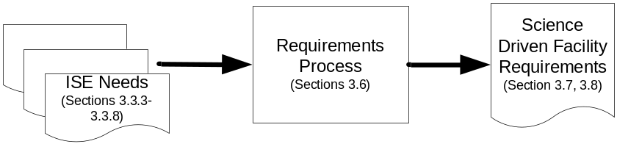
Figure 3.6.2-1 Requirements process inputs and outputs.
This volume of the PDR discusses specific experiment proposals and related requirements in Sections 3.3.3 through 3.3.8. Generic requirements were developed for dark matter and neutrinoless double-beta decay experiments, as there are multiple proposals within these two categories; these are discussed in Section 3.7. Finally, in Section 3.8, science-driven requirements are associated with laboratory locations and facilities. The current section describes the high-level process employed by the team.
The ISE consists of experiments that physically reside in different areas in DUSEL. Physics experiments will typically be housed within dedicated laboratory spaces that are part of the Mid-Level Laboratory (MLL) and Deep-Level Laboratory (DLL) campuses. The biology, geology, and engineering (BGE) experiments will typically reside in drifts or other areas outside the main campuses; these areas are designated as other levels and ramps (OLR). Table 3.6.2 lists the physics experiments that were directly considered in the determination of the requirements of the large cavity (LC) and lab modules (LMs). Figures 3.6.2-2 and 3.6.2-3 illustrate the requirements flow-down for the LMs. Table 3.8.3-1 summarizes proposed experiments by level. Table 3.8.3-2 summarizes the available access in linear feet for each level, and the total power available to support the proposed experiments by level.
All spaces associated with the Long Baseline Neutrino Experiment (LBNE) will be dedicated solely to this experiment. Requirements associated with this experiment are discussed in Section 3.3.5. Sections 3.6, 3.7, and 3.8 will discuss requirements and processes associated with LMs and OLR, which are shared spaces.
The following logic has been used to associate experiment requirements with the two MLL LMs (LM-1 and LM-2) and the single DLL LM (LMD-1):
- LM-1 is 50 m long and will accommodate either the proposed DIANA nuclear astrophysics experiment or a single large dark-matter, double-beta decay, or low-background counting experiment. DIANA is unsuitable to be close to other experiments, so it would be the only occupant. For other experiments, approximately half the space would be available for R&D and prototyping activities. Requirements will be based on the most challenging individual requirement among the experiments. Since DIANA has the highest power requirement, it will be used to set the power and other associated requirements, such as chilled water. All other requirements are driven by large cryogenic dark-matter or double-beta decay experiments.
- LM-2 is 100 m long and is assumed to be compatible with three physics experiments of any variety other than DIANA. Requirements will be based on the most challenging combination of three.
- Although four proposed experiments have designated the DLL as their preferred or required location, LM-1 and LM-2 will be compatible with installation of these experiments as well. Full justification for installation for experiments at the deep level will be based on experiments that are currently under way or that are planned to start in the next few years. We therefore do not want to preclude the possibility of installing one of these at the MLL.
- LMD-1 is 75 m long and is assumed to be compatible with installation of two experiments. Only requirements associated with the four experiments asking for DLL installation will be used to set requirements for the LMD-1. The most challenging combination of two will be used to set requirements where they are compatible within the constraints associated with the baseline design.
- Experiment envelope size is based on constraints associated with the baseline LM designs. Note that current layouts for several of the experiments proposed for installation in LMD-1 are not compatible with these envelope definitions.
- Requirements for OLR are organized by level. This is discussed in detail in Section 3.8.4.
Figures 3.6.2-2 and 3.6.2-3 illustrate the flow of experiment requirements into laboratory facility requirements. Note that all the generic neutrinoless double-beta decay requirements are the same as those for LM-1 and LM-2, with the sole exception of size constraints. Generic dark matter constraints are different, as there are no proposed cryogenic dark-matter experiments for LMD-1.

Facility | Experiment Name | Experiment Type
Large Cavity | LBNE | Long Baseline Neutrino
Large Cavity | LBNE | Proton Decay
Large Cavity | LBNE | Other Neutrinos
LM-1 | EXO | Neutrinoless Double Beta Decay
LM-1 | 1TGe | Neutrinoless Double Beta Decay
LM-1 | LZD | Dark Matter
LM-1 | MAX | Dark Matter
LM-1 | GEODM | Dark Matter
LM-1 | COUPP | Dark Matter
LM-1 | DIANA | Nuclear Astrophysics
LM-1 | FAARM | Low Background Counting
LM-2 | EXO | Neutrinoless Double Beta Decay
LM-2 | 1TGe | Neutrinoless Double Beta Decay
LM-2 | LZD | Dark Matter
LM-2 | MAX | Dark Matter
LM-2 | GEODM | Dark Matter
LM-2 | COUPP | Dark Matter
LM-2 | FAARM | Low Background Counting
LMD-1 | EXO | Neutrinoless Double Beta Decay
LMD-1 | 1TGe | Neutrinoless Double Beta Decay
LMD-1 | GEODM | Dark Matter
LMD-1 | COUPP | Dark Matter
Table 3.6.2 Experiments considered in the derivation of the lab module and large cavity facility requirements.
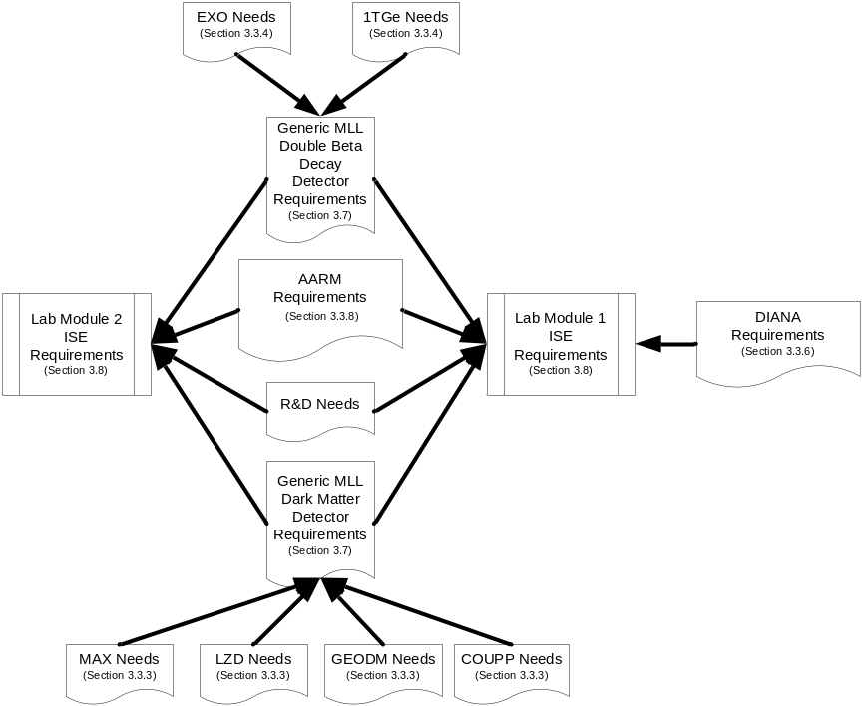
Figure 3.6.2-2 Flow of Integrated Suite of Experiments needs into LM-1 and LM-2 requirements.

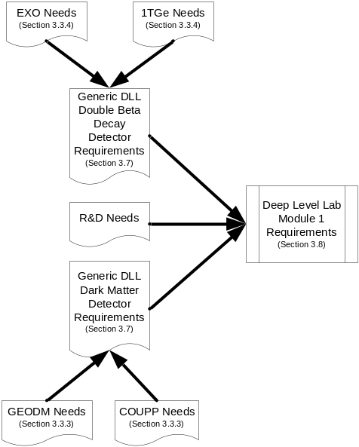
Figure 3.6.2-3 Flow of Integrated Suite of Experiments needs into LMD-1 requirements.
3.6.3 Physics Campus Layouts
Figure 3.6.3-1 shows a typical experiment installation in LM-1. This figure shows the proposed LZD (LUX ZEPLIN at DUSEL) dark-matter experiment installed. The allowance for a single experiment installation is 25m long. This will leave half of the 50 m long space available for prototypes and general R&D space.
Figure 3.6.3-2 shows typical installation of three experiments in LM-2. The figure shows FAARM, the proposed low-background assay facility, and MAX, the proposed dark-matter experiment comprising two cryogenic detectors, one liquid xenon and the other liquid argon. The MAX installation shows a shared clean room than can access either detector. This design feature could be used for other combinations of cryogenic detectors installed in the same LM.
Figure 3.6.3-3 shows a typical installation of two detectors in LMD-1. The figure shows the proposed Germanium Observatory for Dark Matter (GEODM) experiment, and the Cu/Pb shield configuration for 1TGe. Note that installation of these experiments with layouts as shown would be problematic, as there is no space left for lay-down and assembly. The maximum allowance for an experiment installation would be 25m to allow for lay-down and assembly space. While the GEODM layout fits within this constraint, the 1TGe layout is approximately 45 m long.
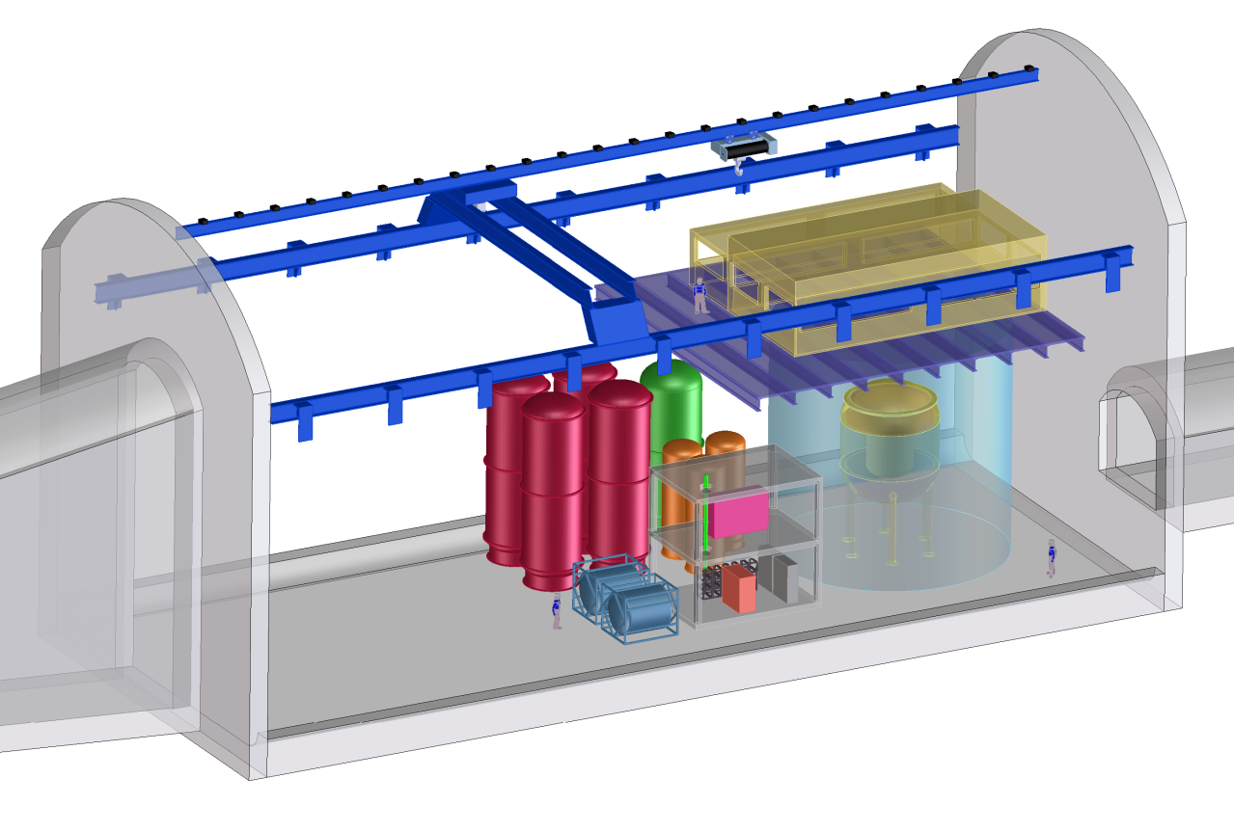
Figure 3.6.3-1 Typical experiment installation in LM-1.

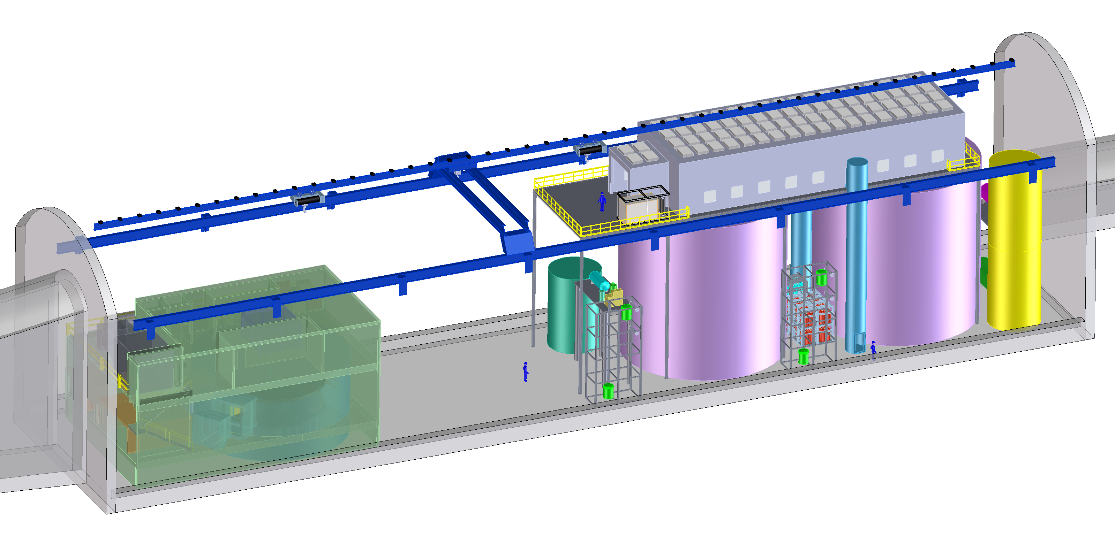
Figure 3.6.3-2 Three experiment installations in LM-2.
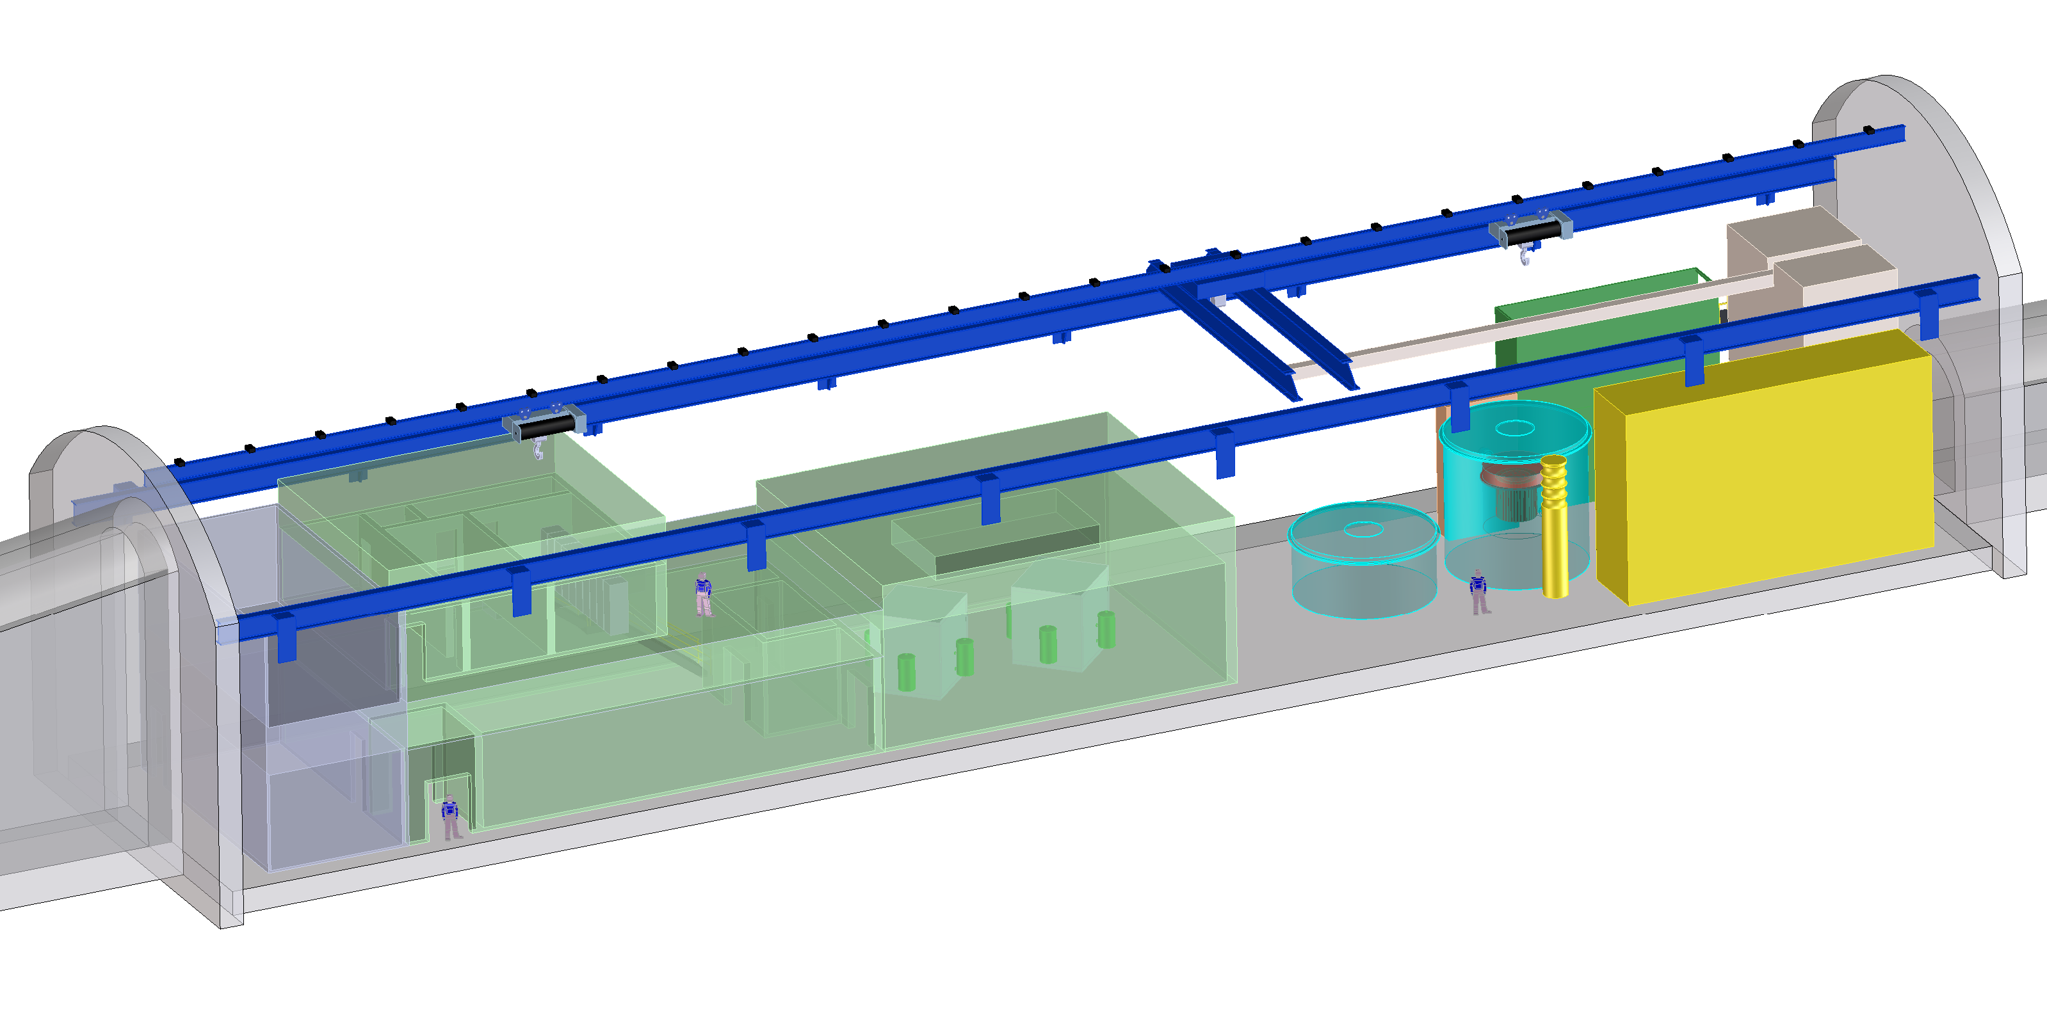
Figure 3.6.3-3 Installation of two experiments in LMD-1.
3.7 Generic Physics Requirements
The requirements of specific proposed experiments, as outlined in Sections 3.3.3 through 3.3.8, form the basis for generic experiment requirements, in the cases where multiple proposals exist for a given scientific category. The three generic categories—for which requirements are outlined in Tables 3.7-1, 3.7-2, and 3.7-3—are dark matter at MLL, dark matter at DLL, and neutrinoless double-beta decay at DLL. A separate table for generic neutrinoless double-beta decay for MLL is not included; this would differ from that for DLL only in the constrained size of experiments. For cases of a single proposal within a category, the specific experiment requirements are used. Single-proposal physics categories include nuclear astrophysics and low-background counting; for these, refer to the appropriate section above. Requirements for the LBNE project are outlined in Section 3.3.5. Requirements for BGE experiments are summarized in Section 3.3.7.
A generic requirement, for example for the dark-matter category, is, in general, the most demanding requirement among the specific requirements of the group of proposed experiments in cases where that requirement is consistent with the facility baseline design. In some cases, specific experiment requirements are not consistent with the baseline design; in these instances, the generic requirement is based on constraints imposed by the baseline facility design. These inconsistencies are addressed as options within trade studies discussed in Section 3.8.6.
Requirement | Value/Description | Comment/Justification
Layout
Depth | 4850L
Footprint | 25m L x 17m W | Constrained value
Height [m] | 19 | Constrained value
Floor Load [kPa] | 200 | Corresponds to 20m high water tank
Utilities
Power [kW] | 300 | LZD + 33%
Standby Power [kW] ¹ | 70 | GEODM
Chilled Water [kW] | 160 | GEODM
Waste Heat to Air [kW] | 240 | LZD, 60 kW chilled water
Purified Water [m³] | 4000 | 19m h, 17m dia. water shield
Potable Water [lpm] | Nominal use
Compressed Air | Nominal use
Network | 10 Gb/s | Nominal
Environment
Temp. Min [⁰C] | 20 | Nominal, may be tighter in clean rooms
Temp. Max [⁰C] | 25
Humidity Min [%] | 20 | Nominal, may be tighter in clean rooms
Humidity Max [%] | 50
Rn Background [Bq/m³] | Meets OSHA and other applicable codes
Crane
Max. Load [Short Ton] | 20 | Nominal bridge crane
Occupancy
Peak Installation Occupancy [count] | 24 | MAX single detector
Installation Duration [months] | 24 | GEODM
Peak Commissioning Occupancy [count] | 20 | LZD
Commissioning Duration [months] | 12
Peak Operation Occupancy [count] | 10
Operation Duration [months] | 60
Cryogens
LN Storage | 3000 L | LZD
LN Consumption | 500 L/day
LXe Storage | 6700 L | 20T LZD detector
LXe Consumption | NA
LAr Storage | 21000 L | 20T Ar MAX + 10T storage
LAr Consumption | NA
Major Hazards (Other Than Cryogens)
Liquid Scintillator | 100T | LZD, MAX single detector, type TBD
Water Flood Hazard | 4000 m³
Assay and Storage
Assay Needs | Nominal
Underground Storage | 100 m² | Depleted Ar for MAX
Table 3.7-1 Generic dark-matter requirements for MLL. Experiments: COUPP, GEODM, LZD, MAX.
¹ Standby power is meant to provide systematic shutdown or continuous operation, as appropriate, for critical equipment that will suffer damage in a power outage. According to NFPA 520, Sections 6.6, 6.7, 6.8, the transition from the instant of failure of the normal power source to an alternative power source shall not exceed 60 seconds.

Requirement | Value/Description | Comment/Justification
Layout
Depth | 7400L
Footprint | 25m L x 12m W | Constrained value
Height [m] | 11 | Constrained value
Floor Load [kPa] | 100 | Corresponds to 10m high water tank
Clean Room | Class 1000  12m x 25m x 10m | GEODM
Clean Room | Class 100  10m x 15m x 10m | GEODM
Utilities
Power [kW] | 240 | GEODM + 33%
Standby Power [kW] | 70 | GEODM
Chilled Water [kW] | 160 | GEODM
Waste Heat to Air [kW] | 80 | GEODM
Purified Water [m³] | 1700 | COUPP
Potable Water [lpm] | Nominal use
Compressed Air | Nominal use
Network | 10 Gb/s | Nominal
Environment
Temp. Min [⁰C] | 20 | Nominal, may be tighter in clean rooms
Temp. Max [⁰C] | 25
Humidity Min [%] | 20 | Nominal, may be tighter in clean rooms
Humidity Max [%] | 50
Rn Background [Bq/m³] | Meets OSHA and other applicable codes
Crane
Max. Load [Short Ton] | 20 | Nominal bridge crane
Occupancy
Peak Installation Occupancy [count] | 24 | GEODM
Installation Duration [months] | 24 | GEODM
Peak Commissioning Occupancy [count] | 5 | GEODM
Commissioning Duration [months] | 9
Peak Operation Occupancy [count] | 10 | COUPP
Operation Duration [months] | 120 | GEODM
Cryogens
LN Storage | 200 L | GEODM
LN Consumption | 100 L/day | COUPP cover gas option
LHe Storage | 200 L | GEODM
LHe Consumption | 2 L/day
Major Hazards (Other Than Cryogens)
CF3I | 1600 kg | 500kg/module, nontoxic, ODH
Water Flood Hazard | 1700 m³
Assay and Storage
Assay Needs | Nominal
Underground Storage | NA
Table 3.7-2 Generic dark-matter requirements for DLL. Experiments: COUPP, GEODM.

Requirement | Value/Description | Comment/Justification
Layout
Depth | 7400L
Footprint | 25m L x 12m W | Constrained value; current layouts exceed this
Height [m] | 11 | Constrained value; current layouts exceed this
Floor Load [kPa] | 1670 | EXO lead shield option
Utilities
Power [kW] | 400 | EXO + 33%
Standby Power [kW] | 60 | EXO
Chilled Water [kW] | 250 | EXO
Waste Heat to Air [kW] | 150 | EXO
Purified Water [m³] | 4000 | 19m h, 17m dia. water shield
Potable Water [lpm] | Nominal use
Compressed Air | Nominal use | 1T Ge will use air pads to move Pb shielding
Network | 10 Gb/s | Nominal
Environment
Temp. Min [⁰C] | 20 | Nominal, may be tighter in clean rooms
Temp. Max [⁰C] | 25
Humidity Min [%] | 20 | Nominal, may be tighter in clean rooms
Humidity Max [%] | 50
Rn Background [Bq/m³] | Meets OSHA and other applicable codes
Crane
Max. Load [Short Ton] | 40 | Nominal monorail crane
Occupancy
Peak Installation Occupancy [count] | 20 | Generic experiment estimate
Installation Duration [months] | 24
Peak Commissioning Occupancy [count] | 10
Commissioning Duration [months] | 12
Peak Operation Occupancy [count] | 10
Operation Duration [months] | 60
Cryogens
LXe Storage | 3400 L | 10T EXO
LXe Consumption | NA
LAr Storage | 21000 L | 1T Ge GERDA style. 30 T used in GERDA
LAr Consumption | NA
LN Storage | 10000 L | 1TGe. Assume 5 days storage—tied to consumption rate
LN Consumption | 2000 L/day | Based on 2L/day per 1000 detectors
Major Hazards (Other Than Cryogens)
HFE Refrigerant |  | EXO—nontoxic
Water Flood Hazard | 4000 m³
Assay and Storage
Assay Needs | Nominal
Underground Storage | 5m x 6m x 3m | 1TGe
Table 3.7-3 Generic neutrinoless double-beta decay requirements for DLL. Experiments: 1TGe, EXO.

3.8 Science-Driven Facility Infrastructure Requirements
To translate experiment requirements into facility requirements, the various experiment categories must be associated with particular locations. This section describes requirements for the lab modules (LMs), other 4850L support, other levels and ramps (OLR), and surface requirements. Trade studies applicable to science requirements are discussed in the final subsection. The process through which these values were determined is described in Section 3.6.
3.8.1 Lab Module Science Requirements
Figure 3.8.1-1 shows a cross-section for LM-1 and LM-2 with the permissible experiment envelope indicated by the crosshatched area. The 19m maximum height is limited by bridge crane clearance. The maximum 17-m width allows for personnel egress and a utility corridor. The allowed length for a single experiment is 25 m to accommodate lay-down and assembly space. Figure 3.8.1-2 shows the LMD-1, with the same constraints.
Tables 3.8.1-1, 3.8.1-2, and 3.8.1-3 list science requirements for LM-1, LM-2, and LMD-1, respectively. Utility requirements are for direct experiment support only; requirements for lighting, ventilation, cranes, and other infrastructure are not included.

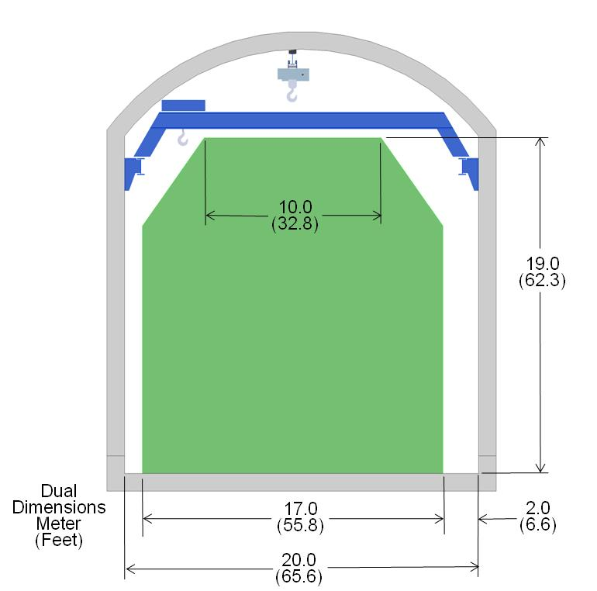
Figure 3.8.1-1 MLL LM cross section and experiment envelope.
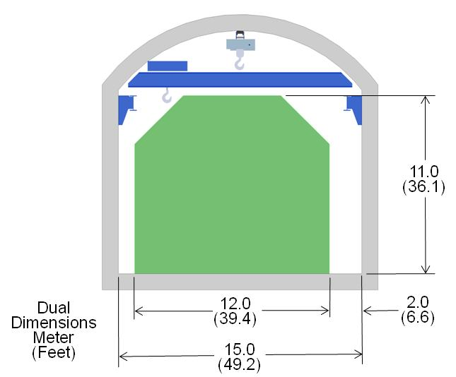
Figure 3.8.1-2 DLL LM cross section and experiment envelope.

Requirement | Value/Description | Comment/Justification
Layout
Footprint | 50m L x 20m W | Nominal size
Height [m] | 24 | Nominal size, crowned roof
Floor Load [kPa] | 1670 | EXO lead shield case
Utilities
Power [kW] | 2000 | DIANA 1.5MW load + 33% margin
Standby Power [kW] | 100 | DIANA detectors and cryo pumps
Chilled Water [kW] | 1800
Waste Heat to Air [kW] | 1400
Purified Water [m³] | 4100 | Assume water tank 19m high, 17m dia.; inner volume 9m high, 5m dia.
Potable Water [lpm] | Nominal use
Compressed Air | Nominal use
Network | 10 Gb/s
Environment
Temp. Min [⁰C] | 20 | Generic lab environment temp. values
Temp. Max [⁰C] | 25
Humidity Min [%] | 20 | DIANA
Humidity Max [%] | 45 | Nominal expected value; DIANA max. 30%
Rn Background [Bq/m³] | Meets OSHA and other applicable codes
Crane
Max. Load [Short Ton] | 40 | EXO lead shield case
Occupancy
Peak Installation Occupancy [count] | 25
Installation Duration [months] | 24
Peak Commissioning Occupancy [count] | 20
Commissioning Duration [months] | 6
Peak Operation Occupancy [count] | 9
Operation Duration [months] | 60 | Assume typical 5-year experiment. Laboratory module lifetime is 30 years.
Cryogens—Target will be either LXe or LAr
LXe Storage | 20T | LZD
LXe Consumption | NA
LAr Storage | 30T | MAX
LAr Consumption | NA
LN Storage | 500L
LN Consumption | 50L/day
Major Hazards (Other Than Cryogens)
Liquid Scintillator | 100T | LZD, MAX
High Voltage | 400 kV, 100 mA | DIANA
Table 3.8.1-1 Science requirements for LM-1.

Requirement | Value/Description | Comment/Justification
Layout
Footprint | 100m L x 20m W | Nominal size
Height [m] | 24 | Nominal size, crowned roof
Floor Load [kPa] | 1670 | EXO lead shield case
Utilities
Power [kW] | 1100 | EXO + GEODM + FAARM + 33%
Standby Power [kW] | 160 | MAX (2 detectors) + EXO
Chilled Water [kW] | 840 | EXO + GEODM + FAARM + 50%
Waste Heat to Air [kW] | 820
Purified Water [m³] | 10000 | Assume 2 water tanks 19m high, 17m dia. with inner volume 9m high, 5m dia. + FAARM
Potable Water [lpm] | Nominal use
Compressed Air | Nominal use
Network | 10 Gb/s
Environment
Temp. Min [⁰C] | 20 | Generic lab environment—maybe tighter control within clean rooms
Temp. Max [⁰C] | 25
Humidity Min [%] | 20 | Generic lab environment—maybe tighter control within clean rooms
Humidity Max [%] | 50
Rn Background [Bq/m³] | Meets OSHA and other applicable codes
Crane
Max. Load [Short Ton] | 40 | EXO lead shield - nominal monorail capacity
Occupancy
Peak Installation Occupancy [count] | 40 | Assume installations staggered by 1 year, 20 per experiment—two overlap
Installation Duration [months] | 48
Peak Commissioning Occupancy [count] | 20 | Assume commissioning does not overlap
Commissioning Duration [months] | 6
Peak Operation Occupancy [count] | 18 | Assume 6 per experiment
Operation Duration [months] | 60 | Assume typical 5-year experiment. Laboratory module lifetime is 30 years.
Cryogens
LXe Storage | 20T | LZD
LXe Consumption | NA
LAr Storage | 30T | MAX
LAr Consumption | NA
LN Storage | 1200L | Assume 2 Cryogen detectors (500L each) + FAARM (200L)
LN Consumption | 150L/day | Assume 50L/day per experiment
Major Hazards (Other Than Cryogens)
Liquid Scintillator | 200T | Two DM cryogen detectors (100T each), type TBD
Table 3.8.1-2 Science requirements for LM-2.

Requirement | Value/Description | Comment/Justification
Layout
Footprint | 75m L x 15m W | Nominal size
Height [m] | 15 | Nominal size, crowned roof
Floor Load [kPa] | 1670 | EXO lead shield case
Utilities
Power [kW] | 650 | EXO + GEODM + 33%
Standby Power [kW] | 100 | EXO + 1TGe
Chilled Water [kW] | 650 | EXO + GEODM + 50%
Waste Heat to Air [kW] | 420
Purified Water [m³] | 0 | Purified water must be generated by the experiment. No purified water supply is provided to LMD-1.
Potable Water [lpm] | Nominal use
Compressed Air | Nominal use
Network | 10 Gb/s
Environment
Temp. Min [⁰C] | 20 | Generic lab environment—maybe tighter control within clean rooms
Temp. Max [⁰C] | 25
Humidity Min [%] | 20 | Generic lab environment—maybe tighter control within clean rooms
Humidity Max [%] | 50
Rn Background [Bq/m³] | Meets OSHA and other applicable codes
Crane
Max. Load [Short Ton] | 40 | EXO lead shield—nominal monorail capacity
Occupancy
Peak Installation Occupancy [count] | 40 | Assume installations staggered by 1 year, 20 per experiment—two overlap
Installation Duration [months] | 36
Peak Commissioning Occupancy [count] | 20 | Assume commissioning does not overlap
Commissioning Duration [months] | 6
Peak Operation Occupancy [count] | 12 | Assume 6 per experiment
Operation Duration [months] | 60 | Assume typical 5-year experiment. Laboratory module lifetime is 30 years.
Cryogens
LXe Storage | 10T | EXO
LXe Consumption | NA
LAr Storage | 30T | 1T Ge, Ar option
LAr Consumption | NA
LN Storage | 10000L | 1TGe. Assume 5-day storage—tied to consumption rate
LN Consumption | 2000L/day | Based on 2L/day per 1000 detectors—probably too high
LHe Storage | ~200L | GEODM
LHe Consumption | ~10L/day
Table 3.8.1-3 Science requirements for LMD-1.
3.8.2 Other MLL Campus Support Requirements
Davis Campus
The Davis Campus has been developed for the LUX dark-matter experiment and the Majorana Demonstrator neutrinoless double-beta decay experiment as part of the Initial Science Program as described in Section 3.4. The LUX detector is a 350-kg LXe detector with a water shield; the Davis Cavern and water shield have been designed to house a 3-T LXe detector. After the LUX experiment is complete, this space could be used for moderate-size cryogenic detectors (eg., Generation-2 dark matter) or R&D space.
The Davis Transition Area supports the Majorana Demonstrator as well as the Cu electroforming and clean machine shop space that support this experiment. The support room is sized to house an expanded electroforming facility that will be capable of supporting the 1TGe experiment as well as other experiments that need low-background Cu. This expansion will require relocation of the clean machine shop space elsewhere.
Shops
The MLL Campus will have a clean machine shop as well as a general machine shop. The area for each will be approximately 60 m².
3.8.3 Other Levels and Ramps (OLR) to Support Biology, Geology, and Engineering (BGE) Experiments
A number of drifts and ramps will be available to support DUSEL infrastructure and a variety of BGE experiments. Safe access will be provided, but these areas will not be maintained at the same level as those more frequently occupied. The discussion below includes figures showing locations of proposed experiments and the associated requirements. In OLR spaces, unless noted otherwise, DUSEL will be responsible for maintaining ground support and providing power, data network, and ventilation. In most areas, ventilation will be continuous flow-through. In some cases, ventilation will be provided on an as-needed basis using localized fans.
Table 3.8.3-1 summarizes the proposed BGE locations by level. Table 3.8.3-2 summarizes the total accessible area, in linear feet, and the total estimated power required to power the full set of installations summarized in Table 3.8.3-1, with the exception of CO₂ Sequestration, which will have power fed from its surface facility. The total power for each level includes only the power to support the proposed BGE experiments on that level; it does not include power for general infrastructure support, or the power for physics experiments within the developed MLL and DLL Campuses. The funding allocation associated with providing power to the OLR has been capped, based upon a cost estimate for providing the power listed in Table 3.8.3-2.
Figures 3.8.3-1 to 3.8.3-8 show level diagrams for the 300L, 800L, 2000L, 4100L, 4550L, 4850L, 6800L, and 7400L. The areas open to experiment are indicated. The site number indicators, as designated in Table 3.8.3-1, will be used throughout the level diagrams to indicate experiments.
Level | Site | Experiment
300 | 1 | CO₂ Sequestration
300 | 2 | Ecohydrology
800 | 3 | CO₂ Sequestration
800 | 1, 4 | Ecohydrology
2000 | 1, 3, 5 | Ecohydrology
2000 | 3 | Fractured Processes
2000 | 3 | GEOXTM (Distributed around 3)
2000 | 1, 2, 5 | Transparent Earth (Broadband Seismic Array)
2000 | 1, 2, 5 | Transparent Earth (Earth Passive EEM1)
2000 | 1d, 4d | Transparent Earth (Earth Electrical Array, Distributed around 1d and 4d)
4100 | 2, 4, 6 | EcoHydrology
4100 | 2, 5 | GEOXTM (Distributed around 2 and 5)
4100 | 1, 3, 4, 6 | Transparent Earth(Broadband Seismic Array)
4100 | 1, 3, 4, 6 | Transparent Earth (Earth Passive EEM1)
4100 | 3 | Transparent Earth (Earth Passive EEM2)
4100 | 1-3, 4d | Transparent Earth (Earth Electrical Array, Between 1 and 3, around 4d)
4100 | 1, 3, 6 | Transparent Earth (Active Seismic Monitoring
4550 | 1 | Transparent Earth (Broadband Seismic Array)
4550 | 1 | Transparent Earth (Earth Passive EEM1)
4550 | 1 | Transparent Earth (Active Seismic Monitoring)
4550 | 1 | Transparent Earth (USGS Calibration Site)
4850 | 1 | Cavern Design
4850 | 1 | Cavern Monitoring
4850 | 3 | Coupled Processes
4850 | 2, 6 | Ecohydrology
4850 | 3 | Fractured Processes
4850 | Distributed | GEOXTM (Distributed around main triangle)
4850 | 5, 6 | Transparent Earth (Broadband Seismic Array)
4850 | 5, 6 | Transparent Earth (Earth Passive EEM1)
4850 | 5, 6 | Transparent Earth (Active Seismic Monitoring)
4850 | 4 | Transparent Earth (Earth Passive EEM2)
4850 | 4 | Transparent Earth (Active Seismic Stress)
4850 | 6d | Transparent Earth (Earth Electrical Array, Distributed around 6d)
6800 | 1 | GEOXTM (Distributed around 1)
7400 | 2 | Ecohydrology
7400 | 1 | Transparent Earth (Broadband Seismic Array)
7400 | 1 | Transparent Earth (Earth Passive EEM1)
7400 | 1 | Transparent Earth (HPPP, MicroGravity, SQUID)
Table 3.8.3-1 Proposed BGE locations by level.

Level | Total Linear Feet | Total Power [kW]
300 | 1740 | 23
800 | 8010 | 23
2000 | 15810 | 481
4100 | 16940 | 742
4550 | 3770 | 2
4850 | 11390 | 978
6800 | 1800 | 425
7400 | 880 | 628
Table 3.8.3-2 Summary of access and power by level.
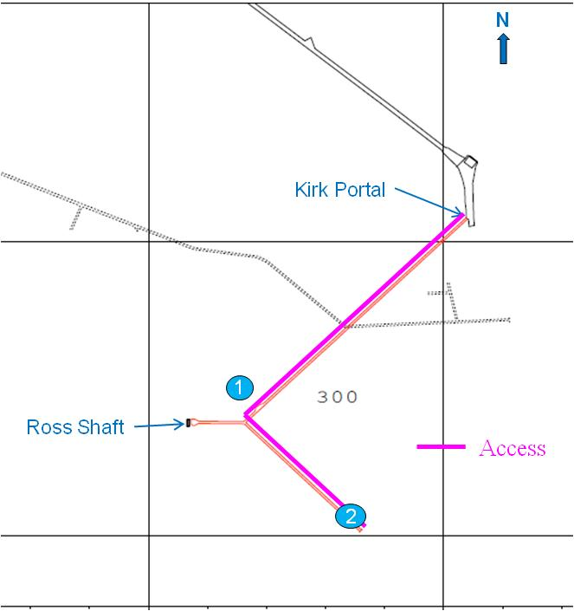
Figure 3.8.3-1 Level map for the 300L. A number of initial science groups have deployed instruments near site #1, including the DUGL group.
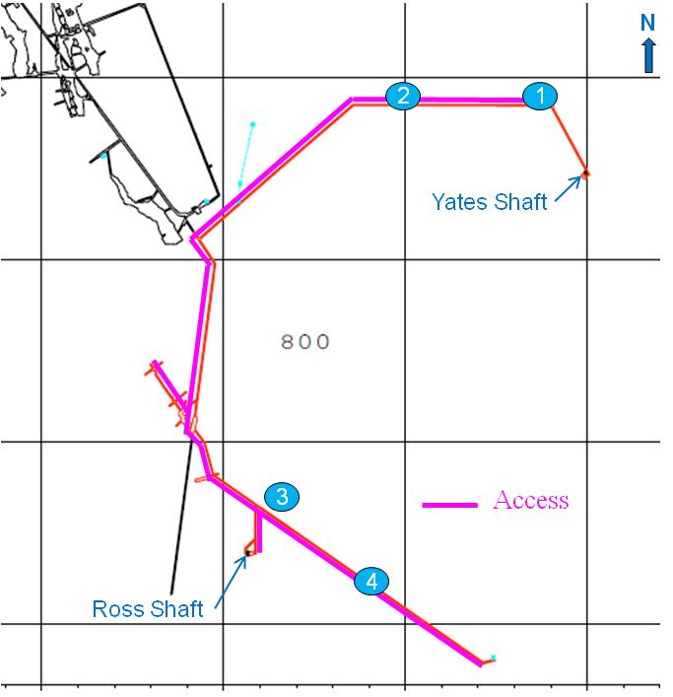

Figure 3.8.3-2 Level map for the 800L. A number of initial science groups have deployed instruments near sites #3,4, including the physics background characterization group and the DUGL group. Shielding materials for the Majorana Demonstrator are currently being stored ~100 m to the west of site #3.

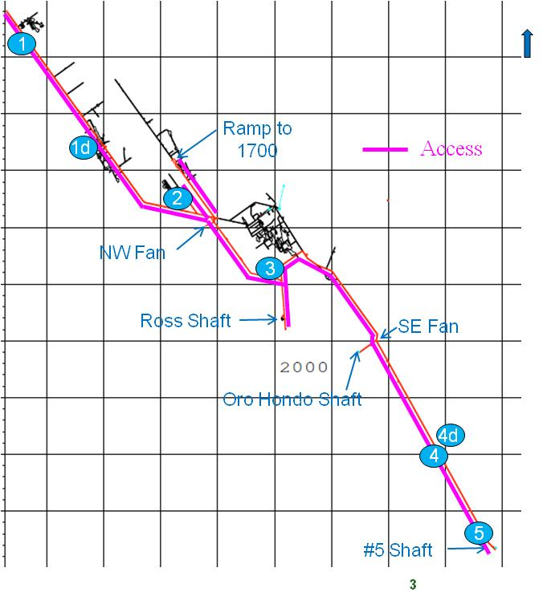
Figure 3.8.3-3 2000L
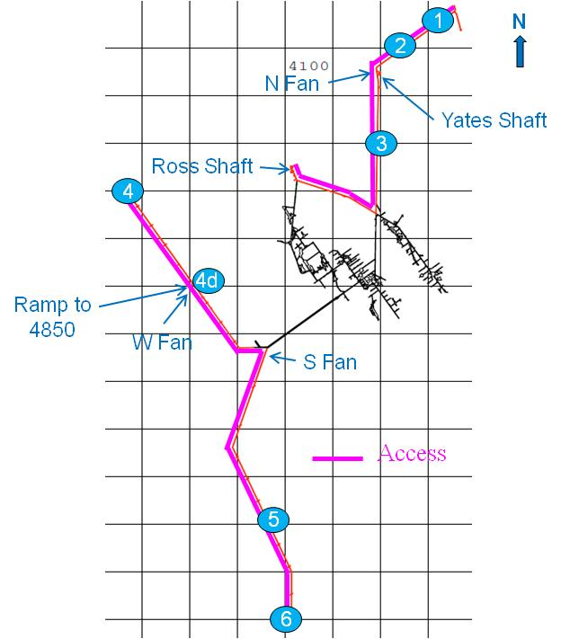
Figure 3.8.3-4 4100L
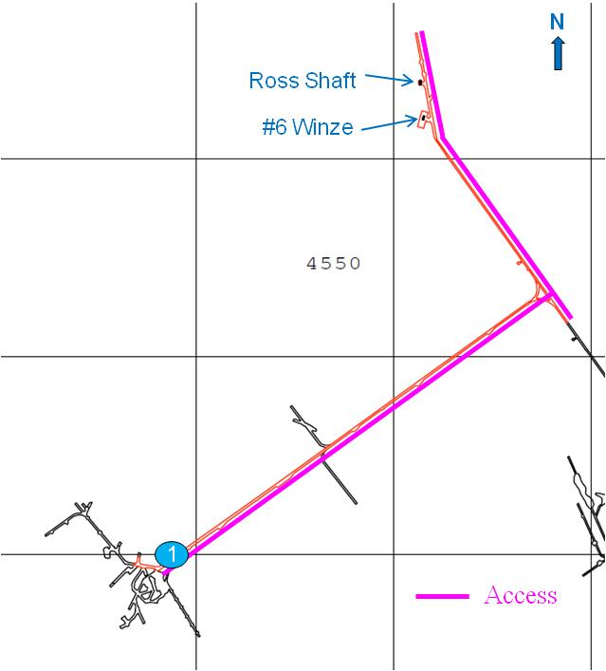
Figure 3.8.3-5 4550L
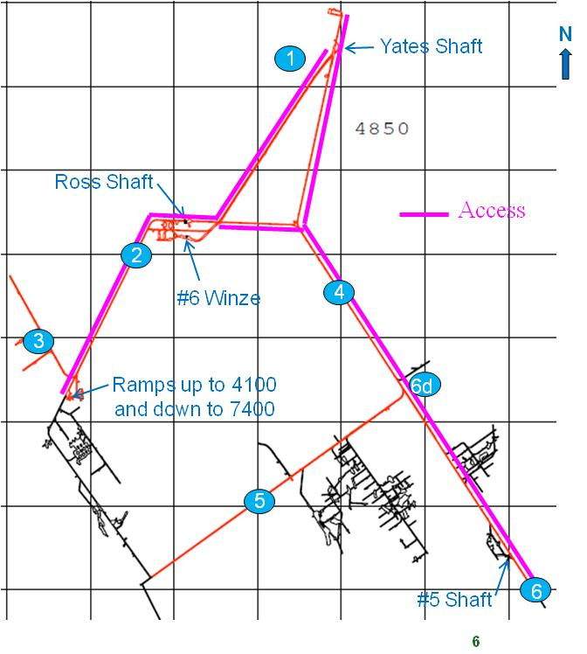
Figure 3.8.3-6 4850L
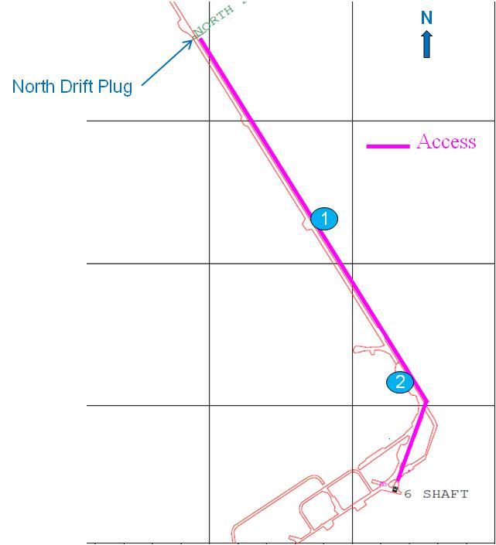
Figure 3.8.3-7 6800L
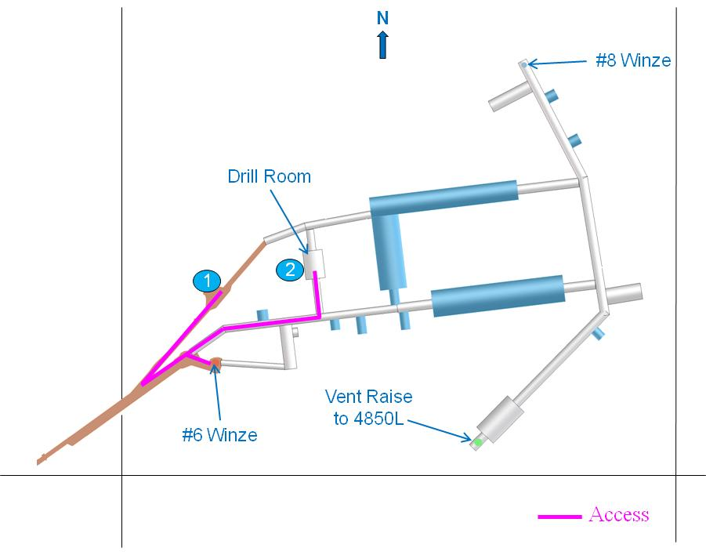
Figure 3.8.3-8 7400L
3.8.4 Surface Requirements
Surface facilities to support science will include experiment-specific as well as shared spaces. Experiment-specific spaces will generally include a control room and a limited number of dedicated offices. Shared spaces will include additional offices and meeting rooms, electronic and mechanical shops, shipping and receiving, storage, laboratories, and assembly space.
Two high-bay surface assembly areas will be provided for assembly of critical elements before transporting underground. The assembly spaces have approximately the same floor space as will be allocated in a lab module. The high bay will be 10 m high. Refer to Volume 5, Section 6 of this document for more details on the surface facility design.
3.8.5 Trade Studies Related to Science and Facility Requirements
A number of trade studies have been initiated to consider optional laboratory configurations relative to the baseline design. The objective is to assess the additional cost or savings of a particular option and to assess its impact on the potential for fulfilling the Laboratory’s science mission. The trade studies are described below. Many of the studies will continue beyond the completion of the Preliminary Design during the period leading up to the start of the Final Design. Results will be presented here for those that are complete; status and the plan for resolution will be described for the others. The cost differences presented in this section include direct and indirect costs, and contingency (in FY 2010 dollars). Cost differences compared to the baseline are given to the nearest $0.1 million.
For Sections 3.8.5.1 and 3.8.5.2, a simple parametric scaling of the excavation-related costs was used to estimate the cost difference compared to the baseline. Excavation-related costs include excavation of Laboratory modules and related access drifts, ground support, and shotcrete and concrete floors. Calculated excavation cost variations in length and height assume linear scaling with volume; this reasonably represents the cost of rock removal. An increase of width or span will result in increased rock stress that is nonlinear with width. This will require additional ground control, and therefore we expect that cost will scale with width at an order higher than linear. We have assumed a quadratic scaling for these parametric studies; this is assumed to be conservative. Cost differences related to ventilation and other utilities have been included.
Direct costs include estimates for labor and materials. A 60% factor is assumed for indirect costs; 40% contingency is assumed for LM-1 and LM-2 at the Mid-Level Campus; 50% contingency is assumed for LMD-1 at the Deep-Level Campus. We recognize that these estimates are highly preliminary. More detailed estimates of costs will be needed if the baseline Laboratory module dimensions are changed.
3.8.5.1 LM-1 Size and Configuration for DIANA
If the nuclear astrophysics accelerator proposal, DIANA, is part of the ISE, it will be installed as the sole experiment in LM-1. Neutron backgrounds are one of the noise sources for experiments proposed for DUSEL; a reduction in neutron backgrounds provides the primary motivation for deploying deep underground. Since DIANA is a potential neutron source, it is important that it is sufficiently shielded so that neutron exposure for other experiments is not affected by the presence of DIANA. This will require some specialization in the form of an egress maze at both entries. The required height will be reduced to 20 m rather than 24 m, and will not require the floor to be below the MLL grade. As this experiment, if approved, will likely operate through the duration of the Laboratory life, another experiment likely will not replace it in the future. It therefore makes sense to consider the associated increased costs or savings associated with a DIANA-specific cavern design.
A conceptual plan view of DIANA with the desired modifications is presented in Section 3.3.6.3.2. How these modifications might look in the context of the overall 4850L layout is shown in Figure 3.3.6.3.2-1. The overall cost of a lab module designed specifically for DIANA is expected to be less than the cost of the baseline LM-1 configuration by about $1.7 million, as summarized in Table 3.8.5.1.
Change | Cost Difference($M) | Comments
Decrease height 24 m → 20 m | -0.55 | Linear scaling of volume @ $138/m³
Remove slope in entry drift | -0.26 | Linear scaling of volume @ $400/m³
Add East entrance maze | +0.15 | Linear scaling of volume @ $400/m³
Add West entrance maze | +0.16 | Linear scaling of volume @ $400/m³
Ventilation change | -0.27 | Linear scaling of volume @ 45/m³
Subtotal | -0.77 | Direct costs
Total | -1.7 | Direct + indirect costs + contingency
Table 3.8.5.1 Trade studies as described in the text for DIANA in LM-1.
3.8.5.2 LM-2 Size and Configuration
The baseline cross sections for LM-2 are shown in Figure 3.8.1-1. This trade study looked at the cost difference for 20% variations in the height, width, or length of LM-2. The results are summarized in Tables 3.8.5.2-1 to 3.8.5.2-4. The cost of large excavations is believed to be particularly sensitive to the maximum span of the excavation.
Change | Cost Difference ($M) | Comments
Increase excavation volume | 1.10 | Linear scaling of volume @ $138/m³
Addition to entry drift | 0.43 | Linear scaling of volume @ $400/m³
Ventilation change | 0.54 | Linear scaling of volume @ $67/m³
Subtotal | 2.07 | Direct costs
Total | 4.6 | Direct + indirect costs + contingency
Table 3.8.5.2-1 Option 1: Increase height from 24 m to 28 m.
Change | Cost Difference ($M) | Comments
Increase excavation volume | -1.10 | Linear scaling of volume @ $138/m³
Addition to entry drift | -0.43 | Linear scaling of volume @ $400/m³
Ventilation change | -0.54 | Linear scaling of volume @ $67/m³
Subtotal | -2.07 | Direct costs
Total | -4.6 | Direct + indirect costs + contingency
Table 3.8.5.2-2 Option 2: Decrease height from 24 m to 20 m.
Change | Cost Difference ($M) | Comments
Increased width | 2.65 | Quadratic scaling of width
Ventilation change | 0.52 | Linear scaling of volume @ $67/m³
Increased struct./archit. | 0.27 | Linear scaling of area @ $667/m²
Increased misc. electrical | 0.45 | Linear scaling of area @ $1120/m²
Increased misc. plumbing | 0.11 | Linear scaling of area @ $285/m²
Increased crane width | 0.13 | Scaling of width @ $32,800/m
Subtotal | 4.13 | Direct costs
Total | 9.3 | Direct + indirect costs + contingency
Table 3.8.5.2-3 Option 3: Increase width from 20 m to 24 m.
Change | Cost Difference ($M) | Comments
Increased volume | 1.21 | Linear scaling of volume @ $138/m³
Decrease East drift by 10 m | -0.27 | Linear scaling of volume @ $400/m³
Decrease West drift by 10 m | -0.27 | Linear scaling of volume @ $400/m³
Ventilation change | 0.52 | Linear scaling of volume @ $67/m³
Increased struct./archit. | 0.27 | Linear scaling of area @ $667/m²
Increased misc. electrical | 0.45 | Linear scaling of area @ $1,120/m²
Increased misc. plumbing | 0.11 | Linear scaling of area @ $285/m²
Increased bridge crane length | 0.22 | Scaling of length @ $11,200/m
Increase monorail length | 0.11 | Scaling of length @ $5600/m
Subtotal | 2.35 | Direct costs
Total | 5.3 | Direct + indirect costs + contingency
Table 3.8.5.2-4 Option 4: Increase length from 100 m to 120 m.
      - LMD-1 Size and Configuration
The baseline cross sections for LMD-1 are shown in Figure 3.8.1-2. This trade study looked at 20% variations in height, width, or length of LMD-1. The initial design and cost estimates for excavations at the 7400L are at a Conceptual Design level, without the benefit of in-depth site and geotechnical investigations. The results of the trade study are summarized in Tables 3.8.5.3-1 to 3.8.5.3-3.
Change | Cost Difference ($M) | Comments
Increase excavation volume | 1.60 | Linear scaling of volume @ $138/m³
Ventilation change | 0.52 | Linear scaling of volume @ $67/m³
Subtotal | 2.12 | Direct costs
Total | 5.6 | Direct + indirect costs + contingency
Table 3.8.5.3-1 Option 1: Increase height from 15 m to 18 m.
Change | Cost Difference ($M) | Comments
Increased width | 3.15 | Quadratic scaling of width
Ventilation change | 0.39 | Linear scaling of volume @ $67/m³
Increased struct./archit. | 0.17 | Linear scaling of area @ $667/m²
Increased misc. electrical | 0.32 | Linear scaling of area @ $1120/m²
Increased misc. plumbing | 0.08 | Linear scaling of area @ $285/m²
Increased crane width | 0.11 | Scaling of width @ $32800/m
Subtotal | 4.23 | Direct costs
Total | 11.08 | Direct + indirect costs + contingency
Table 3.8.5.3-2 Option 2: Increase width from 15 m to 18 m.
Change | Cost Difference ($M) | Comments
Increased volume | 1.43 | Linear scaling of volume @ $138/m³
Ventilation change | 0.46 | Linear scaling of volume @ $67/m³
Increased struct./archit. | 0.17 | Linear scaling of area @ $667/m²
Increased misc. electrical | 0.32 | Linear scaling of area @ $1120/m²
Increased misc. plumbing | 0.08 | Linear scaling of area @ $285/m²
Increased bridge crane length | 0.20 | Scaling of length @ $11200/m
Increase monorail length | 0.10 | Scaling of length @ $5600/m
Subtotal | 2.76 | Direct costs
Total | 7.23 | Direct + indirect costs + contingency
Increased volume | 1.43 | Linear scaling of volume @ $138/m³
Ventilation change | 0.46 | Linear scaling of volume @ $67/m³
Table 3.8.5.3-3 Option 3: Increase length from 75 m to 90 m.
3.9 Systems Engineering for the Integrated Suite of Experiments
Systems Engineering related to the ISE is focused on the following areas:
- Experimental needs solicitation and documentation
- Development and maintenance of a top-level ISE requirement set per lab module or other levels and ramps area
- Interface control and management between the civil facilities and the experiments
- Value engineering and trade studies
- Change control and management
More detailed information about Systems Engineering on DUSEL may be found in Volume 9, Systems Engineering.
3.9.1 Interface and Requirements Management
During the DUSEL Preliminary Design phase, Systems Engineering developed and released the Integrated Suite of Experiments Interface Requirements Document (ISE-IRD), which can be found in Appendix 3.A. The ISE-IRD is the repository for requirements between the science program and the facility design. The document also captures constraints placed by the facility design on experiment hardware. The requirements presented in this PDR volume for the lab modules, LBNE water Cherenkov detector, and the BGE experiments on the OLR are captured in the ISE-IRD. The ISE-IRD is subject to the DUSEL Configuration Control process: It requires the signatures of the Deputy Project Director, the Science Project Manager, and Facility Project Manager before obtaining Change Board approval. Changes and updates will be made to the ISE-IRD as appropriate to support the continued maturation of both facility and science program designs.
The ISE-IRD is a key part of the overall DUSEL requirement structure that is described in more detail in Volume 9, Systems Engineering. The requirements in the ISE-IRD are stored in the DOORS requirements management database and linked to lower-level facility requirements. This linking process systematically ensures that every requirement contained in the ISE-IRD has a lower-level requirement “child” that fulfills the science need. Noncompliances between the requirements set and the DUSEL design can then be systematically identified, tracked, and managed. The DUSEL requirements management system ensures that all stakeholders are involved in the creation of requirements, allows integration among different levels of the organization, and formalizes the connection between the science needs and the facility design.
During the period after Preliminary Design and during Final Design phase, Systems Engineering will continue to be engaged in requirements definition and maturation. As changes occur in the program, Systems Engineering thoroughly assesses impacts to the various stakeholders by examining the linkages between requirements, thereby helping ensure an informed project decision occurs. As experiments are selected for DUSEL, Systems Engineering will lead the development of Interface Control Documents between the facility and the experiment. These documents will be of greater detail than the Interface Requirements Document and ensure a smooth integration of the experiment into the facility.
3.9.2 Value Engineering, Trade Studies
Systems Engineering supports value engineering and trade studies for the DUSEL facility, many of which involve issues related to capability available for the resident science investigations. Systems Engineering participates in the assessment of the priority of trades, the trade study approach, and the overall approval and impact assessment to the facility design baseline as it develops.
3.9.3 Configuration Control
Configuration Control is a vital aspect of any complex project because it provides a clear baseline by offering official documentation and an official change process. DUSEL Systems Engineering developed the DUSEL Configuration Control Plan and is, along with project management, responsible for its execution. Systems Engineering will ensure that the proper procedures are followed and the agreements are adequately reviewed by and disseminated to the proper parties. The ISE-IRD is the key configured item related to the science program that is under configuration control.
3.10 Organization and Management of the Research Program
This section provides a short summary of plans for organization and management of the research program. We first outline the principal roles of the U.S. funding agencies (NSF and DOE) for elements of the DUSEL research program. We then summarize the proposed roles and responsibilities for experiments by the management of the DUSEL MREFC project, including the evolution from the current organization for the operation of Sanford Laboratory and the DUSEL design team. We then describe the general considerations expected to pertain to the organization and management of experiments.
3.10.1 Agency Roles and Stewardship
The National Science Foundation (NSF) and the Department of Energy (DOE) have formed a DUSEL Joint Oversight Group (JOG) to coordinate and oversee DUSEL program elements. The agencies have furthermore defined the concept of stewardship of the different elements of the potential DUSEL program as shown in Table 3.10.1. The stewards of the facility and of the physics program are the NSF, the DOE Office of Nuclear Physics (ONP), and the DOE Office of High Energy Physics (OHEP), whose designated responsibilities are shown in the table. The NSF is the steward of the experimental activities in biology, geology, and engineering (BGE), with DOE partnership. Nonfederal funding of experiments is anticipated, and may include funds from private individuals, industrial partners, and the state of South Dakota. In addition, participation from funding agencies outside the United States is expected, consistent with a world-leading scientific program at DUSEL.
U.S. Agency Roles and Stewardship
Program Element | Steward Agency | Partner Agency
DUSEL facility | NSF | DOE
Dark-matter experiments | NSF | DOE OHEP
0νββ | DOE ONP | NSF
Long-baseline neutrino and proton decay | DOE OHEP | NSF
Nuclear astrophysics | NSF | DOE ONP
Advanced low background and other physics | NSF | DOE
Biology, geology, and engineering experiments | NSF | DOE (BES/BER)
Table 3.10.1 Summary of agency roles in and stewardship of DUSEL program elements.
The steward of a program element will provide the majority of the funding for that element and also will accept the risk inherent in funding the program element. Additional scientific topics may arise during the course of defining the DUSEL experimental program. The appropriate stewardship role will be defined as required.
3.10.2 DUSEL Management of the Experimental Program
The management of the DUSEL MREFC project and related operations is described in detail in Volume 7 (Project Execution Plan) of this Preliminary Design Report. We summarize here the salient features that pertain specifically to the experimental program.
Program Advisory Committee
A Program Advisory Committee (PAC) with representation from all scientific disciplines that form the DUSEL scientific program advises the Vice Chancellor for Research at the University of California, Berkeley. This committee will review all experiments proposed to be located at the DUSEL site.
A scientific program is in existence at Sanford Laboratory and is expected to continue (see Section 3.4, Research Activities at the Sanford Underground Laboratory). In early 2006, the Homestake Collaboration convened a PAC to review the 80 Letters of Intent (LOIs) that were submitted following a solicitation to the underground science community. Several experiments suitable for initial deployment in a so-called Early Implementation Program (EIP) were identified, including the Large Underground Xenon (LUX) experiment, the Majorana Demonstrator, and several geophysics and biology initiatives. By early 2008, the dewatering and reopening of the mine had progressed to the point that it became possible to consider the development of a deployment timetable for an early science program. The Sanford PAC (now labeled the EEAC—External Experimental Advisory Committee) was reconvened to recommend a prioritized list of experiments that could be realistically installed within the reopened areas of the mine deemed safe and suitable. LUX and the Majorana Demonstrator were identified as top priorities from the seven physics initiatives reviewed. Sanford Laboratory was encouraged to support several of the smaller-scale biology and geophysics efforts. The EEAC is no longer active and all review of existing or planned scientific programs at Sanford Laboratory and at the DUSEL site will be performed by the DUSEL PAC.
Science Liaison and Integration
The Scientific Liaison Department at Sanford Laboratory is currently responsible to the Director of Sanford Laboratory for oversight of the experimental program at the Laboratory. The Liaison Department is headed by an experienced physicist and includes technical-support personnel. The Liaison Department calls on other resources—EH&S, Operations, and Engineering—at Sanford Laboratory to support the experimental program. The DUSEL science integration team (described in Section 3.6, Integrated Suite of Experiments (ISE) Requirements Process) is primarily responsible for the interface to the experimental community and for the scientific input to requirements that determine the future DUSEL facility design. The team also has an ad hoc role in aspects of engineering and EH&S review of experiments at Sanford Laboratory and Memoranda of Understanding (MOUs) between these experiments and Sanford Laboratory. The organization of the support of experiments at Sanford Laboratory and then later at the DUSEL facility is in a transition phase. A unified organization, combining all functions, is expected to be in place by mid-to-late 2011 under the auspices of the DUSEL LLC (see Volume 7).
The costs of personnel and related materials and supplies in support of the experimental program are included under the Work Breakdown Structure (WBS) element DUS.SCI.SUP. The unified DUSEL science integration team will then be responsible for supporting the integration of experiments into the facility during the design, construction, and installation phases of these experiments. The team will then become responsible for common aspects of operational and maintenance support of experiments as they complete commissioning and begin operations. The team will concurrently support research and development at the DUSEL facility and integration of new experiments as they are conceived, proposed, accepted, built, installed, and operated. It should be noted that the primary support of experiments, in all phases, is the responsibility of the experimental teams and the associated funding sources. The science integration team is and will be responsible for the interface of experiments to the facility, for establishing and maintaining a safe working environment, and for coordination and implementation of common aspects to support multiple experiments. In the sections below we describe briefly the major elements of the team.
Scientific Staff
Scientific staff is essential to lead the integration and support effort. The scientific staff will consist of senior personnel with management and coordination responsibilities; permanent staff with well-identified responsibilities for major activities; and term scientists with specific responsibilities. Our model for the evolution of the scientific staff assumes an equal number of senior, staff, and term scientists reaching a total number of 15 FTEs by about 2020 for integration, operations and support. We note that these scientists will also be involved in research activities (see below) at a total level of approximately 10 FTE by about 2020.
Engineering Staff
Engineering staff covering the mechanical, electrical, and computer-science disciplines will ultimately be required for integration and support of experiments. Mechanical engineering is currently in place to support the integration of future potential experiments and some support of initial science will be necessary in the next few years. We plan to add electrical engineering. Computing and IT support will be provided in an integrated way through a common IT group that is described elsewhere.
Technical and Administrative Staff
Current technical staff is devoted to support of surface and underground locations at the Sanford Laboratory. These personnel are designated as Laboratory Operations Support. Mechanical and electrical technicians will be needed and will be added according to our planning as the experimental program grows and requires these skills. The total technical staff in direct support of the scientific program will ultimately reach 11 FTEs in our plan.
Administrative support will be needed as the science integration team grows. We are planning for a total of 1 FTE.
Mechanical Shop
A mechanical shop is foreseen to be located on the surface at DUSEL. This will have modest capabilities for machining in direct support of experimental needs. A modest shop capability will also exist underground to support experiments. Mechanical shop activities in support of experiments will be integrated with the overall mechanical shop support for the facility. Staffing for mechanical shops is covered under Technical and Administrative Staff, above. Only procurements of tools and supplies in direct support of experiments are covered under the Mechanical Shop heading in our cost estimate.
Electrical Shop
A modest electrical shop in direct support of experiments is required. This will provide repair functions, simple board layout (or coordination of the layout), board repair and simple loading, coordination of an electronics pool, and other functions. Only procurements of tools and supplies in direct support of experiments are covered under the Electrical Shop heading in our cost estimate. Staffing costs are part of Technical and Administrative Staff, described above.
Biology, Geology, and Engineering (BGE) Shop and Laboratory
Capabilities to support BGE experiments are required and are supplementary to the mechanical and electrical shops. The ability to store and analyze biological, chemical, and rock samples is required. Staffing for this function is covered under Technical and Administrative Staff, above. Only procurement costs in direct support of experiments are covered under this heading.
Low-Background Counting
The ability for materials assay is critical to the success of the initial science and DUSEL physics program. Some capability in this area will be established in 2012 in the Davis Campus. Additional support at the DUSEL site will be required to support the DUSEL physics experiments. The cost of equipment and supplies to support this function is included in this heading. Staff are covered under Technical and Administrative Staff, above. Scientific staff will also be involved.
Some operational support of experiments, including consumables, is currently provided by SDSTA Sanford Laboratory. It is currently planned that this support from SDSTA will continue through FY 2012. A complete transition to federal support (NSF and DOE) is anticipated by FY 2013. The phasing and detailed planning for this transition remains to be developed with the federal agencies and SDSTA. The costs for support of experiments are included under the WBS element DUS.SCI.EXP.
Organization of Experiments
The DUSEL facility will be open to all proposals from any scientific discipline. Proposals will be subject to the review process described briefly below. It is anticipated that major proposals for experiments at DUSEL will undergo a phased review process by the DUSEL management and PAC in a manner very similar to the review of experiments at accelerator laboratories or other user facilities. The DUSEL management team, in consultation with the PAC and the agencies, will develop more detailed guidelines for experimenters and the associated review process by fall 2011.
The financial and technical scope of the experiments at the DUSEL facility will vary greatly. The number of scientists participating in a given experiment will also vary from single-investigator-driven science to international collaborations of hundreds of physicists and students. Despite this large variation, all experiments will share some common features; other features of the organization and management will be adapted to the scope, funding, and nature of a particular experiment or experimental program at DUSEL.
General Requirements for Experiments
All future experiments at DUSEL will share the following features:
- Review by DUSEL management regarding the suitability of the proposed experiment for the DUSEL facility
- Review and approval by the appropriate elements of the DUSEL organization of all relevant EH&S issues
- Review by the DUSEL PAC, including its recommendations
- A signed MOU between the designated representative(s) of an experiment and DUSEL management
- A General Services Agreement (GSA), to be amended and signed yearly by the experimental representative(s) and DUSEL management, that specifies services and items to be provided by DUSEL to the experiment and the responsibilities of the experiment
- Addenda or other documents related to the MOU as required to meet fiduciary or other requirements
- A well-identified organizational structure and defined points of contact with clearly defined responsibilities on the part of the experiment team
- Implementation of experiments done according to codes and standards established by DUSEL
The organization of a particular experiment or R&D activity will depend on the nature of the experiment, its financial scope (including the participation of non-U.S. parties), and the relevant agency steward. We note that MOUs and GSAs are now in place with the LUX and Majorana Demonstrator experiments, for example. The process for establishing these agreements, and the documents themselves, provide experience and templates for future experiments at DUSEL.
Major Experiments
Major experiments will have dedicated management in the form of a spokesperson (or co-spokespersons), a project manager, a project office adequately staffed to provide engineering and project-management support, and an organizational structure commensurate with the scope and complexity of the experiment. The responsibility to form and staff the management team for a major experiment rests with the experiment. DUSEL management reserves the right to review the management structure and management team of major experiments, including the necessity to concur in the selection of project manager. The roles and responsibilities of the experiment management team and the DUSEL organization will be documented in a corresponding MOU.
The DUSEL science integration team involved directly in aspects of the experimental program is anticipated to be small. Its primary focus will be on the experiments’ interfaces with the DUSEL facility, including the implementation of common infrastructure shared among different experiments. Such interfaces will be documented for each experiment in an Interface Control Document (ICD) that will provide the basis for all interfaces between a given experiment and the DUSEL facility. The mechanism for review, approval, oversight, and reporting for each major experiment will be developed on a case-by-case basis by the experiment management, DUSEL management, and the funding agencies (primarily the steward agency). In some cases, substantial in-kind or financial contributions from outside the United States may be needed to complete a proposed experiment. DUSEL management may choose to form an international finance board for a given experiment or group of experiments as needed and in close collaboration with the management of the respective experiments.
Experiments at User Facilities
The scientific program at DUSEL may include long-term experimental facilities that will have a changing set of users. Examples of this include an accelerator facility for nuclear astrophysics, an advanced low-background counting facility, or some aspects of potential experiments in BGE. In such a case, DUSEL management may form an advisory body, in addition to the PAC, to provide advice and recommendations and to provide periodic reports to the PAC.
Other Experiments
Experiments or R&D efforts not falling under the “major” classification will be subject to the general conditions and requirements described earlier. The organization of these efforts will be tailored to the circumstances of the individual proposed experiment by DUSEL management, the proponents, and the steward agency.
3.10.3 User Community
The user community for DUSEL is substantial and estimated to include 750-1000 interested scientists and engineers. The DUSEL Experiment Development Coordinators (DEDC) group was formed in January to address the development of the initial experiments to be included in DUSEL facility. The DEDC through workshops and working groups provided input and assistance to the DUSEL project staff to develop the requirements for the DUSEL facility. The mission of the DEDC was completed in early 2010 and a new user body was formed, the DUSEL Research Association (DuRA). This Association comprises the full cadre of members of the DUSEL scientific community with representation by a smaller Executive Committee to liaise with the Facility and with the funding agencies. The Executive Committee is elected by the general user community and is representative of the much broader scientific community intending to propose experiments at DUSEL.
3.10.4 Experimental Program Costs and Funding
The overall scope of the initial experimental program at the DUSEL facility will, in part, be determined by funds available from U.S. and non-U.S. funding agencies, research institutions, and other sources. The DUSEL facility design is based on housing and supporting an initial generic experimental program—the Integrated Suite of Experiments (ISE) (see Section 3.5, Integrated Suite of Experiments). Here follows a summary of the proposed MREFC funding requested to implement a world-leading program of scientific research. The results of experiments in the next few years will inevitably influence the nature of the future experiments at DUSEL. In addition, funding for the ISE must come from a number of sources outside the MREFC to realize the proposed program.
NSF funding for experiment design and R&D is currently in place, primarily through the funding of S4 proposals. The S4 funding is expected to be exhausted by the end of FY 2012. However, the design of potential experiments, and the related R&D, will not be completed. NSF funding to complete Preliminary and Final Design of the first DUSEL experiments, and the related R&D, must continue smoothly after S4 funding ceases. We propose that funding outside the MREFC for completion of experiment design and R&D be in place from FY 2013-FY 2016 for the first experiments at the DUSEL facility. Our planning assumes full implementation of the stewardship model (Table 3.10.1) is in place by FY 2013 and that responsibility for completion of design and R&D for the first DUSEL experiments follows that model. These design and R&D costs are under WBS element DUS.SCI.EXP.
The proposed MREFC funding for experiments is based in part on preliminary cost estimates provided by the NSF S4 awardees (see Section 3.3.1). The S4 awardees were requested to provide cost information in the form of FTEs for different types of personnel (scientists, engineers, technicians, etc.) and procurement costs. They were also requested to provide a very preliminary schedule. The DUSEL project controls team used this information to formulate a rough cost estimate. It must be emphasized that these cost estimates are at a very early stage. The DUSEL team applied a uniform costing model for personnel to all estimates. This model used composite rates for personnel based on a 50:50 mixture of university and national laboratory labor. The costs of scientific personnel were not included in these estimates for physics experiments. Given the very preliminary nature of these estimates, we believe a risk-based contingency of 50% is appropriate at this time. MREFC costs are under WBS element DUS.SCI.EXP.
The cost range for specific experiment types is given in Table 3.10.3-1. The costs shown include 50% contingency and are in $M (FY 2009). The costs shown do not include R&D or Final Design activities. Installation costs are included, but not operations. The cost range for 0νββ experiments includes a very rough estimate of scope contingency as well. A large fraction (30-40%) of the cost of the 0νββ experiments is projected to be in separated isotopes. A reduction in scope (target mass) thus translates directly into a substantial reduction in cost. We have attempted to include such a reduction (factor of two from the maximum mass proposed) but recognize well that the cost of 0νββ experiments can only be set for a given design with a specified scientific reach. The cost range of the nuclear astrophysics facility is based solely on the DIANA proposal. The upper range is as proposed and the lower range assumes scope contingency or staging is possible, an assumption made by the DUSEL Project team. The cost range of providing low-background counting is significant. The upper range is based on the full FAARM proposal. The lower range reflects the possibility of implementing only a more limited capability at the DUSEL site. The cost range of BGE experiments is very uncertain. The range given in Table 3.10.4-1 is based on the S4 BGE proposals but the upper range is not a sum of the cost estimates of these current proposals. The range reflects the project’s judgment regarding a plausible range of proposals for initial BGE experiments.
Experiment Type | Cost Range ($M – FY09)
Dark-matter experiments (per experiment) | 80-100
0νββ experiments (per experiment) | 240-330
Nuclear astrophysics facility | 30-45
Advanced low background | 2-15
Biology, geology, and engineering experiments | 60-180
Table 3.10.4-1 Cost range of potential initial DUSEL experiments, as explained in the text.
The total MREFC funding proposed for experiments is $300 million (FY 2009). Of this, a fixed amount of $125 million is allocated to the Long Baseline Neutrino Experiment (LBNE) project, which will provide all other funds required, including contingency, for the LBNE far-detectors. A total of $175 million (FY 2009) is allocated to other experiments—see Table 3.10.4-2.
The ultimate allocation to specific experiments within the $175 million envelope will be determined by scientific merit, interactions with the steward agencies, and non-U.S. agencies, and will include thorough review by the DUSEL PAC.
However, to advance planning of the future DUSEL experimental program, we present here a description of a model for experiment types within the $175 million envelope. We emphasize this is a preliminary model intended to initiate further development of a robust experimental program and is consistent with meeting the key scientific goals of the DUSEL MREFC proposal.
MREFC funds, including contingency, would be allocated with high priority such that one or more Generation-3 (G3) dark-matter experiments would be realized as part of the initial DUSEL experimental program. Additional financial support from DOE and non-U.S. sources is needed to create a robust program of multiple G3 dark-matter experiments. MREFC funds may be allocated to allow funding to complete a G2 dark-matter experiment to be located in the Davis Campus, if a compelling scientific case is made and if such an experiment has negligible impact on the cost and schedule of the DUSEL facility. A decision to solicit proposals for G2 experiments in the Davis Campus will be made by the end of 2011, in consultation with the funding agencies and after review by the DUSEL PAC. Initial funding of such a G2 experiment for the Davis Campus must come from non-MREFC sources. The earliest selection of such an experiment could be made by mid-2012.
A fixed amount of MREFC funding (no contingency, similar to the LBNE case) would be allocated to 0νββ experimental activities, and most of the funding (and all of the contingency) would be provided by DOE ONP, the steward agency, and other sources.
An allocation of MREFC funding for a nuclear astrophysics facility may be made and is contingent upon review by the DUSEL PAC of scientific merit and availability of funding. The total MREFC funding of this aspect of the scientific program can only be determined after thorough review and a better understanding of potential funding from DOE and non-U.S. sources. A decision to proceed with an underground accelerator to accomplish this scientific program must be made relatively early. Modifications to the current, generic, design of the candidate laboratory module (LM-1 at the 4850L) are likely required to accommodate an underground accelerator. Thus a decision to design LM-1 specifically for an underground accelerator must be made by mid-2012.
MREFC funding for low-background counting, material assay, and related activities is planned to allow for the minimum support that is required at the DUSEL site that cannot be provided by other facilities. MREFC funding may allow for an advanced facility to meet future needs, including the option of a phased approach to such a facility.
Funding for BGE experiments would allow a science program in these areas to start early in the MREFC period and would provide the basis for continued activities that are likely to be also supported by funds from multiple sources outside the MREFC.
Experiment Type | MREFC Funds Proposed  $M (FY09)
Long-baseline neutrino, proton decay | 125
Dark-matter experiments | 175
0νββ experiments | 175
Nuclear astrophysics | 175
Low background counting | 175
Biology, geology, and engineering | 175
TOTAL | 300
Table 3.10.4-2 Proposed MREFC funding of experiments.
3.10.4 Schedule of the Initial Experimental Program
This section provides a high-level overview of the schedule for experiments at the DUSEL site through the end of the MREFC period. The need to begin Final Design of the DUSEL facility in early 2012 and the plan to begin construction of the facility (MREFC start) in January 2014 are critical near-term schedule constraints.
Long Baseline Neutrino and Proton Decay
The schedule for the LNBE project is under active development and depends in detail on the final choice of technologies for the LBNE far detectors. A Critical Decision-1 (CD1) review is anticipated in the fourth quarter of 2011, when a more developed schedule will be available. A CD2 review is currently anticipated in the 2013. The CD3 milestones are under development and CD3a (for long-lead-time items) and CD3b milestones may be developed. Final CD3 approval is anticipated for the last quarter of 2014. Underground construction of a large cavity could begin in late FY2015 and be ready for experiment installation to begin by the first quarter of 2019, assuming one or more water Cherenkov detectors are selected by the LBNE project. Experimental installation would follow. A schedule for the liquid argon (LAr) option for LBNE and its impact on the DUSEL facility schedule is under development.
Dark Matter Experiments
The U.S. dark-matter community has proposed a road map leading from the current generation of dark-matter experiments (G1) through implementation of G3 dark-matter experiments at DUSEL (see Section 3.3.3, Dark Matter Overview). The U.S. community proposes to make a selection among the various experimental techniques such that G3 experiments can be fully realized at DUSEL by 2018-2020. They propose a choice of technique be made about 3½ years before the beneficial occupancy of the relevant laboratory module for housing an experiment. It is recognized that this is an aggressive schedule and may not take full advantage of the information obtained from sustained operation of G2 dark-matter experiments. For dark-matter experiments at the 4850L, this implies a technology choice in 2014. We have assumed about four years between selection of a G3 dark-matter experiment (by mid-2014) and when the relevant 4850L laboratory module is ready to begin experiment installation (the second quarter of 2018). The duration of assembly and installation for these experiments is not yet well understood but is estimated to be up to two years. This would lead to a start in data taking by ∼2019-2020. The laboratory module at the 7400L is expected to be ready for experiment installation by the second quarter of 2019. Assembly and installation at the 7400L will be more difficult than at the 4850L (for an experiment of similar complexity) and a two-year or longer duration is likely to be needed, leading to data taking at the 7400L by ∼2021-2022.
Neutrinoless Double Beta Decay Experiments
The 0νββ experiments, as represented by the 1TGe and EXO examples, anticipate starting construction (first procurements) no earlier than the latter half of 2015. This approximate date is driven primarily by the need to obtain data from ongoing experiments—the Majorana Demonstrator, GERDA, and EXO200—and the time needed for Preliminary and Final Design. Both the 1TGe and EXO experiments want to be located at the 7400L. The time for production of the enriched isotopes needed for these experiments is significant, as is the fabrication of the remainder of the experimental apparatus. These example 0νββ experiments desire beneficial occupancy of the laboratory module in early 2018, which is not consistent with the current planning for the 7400L (experiment installation to begin by the second quarter of 2019). However, planning for these experiments is at an early stage and constraints from availability of funding or technical choices have not yet been fully evaluated. The assembly and installation durations of these experiments are long (see Section 3.3.4, Neutrinoless Double Beta Decay Experiments)—potentially three years, roughly, after beneficial occupancy. Depending on the type of experiment, staged operation may be possible, but full operation of multitonne-scale detectors would begin three to four years after beneficial occupancy of the 7400L laboratory module, that is in approximately 2022.
Nuclear Astrophysics Facility
The design of an accelerator facility for nuclear astrophysics experiments, as represented by DIANA, is relatively well advanced. We have already noted in a previous section that a choice to proceed with an underground accelerator needs to be made by mid-2012 if LM-1 at the 4850L is to be a “custom” design for an underground accelerator. Final Design of the accelerator complex could begin in late 2012, and some aspects of the accelerator could be built and operated on the surface (not at the DUSEL site), prior to the availability of the underground laboratory module, if funds were available and if scientifically justified. The schedule for deployment of the accelerator underground is, of course, tied to the beneficial occupancy of LM-1 at the 4850L (second quarter of 2018). The duration of installation and the phasing of commissioning of the accelerators are not yet well understood, but operations could likely begin in 2019.
Low-Background Counting and Material Assay
Low-background counting and material-assay capabilities are needed during the design, R&D, and early construction phases of the initial dark-matter, 0νββ, and LBNE experiments. This early capability would be provided partly by capabilities at Sanford Laboratory located in the Davis Campus and by other facilities located elsewhere in and outside of the United States. The large FAARM facility requires occupancy of LM-2 (or LM-1 if a nuclear astrophysics facility is not selected to be among the initial experiments). Implementation of FAARM after beneficial occupancy is expected to take one to two years, and thus would be available by late 2019 or 2020. It would therefore benefit future experiments and R&D on pushing the limits of low-background counting. In our planning, we assume a choice to proceed with FAARM or similar facility would be taken by about mid-2015.
Biology, Geology, and Engineering Experiments
Elements of a number of BGE experiments are already under way in a modest way at Sanford Laboratory (see Section 3.4). The implementation of BGE experiments could begin in a phased way very early in the MREFC era, as continuations of ongoing work in 2014 and then as new experiments in 2015-2016. Some potential BGE experiments are of sufficiently short duration that they could begin early in the MREFC era and be completed well before completion of the project. The critical issue for some experiments would be access to the 4850L and later to the 7400L, and phasing implementation of these experiments with construction will be an important constraint. Some proposed BGE experiments are of significant scope and require new excavation and related work beyond that included in the DUSEL baseline design. These experiments would be reviewed by the DUSEL PAC in 2012-2013, such that the appropriate selections can be made, potentially leading to timely start of such experiments in 2014-2015.
Long-Term DUSEL Schedule
The DUSEL facility, once completed, would have an operational lifetime of more than 30 years and would serve multiple generations of experiments. The descriptions in this Volume have emphasized the characteristics and facility requirements for the initial DUSEL experiments. However, the facility design is sufficiently flexible, and upgradeable, to accommodate future generations of experiments in dark matter, neutrinoless double beta decay, neutrino oscillations and possibly proton decay. An accelerator dedicated to nuclear astrophysics is in itself a facility with decades of anticipated experiments. Experimental studies in underground biology and geosciences are also anticipated to be relevant over many decades.

Section 3.2
1. Dark Matter White Paper, by the DUSEL Dark Matter Working Group (and references therein) Available from: http://dmtools.brown.edu/DMWiki/index.php/Dark_Matter_Working_Group)
2. Baltz E, Battaglia M, Peskin ME, Wizansky T. Phys. Rev. D74, 103521 (2006).
3. DMTools dark matter direct detection experiment and theory data available at http://dmtools.brown.edu
4. This section taken and modified, with permission, from EXO’s and 1 TGe’s S4 proposals and DUSEL submissions.
5. Moe MK, Nucl. Phys. B Proc. Supp. 19, 158 (1991); S. R. Elliott and P. Vogel, Ann. Rev. Nucl. Part. Sci. 52, 115 (2002).
6. Klapdor-Kleingrothaus, et al., Mod. Phys. Lett. A 21, 1547 (2006).
7. B. Pontecorvo, Sov. Phys. JETP 6, 429 (1957), Zh. Eksp. Teor. Fiz. 33, 549 (1957), Sov. Phys. JETP 7, 172 (1958), Zh. Eksp. Teor. Fiz. 34, 247 (1957).
8. C. Amsler, et al. (Particle Data Group, Phys. Lett. B 667, 1 (2008).
9. Y. Fukuda et al. (Super-Kamiokande Collaboration), Phys. Rev. Lett. 81, 1562 (1998).
10. “An appearance experiment to search for ν_{μ} ↔ ν_{τ} oscillations in the CNGS beam (OPERA)”, CERN/SPC 2000-028, SPSC/P318, LNGS P25/2000, July 12, 2000.
11. “General description of the CERN project for a neutrino beam to Gran Sasso (CNGS)”, CERN AC Note 2000-03, 2000.
12. H. Nunolkawa, S. Parke, J. Valle, “CP Violation and Neutrino Oscillations”, arKiV 0710.05542V2, 18 Oct. 2007.
13. H. Nishino et al. (Super-Kamiokande Collaboration), Phys. Rev. Lett. 102 141801 (2009) [arXiv:0903.0676 [hep-ex]] and [http:www-sk.icrr.u-tokyo.ac.jp/whatsnew/new-20091125-e.html
14. Super-Kamiokande Experiment, Phys. Rev. Lett. 90 061101 (2003).
15. K. Scholberg, arXiv:astroo-ph/0701081.
16. A. Dighe, arXiv:0809.2977 [hep-ph]. A. Mirizzi, G. G. Raffelt and P. D. Serpico, JCAP 0605, 012 (2006) [arXiv:astro-ph/0604300]. G. G. Raffelt, arXiv:astro-ph/9707268. S. Hannestad and G. Raffelt, Phys. Rev. Lett. 87, 051301 (2001) [arXiv:hep-ph/0103201]
17. P. Antonioli et al., New J. Phys. 6, 114 (2004) [arXiv:astro-ph/0406214]], K. Scholberg, arXiv:0803.0531 [astro-ph]
18. R.Bionta, et al, Physical Review D37 3361(1988); K. S. Hirata, et al., Phys Rev D38 448 (1988); Alekseev, E. N., Alekseeva, L. N., Krivosheina, I. V., Volchenko, V. I., Phys. Lett. B205 209-214 (1988)
19. SuperK Collaboration, Phys. Rev. Lett. 90 061101 (2003)
20. E. G. Adelberger et Al., arXiv :1004.2318v2 (2010).
21. J. M. Bahcall, A. M. Serenelli, and S. Basu, Astrophys. J. Suppl. 165 (2006) 400.
22. T. A. Weaver, and S. E. Woosley, Phys. Rep. 277 (1993) 65.
23. M. Busso, R. Gallino, and G. J. Wasserburg, Ann. Rev. Astr. Astrophys. 37 (1999) 329.
24. F. Kaeppeler et Al., Astrophys. J. 437 (1994) 396.
25. L. S. The, M. F. El Eid, and B. S. Meyer, Astrophys. J. 655 (2007) 1058.
26. M. Pignatari et Al., (2010) to be submitted.

Section 3.3.3
1.Bernabei R, Belli P, Cappella F, Cerulli R, d’Angelo A, Dai CJ, He HL, Incicchitti A, Kuang HH, Ma XH, Montecchia F, Nozzoli F, Prosperi F, Sheng XD, Ye ZP. Direct detection of Dark Matter particles. Nucl Instr and Meth A. (2010). Available from: http://10.1016/j.nima.2010.06.084
2. DUSEL Dark Matter Group. Dark Matter White Paper. Available from http://dmtools.brown.edu/DMWiki/index.php/Dark_Matter_Working_Group
Section 3.3.4
1. Section taken and modified, with permission, from EXO’s and 1TGe’s S4 proposals and DUSEL submissions.
2. Klapdor-Kleingrothaus HV, Krivosheina IV. The evidence for observation of 0νββ decay: the identification of 0νββ events from the full spectra. Mod Phys Lett A. 21, 1547-1566 (2006).
3. Danilov M, DeVoe R, Dolgolenko A, Giannini G, Gratta G, Picchi P, Piepke A, Pietropaolo F, Vogel P, Vuilleumier J-L, Wang Y-F, Zeldovich O. Detection of very small neutrino masses in double-beta decay using laser tagging. Phys Lett B.;480, 12-18 (2000)
Neuhauser W, Hohenstatt M, Toschek P. Optical-sideband cooling of visible atom cloud confined in parabolic well. Phys Rev Lett. 41, 233-236 (1978); Available from http://prl.aps.org/pdf/PRL/v41/i4/p233_1
Moe MK. Detection of neutrinoless double-beta decay. Phys Rev C. 44, R931-R934 (1991) Available from http://prc.aps.org/abstract/PRC/v44/i3/pR931_1
Section 3.3.5
1. Lunardini C. The diffuse supernova neutrino flux, supernova rate and SN1987A. Astropart Phys. 26, 190 (2006). doi: 10.1016/j.astropartphys.2006.06.008
2. Barger V, Huber P, Marfatia D, Winter W. Upgraded experiments with super neutrino beams: Reach versus exposure. Physical Rev D. 76, 031301(R) (2007). Available from http://link.aps.org/doi/10.1103/PhysRevD.76.031301
3. Scholberg K. Supernova neutrino detection. (2007). Available from: http://arXiv:astro-ph/0701081
4. Dighe A. Physics potential of future supernova neutrino observations. J Phys Conf Ser. 136, 022041 (2008). Available from: http://arxiv.org/abs/0809.2977
Mirizzi A, Raffelt GG, Serpico PD. Earth matter effects in supernova neutrinos: optimal detector locations. JCAP 05, 012 (2006). Available from: http://arxiv.org/PS_cache/astro-ph/pdf/0604/0604300v2.pdf
Raffelt GG. Astrophysical axiom bounds: an update. (1997). Available from: http://arxiv.org/abs/astro-ph/9707268
Hannestad S, Raffelt G. New supernova limit on large extra dimensions: bounds on Kaluza-Klein graviton production. Phys Rev Lett. 87, 051301 (2001). Available from: http://arxiv.org/abs/hep-ph/0103201
5. Antonioli P, Fienberg RT, Fleurot F, Fukuda Y, Fulgione W, Habig A, Heise J, McDonald AB, Mills C, Namba T, Robinson LJ, Scholberg K, Schwendener M, Sinnott RW, Stacey B, Suzuki Y, Tafirout R, Vigorito C, Viren B, Virtue C, Zichichi A. SNEWS: the SuperNova Early Warning System. New J Phys. 6, 114 (2004) Available from: http://iopscience.iop.org/1367-2630/6/1/114/pdf/1367-2630_6_1_114.pdf
Scholberg K. The SuperNova Early Warning System. Astron Nachr. 329, 337 (2008). Available from: http://arxiv.org/abs/0803.0531arXiv:0803.0531
6. Bionta RM, Blewitt G, Bratton CB, Casper D, Claus R, Cortez B, Errede S, Foster G, Gajewski W, Ganezer KS, Goldhaber M, Haines TJ, Jones TW, Kielczesdka D, Kropp WR, Lerned JG, Lehmann E, LoSecco JM, Park HS, Reines R, Schultz J, Seidel S, Shumard E, Sinclair D, Sobel HW, Stone JL, Sulak L, Svoboda R, Van der Velde JC, Wuest C. Contained neutrino interactions in an underground water detector. Physical Review D. 38, 768 (1988). Available from: http://prd.aps.org/abstract/PRD/v38/i3/p768_1
Hirata KS, Kajita T, Koshiba M, Nakahata M, Oyama Y, Sato N, Suzuki A, Takita M, Totsuka Y, Kifune T, Suda T, Takahashi K, Tanimori T, Miyano K, Yamada K, Beier EW, Feldscher LR, Frati W, Kim SB, Mann AK, Newcomer FM, Ban Berg R, Zhang W. Cortez BG. Observation in the Kamiokande-II detector of the neutrino burst from supernova SN1987A. Phys Rev D. 38, 448 (1988). Available from: http://prd.aps.org/abstract/PRD/v38/i2/p448_1
Alexeyev EN, Alexeyeva LN, Krivosheina IV, VolchenkoVI. Detection of the neutrino signal from SN 1987A in the LMC using the INR Baksan underground scintillation telescope. Phys. Lett B. 205, 209 (1988). doi:10.1016/0370-2693(88)91651-6
7. Super-Kamiokande Collaboration. Search for supernova relic neutrinos at Super-Kamiokande. Phys Rev Lett. 90, 061101 (2003). Available from: http://prl.aps.org/abstract/PRL/v90/i6/e061101
8. SNO Collaboration. Electron energy spectra, fluxes, and day-night asymmetries of ⁸B solar neutrinos from measurements with NaCl dissolved in the heavy-water detector at the Sudbury Neutrino Observatory. Phys Rev C. 72, 055502, (2005). Available from: http://prc.aps.org/abstract/PRC/v72/i5/e055502
9. Bernstein A, Bishai M, Blucher E, Cline DB, Diwan MV, Fleming B, Goodman M, Hladysz ZJ, Kadel R, Kearns E, Klein J, Lande K, Lanni F, Lissauer D, Marks S, McKeown R, Morse W, Raeika R, Roggenthen WM, Scholberg K, Smy M, SObel H, Steward J, Sullivan G, Svoboda R, Vagins M, Viren B, Walter C, Zwaska R. Report on the depth requirements for a massive detector at Homestake. Fermilab-TM-2424-E, BNL-81896-2008-IR, LBNL-1348E (9 Aug 2009). Available from: http://arxiv.org/abs/0907.4183v2
10. NOνA Collaboration. Proposal to Build a 30 Kiloton Off-Axis Detector to Study ν_{μ} → ν_{e} Oscillations in the NuMI Beamline NOνA NuMI Off-Axis ν_{e} Appearance Experiment. Fermilab-Proposal-0929 (Mar 2005). Available from: http://arxiv.org/abs/hep-ex/0503053
11. MINERvA Collaboration. MINERvA Technical Design Report. MINERvA doc 700-v28 (2008). Available from: http://minerva-docdb.fnal.gov/cgi-bin/ShowDocument?docid=700
12. MicroBooNE Collaboration. A Proposal for a New Experiment Using the Booster and NuMI Neutrino Beamlines: MicroBooNE. (15 Oct 2007). Available from: http://www-microboone.fnal.gov/project/index.html
13. DOE and NSF Joint Oversight Group for the development of DUSEL
14. LBNE Physics Working Group. Fall 2010 Report from the LBNE Physics Working Group. LBNE-PWG-001 (Rel. 1.2) (12 Sep 2010).
Section 3.3.6
1. Greife U, Arpesella C, Barnes CA, Bartolucci F, Bellotti E, Broggini C, Corvisiero P, Fiorentini G, Fubini A, Gervino G, Gorris F, Gustavino C, Junker M, Kavanagh RW, Lanza A, Mezzorani G, Prati P, Quarati P, Rodney WE, Rolfs C, Schulte WH, Trautvetter HP, Zahnow D. Laboratory for Underground Nuclear Astrophysics (LUNA). Nucl Instr Meth A. 350, 327 (1994). doi:10.1016/0168-9002(94)91182-7
2. Formicola A, Imbriani G, Junker M, Bemmerer D, Bonetti R, Broggini C, Casella C, COrvisiero P, Costantini . The LUNA II 400 kV accelerator. Nucl Instr Meth A. 507 609 (2003). doi:10.1016/S0168-9002(03)01435-9
3. Adelberger EG, Balantekin AB, Bemmerer D, Bertulani A, Chen J-W, Costantini H, Couder M, Cyburt R, Davids B, Freedman SJ, Gai M, Garcia A, Gazit D, Gialanella L, Greife U, Hass M, Heeger K, Haxton WC, Imbriani G, Itahashi T, Junghans A, Kubodeera K, Langanke K, Leitner D, Leitner M, Marcucci LE, Motobayashi T, Mukhamedzhanov A, Nollett KM, Nunes FM, Park T-S, Parker PD, Prati P, Ramsey-Musolf MJ, Robertson RGH, Schiavilla R, Simpson EC, Snover KA, Spitaleri C, Striedeer F, Suemmerer K, Trautvetter HP, Tribble RE, Typel S, Uberseder E, Vetter P, Wiescher M, Winslow L. Solar fusion cross sections II: the pp chain and CNO cycles. (2010). Available from: http://arxiv.org/abs/1004.2318v2
4. Junker M, et al. Phys Rev C. 57, 2700 (1998).
5. Heusser G. Ann Rev Nucl Part Sci. 45, 543 (1995).
6. Imbriani G, et al. Eur Phys J A. 25, 455 (2005).
7. Mei D-M, et al. Astropart Phys. 34, 33 (2010).
Section 3.3.8
1. Heusser G. Ann Rev Nucl Part Sci. 45, 543 (1995).
2. Schnee RW, Ahmed Z, Golwala SR, Grant DR, Poinar K. Screening surface contamination with BetaCage. AIP Conf Proc. 897, 20 (2007).
3. Alimonti G, et al. (Borexino-CTF Collaboration). Astropart Phys. 8, 141 (1998).
4. The KamLAND Collaboration. Phys Rev Lett. 90, 021802 (2003).
5. Nico J, Piepke A, Shutt T. NUSL White Paper: Ultra Low Background Counting Facility (2001).
6. DUSEL Site Independent Study, Solicitation 1. Unpublished Infrastructure Matrices for Proposed Experiments, LBNL/UC Berkeley. (2007).
7. Cushman P. DUSEL: Low Level Counting, NSF Report: Deep Science.
Section 3.3.9
1. Alonso J, et al. (DAEdALUS Collaboration). Expression of interest for a novel search for CP violation in the neutrino sector: DAEδALUS. (1 June 2010). Available from: http://arxiv.org/abs/1006.0260v1
2. Raby S, et al. DUSEL Theory White Paper. (Oct 2008). Available from: http://arxiv.org/abs/0810.4551
3. Baldo-Ceolin M., et al. Z Phys C. 63, 409 (1994).
4. Nakamura K, et al.,J Phys G. 37, 075021 (2010).
5. Baxter D, et al. Letter of Interest #7 to Homestake/DUSEL: Search for Neutron-Antineutron Transition at Homestake DUSEL. (27 Jan 2006).
Snow WM. Toward an improved search for neutron-antineutron oscillations. Nucl Inst Meth A. 611, 144 (2009).
Section 3.3.10
1. 1TGe depth document
2. COUPP Response to the DUSEL Project Office
3. EXO depth document
4. GEODM depth document
5. LZD Study of Cosmogenic Background in 20 tonne Xe Detector at 4850L
6. MAX Response to the DUSEL Project Office
7. Brun R, et al. Report No. CERN DD/EE/84-1, revised. (1987).
8. Agostinelli S, et al. Nucl Instrum Meth Phys Res A. 506, 250 (2003).
Allison J, et al. IEEE Trans Nucl Sci. 53, 270 (2006).
9. Ferrari A, et al. CERN-2005-010 (2005).
10. Mei DM, Hime A. Phys Rev D. 73, 053004 (2006).
11. Abe S, et al. Phys Rev C. 81, 025807 (2010).
12. Lindote A, et al. Astropart Phys. 31, 366 (2009).
13. Marino MG, et al. Nucl Inst Meth Phys Res A. 582, 611 (2007).
14. Wang YF, et al. Phys Rev D. 64, 013012 (2001).
Section 3.4
1. Fiorucci, et al. Status of the LUX dark matter search. AIP Conference Proceedings (SUSY09) 1200 977-980 (2010). Available from: arXiv:0912.0482 [astro-ph.CO] 2 Dec 2009
McKinsey, et al. The LUX dark matter search. J Phys: Conference Series 203, 012026 (2010).
LUX Collaboration website: http://luxdarkmatter.org
2. Elliott, et al. The Majorana Project. Proceedings of the Carolina International Symposium on Neutrino Physics. 173 (IOP Publishing, London, 2010); Available from: http://arxiv.org/abs/0807.1741 (2008)
Guiseppe, et al. The Majorana neutrinoless double-beta decay experiment. Nuclear Science Symposium Conference Record (NSS08) 1793 (2008); Available from: http://arxiv.org/abs/0811.2446
Henning et al. The Majorana Demonstrator: An R&D project towards a tonne-scale germanium neutrinoless double-beta decay search. AIP Conf Proc (CIPANP09) 1182, 88 (2009). Available from: http://arxiv.org/abs/0907.1581
3. Keller, et al. CUBED: South Dakota 2010 research center for DUSEL experiments. Nuc Phys A. 834, 816c (2010).
4. Avignone, King, Zdesenko. Next generation double-beta decay experiments: metrics for their evaluation. New J Phys. 7, 6 (2005).
5. Mei, Yin, Elliott. Cosmogenic production as a background in searching for rare physics processes. Astropart Phys. 31, 417 (2009).
6. Mei, Zhang, Thomas, Gray. Early results on radioactive background characterization for Sanford Laboratory and DUSEL experiments. Astropart Phys. 34, 33 (2010). Available from: http://arxiv.org/abs/0912.0211v2
7. Gray, Ruybal, Totushek, Mei, Thomas, Zhang. Cosmic ray muon flux at the Sanford Underground Laboratory at Homestake. (2010). Available from: http://arxiv.org/abs/1007.1921v2
8. Fukuda, et al. (The SuperK Collaboration). The Super-Kamiokande detector. Nucl Instr Meth Phys Res A. 501, 418 (2003).
9. Smith AR. Low Background Facility, LBNL, Private Communication, (2010)
10. Harms, et al. Characterization of the seismic environment at the Sanford Underground Laboratory, South Dakota. Class Quantum Grav. 27, 225011 (2010). doi: 10.1088/0264-9381/27/22/225011
11. Waddell, Elliott, Vahrenkamp, Roggenthen, Sani, Anderson, Bang. Phylogenetic evidence of noteworthy microflora from the subsurface of the former Homestake gold mine, Lead, South Dakota. Envir Techn. 31, 979 (2010).
12. Rastogi, Muppidi, Gurram, Adhikari, Bischoff, Highes, Apel, Bang, Dixon, Sani. Isolation and characterization of cellulose-degrading bacteria from the deep subsurface of the Homestake gold mine, Lead, South Dakota, USA. J Indust Microbiol Biotech. 36, 585 (2009).
13. Rastogi, Stetler, Peyton, Sani. Molecular analysis of prokaryotic diversity in the deep subsurface of the former Homestake gold mine, South Dakota, USA. J Microbiol. 47, 371-384 (2009).
14. Rastogi, Osman, Kukkadapu, Engelhard, Vaishampayan, Andersen, Sani. Microbial and mineralogical characterizations of soils collected from the deep biosphere of the former Homestake gold mine, South Dakota. Microbial Ecol. 60, 539 (2010). Available from: http://www.springerlink.com/content/636pu2qj11w1601l/
15. Rastogi, Bhalla, Adhikari, Bischoff, Hughes, Christopher, Sani. Characterization of thermostable cellulases produced by Bacillus and Geobacillus strains. Bioresour Technol. 101, 8798 (2010).

Changes in the ventilation system (either due to temperature changes, maintenance, or when ventilation doors are left open for certain activities) can give rise to significant short-term deviations from the baseline.
LZD is a joint effort of two LXe-based dark-matter collaborations: LUX (Large Underground Xenon) and ZEPLIN (ZonEd Proportional scintillation in LIquid Noble gases).
Close coordination with the Fermilab PAC is planned for consideration of the LBNE project and other experiments reviewed by the Fermilab PAC to minimize duplication of reviews.
We assume here that a major experiment is one with a project cost of $5 million or more.

