Notes on Qualification of Repair of Disk Capillary

March 23, 2007
M. Cepeda, M. Gilchriese, R. Post and T. Weber

These are notes on the qualification of joining disk capillaries by means of a soldered copper sleeve and by gluing. This note addresses final qualification. Early trials are described in http://www-physics.lbl.gov/~gilg/CoolingFittings/Repair/Capillary%20patch%20tests.pdf

Some daily notes during the qualification are at http://www-physics.lbl.gov/~gilg/CoolingFittings/Repair/Capillary%20Repair%20Log.doc

Soldering
Copper sleeve dimensions shown below(not to scale)
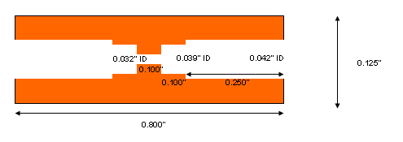
Trials with no-clean flux(see below) only are described here.
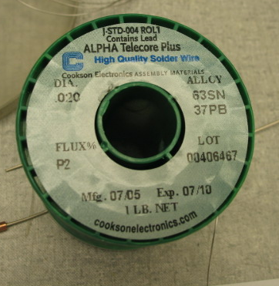

Seven samples were prepared, tested and sectioned. The leak checking protocol in all cases was leak check/pressurize to 20 bar a 50 times/leak check/dunk in LN2 10 times/leak check. Samples are summarized in table below.

Sample | Who | Crimp? | Leak/20 bar/leak | LN2/Leak | Comments
C1 | Post | No | OK | OK
C2 | Post | Yes | OK | OK
C3 | Post | Yes | OK | OK
C4 | Post | Yes | OK | OK
C5 | Post | Yes | No then OK after reflow | No | Hole in sleeve too large by accident
C6 | Gil | Yes | OK | OK | Got too hot. Added 2nd wrap of solder one side
C7 | Gil | Yes | OK | OK

The only “leak” failure resulted from a bad sleeve(C5). The large hole in the sleeve was drilled improperly so that the hole(0.042” ID nominal) was too large. Tried adding solder on one side but did not realize this problem until sectioned.

Sectioned pictures of each of the samples are below. C6 shows solder leakage into the cavity between capillaries. This was clearly both operator error(too hot) and from the addition of extra solder on one side(the side with excess into cavity). Otherwise there is no obstruction of the capillaries, even for C5 in which additional solder was added(but not overheated).
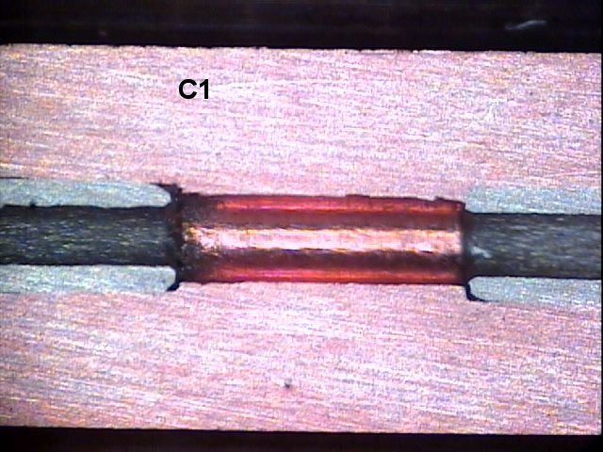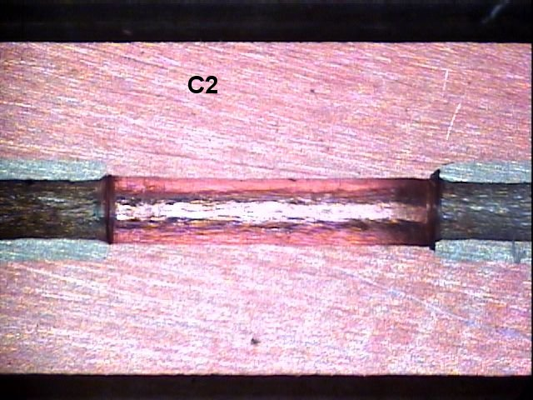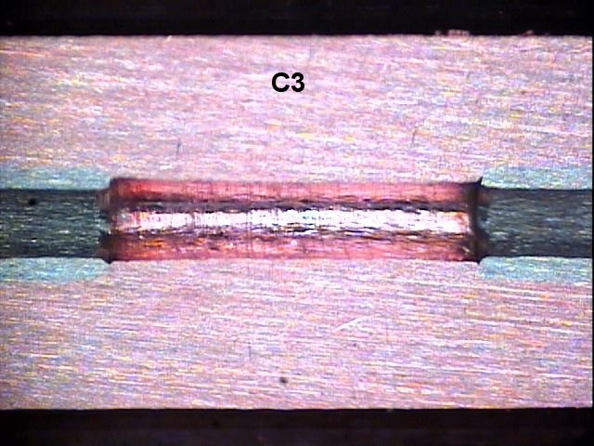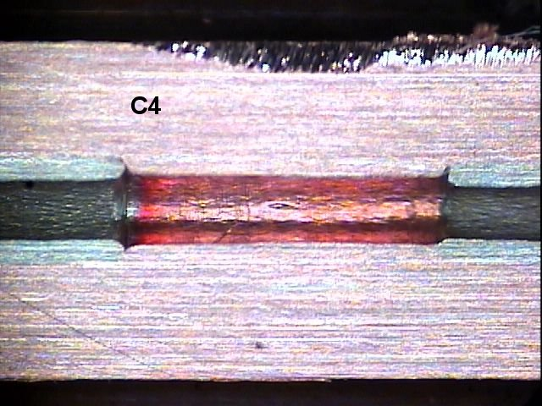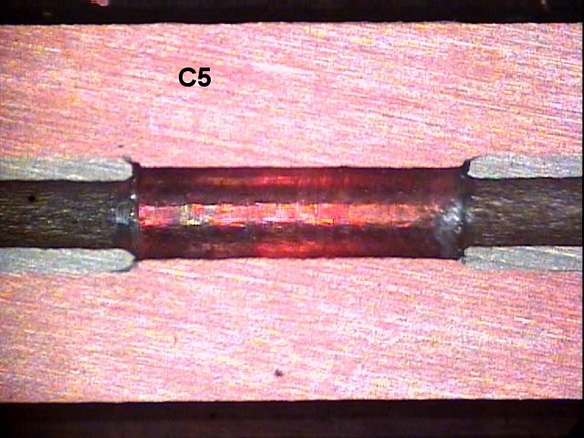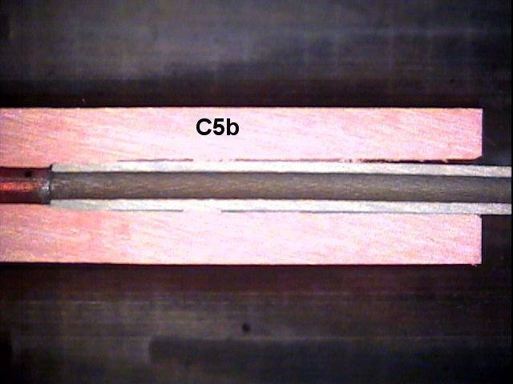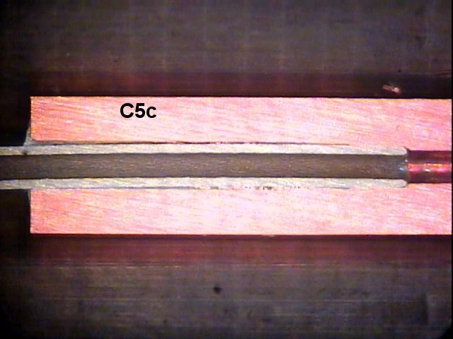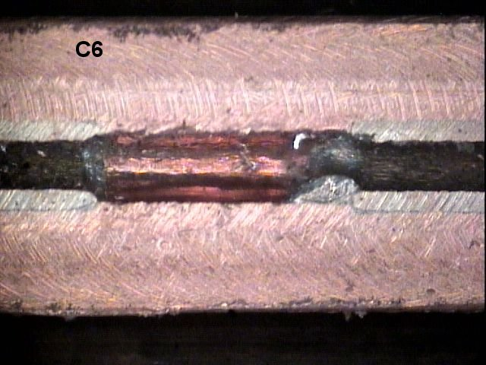
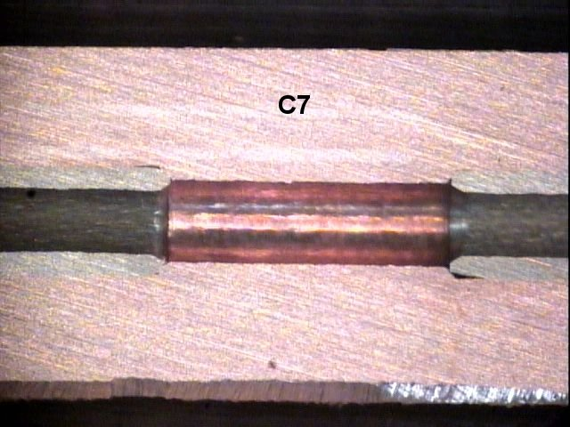

Gluing
Gluing was tried in a two step process. The capillary ends are glued into a Cu sleeve (but one with 0.044” ID instead of 0.042” ID) using Hysol 9396 – see below
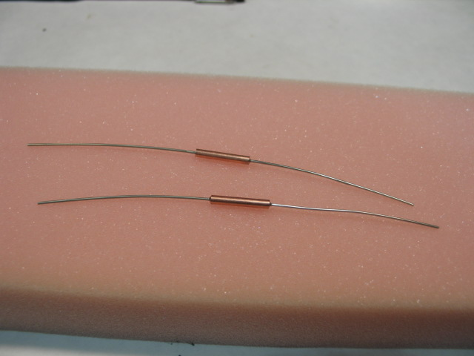
After a day of cure, these in turn were bonded into an aluminum sleeve with Hysol 9394 – see below. A teflon cap was used to retain the glue on one side. Two samples were made and allowed to cure for about three days. The test protocol was identical to the soldered samples. Both glued samples passed. In addition, three samples of just the sleeve and 9396 were sectioned. Two of these were not crimped. One had glue leakage into the cavity and one did not. The third sample was crimped and no glue leakage into cavity.


