December 10, 2007

First test of pixel prototype stave shown below for painting. Silicon heater in middle. Copper-kapton heaters at each end. YSH-70 side only has heaters. No heaters other side for these measurements.

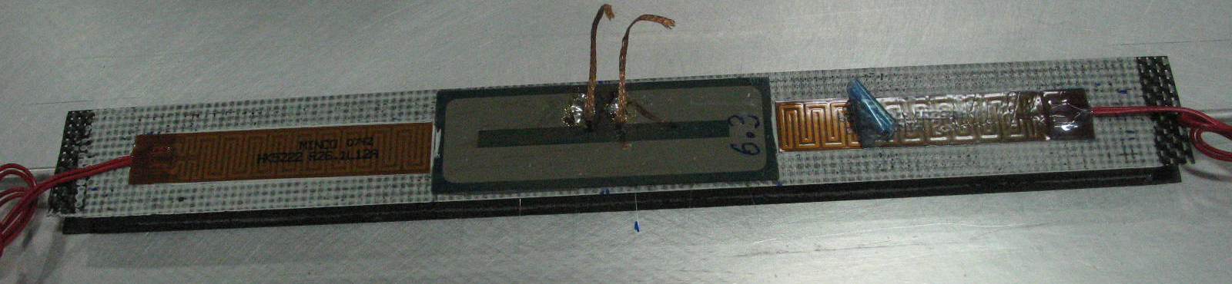

IR setup is shown below
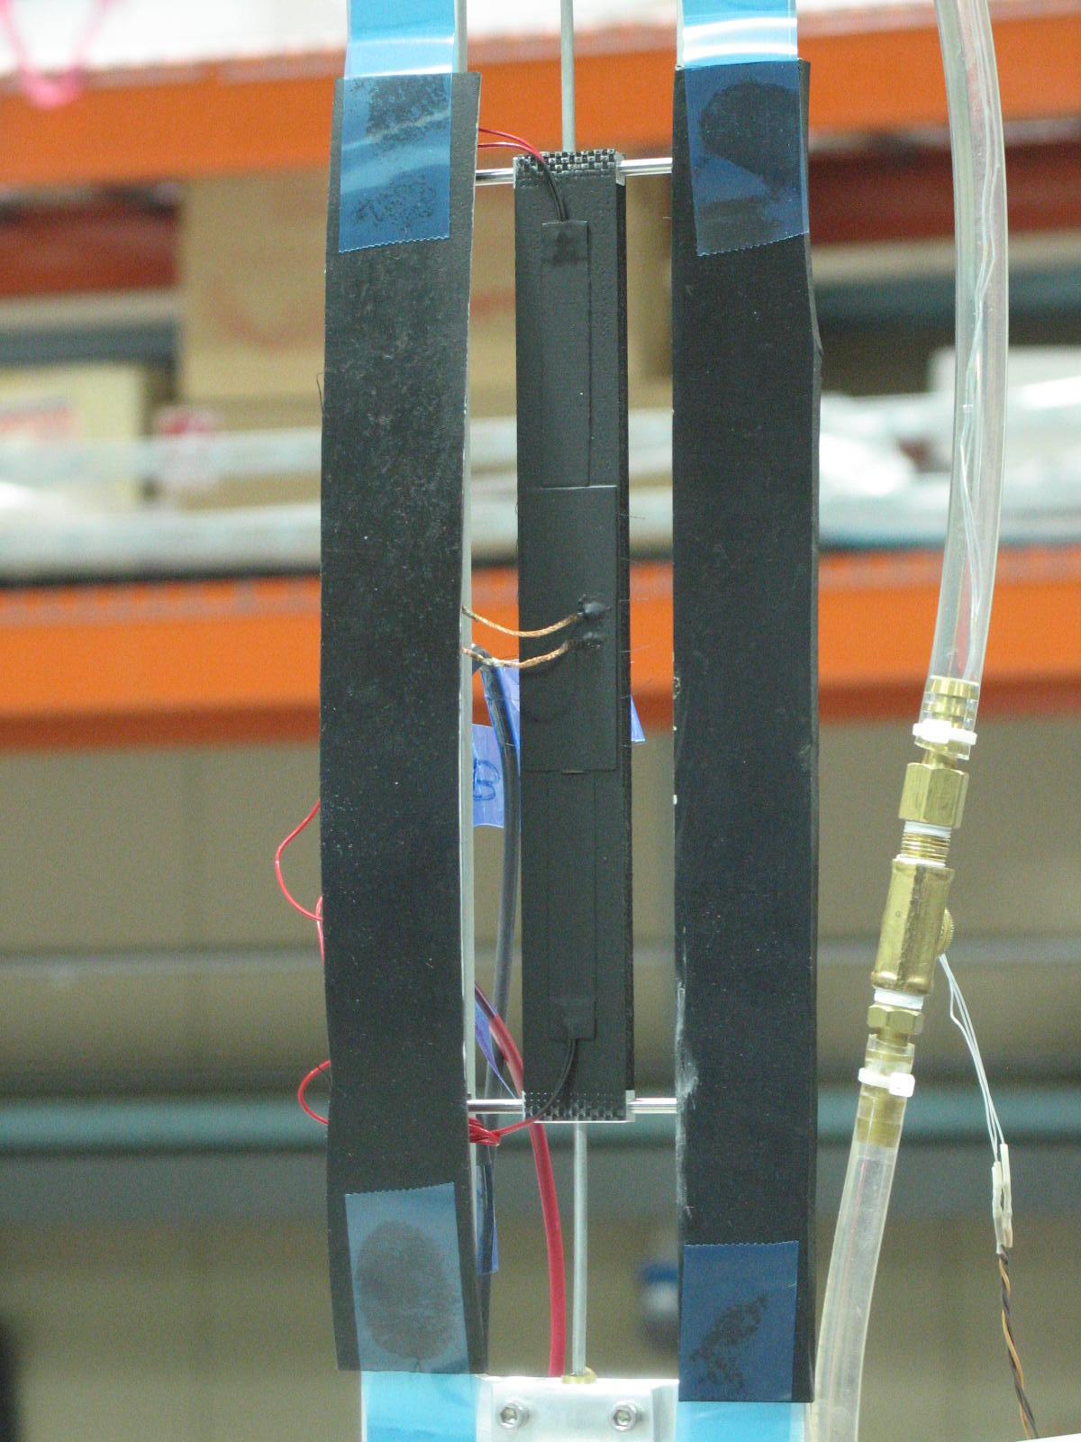

Water flow rate is 1 l/min

Test conditions summarized in table below.

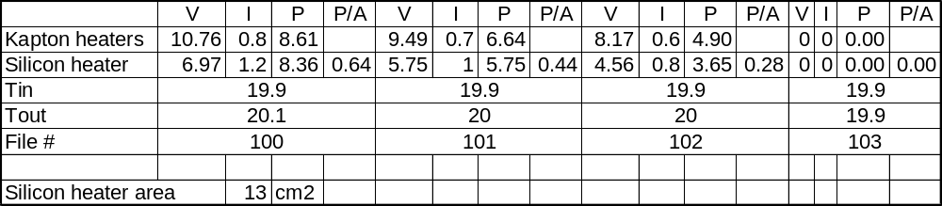

File 100

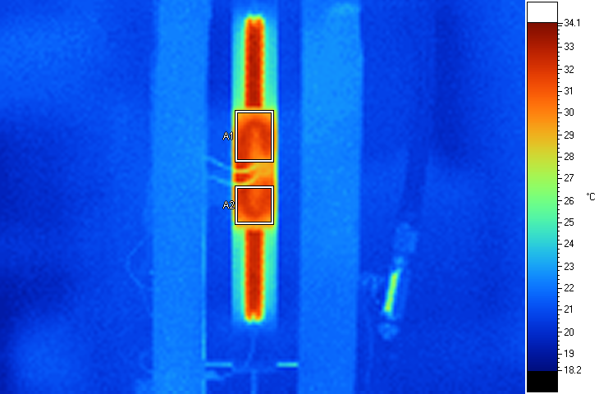
Label Emis BG Ave SD Max Min Unit
A1 0.95 19.0 31.08 0.94 32.4 28.3 C
A2 0.95 19.0 31.31 0.67 32.5 29.3 C

File 101

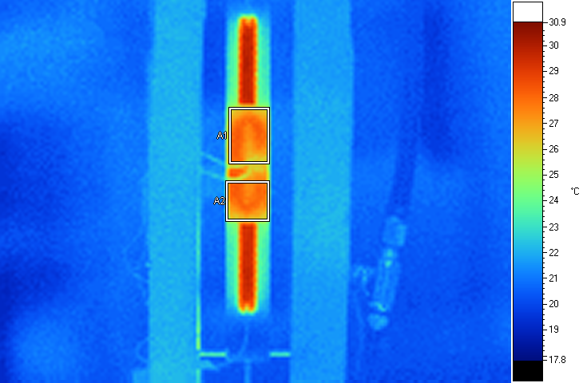
Label Emis BG Ave SD Max Min Unit
A1 0.95 19.0 27.41 0.65 28.4 25.9 C
A2 0.95 19.0 27.36 0.80 28.4 23.8 C

File 102

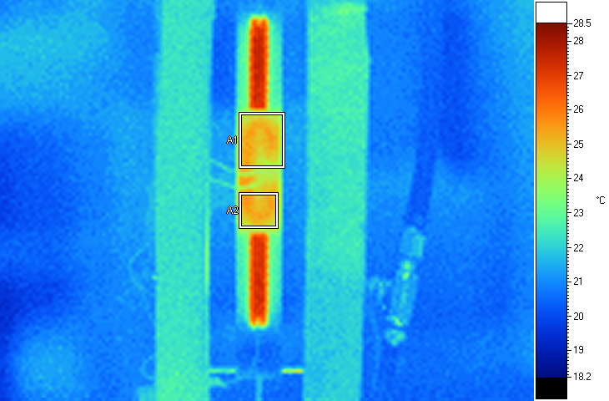
Label Emis BG Ave SD Max Min Unit
A1 0.95 19.0 24.85 0.46 25.6 23.4 C
A2 0.95 19.0 25.11 0.30 25.6 24.3 C

File 103
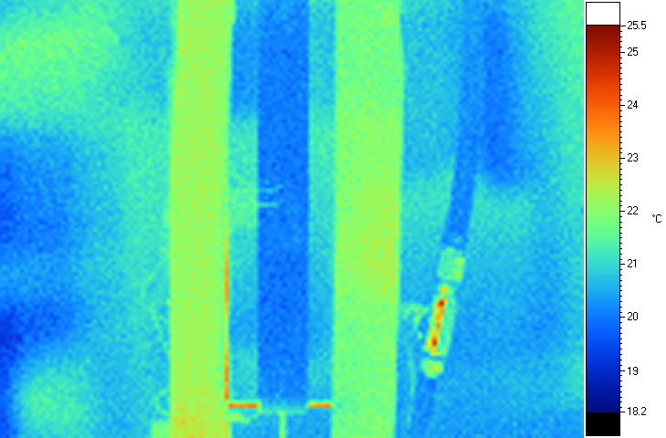

Here is what I extract for the average delta T(assume 20C) vs P/A

P/A(W/cm2) | delta T average
0.64 | 11.2
0.44 | 7.4
0.28 | 5
And plot of result. Very nicely linear.


