September 16, 2008

Testing of Allcomp1 stave after thermal cycle 50 times from +25C to about -30C

Test conditions

Allcomp1 | V | I | P | P/A | V | I | P | P/A
Kapton heaters | 0 | 0 | 0.00 | 0.00 | 6.94 | 1.2 | 8.3 | 0.64
Silicon heater
Tin |  |  |  |  | 20.1
Tout |  |  |  |  | 20.1
File # | 151 |  |  |  | 152

K13D2U side. 0.99 l/min

File 151
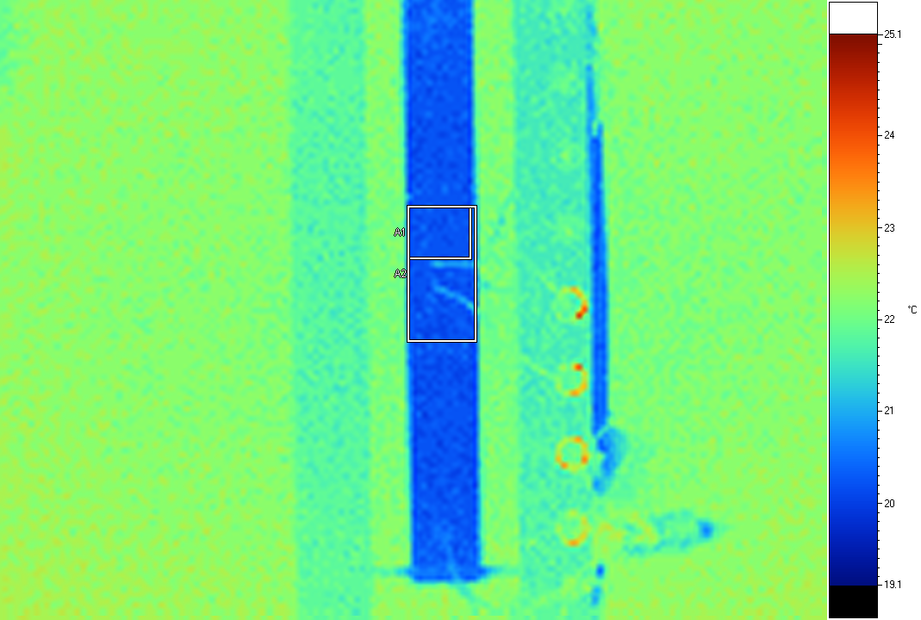
Label Emis BG Ave SD Max Min Unit
A1 0.95 19.0 20.27 0.08 20.5 20.1 C
A2 0.95 19.0 20.31 0.18 21.4 20.1 C

File 152
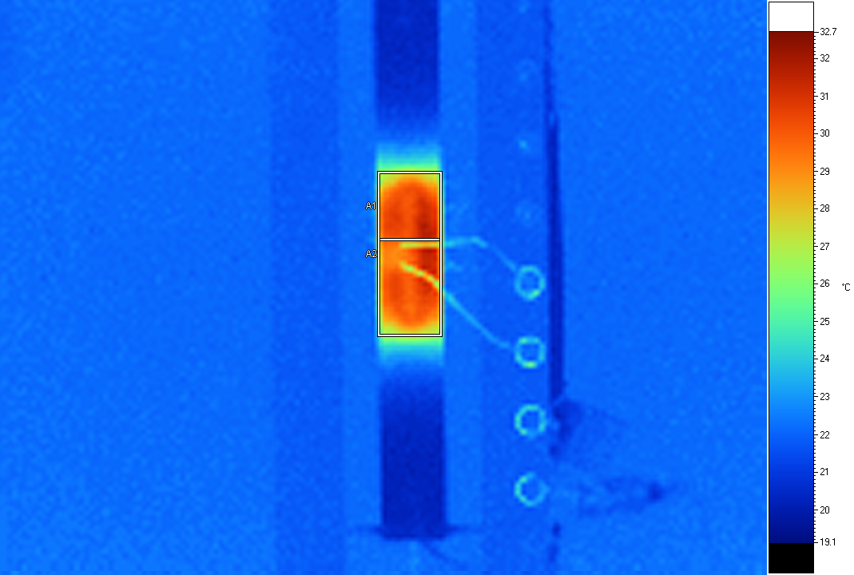
Label Emis BG Ave SD Max Min Unit
A1 0.95 19.0 29.71 1.31 31.8 25.3 C
A2 0.95 19.0 29.52 1.30 31.8 24.6 C

YSH-70 side

Allcomp1 | V | I | P | P/A | V | I | P | P/A
Kapton heaters | 0 | 0 | 0.00 | 0.00 | 6.94 | 1.2 | 8.3 | 0.64
Silicon heater
Tin |  |  |  |  | 20.1
Tout |  |  |  |  | 20.1
File # | 153 |  |  |  | 154

File 153
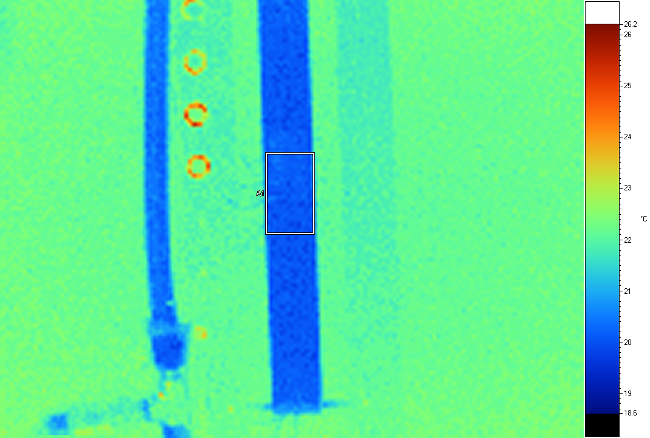
Label Emis BG Ave SD Max Min Unit
A1 0.95 19.0 20.18 0.16 20.8 19.8 C

File 154
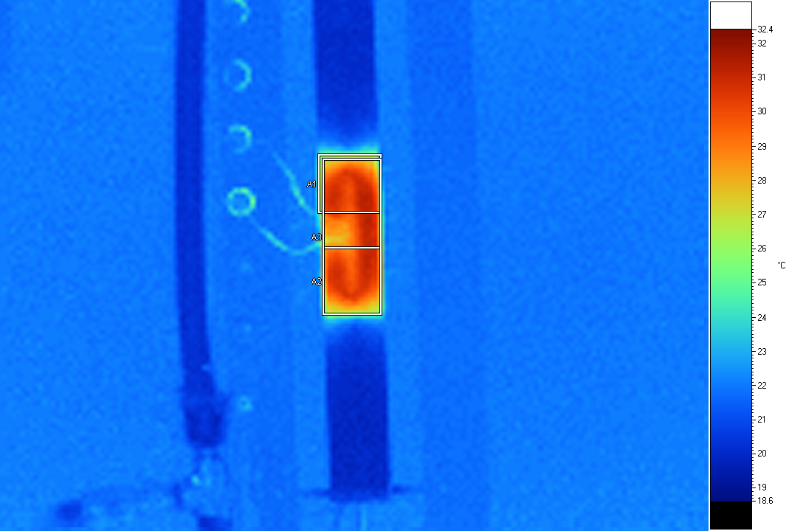
Label Emis BG Ave SD Max Min Unit
A1 0.95 19.0 29.17 1.86 31.4 24.3 C
A2 0.95 19.0 29.54 1.29 31.3 24.4 C
A3 0.95 19.0 29.63 1.23 31.4 24.4 C

