August 18, 2008

Testing of POCO foam PD2 little stave

Test conditions

POCO PD2 | V | I | P | P/A | V | I | P | P/A
Kapton heaters | 0 | 0 | 0.00 | 0.00 | 6.87 | 1.2 | 8.18 | 0.63
Silicon heater
Tin
Tout
File # | 145 |  |  |  | 146

File 145
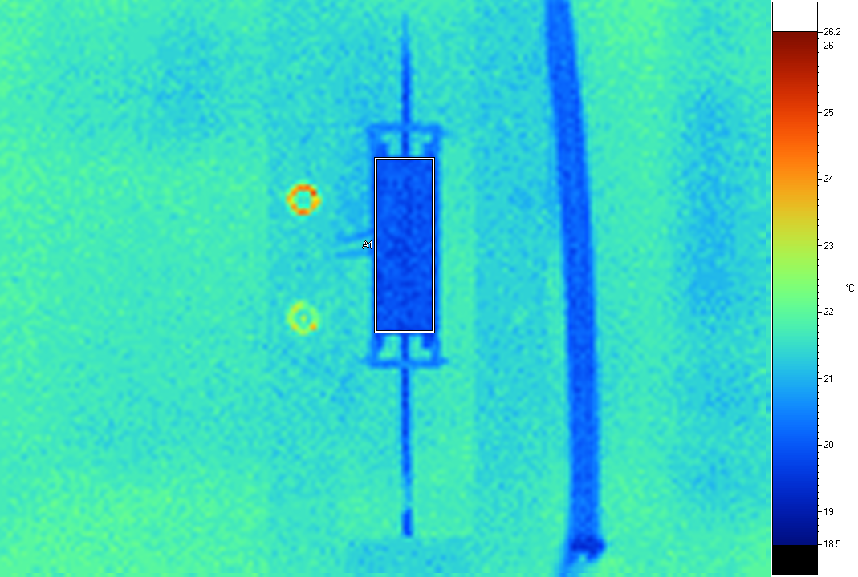
Label Emis BG Ave SD Max Min Unit
A1 0.95 19.0 19.98 0.14 20.4 19.7 C

File 146
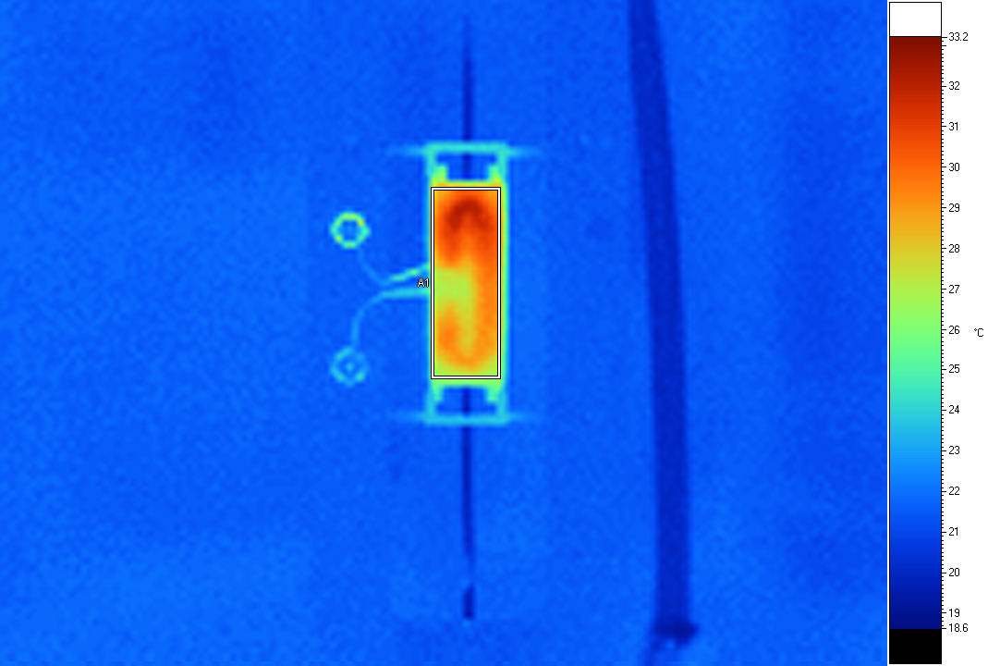
Label Emis BG Ave SD Max Min Unit
A1 0.95 19.0 29.07 1.34 32.2 26.1 C

A different box
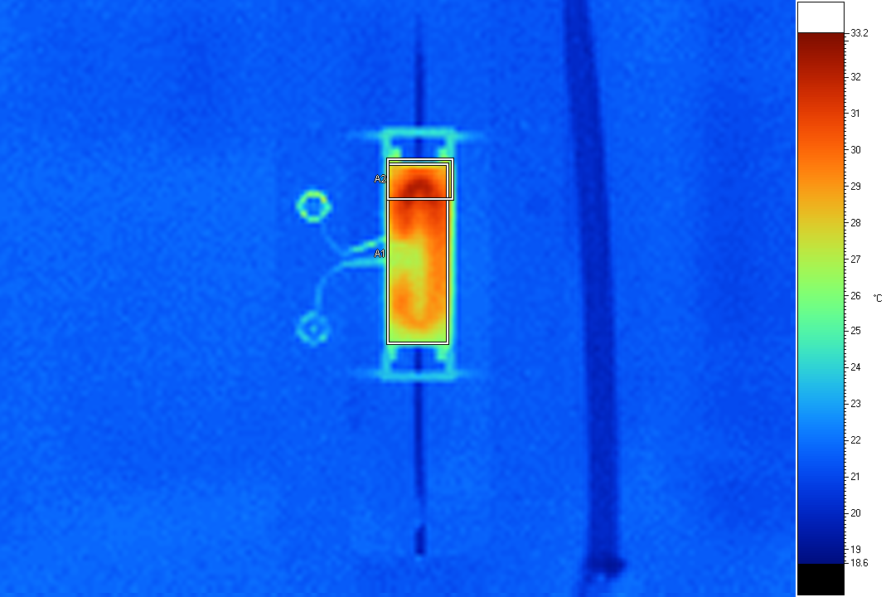
Label Emis BG Ave SD Max Min Unit
A1 0.95 19.0 28.95 1.40 32.2 25.9 C
A2 0.95 19.0 28.97 2.61 32.2 20.9 C

Yet another
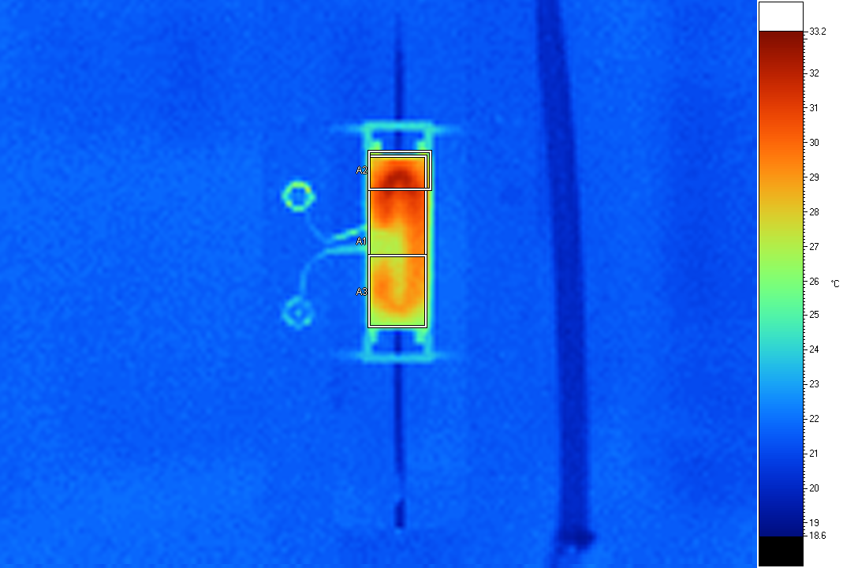
Label Emis BG Ave SD Max Min Unit
A1 0.95 19.0 28.95 1.40 32.2 25.9 C
A2 0.95 19.0 28.97 2.61 32.2 20.9 C
A3 0.95 19.0 28.22 0.84 29.5 25.9 C

August 22, 2008

After thermal cycle 50 times from 25 to about -30C. Flow is 1 l/min

POCO PD2 | V | I | P | P/A | V | I | P | P/A
Kapton heaters | 0 | 0 | 0.00 | 0.00 | 6.89 | 1.2 | 8.18 | 0.63
Silicon heater
Tin | 20.1 |  |  |  | 20.1
Tout | 20.1 |  |  |  | 20.3
File # | 147 |  |  |  | 148

POCO PD2 | V | I | P | P/A | V | I | P | P/A
Kapton heaters | 0 | 0 | 0.00 | 0.00 | 6.89 | 1.2 | 8.18 | 0.63
Silicon heater
Tin | 20.1 |  |  |  | 20.1
Tout | 20.1 |  |  |  | 20.3
File # | 149 |  |  |  | 150

File 149
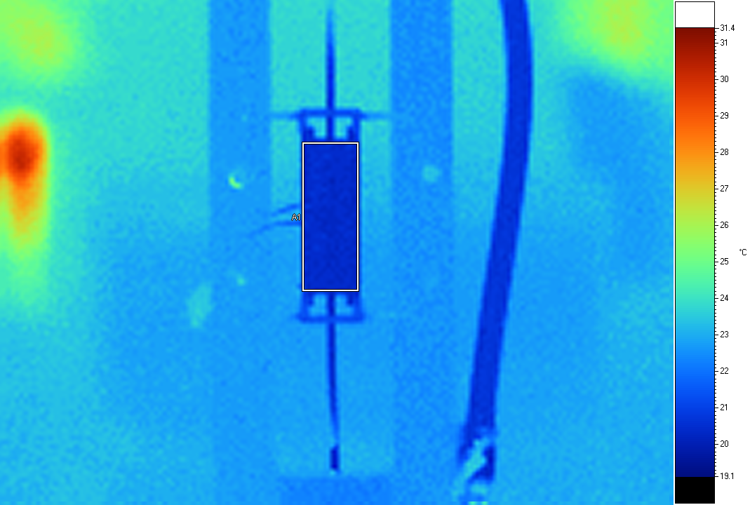
Label Emis BG Ave SD Max Min Unit
A1 0.95 19.0 20.50 0.14 21.1 20.1 C

File 150
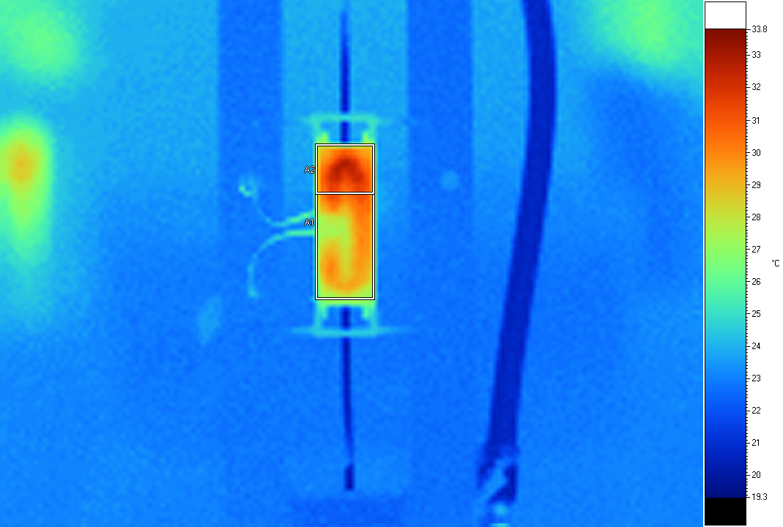
Label Emis BG Ave SD Max Min Unit
A1 0.95 19.0 29.38 1.52 32.8 25.3 C
A2 0.95 19.0 30.45 1.65 32.8 25.5 C

Comparison – large box

Pre-thermal cycle averages: 29-20=9
Post thermal cycle averages: 29.4-20.5=8.9

The same within errors.

Picture post thermal without boxes to look at edges
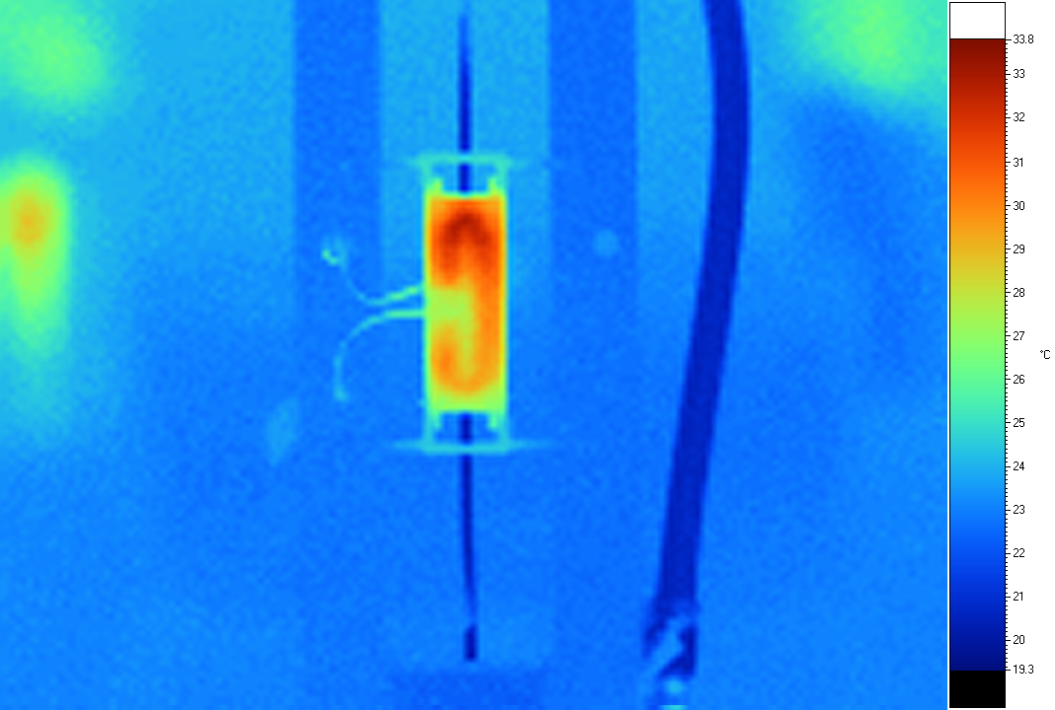

Can’t see anything from this...

