April 4, 2008

Testing different foam prototypes. First test is of just YSH-70 side, just silicon heater powered of all prototype ie. center section of below
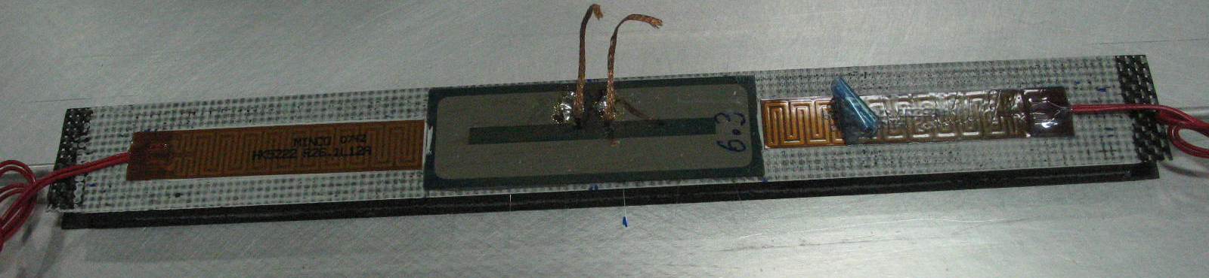

Water flow rate is 1 l/min for all measurements

Test conditions summarized in table below for Allcomp 1.

Allcomp 1 | V | I | P | P/A | V | I | P | P/A | V | I | P | P/A | V | I | P | P/A
Kapton heaters
Silicon heater | 0 | 0 | 0.00 | 0.00 | 6.94 | 1.2 | 8.33 | 0.64
Tin | 20.1 |  |  |  | 20.1
Tout | 20 |  |  |  | 20.2
File # | 120 |  |  |  | 121

File 120
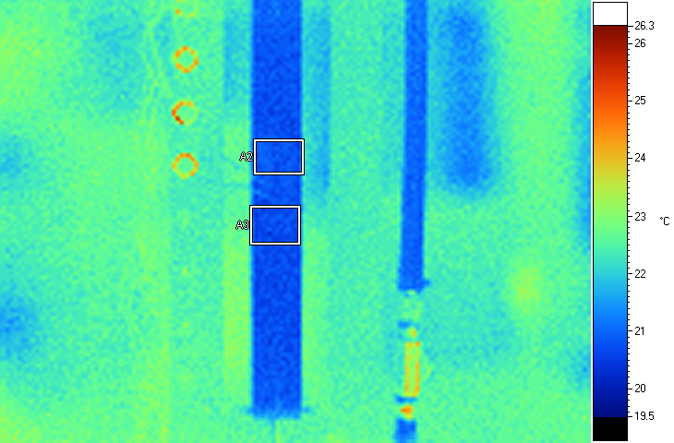
Label Emis BG Ave SD Max Min Unit
A2 0.95 19.0 20.85 0.12 21.0 20.6 C
A3 0.95 19.0 20.78 0.25 21.6 20.5 C

Note that IR is a bit higher than direct fluid measurement by <1C.

File 121
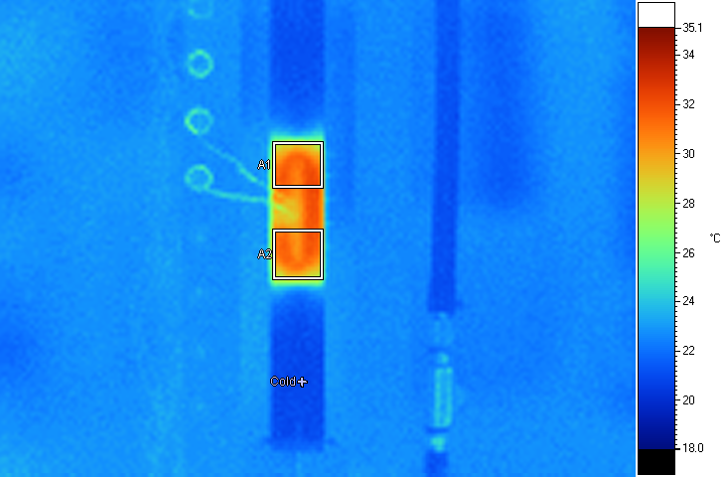
Label Emis BG Ave SD Max Min Unit
A1 0.95 19.0 30.65 1.17 32.2 27.8 C
A2 0.95 19.0 30.71 0.86 32.1 28.1 C
Cold 0.95 19.0 20.75 0.00 20.8 20.8 C

This implies delta T from fluid(direct measurement) of 30.7-20=10.7=11C or from IR it would be 30.7-20.8=9.9=10C. Thus 10-11C, in agreement about with previous measurements some months ago.

Next is Allcomp 2 prototype
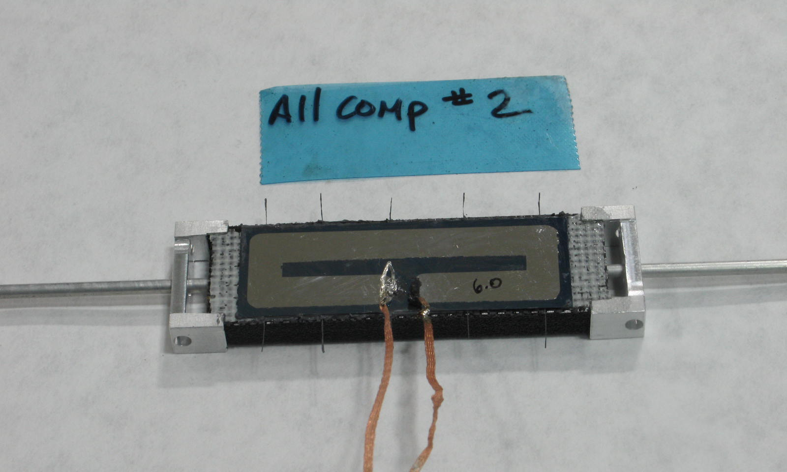
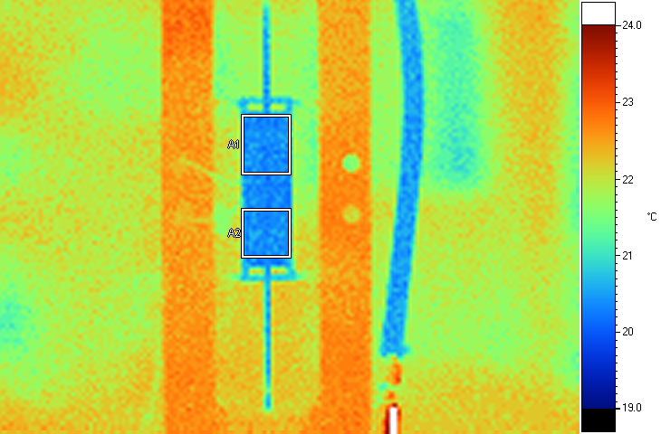
Label Emis BG Ave SD Max Min Unit
A1 0.95 19.0 20.41 0.12 20.8 20.1 C
A2 0.95 19.0 20.44 0.17 21.0 20.3 C

Looks like heater non-uniformity below....
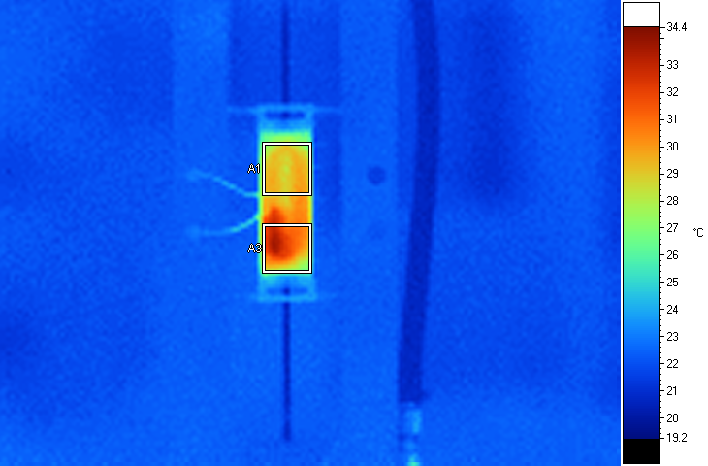
Label Emis BG Ave SD Max Min Unit
A1 0.95 19.0 29.02 0.62 30.1 26.9 C
A3 0.95 19.0 30.91 1.58 33.8 27.1 C

POCO
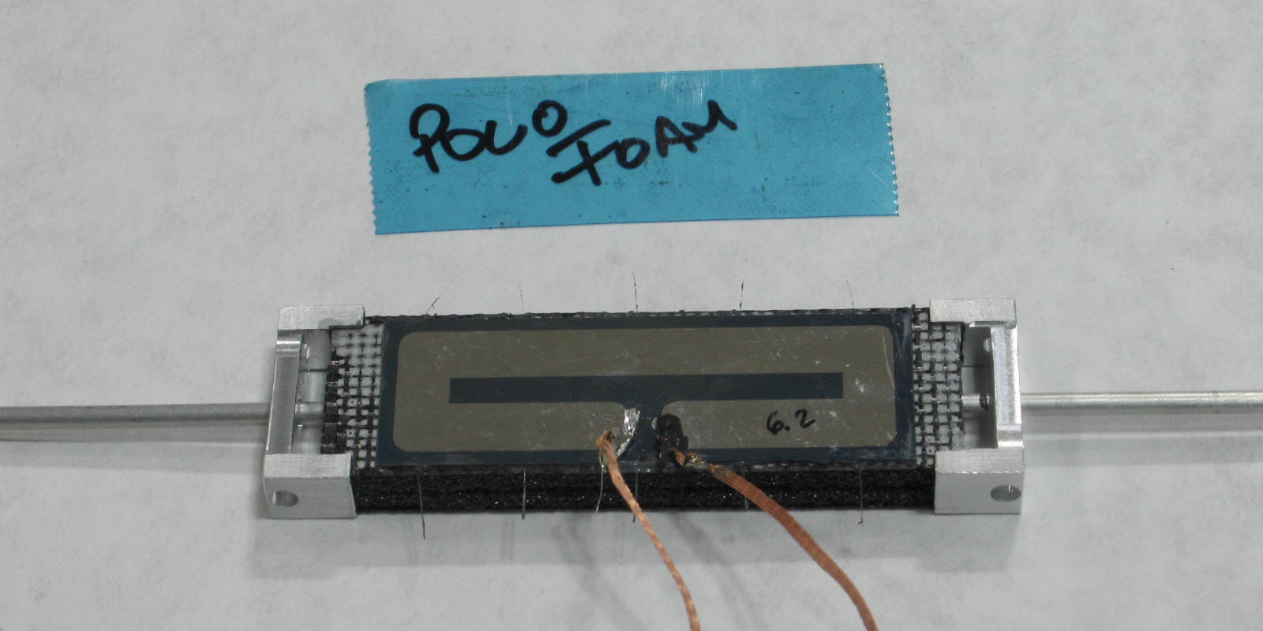

POCO | V | I | P | P/A | V | I | P | P/A | V | I | P | P/A
Kapton heaters
Silicon heater | 0 | 0 | 0.00 | 0.00 | 6.93 | 1.2 | 8.35 | 0.64
Tin | 20.2 |  |  |  | 20.2
Tout | 20 |  |  |  | 20.1
File # | 124 |  |  |  | 125

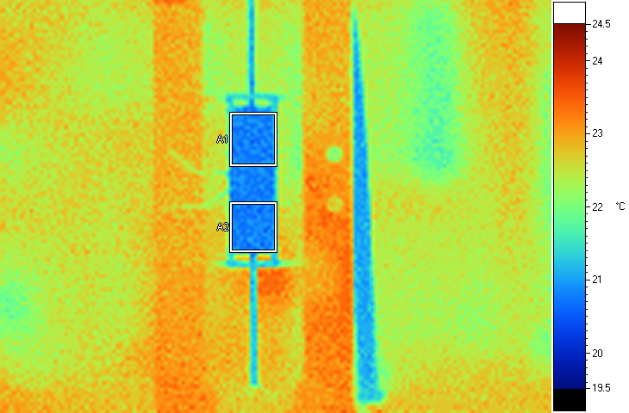
Label Emis BG Ave SD Max Min Unit
A1 0.95 19.0 20.84 0.12 21.3 20.6 C
A2 0.95 19.0 20.83 0.12 21.3 20.5 C

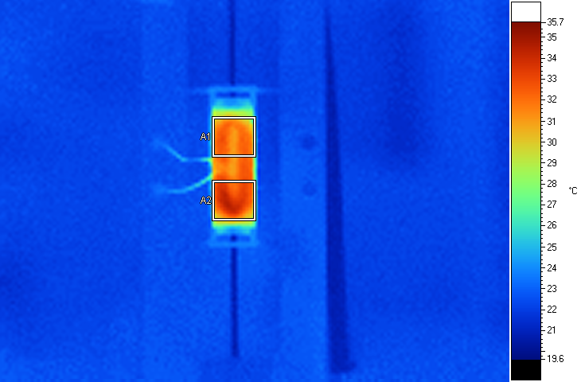
Label Emis BG Ave SD Max Min Unit
A1 0.95 19.0 31.48 0.90 32.9 27.3 C
A2 0.95 19.0 32.66 1.12 34.5 29.0 C

Koppers
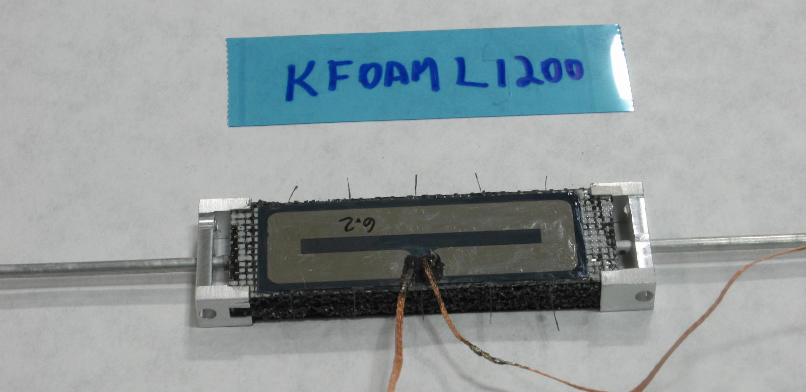

Koppers | V | I | P | P/A | V | I | P | P/A | V | I | P | P/A
Kapton heaters
Silicon heater | 0 | 0 | 0.00 | 0.00 | 6.92 | 1.2 | 8.37 | 0.64
Tin | 20.1 |  |  |  | 20.2
Tout | 20 |  |  |  | 20.2
File # | 126 |  |  |  | 127

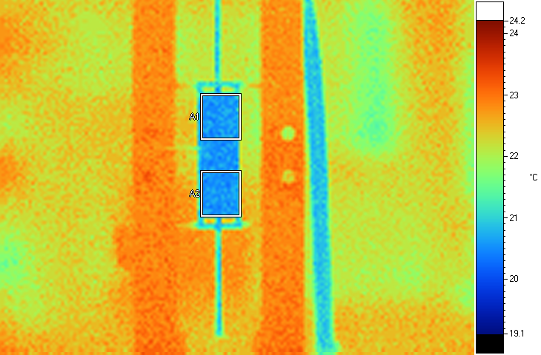
Label Emis BG Ave SD Max Min Unit
A1 0.95 19.0 20.63 0.13 21.3 20.4 C
A2 0.95 19.0 20.60 0.11 20.9 20.4 C

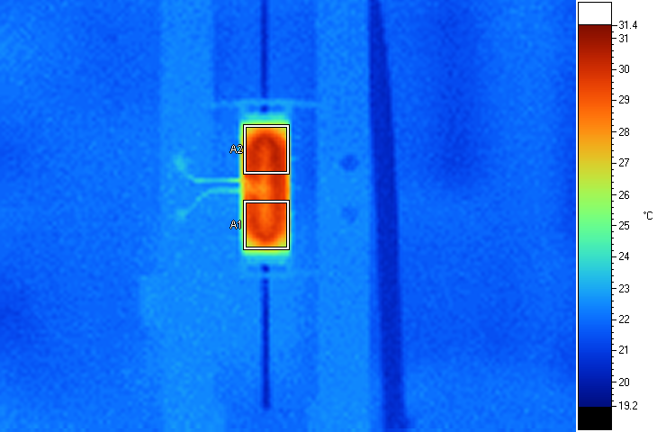
Label Emis BG Ave SD Max Min Unit
A1 0.95 19.0 28.92 0.82 29.9 26.1 C
A2 0.95 19.0 29.20 1.05 30.4 26.3 C

Two different values for Allcomp 2 in table below. One(29 twice) I ignore apparent hot spot on heater. Other entry I don’t.
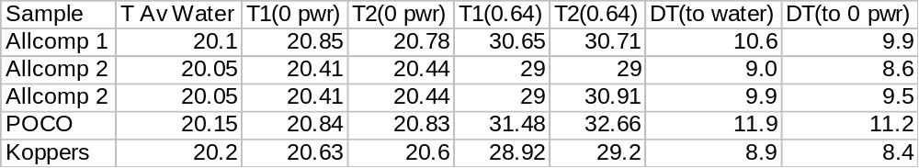

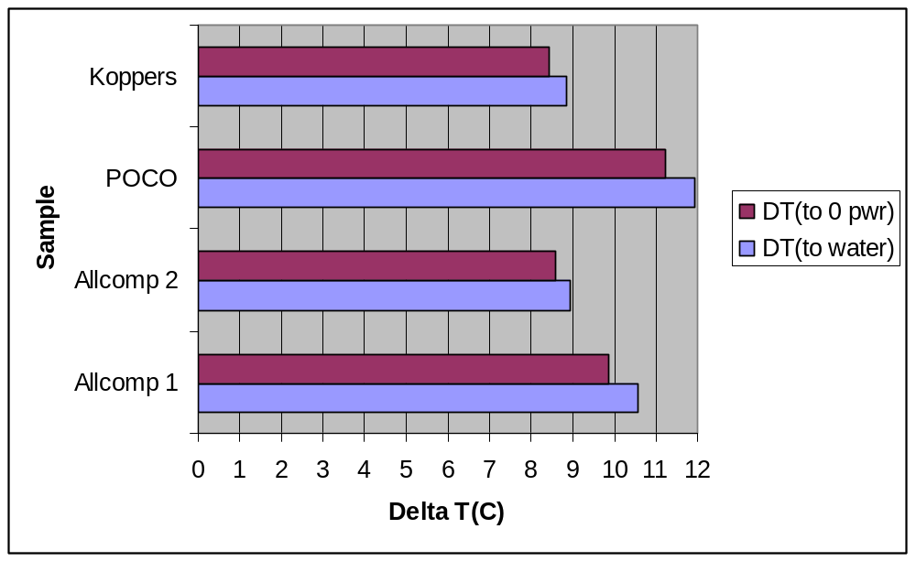

April 18, 2008

Copper kapton heaters were attached to the other side of the three small samples and imaged. Also re-imaged the sides with silicon heaters.

Allcomp 2
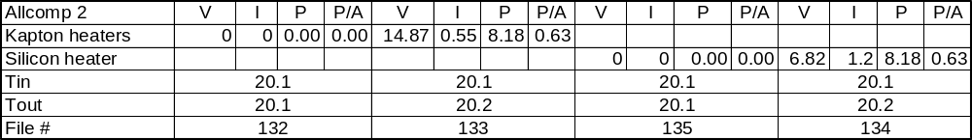

File 132
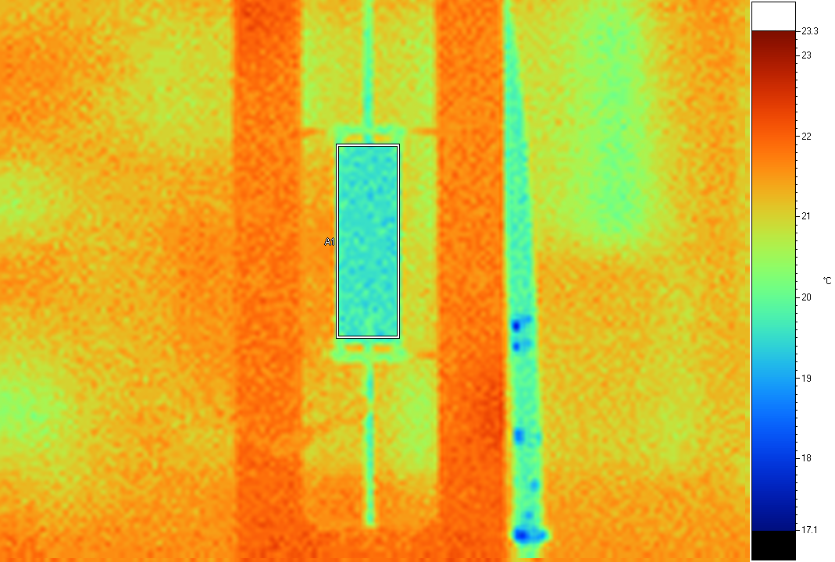
Label Emis BG Ave SD Max Min Unit
A1 0.95 19.0 19.66 0.16 20.3 19.3 C

File 133
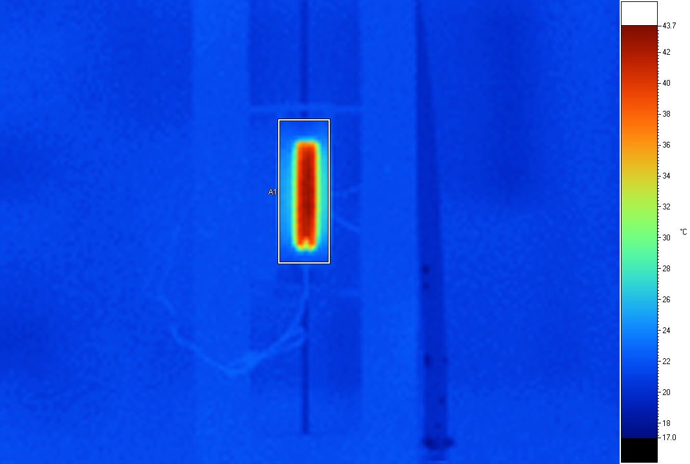
Label Emis BG Ave SD Max Min Unit
A1 0.95 19.0 29.53 7.17 42.8 21.3 C

File 135
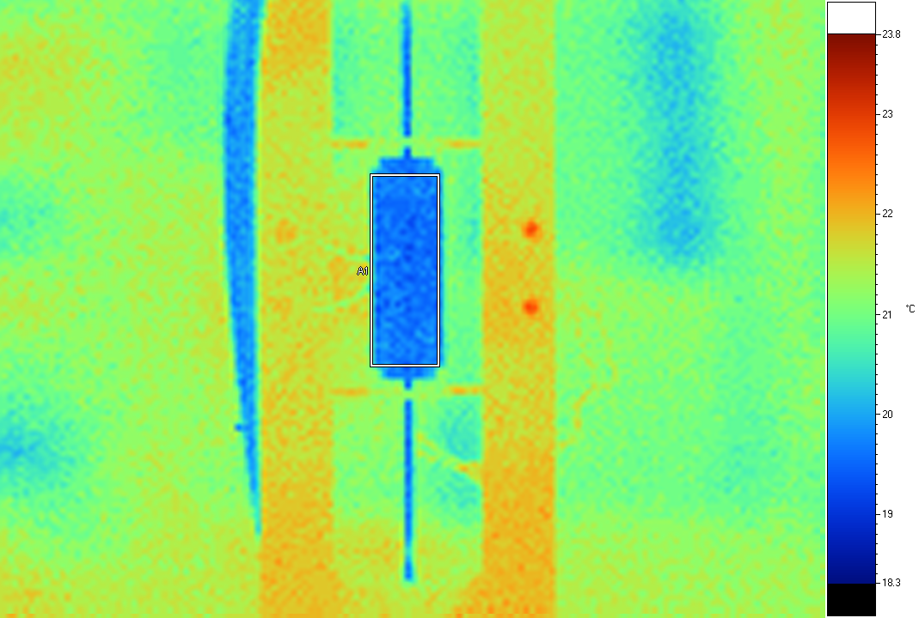
Label Emis BG Ave SD Max Min Unit
A1 0.95 19.0 19.75 0.31 21.0 19.3 C

File 134
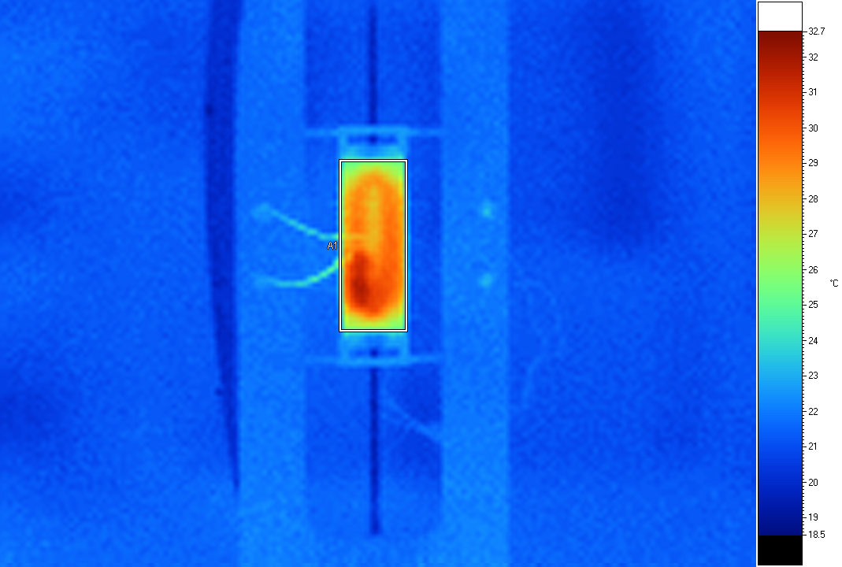
Label Emis BG Ave SD Max Min Unit
A1 0.95 19.0 28.28 1.83 31.8 22.6 C

POCO
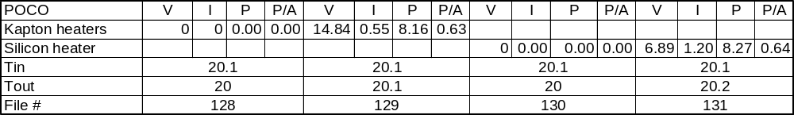

File 128
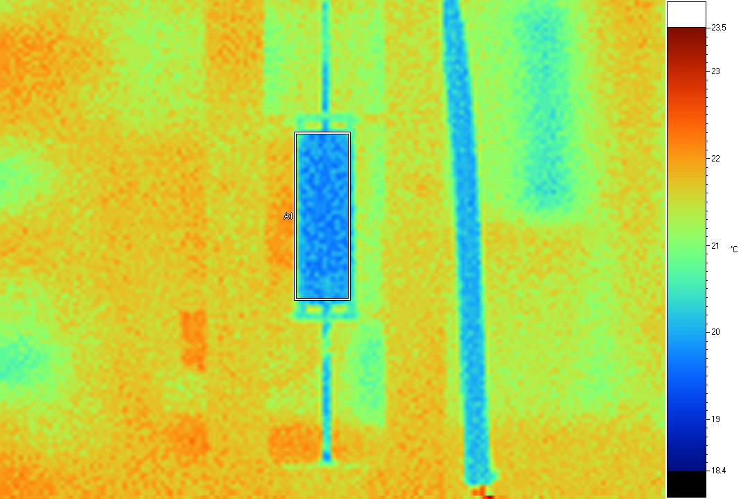
Label Emis BG Ave SD Max Min Unit
A1 0.95 19.0 20.04 0.45 21.8 19.6 C

File 129
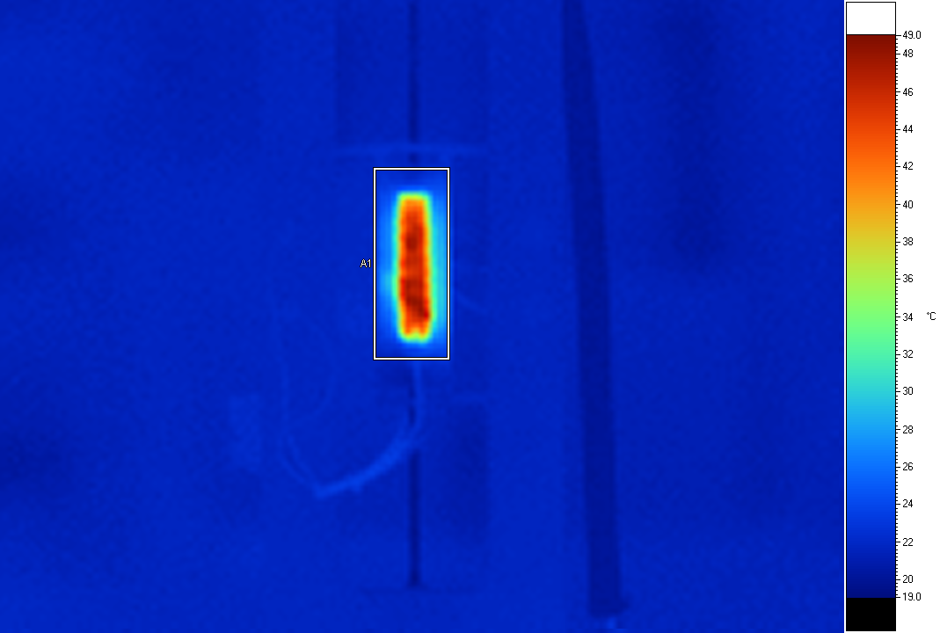
Label Emis BG Ave SD Max Min Unit
A1 0.95 19.0 31.64 8.49 48.0 21.8 C

File 130
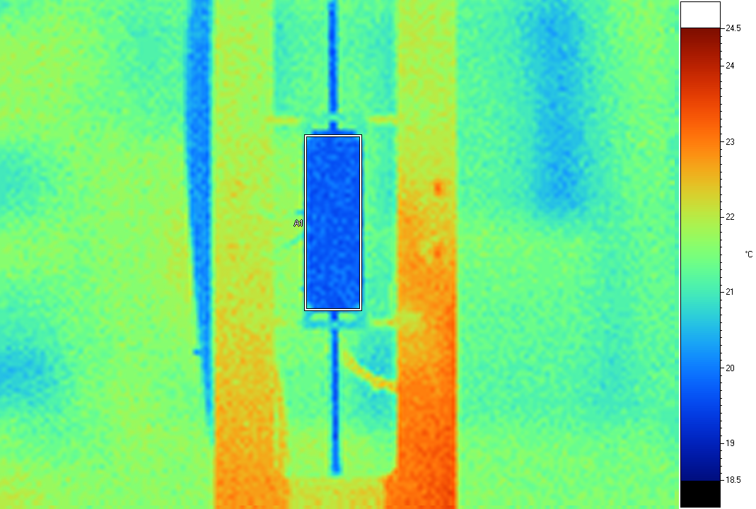
Label Emis BG Ave SD Max Min Unit
A1 0.95 19.0 19.83 0.21 21.1 19.6 C

File 131
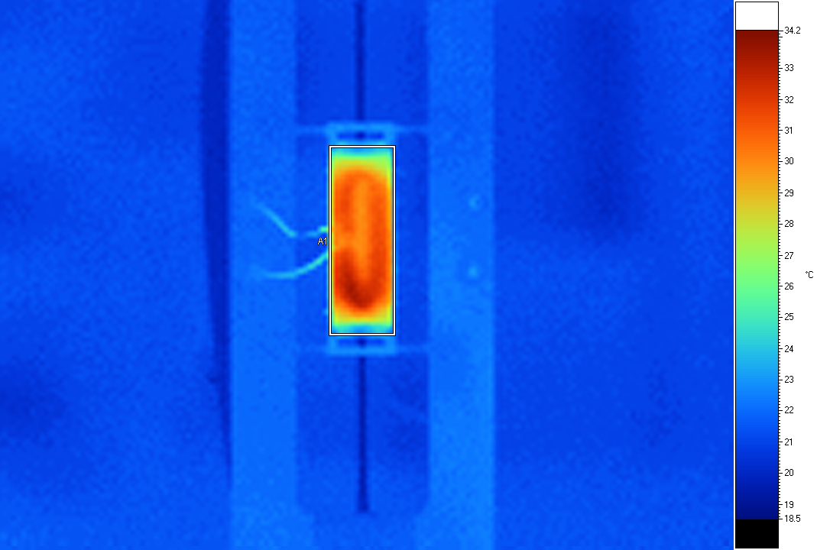
Label Emis BG Ave SD Max Min Unit
A1 0.95 19.0 29.51 2.52 33.3 22.9 C

Koppers
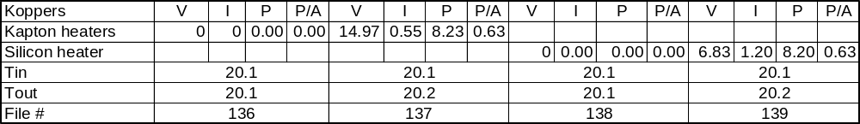

File 136
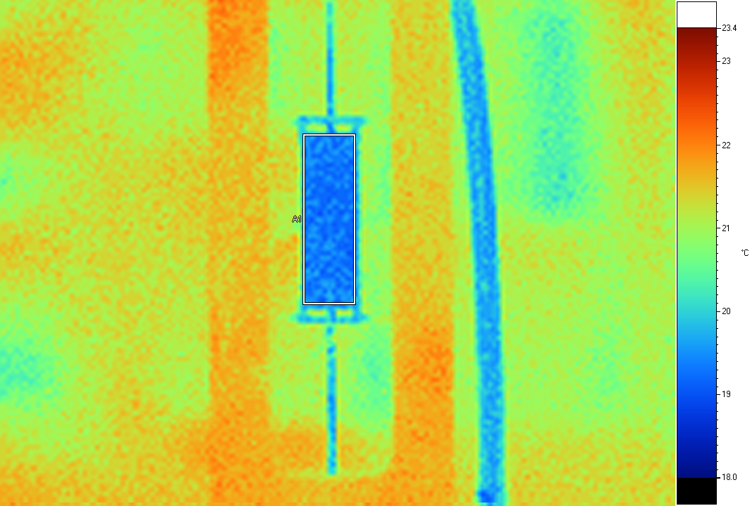
Label Emis BG Ave SD Max Min Unit
A1 0.95 19.0 19.38 0.15 19.8 19.0 C

File 137
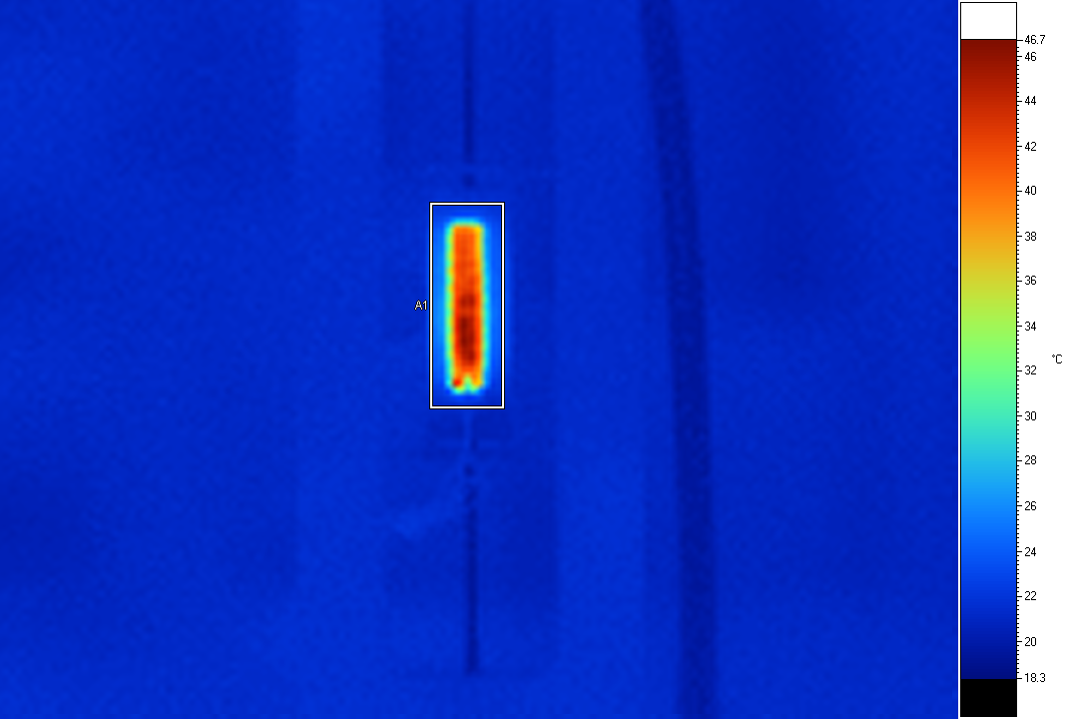
Label Emis BG Ave SD Max Min Unit
A1 0.95 19.0 30.82 7.90 45.7 21.1 C

File 138
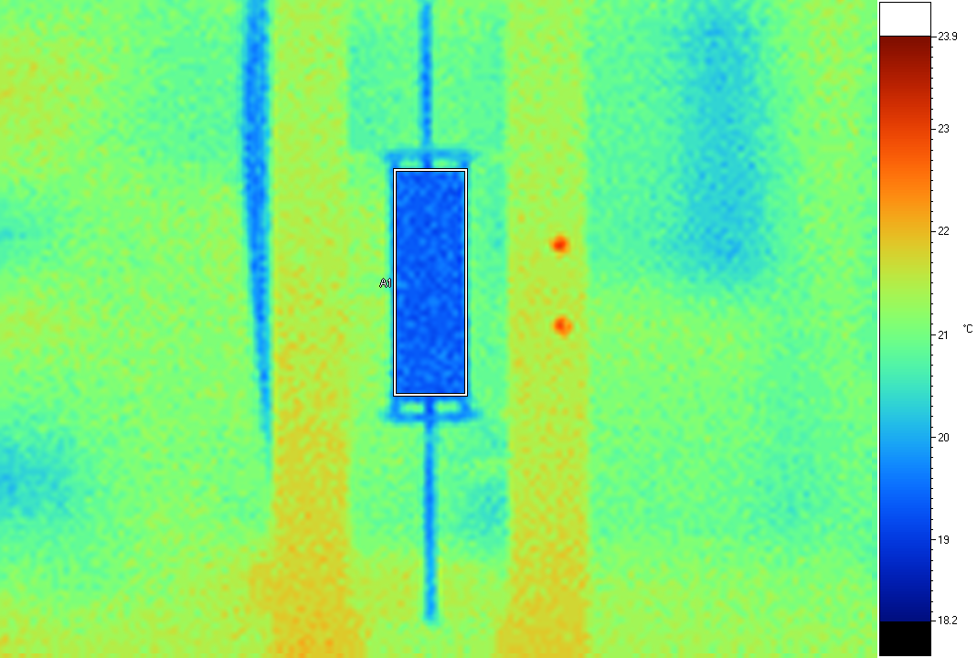
Label Emis BG Ave SD Max Min Unit
A1 0.95 19.0 19.46 0.15 20.1 19.3 C

File 139
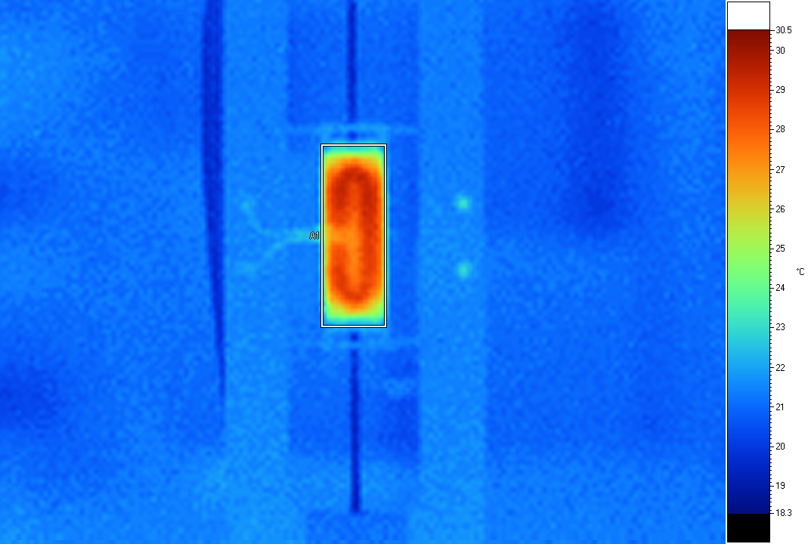
Label Emis BG Ave SD Max Min Unit
A1 0.95 19.0 26.97 2.03 29.4 21.5 C

